**WATUKE FOUNDATION - UGANDA**

**PRIMARY SEVEN ENGLISH LESSON NOTES – 2023**

**TERM ONE**

**ASPECT 1: COMPREHENSION (MK BK 7)**

**LESSON 1 SCHOOL HOLIDAYS**

**A: HOLIDAY PLANS**

1. Vocabulary practice:

Vacation , Travel, Breakup, Prepare , Relatives , Penpal , Commence , Chores , Programme, Remedial, Board, Urban , Rural , Birthday , Up country, End , Remedial classes, holidays ,

1. Language Structures (to be done orally)

………….going to…………

Near future

Examples

1. I am going to visit my grandparents during holidays
2. Tom is going to travel to up country when holidays commence
3. Question tags
4. We shall do a lot of chores in holidays, shan’t we?
5. I am not going for holidays, am I?
6. They will have planned for holidays, won’t they?
7. Speeches

Examples

“Tom will come to the village tomorrow,” he said

He said that Tom would go to the village the next day

NB: and, other

**Comprehension**

1. Passage (going for school holidays)
2. Dialogue (a telephone conversation)
3. Poem (MK modern P7)
4. Guided composition (the sure key to success P.16)
5. Picture composition (Mk modern)
6. Revision exercises

**SUB TOPIC 1B**

**HOLIDAY ACTIVITIES**

1. Vocabulary practice

Study, tour, camp, visit, begin, concert, show, cook, advice, house work, trip, enjoy, nice, interesting, exciting, report, vacation, chores, routine, bash, fare

1. Language structures

Participle

A participle is a word formed from a verb. It can act as the main verb in a verb phrase or as an adjective to explain a noun or pronoun.

e.g. Mbara has visited several places in the city.

The exciting moments made him delay at the hotel

A past participle is formed by adding ‘d’ or ‘ed’ to a regular verb. E.g. cook – cooked, bake – baked.

A helping verb is usually used with the participle such as has, had, have

Exercise

(The winners P20 – 21)

1. If 3 conditional

If 3 is used to express what would have happened if a certain condition had been fulfilled.

If clause – past perfect tense

Main clause – would / wouldn’t have

e.g. If I had seen him in the holiday, he would have given me some money.

NB: You can also express If 3 by beginning with “Had”

Ref: The sure key to success Pg 13

The Winner pg 21 – 22

1. Guided composition (jumbled story)

Nakku goes back to school” (Ref: The sure key to success pg 14

1. Holiday programme (table : The sure key to success Pg 15)

**ASPECT2: PUNCTUATION MARKS**

**Lesson 1 Capital Letters and full stops**

1. Usage of capital letters
2. Used at the beginning of sentences, e.g Mukasa is riding a bicycle.
3. Use for proper nouns and proper adjectives e.g Uganda – Ugandan

Proper nouns e.g

* Names of the months of the year
* Names of people
* Names of streets
* Names of buildings
* Names of avenues

1. Used for all titles applied to one particular person, e.g Our president meet the Egyptian President. The Famous Five
2. To begin direct speech, e.g “I have hurt my finger,” said Tom
3. To write pronoun I, e.g. While I was playing netball, Jane was peeling matooke.
4. To begin words of exclamation, e.g. “Oh!” shouted the boy
5. To begin words He, Him, His, Himself, if they refer to God of Jesus Christ.
6. Usage of full stops
7. Used at the end of either an affirmative or negative sentence, e.g

* We are learning English
* We are not learning English

Activity

Write these abbreviations in full

WSPA, USPA, UWEC, UWA, WCU, ABS, ADI, AVAR, ASAB, CAPS, PP, cc, Re, Mr, MRs, Br, Mt, Hon, Rev, Prof. e-mail

1. Used in abbreviations, e.g

i.e - that is

C.I.I.D - Criminal Investigation and Intelligence Directorate

Capt - Captain

P.S.V - Public Service Vehicle

PMO - Private Motor Omnibus

**Activity**

1. **Rewrite and punctuate the sentences below**
2. he saw a big snake on tuesday
3. robert has left for london
4. i said i shall come tomorrow
5. tom wants to work in italy, so he is learning italian
6. god said i am who i am
7. what an honest man dan is
8. god was happy with his creation
9. **Write the short forms of the following**
10. Mistress
11. Doctor
12. Namely
13. For example

**LESSON 2**

1. Question mark
2. Exclamation

Usage of a question mark

* Used at the end of a direct question, e.g Where is Tom?
* Used at the end of tag questions, e.g She is my wife , isn’t she?

Note: Indirect or reported questions do not take a question mark e.g. He sked me if I had been to America

Use of an exclamation mark

* Used after words that are shouted and after expressions of surprise, e.g
* What a clever boy you are!
* Come here at once!

**Activity**

Punctuate the following sentences correctly

1. What did you see at the park
2. Where did you go after supper
3. What aggregate are you likely to get
4. What time is it asked the traveler
5. How beautiful you sister is
6. What a clever boy you are
7. What a deadly snake a cobra is
8. The child suddenly shouted look
9. What is the capital city of China

**LESSON 3**

1. Apostrophe
2. Comma

Usage of an apostrophe

(i) To show contractions (to show that a letter or letters are missing) e.g.

isn’t - is not

can’ - cannot

O’clock - of the clock

o'er - over

(ii) To show possession / ownership

* Singular form

Example

The girl’s dress, the student’s book

The lady’s bag

However, it may be shown by the apostrophe only if the noun ends in s. e.g.

Jesus’ words

Moses’ wife

* Plural form

1. By the apostrophe only if the plural ends in s

Example

Boys’ books

Ladies’ shoes

1. By the apostrophe and s (‘s) when the plural does not end in s, e.g children’s toys.

Men’s hats

|  |  |
| --- | --- |
| **SINGULAR POSSESSIVE** | **PLURAL POSSESSIVE** |
| (i) a teacher’s chair | teachers’ chairs |
| (ii) a child’s cup | children’s cups |
| 1. the woman’s dress | the women’s dresses |
| 1. a lady’s bag | ladies’ bag |
| 1. the baby’s tooth | the babies’ teeth |
| 1. the fly’s wing | the flies’ wings |

An apostrophe can also be used to show the plural of letters of figures.

Examples

* You should cross your t’s and dot your i’s
* I was born in the 1990’s

**N.B:** Certain words are contracted without an apostrophe

Example

Bus - omnibus

Piano - pianoforte

Auto - automobile

Exam - examination

Photo - photograph

Plane - aeroplane

Specs - spectacles

**Activity**

Correct the following sentences by putting in the apostrophe

1. The boys pencil lay on the floor.
2. The ladies coats were hung on a dirty wall.
3. My nephews hand was badly hurt.
4. The mens boots were covered with mud.
5. The child’s toy fell in the pond.
6. He looked very smart in page boys uniform.

Write the following in short

1. of the clock
2. shall not
3. had not
4. attention

Usage of commas

1. used to separate words in a list, phrases or clauses

Example

He plays football, tennis, volleyball and hockey

A tall ugly man entered the room

He entered the library, walked to the history section, picked a book and started reading.

1. Used after participle phrases

Example

Chained to the post, the dog was unable to attack the thieves

Having said her prayers, the old woman lay down.

1. Used after an adverbial clause in a main clause follows;

Example

Although he worked for the company for many years, he was not promoted.

1. Used to set off words which come after a proper noun and explain or describe it

Example

George Kakoma, who composed the National Anthem, visited our school.

1. Used after Yes, No or well, if other words are to follow in a sentence

Example

Yes, he does smoke a lot

No, I don’t think so

Well, I will see what I can do for her.

1. Used with words used to address a person

Example

Mr Mukasa, you can have a seat

Good morning, Mr. Mukasa

Come here, Jane, and I tell you

1. Used to separate items of the date

Example

Saturday, 14th May, 2012

1. Used to separate lines within an address

Example

Sir Apollo Kaggwa Primary School

P. O. Box 28589,

Kampala.

1. To separate a question tag from the rest of the sentence e.g.

It is quite expensive, isn’t it?

1. Used with direct speech to mark off actual words from the reporting verb.

Example

‘I am nine years old,” said Julius

**Activity**

Insert commas and use capital letters where necessary in the following sentences

1. Although he worked hard he did not get any promotion.
2. Unless you give me my money I will not forgive you.
3. Thursday 14th January 2012
4. Mr. Museveni the president of Uganda is a very wise man.
5. In spite of the sickness he played football.

**LESSON 4**

Semi colon; colon: Quotation marks “ “ Hyphen –

Usage of a semi colon;

* Used between two closely related main clauses

Example

There was not a cloud in the sky; it was so hot.

**N.B:** certain words like nevertheless, therefore, moreover

Show a close connection between two clauses and are preceded by a semi colon

Usage of a colon:

1. Used to introduce a quotation which may be indented e.g.

Churchill said: “Uganda is the Pearl of Africa.”

1. Used to introduce a list of items or things, e.g.

We study four subjects at school: English, Science, Social studies and Mathematics.

Usage of quotation marks

1. Used before and after words of direct speech

Example

“Don’t forget to bring your own pen,” our teacher said.

“The dead man,” said John, “is my father”

1. Used to mark a quotation

Example

Politicians should never forget that “a week is a long time in politics”

1. Used to quote titles of books, articles, poems, and plays

Example

I was reading “Oliver Twist”

1. Used to quote words not accepted as normal English.

Example

The Baganda women wear “gomesi”

Usage of a hyphen

1. To form compound words (composite words) e.g.

Hard – hearted, mother – to – be, fork – lift truck

1. Writing compound numbers between 21 and 99 in words e.g.

Twenty – one , ninety – nine etc

1. To form a compound from a prefix e.g.

Pro – European, pre – PLE, pre – mock etc

1. To separate a prefix ending in a vowel from a word beginning with the same vowel e.g.

Co – operate, pre –eminent

Activity

1. Writing figures 21 – 99 in words
2. Identifying compound words in sentences by inserting hyphens e.g.
3. Moses is a hard hearted boy in primary seven
4. Anita bought twenty nine eggs from the supermarket

**Activity**

**Punctuate the following sentences correctly**

1. Annette is very clever no wonder she passed with flying colours.
2. Her parents are very poor nevertheless they have managed to educate her.
3. She went to the market and bought the following onions sugar meat and rice.
4. I can run faster than any other boy in the school boasted Michael.
5. Susans apple is bigger than mine grumbled jack
6. John go and have lunch

**ASPECT 3 JUNIOR ENGLISH**

**LESSON 1**

Abbreviations and contractions

Ref. Junior English Revised pg 132 – 135

The students’ Comparison pg 95 – 100

The New First Aid in English pg 50 – 52

**N.B**

(a) Latin Abbreviations

Example

i.e, etc, a.m, p.m, AD, NB, RIP, No, do, Vs

(b) Military Abbreviations

Example

Brig, capt, Gen, Col, CPL, LMG, Lt/Lieut, Maj, OC, Pte, RPG, SMG

(c) Organizational abbreviations

Examples

TASO, URA, UNRC, RDC, UWESO, NRM, FDC, UNEB, PLE, PRO, PS, NEMA, UMA, CAA, AG, FUFA, FIFA, NCS, IGG, IGP, MP

(d) Common Abbreviations

Examples

Hon, Rev, Ag, Ave, COD, Co-op, Dr, GPO, IOU, LTD, Messrs, Mrs, PP, P.O, PTO, Rd, Ref, St, w.e.f, via, a/c, asst, cf, doz, dept, govt, GMT, BBC, DVD, Jr, Sr, Bro, OK, OB, OG, PSV, Xmas, yr, Fr, MTN, ATM, UTL, e-mail, Tr, Kg, Internet, WWW, PP, PPP, MC, LC, YMCA, YWCA, BC, CID, Ph D, HM, H/M, MC

**ASPECT 4 - NOUNS**

A noun is a naming word or a name given to an object, an action, quality, an idea

***LESSON I***

Types of nouns

1. Common nouns
2. Proper nouns
3. Abstract nouns
4. Collective nouns
5. PROPER NOUNS

A proper noun is a particular name of a person, a thing or a place

Example

Name of a;

Person - Museveni

Country - Uganda

River - River Nile

Lake - Lake Victoria

Mountain - Mt. Elgon

City - Nairobi

Month - February

Day - Sunday

All proper nouns must be written beginning with capital letters

Evaluation activity

1. Underline proper nouns in each of the sentences below
2. Exercise in MK precise Eng. Grammar P1 and 2

Punctuate correctly

1. i was born in tanzania
2. the president of kenya mr mwai kibaki will visit uganda in december
3. i was born on tuesday 10th february
4. river nile is the longest in africa
5. We always do four subjects at PLE and these are english, mathematics, social studies and science

**LESSON 2**

Collective nouns

A collective noun is a name given to a number of persons or things taken together and spoken of as a whole

Example

* A flock of sheep
* A class of pupils

**N.B:** Collective nouns generally (but not always) take a singular verb.

Example

The herd of cattle has crossed the river.

This bouquet of flowers is expensive.

**Evaluation activity**

***Noun***  ***collective noun***

Actors company

Aeroplanes flight/squadron

Angels host

Arrows sheaf

Bananas bunch/hand

Bees swarm/hive

Fire hail

***Ref:*** The Students’ Companion pg 1 – 3

Junior English Revised pg 17 – 19

The New First Aid in English pg 19 – 21

**ABSTRACT NOUNS**

These are names of qualities actions or ideas.

**Example**

Qualities actions state

Kindness laughter childhood

Honesty theft death

Bravely movement poverty

Cowardice construction sickness

Formation of abstract nouns

A lot of abstract nouns end in the following suffixes.

* ness - th
* sm - dom
* ty - ion
* ment - hood

1. From adjectives

Example

Cold - coldness

warm - warmth

wise - wisdom

able - ability

angry - anger

thirsty - thirst

wide - width

long - length

broad - breadth/broadness

deep -

true -

wealthy –

sad -

happy -

bitter -

ugly -

proceed -

guilty -

present -

generous -

absent -

abundant -

accurate -

anxious -

accurate -

beautiful -

brave -

bankrupt -

clean -

cruel -

curious -

loyal -

dark -

faithful -

false -

famous -

fierce -

fragrant -

great -

high -

holy -

just -

lazy -

merry -

moral -

punctual -

ready -

real -

poor -

reliable -

comfortable -

similar -

enthusiastic -

humble -

dry -

ignorant -

1. **From verbs**

Example

think - thought

hate - hatred

separate-

believe -

act -

admire -

advertise -

appear -

apply -

approve -

arrive -

ascend -

assist -

attend -

attract -

admit -

adjust -

advise -

avail -

accommodate -

abstain -

allow -

bury -

begin -

behave -

breathe -

butcher -

classify -

choose -

congratulate -

converse -

confuse -

conclude -

confess -

conduct -

compare -

clean -

compose -

certify -

defend -

decide -

distribute -

destroy -

discuss -

divide -

diffuse -

develop -

depend -

deceive -

explain -

expand -

expel -

execute -

express -

excite -

enter -

expect -

achieve -

employ -

fly -

fail -

fix -

grow -

govern -

hinder -

imagine -

injure -

interfere -

introduce -

invert -

invade -

impress -

invite -

imitate -

inquire -

inspire -

interpret -

inject -

judge -

join -

know -

lend -

laugh -

lose -

live -

locate -

mix -

marry -

move -

mock -

maintain -

measure -

manage -

multiply -

modify -

moderate -

obey -

occupy -

occur -

oppose -

organize -

obstruct -

persuade -

pursue -

perform -

permit -

please -

postpone -

practice -

punish -

press -

prepare -

prescribe -

pretend -

prevail -

proceed -

produce -

pronounce -

propose -

prophesy -

prosecute -

prove -

provide -

pay -

publish -

proclaim -

qualify -

rebel -

repel -

receive -

recognize -

require -

reveal -

relieve -

remain -

repeat -

resemble -

resign -

revive -

resist -

resolve -

remember -

rely -

satisfy -

sell -

succeed -

serve -

save -

solve -

see -

secure -

speak -

transmit -

try -

transpire -

**From nouns, e.g**

Child – childhood

Neighbour – neighbourhood

Hero – heroism

Chief - chiefdom

Owner - ownership

Infant - infancy

Captain - captaincy

Glutton - gluttony

Friend - friendship

Pilgrim - pilgrimage

Thief - theft

Patriot - patriotism

Priest - priesthood

Man - manhood

**LESSON 6, 7, 8,**

**COMMON NOUNS**

A common noun is a name given to every person or thing of the same kind.

Example:

Tree, man, school, dog, desk, etc.

Formation of singulars and plurals of common nouns

**General rules**

1. Most nouns form their plurals by adding ‘s’

Example

boy boys

table tables

plane planes

chair chairs

king kings

1. If the singular noun ends in s, sh, ch, x or z we add es, to it to form the plural

Example

Singular plural

dress dresses

dish dishes

church churches

box boxes

bench benches

kiss kisses

bush bushes

tax taxes

1. If the singular noun ends in f or fe, change the f or fe to v before adding ‘es’

Example

Singular plural

Calf - calves

Knife - knives

Shelf -

Wife -

Wolf -

Leaf -

**EXCEPTIONS**

(i) Other words ending in f or fe form their plurals by simply add ‘s’

Example

Singular plural

Chief - chiefs

Gulf -

Roof -

Cliff -

Safe -

Chef -

Belief -

Staff -

(ii) Other nouns that end in f or fe take either ‘s’ or ‘ves’ in the plural

Examples

Singular plural

Hoof - hoofs/hooves

Dwarf - dwafts/dwarves

Scarf - scarfs/scarves

Handkerchief - handkerchiefs/handkerchieves

1. (i) If the singular ends in ‘o’ preceded by a vowel simply ass ‘s’

Example

Singular plural

radio radios

cuckoo cuckoos

studio studios

igloo igloos

video videos

bamboo bamboos

taboo taboos

(ii) If the singular ends in ‘o’ preceded by a consonant, add ‘es’ to form the plural

Example

Singular plural

Echo -

tomato -

negro -

volcano -

mango -

flamingo -

**EXCEPTIONS**

singular plural

solo - solos

photo -

piano -

logo -

dynamo -

kilo -

avocado -

1. (i) If the singular ends in ’y’ preceded by a consonant change ‘y’ into ‘i’ before adding ‘es’

*Examples*

Singular plural singular plural

City - cities - company - companies

Lady - ladies - country -

Duty - duties - industry -

Fly - - society -

Factory - - puppy -

Party - - penny -

Spy - - family -

Story - - family -

Vacancy - - body -

(ii) If the singular ends in ‘y’ preceded by a vowel, simply add ‘s’

Example:

Singular plural

boy boys

monkey -

donkey -

chimney -

storey -

trolley -

play -

turkey -

day -

jockey -

key -

1. A few nouns form their plural by changing their inside vowels

Example

Singular plural

man men

woman women

tooth teeth

louse lice

mouse mice

goose geese

1. There are two nouns that form their plural by adding ‘en’ to their singular i.e

Singular plural

Ox oxen

Child children

1. If the singular is a compound noun, add ‘s’ to the word that has the most important meaning.

Example

Singular plural singular Plural

Father-in-law - spoonful - spoonfuls

Mother-in-law - cupful - cupfuls

Guest of honour – foot print -

Passer-by - handful - handfuls

By-law

Timekeeper

Life boat

Secretary general

Mouse trap

Egg-tray

Maid of honour

1. If a compound word has two equal words, its plural is formed by changing both noun into the plural form

Examples

Singular plural

Manservant menservants

Womanfriend womenfriend

Manfriend menfriend

Woman councilor women councilors

1. Some nouns do not change their plural forms

Example

Singular plural Singular plural

sheep -

deer - grass -

fish - hair -

luggage - wood -

equipment - swine -

advice - money -

rubbish - baggage -

information - head of cattle -

aircraft -

furniture -

1. Other singular nouns with ‘i' change to ‘e’ when put in plural, e.g oasis – oases

Axis -

Crisis -

Basis -

Analysis -

Oasis -

1. A few nouns look like plural yet they are singular

Examples

News athletics politics civics

Barracks rickets draughts tuberculosis

Headquarters measles sports Mumps

Mathematics economic gallows

1. Nouns which have two parts forming a pair are used only in the plural form

Example

Singular plural

a pair of shorts - pairs of shorts

a pair of scissors - pairs of scissors

a pair of spectacles -

a pair of compasses -

a pair of shears -

a pair of pants -

a pair of knickers -

a pair of trousers -

a pair of glasses -

a pair of pliers -

1. Many nouns taken from foreign languages keep their original plural form, whereas others take two forms

Example

Singular plural

Index indices/indexes

formular formulae/formulars

stadium stadia/stadiums

syllabus syllabi/syllabuses

focus foci/focuses

vertex vertices

aquarium aquaria

radius radii

stimulus stimuli

bacterium bacteria

larva larvae

pupa pupae

fungus fungi

agendum agenda

1. Some nouns have two forms for the plural, each with a different meaning

Examples

Brother - brothers: sons of the same parent

Brethren: members of a society

Die - dies: stamps for coining

Dice: small cubes for playing games

Index - indexes: tables of content in books

Indices: sings used in algebra

Cloth - cloths: pieces of cloth

NB: Clothes refer to garments and ever in plural

**ASPECT 5: LETTER WRITING**

1. Vocabulary practice

Address, first name, personal letter, stamp, envelope, occasion, party, affectionately, sincerely, relatives, friends, classmates, informal, introduction, body, date, reply, purpose, thank, ask, salutation

1. Language structures
2. ………..is likely to……….. (Used when there’s a possibility that something will happen)
3. Judith may write to me next week

Judith is likely to write to me next week.

1. ………..hardly ……(Used to show quantity or near negative i.e. very little, few, or none, It also means unlikely or almost not)

Examples

There is hardly any ink in pen

We have hardly received any letters this week.

Exercise 4 (Ref: The winner pg 36)

1. Dialogue (Mk English….)
2. Comprehension: Passage 31 The winner
3. Picture composition (MK English)
4. Guided composition (MK English)
5. Revision exercises

**SUB TOPIC 2A**

Informal letters

1. Vocabulary

Address, personal, greetings, affectionately, loving, sincerely , relatives, salutation

Parts of an informal letter

Address (writer’s) e.g. Winston Boarding primary school

P.O Box 25629 Kampala

Date: 21st February, 2015

Greetings/ salutation; Dear Joseph

Introduction; body Message

Conclusion / ending, Your loving ….

Signature

1. A sample of an informal letter

Reading and answering questions about it (Ref The sure key to success pg 23)

1. Guided composition (Jumbled) : The sure key Pg 25)
2. Picture composition: The sure key pg 27
3. Revision exercise ; writing friendly letters

**SUB TOPIC 2B**

**FORMAL LETTERS**

1. Vocabulary practice

Formal letters, surname, address, maiden name, (First or given name) introduction, edit, salutation, formal, faithfully, reply, vacancy, application, reference, referees, conclusion, signature, application, legible, illegible, advertisement, sign, post, pp (person present) draft, for, c.c. (carbon copy) re (reference) , Madam, Sir, Mr, aerogram, Hon, Rev, Miss, Sister, Professor, post office, e-mail, internet, sign in, sign out

1. Language structures

Barely: We can use barely at the beginning to mean “any” , “very few”, or “very little”

e.g. Barely 30% of the people applied for the position advertised

……….barely……….(The winner pg 43 – 45)

e.g. The letter was barely legible

……….since and for……..

……….whenever……….(Ref: MK English pg 109 – 110)

1. Dialogue: Ezati and Alena (The winner pg 46 – 48)
2. Guided composition: The sure key to success (Pg 39)
3. Guided composition (jumbled) “Letter writing” (the sure key pg 39)
4. Reading the letter and answering the question (The sure key pg 38)
5. Poem: Why write letters (Mk bk 7 pg 116)
6. Picture composition :”Fiona’s success (Mk bk 7 pg 118)
7. Revision exercises: A, B, C, D (Mk bk7 119 – 120)

**WRITING FORMAL LETTERS**

**PARTS OF FORMAL LETTERS**

1. Writer’s address
2. Date
3. Receiver’s title ad address
4. Salutation
5. Reference (Re)
6. Body/ message( introduction, message, conclusion)
7. Complimentary clause

Sign, name, designation (if necessary)

**ASPECT 6: JUNIOR ENGLISH**

**LESSON 12**

**PROVERBS**

Ref: Students’ Companion page 61 – 74

**LESSON 3, 4**

**SIMILES**

Ref: The students’ comparison pg 81 – 84

**ASPECT 7 – PRONOUNS**

Pronouns are words which stand in places of nouns.

They avoid making repetition of the noun.

**Types of pronouns**

1. Personal pronouns/ subjective
2. Adjective pronouns
3. Demonstrative pronouns
4. Relative pronouns
5. Objective pronouns
6. Reflexive pronouns
7. Possessive adjectives

**PERSONAL PRONOUNS**

|  |  |  |  |  |  |
| --- | --- | --- | --- | --- | --- |
|  | **Subjective/ personal** | **Objective** | **Adjective** | **Possessive** | **Reflexive** |
| (i) Singular | 1  You  He  She  It  One | Me  You  Him  Her  It  One | My  Your  His  Her  Its  One’s | Mine  Yours  His  Hers  Its  One’s | Myself  Yourself  Himself  Herself  Itself  Oneself |
| (ii) Plural | We  You  They | Us  Your  Them | Our  Your  Their | Ours  Yours  Theirs | Ourselves  Yourselves  Themselves |

Ref: The new first aid in English p. 84

**Evaluation activity**

Standard Aid in English pg 21 – 22 Exercise 18

Living English structure for schools exercise 13 pg 12 – 13

**ASPECT 8: EXAMINATIONS**

Sub topic A1: Preparation for examinations

1. Vocabulary practice

Timetable, instructions, index number, candidate, school name, time allowed, examiner, answer sheet, examination room, examination centre, briefing, registration, revision

1. Language structures

Using ……….or else……….(means otherwise )

It is used to warn or advise someone that something bad could happen

e.g. If you don’t revise your notes, you will fail your examinations

you must revise your notes or else you will fail your examinations

……..look forward………means thinking with pleasure about something that is going to happen.

e.g. We expect to sit for our final examinations

We look forward to sitting our final examinations (Ref: The sure key to success pg 43)

……..so…….that………..

……….although………. Mk bk 7 pg 178 – 181

If ………., you will……….

1. Guided dialogue
2. Jumbled : Kamaya registers for PLE (the sure key pg 44)
3. Conversation : The winner pg 58 – 59

**SUB TOPIC 3B: SITTING EXAMINATIONS**

1. Vocabulary practice

Pass mark, quality, timetable, invigilator, supervisor, instructions, ink, answers, marking, results, grades, aggregate, accurate, percent, candidate, cheat, malpractice, score, duration, examination, leakage, disqualify, pass-slip, success, certificate, revision

1. Language structures
2. Using: Whereas…… (is used to compare and contrast two facts)

When ‘whereas’ begins a sentence, a comma is used

e.g. Whereas many candidates passes, Okello failed

the pupils were busy revising whereas the teachers were meeting in the staffroom (Ref: The winner pg 70-71, the sure key pg 49)

1. Using………could……….

Past form of ‘can’

Used to express the general possibility in the past

Used to ask for permission in a very polite way

Used to suggest something

e.g. Cheating could lead to closure of the examination centre (The winner pg 72, the sure key pg 50)

1. Using……..in spite of………..

Is a preposition of contrast

It introduces a state which makes the main clause of sentence surprising or unexpected

NB: followed by the fact that……….e.g.

In spite of the fact that Ssebulinde revised thoroughly he had less time

………being …….e.g. HE attended school in spite of his being sick.

……..ing of the verb e.g. In spite of owning a car, Abaasa prefers walking

………a possessive determiner or noun e.g.

We lived with him in spite of his behavior

In spite of Tugume’s riches, he did not contribute towards the displaced people (Ref: The winner pg 74, the sure key pg 50)

1. Using : Despite …….

Is a preposition of contrast

e.g. followed by …..being: Despite being beautiful, she never married a serious man

a possessive determiner e.g. : Despite her beauty, she never married a serious man

(Ref: The winner pg 75, the sure key pg 51 – 52)

**Comprehension**

1. Passage : examinations (MK pg 186) Apolot gets the top prize (The Winner pg 67)
2. Poem: Examinatons (MK pg 185)
3. Dialogue: Never panic in examinations (MK pg 183)
4. Picture composition: Examination at Lugazi parents school (Mk pg 188 – 189)
5. Graph: The sure key pg 57
6. Jumbled : the sure key pg 53
7. Revision exercises (Mk bk 7 pg 189)

**PRESENT SIMPLE TENSE**

We use it for

1. Facts: e.g. A magnet attracts other metals/ River Nile flows in the north
2. Repeated actions, customs and habits e.g. He visits his family every weekend./ We cerebrate Christmas on 25th December./ He goes to bed at 11:00 o’clock every night
3. Abilities: e.g. He plays the piano very well. / She writes neatly
4. The future:
5. after: ‘if’ in likely conditional clauses

if he gets money tomorrow, he will go to Dubai

1. after words like ‘when’, ‘until’ ‘ before’ ‘ after’ , ‘as soon as’

e.g. When the rain stops, we shall go out.

They will stop playing as soon as the whistle blows

**ASPECT 9 – JUNIOR ENGLISH**

**LESSON 1, 2**

* Homophones
* Synonyms
* Analogies
* Idioms

Homophones – Exercise 66 pp 232 – 233 MK Precise

Synonyms – PLE Guide Book page 163

Analogies – PLE Guide page 158 – 9

English Aid Standard 8

**ASPECT 10 – VERBS AND TENSES**

A verb is an action word while a tense is the change of a verb according to time.

-Formation of verbs

-Forms of verbs

**LESSON 1 – 13**

Present simple tense

This is commonly used for actions which happen every day, always, weekly, yearly etc.

We go to school everyday

I always go to the market

I eat food daily

The tense can also be used to describe one’s ability to do something.

e.g. He plays the guitar very well.

The tense can be used to describe facts e.g The sun rises in the east and sets in the west.

Water boils at 1000C

The tense is also used after ‘if’ in likely conditional clauses.

E.g. if he comes tomorrow, we shall remind him.

Evaluation activity

Pupils will do the task on page 74 MK precise English

English Grammar in use page 5.

**NEGATIVE, INTERROGATIVE AND AFFIRMATIVE OF THE PRESENT**

A negative sentence is one that disagrees with an action

Example

The teacher does not come late.

Girls do not grow beards.

Bad students never work hard.

Interrogative sentences are question sentences. They end in a question mark.

Example

Does the teacher come late?

Do girls grow beards?

Do bad girls work hard?

Evaluation activity

Change the following sentences

1. Interrogative
2. Negative

Junior English Composition and Grammar page 8 MK Precise English pg 74

**ACTIVE AND PASSIVE VOICE**

In active voice, the sentence starts with a subject (doer) and ends with an object (receiver)

In passive voice, the sentence starts with an object.

**N.B:** Vague subjects should not be repeated in passive voice e.g someone, somebody, people, some girls, no one, we, they

Someone ate my food.

My food was eaten.

People speak English all over the world.

English is spoken all over the world.

Evaluation activity

Change the following sentences to passive voice.

Junior English Composition and Grammar page 52

***Rewrite the following sentences in passive voice***

1. Those girls wear khaki skirts
2. You dig the pit latrine first
3. Radio Uganda often broadcasts lunch time news
4. That team wins a match whenever Bob is the referee.
5. Who punishes the stubborn boys?
6. Why does he clean the blackboard?
7. Who slaps those little boys?
8. Musa does not drink milk.
9. They never comb their hair.
10. Nobody likes Tom.

**QUESTION TAGS IN PRESENT SIMPLE TENSE**

**NOTE**

An affirmative sentence requires a negative question tag

Example

I live here, don’t I?

A negative sentence requires an affirmative question tag.

I don’t need to work, do I?

A sentence is separated from the question tag by a comma

A question tag must end in a question mark

The question tag is written beginning with a small letter.

Requests, commands and suggestions require special question tags

e.g Let’s go out, will you?

- Stop shouting, will you? /won’t you?

- Write to me, will you? / will you?

- You’d better go, hadn’t you?

- you’d rather stay, wouldn’t you?

* I am in P.7, aren’t I ?
* I am not in P.7 am I?
* We need to work, don’t we?
* He rarely comes here, doesn’t he?
* He always comes here, doesn’t he?
* There is a kitten in the kitchen, isn’t there?

Evaluation activity

Add a suitable question tag

1. That boy runs very fast,
2. You don’t like sugar,
3. You can do that for him,
4. I am not slow,
5. I am very slow,
6. Let’s pretend we are not here,
7. Let me have a look,
8. One cannot be perfect,
9. Close the door,
10. He plays the piano badly,

**PRESENT CONTINUOUS TENSE**

This tense is used to express actions going on at the time of speaking and even for those actions that are to take place in the near future.

Example

The teacher is teaching English

My uncle is coming tomorrow

**N.B:** Verbs not used in the continuous tense

* See
* Never
* Smell
* Taste
* Feel
* Agree
* Doubt
* Forget
* Wish
* Need
* Desire

Example

I am see you (wrong) etc.

Evaluation activity

Junior English Composition and Grammar page 17

DEG BK I page 18

PLE English by Akabway pp 11 – 12

**Negative and interrogative in present continuous tense**

Example

Betty is cooking cassava (affirm)

Betty is not cooking cassava (negative)

Is Betty cooking cassava?

Evaluation activity

Rewrite to

1. Negative
2. Interrogative

Use the words in brackets to complete the given sentences correctly

Page 13 exercise c PLE Revision English by Akabway

Junior English Composition and Grammar page 16.

**ACTIVE AND PASSIVE VOICE IN THE CONTINOUS TENSE**

Example

Somebody is sleeping in my bed

My bed is being slept in

The girls are sweeping the room

The room is being swept

Evaluation activity

1. Change the following from passive voice to active voice
2. The room is being swept by the boys’
3. The compound is being cleaned by Fred
4. Football is being played by Kato
5. A letter is being written by Jane.
6. The flowers are being arranged by the florist

**QUESTION TAGS IN PRESENT CONTINUOUS TENSE**

Example

The baby is smiling, isn’t it?

The girls are playing, aren’t they?

We are not reading, are we?

Evaluation activity

MK Precise page 115 task 31

**THE PRESENT PERFECT TENSE**

1. It is used to show an activity completed in the immediate past

Helping verbs used; has singular subjects

Except I and you/ Have (plural subjects) including I and you

1. The main verbs used are in the past participate form
2. To show an action which started in the past and still continues,

Example

I have taught in this school for seven years

I have been in this country since 2001

1. Adverbs of time used

Already, just, ever, now, this year, yet, this week, etc

Example

He has already announced his candidacy

I have just seen him

Have you read that book yet?

Evaluation activity

Junior English Composition and Grammar pp 20 – 21

PLE English by Akabway pg 19

DEG pg 19

**NEGATIVE, INTERROGATIVE AND AFFIRMATIVE IN THE PRESENT PERFECT TENSE**

Example

Musa has gone out (affirm)

Musa has not gone out (neg)

Has Musa gone out? (niter)

* I have ever been to London (affirm)
* I have never been to London (neg)
* Have I ever been to London? (inter)

Evaluation activity

Change to negative and interrogative

1. I have gone to the beach
2. John has ridden a nice bicycle
3. The boys have written nice composition
4. Nambi has joined a new school.
5. Uganda has gained her independence.

**THE ACTIVE AND PASSIVE VOICE OF THE PRESENT PERFECT TENSE**

Evaluation

(i) Pupils will write Drill 77 in passive voice from Junior English Composition and Grammar. Pg 53.

Change from passive to active voice

(i) A ring has been taken by Peter

(ii) John and Mary have been punished by the teacher

(iii) Latin has been spoken by him.

(iv) The meeting has been postponed by the chairman.

(v) The rat has been eaten by a lion.

**QUESTION TAGS IN PRESENT PERFECT TENSE**

Supply suitable question tags to the following

(i) He has come very early today, …………………………………..

(ii) She has treated her brother badly, ……………………………..

(iii) They have not eaten anything, ……………………………………………….

(iv) We have finished the work, ……………………………………………….

Evaluation

1. They have been dancing since morning
2. She has been lying there for three hours.
3. They have been learning English since yesterday.
4. Tom has been driving a lorry for two days
5. It has been raining for 2 hours.
6. AIDS has been killing people since 1980.
7. Christians have been praying since the departure of Jesus
8. He has been boxing since his youth.
9. The baby has been suffering from malaria since its birth.
10. She has been farting since she entered the room.

**ACTIVE AND PASSIVE OF THE PRESENT PERFECT CONTINUOUS TENSE**

Structural pattern to use;

Example

Act: Namukose has been singing the National Anthem

Pass: The National Anthem has been being sung by Namukose

Evaluation

Change the following to passive voice

1. John has been cleaning the chalkboard
2. We have been playing football.
3. The baby has been drinking milk.
4. The children have been swimming in dirty water
5. A blind man has been cutting a tree.
6. A rat has been eating groundnuts.
7. A pilot has been flying an old aeroplane.

**USE OF ‘SINCE’ AND ‘FOR**

SINCE: when used

* To show a point in time (when an action began)

Example

(i) They have been playing football since morning

(ii) I have been sick since last week.

FOR: When used;

* When the length of time (duration) of an action has been given

(i) Boys have played football for two hours.

(ii) I haven’t seen my niece for three months now.

Evaluation

JEC and Grammar page 25 Drill 28

MK Precise Pupils’ Task 35 page 125 (---rewrite --------)

English Grammar in Use page 25 exercise 12.1

**N.B:** “since” and “For” are used with either the present perfect or the present perfect continuous tenses.

**PAST SIMPLE TENSE**

* It refers to events which are related to the past.

Example

Tom fought with Nankya last night. (fight)

* Used to show;

(a) Repeated actions in the past.

Example

* They often stole library books
* Ongom used to visit his nephew every holiday

Time adverbs

* Yesterday
* Last night/week/year, ago etc

Evaluation

MK Precise Pupils’ task 21 page 81

Detailed English Grammar (DEG) p. 21 – exercise 9

**NEGATIVE AND INTERROGATIVE SENTENCES IN THE PAST SIMPLE TENSE**

1. John stole Mary’s book. (affirm)

John didn’t steal Mary’s book. (neg)

Did John steal Mary’s book? (inter)

1. I saw somebody in the living room.

I didn’t see anybody in the living room

Did I see anybody in the living room?

Evaluation

1. Juma went to the market yesterday.
2. Solomon came early today
3. I put my money somewhere in the house.
4. Jean hurt her finger last week
5. Columbus discovered America more than four hundred years ago.

**ACTIVE AND PASSIVE VOICE WITH PAST SIMPLE**

Use: was/were + verb (past participate)

Example

Kato played football yesterday.

Football was played by Kato yesterday.

Evaluation activity

MK Precise page 99 pupils’ task 29D

**QUESTION TAGS IN PAST SIMPLE**

Example

1. They wrote letters yesterday, didn’t they?
2. I didn’t go to the party last evening, did I ?

Evaluation activity

1. They hardly visited us, ……………………………………………..
2. The dog dirtied my uniform, …………………………………………..
3. The maid spoke good English, …………………………………………
4. Irene got aggregate four in PLE, 2008, ……………………………………..
5. We knew their parents, ……………………………………………………………..

**THE PAST CONTINUOUS TENSE**

When used;

1. To show that two actions were taking place in the past at the same time.

Example

My father was mending the trye while my mother was sweeping the kitchen.

1. To show that an activity was going on at some time in the past.

Example

Musoke was peeling matooke all morning

1. To show an activity was going on when another one happened (interruption)

Example

I was washing my clothes when he broke the cup.

Evaluation activity

DEG Book 1 page 22 Exercise 10

**NEGATIVE AND INTERROGATIVE SENTENCES IN PAST CONTINUOUS TENSE**

They were splitting firewood (affirm)

They were not splitting firewood (neg)

Were they splitting firewood? (inter)

Evaluation activity

Change the following sentences in;

1. Negative
2. Interrogative
3. I was reading a book when the teacher came in
4. The sun was shining when we went out.
5. He was lying on the bed.
6. He was working all day yesterday.

***ACTIVE AND PASSIVE VOICE OF THE PAST CONTINUOUS TENSE***

Use:

Was/were + being + v (past participle)

Example:

* The teacher was writing on the blackboard
* The blackboard was being written on by the teacher.

Evaluation activity:

MK page 100 exercise E

**THE USE OF WHEN, WHILE AND AS -----------**

**N.B:** If you begin a sentence with any of the above structures insert a comma to separate the two clauses.

When the above structures are used;

* To show that two activities took place in the past one after the other.
* When Christine was slicing onions, she cut herself.
* While --------------------------
* As ------------------------------

But if when, while and as appear in the middle of a sentence, we don’t use a comma.

Example

While /when/as Musoke was drumming, Amooti was dancing.

Evaluation activity

Rewrite the following as instructed

1. The pupils were writing an exam. The teacher was supervising them. (Begin: While ---
2. The doctor was operating on a patient. The patient died. (begin: As ------------)
3. The dentist was examining the boy’s teeth. The boy vomited. (Use: …….when ………..)
4. Julius broke his left leg. He was playing football. (Begin: When ……………..)
5. I was watching a football match on T.V. my elder sister was doing her homework instead. (begin: When: ……………….)
6. My father was organizing his documents, at the same time Barrack Obama was being sworn-in as the USA president. (Begin: While --------------)
7. John was cleaning the kennel but Joseph was cleaning the sty. (Use: ……..as …….)
8. The bat entered the classroom. The pupils were doing an exercise. (Use: …..while …….)
9. I arrived at his house. He was sleeping. (Begin: When ……………..)
10. The boy jumped off the train. It was moving. (Begin: While …………..)

**PAST PERFECT TENSE**

When used;

* It’s used to show that two actions took place in the past; one took place before the other one began.

Example

(i) When Robert came, the teacher has started the lesson.

(ii) By the time dad reached home, we had (already) had our supper. We has already had our supper by the time dad reached home.

Characteristics

Use ………………..had it past participle of main verb

Evaluation activity

DEG 1 page 22 Exercise 11.

MK Precise page 85 Pupils’ Task 23

Akabway (PLE) page 22 exercise A

***NEGATIVE AND INTERROGATIVE IN PAST PERFECT TENSE***

Example

Mary has gone to church.

Mary hadn’t gone to church.

Had Mary gone to church? (inter)

Evaluation activity

J.E Composition and Grammar – page 54-4 Drill – 79

MK Precise Pupils’ task 29 exercise H page 101.

Changing from passive to active (past perfect tense)

Evaluation exercise

PLE Akabway page 22 Exercise B

**QUESTION TAGS IN PAST PERFECT TENSE**

1. Peter hadn’t finished the work before the bell rang, ……………………………..
2. The baby had drunk all the milk when I got home, …………………………….

Evaluation activity

1. Jane had swept the classroom by the time we reached school, …………………….
2. We hadn’t discussed the matter, …………………………………….
3. People had planted the coffee seedlings when it rained, ……………………………….
4. The rain had stopped by the time we reached town, ……………………………………
5. The children has stolen the teacher’s pocket money, ………………………………….

MK Precise page 101 exercise H (for tags only)

**THE FUTURE SIMPLE TENSE**

When used;

* To express facts in the future

Example

We will celebrate X-mass on 25th Dec. this year.

* To express future events

Example

I will pay you tomorrow

Characteristics

It takes: will/shall/going to/ the present tense of the main verb.

Example

John is going to marry next year.

Evaluation activity

1. Complete correctly using the verbs in brackets

MK Precise. Pupils’ task 25 Nos. 1 – 10, page 88

1. Change the following in future simple.

MK Precise: Page 88 pupils’ task 25 Nos. 11 – 20

**NEGATIVE SIMPLE FUTURE TENSE**

Example

It will rain tomorrow

It won’t rain tomorrow

Won’t it rain tomorrow

Or: Will it rain tomorrow

Evaluation activity

Change the following sentences to;

(i) Negative

(ii) Interrogative

1. He will ask somebody the way to hospital.
2. She will find us in Naguru.
3. Joan will go and see her granny.
4. The candidates will receive their admission letters
5. The bus will leave at midnight.

**ACTIVE AND PASSIVE FUTURE SIMPLE TENSE**

------------will/shall be + v(past participate)

Example

Act: Tom will tell him

Pass: He will be told by Tom

Evaluation activity

(Put the following into passive voice)

J.E composition and Grammar page 52 Drill 78

**TAGS**

Examples

(i) She will pay you tomorrow, won’t she?

(ii) The boys will not help us, will they?

Evaluation activity

Complete correctly

1. Someone will leave the money in the house, ………………………………..
2. A bird will entertain us, ………………………………………..
3. The guests won’t be late, ……………………………………….
4. We shall bleed after the shots, …………………………………………….
5. The bandits will not find any resistance, ………………………………….

**THE FUTURE CONTINUOUS**

When use;

* To talk about an action which will be going on at a time in the future.

Example

We shall be playing football at 4 o’clock.

My sister will be doing a course in computer science next year.

Characteristics

----------will /shall be + v (in present participle)

----------shall be eating …………..

Evaluation activity

DEG, Exercise 19 page 30

PLE Akabway page 16 Exercise A

J.A bright page 18 Drill 16.

**ACTIVE AND PASSIVE VOICE OF FUTURE CONTINUOUS TENSE**

-------will / shall being + v (past participle)

Example

Act: John will be eating mangoes

Pass: mangoes will be being eaten by John

**THE FUTURE PERFECT TENSE**

When use;

* To show that a particular point of time in the future an action /event will be in the past.

Example

1. By the time my parents reached home, I will have finished my homework.
2. I will have finished primary seven by the time by sister returns from America.

Evaluation activity

Put the verbs in brackets to the correct future perfect.

PLE Akabway page 24 – 5 exercises A and B.

**ASPECT 11 – JUNIOR ENGLISH**

**PREPOSITIONS**

Prepositions of time, place and movement

Evaluation

MK Precise page 169 – 179

**ASPECT 12 – CONDITIONALS**

**IF II AND IF III**

|  |  |  |  |
| --- | --- | --- | --- |
| **If** | **Condition** | **Tenses in the condition clause** | **Tenses in the main clause** |
| If 1 | Open / likely | Present (simple | Future simple(will/ shall) |
| If 2 | Impossible / unlikely | Past simple | Conditional (would) |
| If 3 | Rejected/ unfulfilled | Past perfect | Perfect conditional (would have) |

**If II condition**

Example

If I were a fish, I would swim.

If I had money, I would buy a car.

If she came late, she would be punished.

Evaluation MK Precise pg 148 – 49

**If III**

Example

If I had had money, I would have gone to London.

Evaluation exercise

MK Precise page 151 No 1 – 10

Using Unless

This is another way of expressing conditions in a negative form

e.g

1. If it does not rain we shall go to school.

2. Unless it rains, we shall go to school.

3. If Tom goes to University, he will study law.

4. Unless Tom goes to university, he won’t study law.

Evaluation

MK Precise p 123- 4, English Revision by Ronald Forest pages 22 – 26

Junior English Composition and Grammar pp 37 – 44

**BRIGHT ADAMS JUNIOR SCHOOL - MPERERWE**

**LESSON NOTES TERM II 2018**

**ASPECT 1: ELECTRONIC MEDIA**

**Sub topic 1A**

**Radio and television**

1. Vocabulary

Programme, music, announcements, knob, volume, channel, aerial, guide, speaker, presenter, studios, advert, news, entertainments, broadcast, gossip, pop, talk show, line up, forecast, tune, station

1. Language structures
2. If 1 – if clause – present simple

Main clause – future simple + infinitive

e.g. If the radio presenter arrives, the Headmaster will welcome him/ if you tune in to many stations at 5:00pm, you will be listening to soccer news.

Exercise: ref: The winner pg 88, the sure key pg 62

1. Using ………and so……..

Used to compare ideas, things and people that are not the same quality

e.g. Joan is a good presenter. Amina is also a good presenter/ Joan is a good presenter and so is Amina

ref: The winner pg 88, the sure key pg 62 - 63

1. Using ………and neither………(the sure key pg 63)
2. Using: I like………..

We use ‘I like’ to show our preferences

e.g. I like listening to gospel music. I like reading novels (Ref the sure key pg 61, the winner pg 89)

1. Using: I don’t like………expressed “dislike”

e.g. I don’t like the new programme on the television. (Ref: the winner pg 89, the sure key pg 65)

**Comprehension**

1. Passage : the sure key pg 66, Mk bk7 pg 127)
2. Poem: the winner pg 82 – 83
3. Guided composition : Mk bk7 pg 130
4. Table interpretation: a radio and Tv programme (guide: the sure key pg 65)
5. Picture composition: Mk bk7 pg 127
6. (f) Revision : Mk bk7 pg 131 – 132

**SUB TOPIC 4B**

**Other electronic media**

1. Vocabulary

Eject, on, off, aerial, CD player, tape, recorder, disc, DVD, the internet, video , tune, press, record, connect, extension, cable, compact, CD ROM

1. Language structures
2. If 2 – if clause – past tense

Main clause – would + infinitive

Used for unlikely or impossible conditions

e.g. If I had a lot of money, I would record all the gospel music on the DVD

Ref: The sure key pg 70, the winner pg 90

1. Using :……..needn’t

Examples

Bob oughtn’t have gone to town because it was late/ Bob needn’t have gone to town because it was late

Ref: The sure key pg 70, the winner pg 98

NB: Needn’t have – used in the past to show that it was not necessary to do something

**Comprehension**

1. Passage : the winner pg 92 – 94
2. Puzzle : the winner pg 95
3. Advertisement : the sure key pg 73
4. Jumbled : the sure key pg 73
5. Graph: the sure key pg 74

**ASPECT 2: JUNIOR ENGLISH**

**LESSON: OPPOSITES (ATONYMS)**

**FORMATION**

1. Using prefix:

un-able - unable

in-direct - indirect

dis-advantage - disadvantage

mis-treat - mistreat

il-legal - illegal

ir-regular - irregular

non-existent - non existent

1. Changing suffix “less” to ‘ful’

e.g careless – careful

useful – useful

Ref: Junior English revised by H. Richard pp 94 – 97

1. Others e.g Genuine

Counterfeit

Ref: Junior English revised by H. Richard P. 93. Student’s Companion pp 123 – 132

Evaluation activity

Supply suffixes or prefixes to write the opposites of the given words

Comfortable

Meaningful

Moral

**LESSON 2**

**ASPECT : OCCUPATIONS (words showing someone’s job or profession)**

Evaluation

Learners will give occupations of different people

Example

Oculist – one who attends to eye diseases

Optician – tests eye sight and sells spectacles

Ref: Junior English revised pp 144 – 148

Peak Revision English p. 26

**LESSON 3**

**ASPECT 3 : ALPHABETICAL ORDER (arranging words in ABC or dictionary order)**

e.g: chair, bench, desk, table

ans: bench, chair, desk, table

Evaluation activity:

Junior English revised p. 88

**ASPECT 4: ADJECTIVES (1 – 10 LESSONS)**

Adjective is a word used to describe a noun/nouns.

Types of adjectives (Nosshacopn)

Adjective of number - one, two, a, some, fifth, etc

Adjective of opinion - ugly, interesting, delicious etc

Adjective of size - big, tall, etc

Adjective of shape - circular, spherical, rectangular etc

Adjective of age - new, ancient, modern, young etc

Adjective of colour - yellow, green, etc

Adjective of origin/nationality – Swiss, Dutch, Ghanaian etc

Adjective of material - silver, golden, plastic, woolen etc

Adjective of purpose - walking, shopping etc

Evaluation activity

Pupils will underline adjectives in the following sentences

1. Musoke killed a tiny black mouse.
2. I have a three-legged round table.
3. Opeta married a toothless woman.
4. John got a red Tanzanian woolen blanket.
5. I have a twenty- page red sports book.
6. My father has a black Swiss golden watch.
7. They entered a narrow dark room.
8. Miss Athieno is an ugly young Mathematics teacher.
9. The president’s office has comfortable, large, yellow, rectangular, Italian, wooden chairs.

Other types of adjectives

1. Demonstrative adjectives: These point out which personal thing is meant.

Example

This/These – point to nearer nouns

That/Those – point to distant nouns

Such

I hate such things

Tell those boys to hand in their books for marking.

From other adjectives

Adjective

Black blackish

Sick sickly

Magic magical

By adding suffixes: ous

Poison poisonous

Danger dangerous

Adding ful/less

Use - useless/useful

Hope - hopeless/hopeful

Adding ‘y’

Rain - rainy

Dirt - dirty

Wealth - wealthy

Adding ‘able’

Eat - eatable /edible

Comfort - comfortable

Adding ‘ish’

Child - childish

Baby - babyish

Yellow - yellowish

1. Interrogative adjectives: They are used to ask questions used with nouns.

Examples

What, which, whose

Application

(i) Which book do you want?

(ii) Whose bag is this?

(iii) What type of man is he?

**Formation of adjectives**

Adjectives can be formed from

1. Nouns
2. Verbs
3. Or from other adjectives using suffixes

Nouns adjective

Boy boyish

Fool foolish

Dirt dirty

Trouble troublesome

Gold golden

Verb adjective

Talk talkative

Avail available

Advise advisable

Other categories

Bible biblical

Angel angelic

Geography geographical etc

Activity

Pupils will do exercise 63 p. 55 Junior English Revision

**FORMATION OF PROPER ADJECTIVES (NATIONAL ADJECTIVES)**

Proper noun proper adjectives

Poland Polish

Netherlands /Holland Dutch

Greece Greek

France French

Spain Spanish

Evaluation activity

Junior English Revised Exercise 67 p. 57

**COMPARISON OF ADJECTIVES**

Adjectives are compared in three forms thus

Positive degree (made when on comparison is made) It is used to show the existence of some quality of what we speak about.

Example

Anna’s mango is sweet.

Comparative degree: It is to show a higher/greater degree of quality than the positive. It is used when two sets of things are compared.

Example:

Musoke is taller than Joy.

Cars are dearer than bicycles.

Superlative degree: It is used to show the highest degree of quality and it is used when more than two things or set of things are compared.

**Formation of comparatives and superlatives**

1. Adjectives (and adverbs) of one syllable (except adjectives in the form of the past participle) make the comparative by adding ‘er’ and ‘est’

Example

Tall - taller - tallest

Big - bigger - biggest

Fast - faster - fastest

Torn - more torn - most torn

1. Adjectives of two syllable ending in “y” ‘er’ ‘ow’ and ‘le’ normally from the comparative and superlative with ‘er’ or ‘est’

Pretty prettier prettiest

Clear clearer clearest

Narrow narrower narrowest

Able abler ablest

(others in the same category are: common, polite, quiet, wicked, cruel, stupid, pleasant

1. Adjectives of two syllables other than those ending in ‘y’, ‘er’ ‘ow’ and ‘ye’ form the comparative with more and most.

Hopeful - more hopeful - most hopeful

Honest -

Selfish -

1. Adjectives of three or more syllables form their comparative and superlative with more and most.

Efficient more efficient most efficient

1. Irregular adjectives

Good better best

Ill worse worst

Evil worse worst

Dad worse worst

Much more most

Little less least

Many more most

Old older oldest (not related

Eldest (same family)

1. When the adjective ends in ‘y’ proceeded by a consonant, the ‘y’ is changed into ‘i' before adding ‘er’ or ‘est’

Example

Easy

Happy

Merry

Noisy

Clumsy

1. If the adjective ends in a simple consonant proceeded by a short vowel, the last consonant is doubled before adding ‘er’ or ‘est’ (cvc of the last three letters)

Red redder reddest

Fat fatter fattest

Thin thinner thinnest

Hot hotter hottest

**Structures**

……as……..as ……..(same quality)

……….not as ……….as……….(not the same quality)

Example

Rose is clever. Richard is also clever

Rose is as clever as Richard (positive)

Tom is tall. Joanita is not tall.

Joanita is not as tall as Tom.

DEG pg 127-8 Exercise 89 - 90

**COMPARATIVE DEGREE OF ADJECTIVES**

Evaluation

Revision English by Ronald Forest

p.97 – 8 exercises 73 – 4 – 5

DEG pg 130 Ex. 93

**DOUBLE COMPARATIVE**

Use of The ………………..the ……………

When you climb high, it becomes cool

The higher you climb, the cooler it becomes

If you pay attention to the teacher, you will score good marks.

The more attention you pay to the teacher, the better marks you will score.

Evaluation activity

DEG p. 131 Ex 94

1. As you pump air into the bicycle tube, it becomes bigger and bigger.
2. As you continue eating nutritious food, you will become healthier.
3. As you grow old, you will become weak.
4. One drank a lot of beer, one became very poor.
5. He walked far, he became very tired.
6. She revised Maths, she understood it better. (The more ………………)

**ORDER OF ADJECTIVES**

NOSHACOMPAN

|  |  |  |  |  |  |  |  |  |  |
| --- | --- | --- | --- | --- | --- | --- | --- | --- | --- |
| Number | Opinion | Size | Shape | Age | Colour | Origin | Material | Purpose | Name |
| One | Smart | Big | Oval | Modern | Green | Kenyan | Solver | Walking | Cup |
| Few | Beautiful | Small | Circular | Old | Black | German | Woolen | Smiling | Girl |
| A | Dirty | Medium | Rectangular | Ancient | Red | Uganda | Golden | Laughing | Boy |

Evaluation

1. Ronald Forest Revision English p. 105 Ex 79
2. DEG P. 135 Exercise 95

**ASPECT 5: RIGHTS, RESPONSIBILITIES AND FREEDOM**

**Sub topic 5A**

1. Children’s rights and responsibilities

Vocabulary practice

Forced, freedom, rights, food, shelter, education, care, clothing, medication, life, help, properly, work, protection, attend, homework, obedient, respect, refuse, report, peace, grow, clean, tidy, responsible, abuse, mistreatment, early marriage, convict, imprison, innocent, sugar daddy, sugar mummy, drop out, labour, abortion, bad touches, chores

Language structures

1. Using…….more interested in…….than……

Girls prefer cooking to playing

Girls are more interested in cooking than playing

Use words like prefer, enjoy, like, rather etc

Ref: the sure key to success pg 81, the winner pg 109

1. Using:………ought to…….

e.g. All children should go to school

All children ought to go to school

The police must arrest those who mistreat children

The police ought to arrest those who mistreat children

NB: “ought to” is used to say what the right thing to do is. (the winner pg 110, the sure key pg 82)

Negative: oughtn’t to

Children mustn’t / shouldn’t greet elders while standing

Children oughtn’t to greet elders while standing

1. Using…….in order to………

Used to show the reason for doing something

e.g. We should always move in groups in order to avoid child abuse( the winner pg 111, the sure key pg 83)

1. Suing …either…….or……

Used to show a choice between two things

e.g. you either provide to your children or risk going to prison

we can prepare either matooke or rice

ref: The sure key to success pg 84, the winner pg 112

NB: You can also embark on neither ………nor……….

1. Using …………likely to……..

Used to say that something is expected or there many chances that it can happen

e.g. Making wrong friends may affect your studies.

Making wrong friends is likely to affect your studies.

Mistreating children may force them to go to streets.

Mistreating children is likely to force them to go to streets

Ref: the sure key pg 84, the winner pg 112

1. Using ……accused of…….. (Ref Mk bk7 pg 150)

**COMPREHENSION**

1. Dialogue : respect children Mk bk7 pg 152
2. Poem: rise up for your right Mk bk7 pg 153
3. Passage: children must be responsible Mk bk7 pg 154
4. Passage: the sure key pg 88
5. Notice: the sure key pg 89, Mk pg 155
6. Picture composition: Mk pg 156
7. Revision exercise: A, B, C and D Mk bk7 pg 157 – 159

**SUB TOPIC 5B**

**ANIMAL NEEDS AND FREEDOMS**

**Vocabulary practice**

Capture, poach, protect, captivity, freedom, needs, reproduction, responsibilities, insemination, discomfort, injury, secure, thirst, hunger, hindrance, natural, distress, frighten, poacher, sanctuary

Language structures

1. Using : much as……….

Used to mean ‘even though’ or ‘although’

E.g. Much as a cow is an animal, it also needs protection

Much as the goat bleated, the farmer couldn’t help it

Ref: the winner pg 118, the sure key pg 97

1. Using : needn’t have………..

Used to say that what was done, was not necessary

e.g. James needn’t have tied his goat on the bicycle carrier. (Ref: the winner pg 119, the sure key pg 97)

1. Using:…….whereas………..

Used to compare or contrast tow facts

e.g. Whereas people want their rights, they don’t respect animal freedoms

Ref: the winner pg 119, the sure key pg 98

**Comprehension**

1. Passage : animal life: ref: the sure key pg 99
2. Passage: animals: ref: the winner pg 116 – 117
3. Guided composition: Animal needs and freedoms: the sure key pg 100
4. Picture composition: the sure key pg 101
5. Jumbled : ref: the winner key pg 124
6. Revision exercises : the winner pg 124 – 125

**TERM III**

**ASPECT 1: ENVIRONMENTAL PROTECTION**

**Sub topic 1A**

Importance of environmental protection

1. Vocabulary practice

Pollution, garbage, refuse, erosion, drought, floods, storms, source, raw materials, habitat, flora, fauna, manure, drainage,, conserve, conservation, smoking, burning, over grazing

1. Language structures
2. Using: We must…….to…..

Examples

We should protect our environment. We need to have rain

We must protect our environment to have rain

We ought to protect wild animals. We should stop destroying forests.

We must stop destroying forests to protect wild animals

Exercise: The winner pg 130, the sure key pg 104

1. Using: ……so…..

Examples

Our well was polluted. We didn’t have clean water

Our well was polluted, so we didn’t have clean water

It was hot. Musoke removed his shirt

It was hot, so Musoke removed his shirt

Exercise: the winner pg 131, the sure key pg 105

1. Using: ..since

Since is used to say why something happens. It can be at the beginning or in the middle of sentences

Examples

We shall have no rain. The forests have been cut.

Since the forests have been cut we shall have no rain.

We shall have no rain since the forests have been cut

Exercises: the winner pg 132, the sure key pg 106

**Comprehension**

1. Passage : the winner pg 136 – 138

Passage: Mk bk 7 pg 140 – 141

Passage: the sure key pg 108

1. Poem: No more rain Mk bk7 pg 139
2. Guided composition: The sure key pg 109, MK bk 7 pg 141 – 142
3. Picture composition: Mk bk7 pg 143 - 144
4. Revision exercises: Mk bk7 A, B, C pg 145 – 146

**Sub topic 6B**

**WAYS OF PROTECTING THE ENVIRONMENT**

1. Vocabulary

Refuse, erosion, terraces, crop rotation, mulching, dumping, pollute, conserve, erode, reserve, degrade, dustbin, dispose, incinerator, waste basket

1. Language structures
2. Using: If we don’t ……..

Used to begin sentences that tell us that unless we do something, something bad or negative may happen

Examples

The soil will erode when we don’t build terraces

If we don’t build terraces, the soil will erode

Exercises : the winner pg 141 – 142, the sure key pg 111, Mk bk 7 pg 136

1. Using: If we had not……..

Used to say that we did something in the past that has affected us in some way

Example

They cut down all the trees. They didn’t have more rain.

If they had not cut down all the trees, they would have had more rain.

Exercises: The winner pg 142, the sure key pg 112

1. Using:…..as well as………..

“as well as” is used to mean “also”

Examples

Bush burning causes environmental degradation. Over grazing causes environmental degradation

Bush burning, as well as, over grazing causes environmental degradation

Exercises: the winner pg 142 – 143, the sure key pg 113

1. Using:……..had to……………

Used after the subject to talk about what we must have done

Used to mean that there was no choice

Examples

We built terraces. We wanted to protect our soil.

We had to build terraces in order to protect our soil

Exercises: the winner pg 144, the sure key pg 113 – 114

**COMPREHENSION**

1. Guided composition: Ref: the winner pg 139 – 140
2. Dialogue: the sure key pg 114
3. Notice: the sure key pg 115
4. Revision exercises: teacher’s own resource.

**ASPECT2: ADVERBS**

An adverb is a word that tells us more about a verb, an adjective or another adverb

Example

Once, slowly, yesterday etc

**Types of adverbs**

1. Adverbs of manner – tell us how something happens to happened.

Example:

They sing beautiful

1. Adverbs of time – tell us when something happens or happened

Example

He came yesterday

1. Adverbs of place – tell us where something takes place or took place e.g My aunt lives in Kenya.
2. Adverbs of frequency – tell us how often something happens or happened.

Usually

Rarely

Example

He seldom comes here

Often seldom

1. Adverbs of degree – tell us to what extent something is or was

Example

She is very tired

quite, too, indeed, so, almost, much, only

1. Adverbs of quality/number tell us how much, many something is or was, once, twice, thrice
2. Adverbs of questioning

Where

When

How

1. Adverbs of affirmation and negation

Yes, certainly, surely, no , not

Ref: MK Precise Pg 50 – 4

First Aid English – pg 74

**FORMATION OF ADVERBS**

1. Adverbs of manner are most formed from adjectives by adding ly.

Adjective adverb

Wise wisely

Foolish foolishly

Slow slowly

Beautiful beautifully

1. When the adjective ends in y proceeded by a consonant, change y into i and add ly

Adjective adverb

Happy happily

Early

Clumsy

Easily

Sleepy

Busy

Hurry

Dry

1. When an adjective ends in ‘le’ simply change ‘e’ into ‘y’

Single singly

Double

Humble

Terrible

Audible

Credible

Able

Horrible

Others

True - truly

Public - publicly

Evaluation Exercise

Junior English Revised pp 59 – 61

MK Revised Pp 57 – 8

Read and write standard 8 p.16 Exercise 11.

**COMPARISON OF ADVERBS**

1. Adverbs like adjectives have three degrees of comparison. i.e positive, comparative and superlative. If any adverb is one syllable, the comparative is formed by adding ‘er’ and the superlative by ‘est’

Fast faster faster

Hard harder hardest

Soon sooner sooner

Clean cleaner cleanest

1. If an adverb ends in ‘ly’ add ‘more’ to form the comparative and ‘most’ to form the superlative.

Clearly more clearly most clearly

Bravely

Loudly

Steadily

1. Irregular adverbs

Positive comparative superlative

Badly worse worst

Well better best

Late later last (time)

Far farther farthest

Ill worse worst

Evaluation activity

Pupils will complete the activity correctly

Ref: First Aid English page 75

Order of adverbs

When there are two or more adverbs (a verb and its object) the normal order is, (MPT)

1. Adverb of manner
2. Adverb of place
3. Adverb of time

Example

She sang well at the party last Friday.

If there are more adverbs of time or place in a sentence, it’s usual to put more exact expressions before the more general ones.

Example

* He was born at 6 0’clock on a cold December morning in 2008.
* She lives at Nateete, Rubaga division in Kampala district.

**ASPECT 3: CEREMONIES**

**SUB TOPIC 7A**

**Marriage**

1. Vocabulary practice

Marriage, religious marriage, cultural marriage, state marriage, baptism, confirmation, introduction, wedding, engagement, function, couple, spouse, bride, bridegroom, maid, bridesmaid, best man, fiancé, fiancée, ring, bouquet, certificate, salon, bridal gown, bridal, refreshments, marry, bride price, dowry, customary, pageboy, flower girl, feast, maid

1. Language structures

Using: Relative pronouns

Used to introduce extra information about the noun mentioned before

“Who” and “whom” are used to refer to people

“whose” is used to show that something belongs to somebody or something

“Which” is used to refer to things

“that” may be used for both people and things

1. Using ……..who……..

Examples

The woman was the bride. The woman is my aunt.

The woman who was the bride is my aunt.

Exercise: the winner pg 154

1. Using……..neither……..nor….

Neither………..nor is a double conjunction used to show that one and not the other. It expresses negative

Examples

My uncle did not attend the burial. My aunt did not attend the burial.

Neither my uncle nor my aunt attended the burial

Exercises: the winner pg 156, the sure key pg 122

1. Using: Both……….and……

Used to show not only one but also the other

Examples

The president attended the wedding. The Minister attended the wedding.

Both the president and the minister attended the wedding

Exercises: the winner pg 157, the sure key pg 122, Mk bk7 pg 165

1. Using:……….prefer……..

Used to show the one likes one thing more than the other. It is used with ‘to’

It is a verb, it doubles its last letter in past tense i.e. preferred

Examples

Most couples like having a religious marriage more than a state one

Most couples prefer having a religious marriage to a state one

Exercises: the winner pg 158, Mk bk7 pg 156, the sure key pg 123

**Comprehension**

1. Passage: Mk bk7 pg 170 – 171, the sure key pg 124
2. Dialogue: Ayo plans to wed, MK bk 7 pg 166 – 167
3. Guided composition (jumbled): the sure key pg 125
4. Guided composition: the winner pg 164 – 165
5. Guided composition: the sure key pg 128
6. Poem (When to have marriage): Mk bk7 pg 168 – 19
7. Poem: the sure key pg 126
8. Invitation card: the sure key pg 125 and 127
9. Marriage certificate: Mk bk7 pg 174
10. Picture composition: Mukasa weds Sarah Mk bk7 pg 172

**SUB TOPIC 7B**

**FUNERAL**

1. Vocabulary

Burial, funeral rites, widow, widower, orphan, orphanage, mourner, will, condolences, last respects, coffin, casket, corpse, bark cloth, funeral services, shroud, state funeral, heir, heiress, ancestral home, cremate, grave, commentary

1. Language structure
2. Using: Despite the fact that…………..

Used to introduce a fact which makes the other part of a sentence suprising.

e.g. Abdul was a rich man. He was buried in two shrouds

Despite the fact that Abdul was a rich man, he was buried in two shrouds

Exercises: The winner pg 170, the sure key pg 131, 132

1. Using: Emphatic pronoun

These are pronouns that end with self/ selves

Examples

He was asked to read a few condolence messages alone.

He was asked to read a few condolence messages himself.

Exercises: the sure key pg 132, the winner pg 171 – 172

1. Using:……….often…………..

Often means many times or commonly

Often also means frequently

Used within the sentence

Examples

I always dream about dead relatives

I often dream about dead relatives

Exercises: the winner pg 173, the sure key pg 133

**Comprehension**

1. Passage: farewell to Mr. Muhindo Mk bk7 pg 81 – 82
2. Dialogue: Mk bk 7 pg 79 – 80
3. Poem: Mk bk7 pg 80 – 81
4. Guided composition: pg 82
5. Picture composition: Silvesto Dies in a car accident Mk bk 7 pg 83 and 84
6. Revision exercise: Mk bk 7 pg 84, 85, 86

**ASPECT 4 – JUNIOR ENGLISH**

**PREPOSITIONS**

Prepositions of time, place and movement

Evaluation

MK Precise page 169 – 179

**ASPECT 6 – COMPREHENSION**

**LESSON 1**

Burial

Vocabulary practice (oral)

Coffin, condolence, funeral, etc

Structural / patterns

1. Whenever
2. ------who ----
3. Neither -------nor ---------
4. Both -----and ------

**LESSON II**

Dialogue reading (pre comprehension activity)

Oral comprehension questions

Evaluation activity

Poem reading (The last goodbye)

Identify new words

Answer the comprehension questions

**LESSON III**

Pre – comprehension activity

1. Farewell to Mr. Muhindo
2. Identify new words

Read the passage and answer the comprehension questions orally

* Pre composition activity (Group discussion)
* Arrange the sentences to make a good story

Evaluation activity

Picture composition

Write a sentence describing what is happening in pictures 1 – 6

Answer comprehension questions about the picture

Ref: Mk BK 7 page 81 – 4

Junior English Composition and Grammar pages 85 – 87

Drills 122, 123, 124

**ADJECTIVAL QUALIFIERS OF RESULTS**

Too ----------------to

so --------that

such --------that

-----------enough to -----------

**LESSON IV**

Pre comprehension activity (appreciation)

Answer questions orally

Evaluation activity

Death announcements

Read the announcement and answer its written questions

Ref: MK Book 7 page 85

**ASPECT 7**

Relative clauses

A relative clause tells us which person or thing the speaker means

Example

The woman who lives next door is a doctor.

Relative clauses are introduced by the following relative pronouns, who, that, which, whom, whose, where

**DEFINING RELATIVE CLAUSES**

Defining relative clauses tell us ho and what the subject is/was

Example

A man is not a good citizen. He steals

A man who steals is not a good citizen

Defining relative clause

Defining relative clauses tell us who and what the subject is/was

Example

A man is not a good citizen. He steals.

A man who steals is not a good citizen.

The boy nearly drowned. He fell into the well.

The boy who fell into the well nearly drowned.

Evaluation activity

JEC & G page 78 drill 115

Defining relative clauses with prepositions

The place was on a high hill. The army advanced to it.

The place to which the army advanced was on a high hill.

N.B: No commas are needed

**NON –DEFINING ADJECTIVAL CLAUSES**

They tell us something about the noun but do not define.

Example

Captain Tamale is leaving for London tomorrow.

You had dinner with him last night.

Captain Tamale, with whom you had dinner last night, is leaving for London.

Evaluation activity

**ADJECTIVAL QUALIFIERS OF REASON**

---------because ----

-------as----------

---------so that ---------could/can

--------in order to ------

-------in order that --------could/can

**CORRELATIVE CONJUNCTIONS**

Neither ----------nor ----------

-----------neither ---------nor --------

---------and neither -------

--------and so --------

Either ----------or -----

--------either ------(without or )

MK Precise page 126 – 127 page 131 – 136

**ASPECT 8: SPEECHES**

**Direct speech**

This is when the actual words of the speaker are written as they were mentioned without changing anything.

Example

Tom said, “I am not feeling well”

“I am very hungry” said Alex.

The actual words of the speaker are enclosed in quotation marks.

A comma separates the speaker’s words from the verb that reports.

Example

said

asked

inquired

The actual words of the speaker begin with a capital letter.

Each punctuation mark is placed clearly away from the others.

Evaluation activity

Punctuate the following sentences

1. I am going to school said John
2. The teacher said close your books.
3. Where is my book asked the boy.
4. Can you show me the way to the mosque asked the stranger.
5. I am not coming he said.

Reported speech/ indirect speech

This is when the speaker’s words are reported

Example

The man said that he wanted to see his son.

Main points

* Quotation marks are not used in reported speech.
* The comma is also dropped.

Some changes are made

* in tenses
* in pronouns
* in adverbs
* If the reporting verb is in the present tense, the tense does not change when reporting

Example

Joy says, “My pen is missing.”

Joy says that per pen is missing.

* When the reporting verb is in the past tense, the tense of the words quoted has to change

Example

John said, “my pen is missing.’

John said that his pen was missing.

* When reporting scientific facts, the tense does not change

Example

‘Water boils at 1000C, the teacher said.

The teacher said that water boils at 1000C.

* ‘Must’ changes

1. ‘must’ in present tense changes to “had to”

Example

“I must write to my friend,” Rebecca said

Rebecca said that she had to write to her friend.

1. Must (future) changes to “would have to”

Example

“I must leave for London next year,” said the teacher.

The teacher siad that he would have to leave for London the following year.

1. Must

It is used as rule remains MUST

Example

“Children must obey their parents,” the Headmaster said.

1. MUST

(To mean certainty) remains must

Example

“He must be 15 years now,” said John.

John said that he must be 15 years then

Note:

Commands and requests

(i) The imperative form of the verb is changed to infinitive

Example

“Take this book to the office,” he told me.

He told me to take the book to the office

(ii) When the reporting verb say takes an object, it is changed to a verb that introduces a command.

Example

* We shall go home tomorrow,” he said to me.
* He told me that they would go home the next day.

**ASPECT 9: NECESSITY, OBLIGATION AND DUTY**

Modal verbs

* Should have to, shouldn’t
* Ought to, have got to, oughtn’t
* Must, must not
* Needn’t, didn’t need to
* Ability, capable of
* Necessary – necessity
* Had better

Ref: Junior English Composition and Grammar p. 97 – 94

Revision English by Ronald Forest pp 47 – 49

MK Precise pp 153 – 162

Living English structure for schools pp 22 – 35

English Grammar in Use pp 52

Topical revision (pamphlet on previous lesson notes)

**ASPECT 10: LESSONS 1 – 12 – ADVERBIAL CLAUSES**

**CLAUSES OF TIME**

A clause is a group of words that include a subject and a verb and forms a sentence or part of the sentence.

* ------as soon as ---------
* Immediately
* ………….immediately ---------
* The moment
* --------the moment --------
* After / ---------after ---------
* Often ---------Before
* Since
* No sooner had/did
* Hardly ---------when
* Scarcely -----------when
* Barely ------------when
* Just as -----------

**Clauses of intention / purpose**

* So that
* Such that
* In order to
* ……..so as to …
* ………..in order that

**Clauses of reason**

* because
* --since
* as
* so

**Clauses of correction**

* not only ---------but also
* both -------and
* neither ---------nor –
* either --------or -----

**Clauses of contrast**

* ‘but’
* Although ---------
* Though …..
* In spite of --------
* Despite ----------
* Even though ----------
* However
* Never the less -----

(Ref: MK Precise pp 126 – 129)

**TERM I TOPICAL BREAK DOWN**

**ASPECT: GRAMMAR (PARTS OF SPEECH)**

**UNIT I**

Punctuation

Areas to emphasize

Capital letters

Full stops

Question marks

Apostrophe

Hyphen

Comma

Colon

Semi – colon

Quotation marks

**Unit 2**

Nouns

Types of nouns

Proper nouns

Collective nouns

Abstract nouns

Common nouns

Numbers (singular and plurals)

Formation of plurals

By adding ‘s’, ‘es’, ‘ies’, ‘ves

Nouns that don’t change

Irregular formation of plurals

The use of article ‘a’/ ‘an’ and the uncountable nouns

Formation of abstract nouns

Gender i.e. masculine, feminine, common and neuter

Unit 4

Pronouns

Subjective pronouns

Objective pronouns

Adjective pronouns

Reflexive pronouns

Demonstrative pronouns

Relative pronouns

Plurals of pronouns

**Unit 4**

Grammar (parts of speech)

Adjectives

Formation of adjectives

By adding suffixes, e.g. ous, ful, able, ly, less, ive

Formation of proper adjectives

Comparison of adjectives

By adding ‘er’, ‘est’, more, most

Double comparatives the use of ‘the’, order of adjectives

**Unit 5**

Verbs / tenses

Formation of verbs

Forms of verbs i.e. regular and irregular verbs

Present simple tense

Negative/ interrogative / affirmative

Active and passive voice

Question tags

Past simple tense

Negative/ interrogative

Active and passive voice

Question tags

Present perfect tense

Negative/ interrogative

Active and passive voice

Question tags

The use of since and for

Present perfect continuous tense

Negative and interrogative

Active and passive voice

The use of since and for

**TERM II**

Unit 1

Adverbs

Types of adverbs

Adverbs of manner

Adverbs of place

Adverbs of frequency

Formation of adverbs

By adding ‘ly’

Irregular formation of adverbs

Comparison of adverbs

Emphasize the use of ‘more’ and ‘most’

By adding ‘er’ and ‘est’

Position (order) of adverbs

**Unit 2**

Articles

**Unit 3**

Conditional sentences if 1, if 2, if 3

Use of unless

**Unit 4**

Relative clauses

**Unit 5**

Tenses and

Future simple tense

Negative / interrogative

Active and passive voice

Question tags

The use of ‘going to’ as a future tense

Future continuous tense

Past perfect tense

Negative / interrogative

Active and passive voice

Question tags

Past perfect continuous tense

Negative / interrogative

Future perfect tense

Negative / interrogative

Active and passive voice

**Unit 6**

Parts of speech

**Unit 7**

Adverbial clauses

The use of; no sooner, immediately, as soon as, just as, hardly, scarcely, barely, in spite of, despite, even though, though, never the less, none the less, however, not only…..but also, although

**Unit 8**

**Adjectival qualifiers**

Results

The use of; too…..to.., so…….that…, such a/ an………that…, enough to,

Reason

……so that……, ……..in order to…………, ……so as….., ……in order that, …….neither…….nor…., either…….or, ……..and neither……., …..and so.

**Unit 9**

**Junior English**

Synonyms

Opposites

Analogies

Occupation

Alphabetical order

Prepositions

**Term I**

**Comprehension**

**Unit 1 and 2**

**Topic school holidays**

Vocabulary practice

Structural patterns

Dialogue

Comprehension

Guided composition

Picture composition

Revision exercise

**Unit 3 and 4**

**Topic holiday plans**

Vocabulary practice

Dialogue

Poem

Comprehension

Guided composition

Picture composition

Revision exercise

**Unit 5 and 6**

**Topic holiday activities**

Vocabulary practice

Structural patterns

Dialogue

Poem

Comprehension

Guided composition

Picture composition

Revision exercises

**Unit 7 and 8**

**Topic: letter writing**

Vocabulary practice

Structural patterns

Dialogue

Comprehension

Guided composition

Picture composition

Revision exercises

**Sub topic: informal letters**

Vocabulary practice

Structural patterns

Dialogue

Comprehension

Guided composition

Picture composition

Revision exercise

**Sub topic: formal letters**

Vocabulary practice

Structural patterns

Dialogue

Comprehension

Guided composition

Picture composition

Revision exercises

**Unit 9 and 10**

**Topic: examinations**

Vocabulary practice

Structural patterns

Dialogue

Poem

Comprehension

Guided composition

Picture composition

Revision exercises

**Unit 11 and 12**

**Sub topic: preparations for examinations**

Vocabulary practice

Structural patterns

Dialogue

Poem

Comprehension

Guided composition

Picture composition

Revision exercise

**Unit 13 and 14**

**Sub topic: sitting examinations**

Vocabulary practice

Structural patterns

Dialogue

Poem

Comprehension

Guided composition

Picture composition

Revision exercises

**TERM II TOPICAL BREAKDOWN**

**Unit 16 and 17**

**Topic: electronic media**

Vocabulary practice

Structural pattern

Dialogue

Poem

Comprehension

Guided composition

Picture composition

Revision exercises

**Unit 18 and 19**

**Sub topic: radio and television**

Vocabulary practice

Structural pattern

Dialogue

Poem

Comprehension

Guided composition

Picture composition

Revision exercises

**Unit 20 and 21**

**Sub topic: other electronic media**

Vocabulary practice

Structural pattern

Dialogue

Poem

Comprehension

Guided composition

Picture composition

Revision exercises

**Unit 22 and 23**

**Topic: rights, responsibilities and freedom**

Vocabulary practice

Structural pattern

Dialogue

Poem

Comprehension

Guided composition

Picture composition

Revision exercises

**Unit 24 and 25**

**Sub topic: Children’s rights and responsibilities**

Vocabulary practice

Structural pattern

Dialogue

Poem

Comprehension

Guided composition

Picture composition

Revision exercises

**Unit 26 and 27**

**Sub topic: animal needs and freedoms**

Vocabulary practice

Structural pattern

Dialogue

Poem

Comprehension

Guided composition

Picture composition

Revision exercises

**Unit 28 and 29**

**Topic: environmental protection**

Vocabulary practice

Structural pattern

Dialogue

Poem

Comprehension

Guided composition

Picture composition

Revision exercises

**Unit 30 and 31**

**Sub topic: importance of environmental protection**

Vocabulary practice

Structural pattern

Dialogue

Poem

Comprehension

Guided composition

Picture composition

Revision exercises

**Unit 32 and 33**

**Sub topic: ways of protecting the environment**

Vocabulary practice

Structural pattern

Dialogue

Poem

Comprehension

Guided composition

Picture composition

Revision exercises

**Unit 34 and 35**

**Topic: Ceremonies**

Vocabulary practice

Structural pattern

Dialogue

Poem

Comprehension

Guided composition

Picture composition

Revision exercises

**Unit 36**

**Sub topic: Marriage**

Vocabulary practice

Structural pattern

Dialogue

Poem

Comprehension

Guided composition

Picture composition

Revision exercises

**Unit 37**

**Sub topic: Funeral**

Vocabulary practice

Structural pattern

Dialogue

Poem

Comprehension

Guided composition

Picture composition

Revision exercises

***TERM II***

**GRAMMAR NOTES PRIMARY SEVEN TERM TWO 3012**

**Week one**

**LESSON I**

**THE PRESENT PERFECT TENSE**

**The present perfect tense is a past tense in one way but it keeps strong links with the present e.g**.

1. I have bought a new watch.

2. He has finished his assignment. However, the present perfect is a past tense because it is used to describe an action that was completed in the past. At the same time it is a present because there is a strong link between the past action and the present time.

It is also used to describe the past events when definite time is stated. e.g.

1. He has finished his homework.

2. Joseph and Musa have gone swimming.

3. Tom has lost his key.

**The present perfect tense is made up of subject + has/have + past participle.**

|  |  |
| --- | --- |
| I / we / they/ you have  He / she/ it has | Finished  Lost  done  been, etc. |

You can use the present perfect with just, already and yet.

Just = a short time ago.

* Would you like something to eat? No, thanks. I have just had lunch.
* We use already to say that something happened sooner than expected.
* Don’t forget to post the letter, will you? I have already posted it.
* Yet, until, now shows that the speaker is expecting something to happen. Use yet only in questions and negative sentences, e.g.

1. Has it stopped raining yet?

2. I’ve written a letter but I haven’t posted it.

**Exercise**

**Complete sentences with the right form of the present perfect tense**

1. I ……………………this book several times. (read)

2. It …………………….a lot this week. (rain)

3. If the children……….………………their homework, they can watch TV (finish).

4. The carpenter………………………the front door. (repair).

5. He …………….………….everything he was supposed to do. (do)

6. I……………..…………….to Busia. (never be)

7. My father’s not in. He ……………….to town (go)

8. There are no sweets left. My little brother……………….them all. (eat)

9. Are you sure you ………………..everything you will need for the trip? (pack).

10. Where………………..they…………? (go)

**Change the infinitives into the present perfect.**

1. He just ……..…………..from America. (return)

2. Her family………………to live with him in England. (go)

3. We…………………..….this house since.

4. I have nearly…………..……..this work. (finish)

5. His brother who died has just…..…………..married. (get).

6. Juma has………………….ill since last Friday. (be)

7. He ……………………….tied a goat on a tree. (tie)

8. Yowana…………………….his hands because he is happy. (lap)

9. I …………………….because I am sick. (sleep)

10. This shirt………………me a lot of money. (cost)

**LESSON II**

**THE PRESENT PERFECT CONTINUOUS TENSE**

When to use it

We use the present perfect continuous for an activity that has recently stopped or just stopped. e.g. 1. It has been raining for two hours.

2. We have been learning how to swim for a week.

This tense is made up of:

Have / has been + ing

I /we/they/you have been doing

He/she/it has been waiting

has been playing.

Put the verb in the present prefect continuous tense.

EXERCISE REVISION BY FOREST(page)

**The past simple tense**

When to use it

The main use of the simple past tense is to describe events which began and ended in the past. e.g. 1. Worked hard last year

2. He drove very carelessly and knocked.

The simple past tense is used for habitual actions in the past. When used in this way, verbs are often found with adverbs like often, always and never.

e.g. 1. During his life time, he often fell sick.

2. Deborah always came late.

We also use the simple past tense when a definite period of time in the past is given. The actions begin at the start of the period and finishes and the end of it.

e.g. 1.1 waited for him for an hour and then gave up.

2I.lived in Tororo for a year and then moved to Mbale.

**Practice (exercise)**

**Complete the sentences by putting the verb in the past form**.

1. It was warm, so I ……………..……..off my coat. (take)

2. The film was very good. I …………….it very much. (enjoy)

3. I knew Sarah was very busy, so I …………………her (disturb)

4. I was very tired, so I………………..to bed early. (go)

5. The bed was very uncomfortable. I ……….………..very well. (sleep)

6. We went to Kate’s house but she ……………….….at home. (be)

7. She wasn’t hungry, so she ………………….anything. (eat)

8. It was a funny situation but nobody………..…………(laugh)

9. The window was open and a bird……………….……into the room. (fly)

10. The hotel was very expensive. It……………us every much. (cost

11. I was in a hurry, so I ……………….…….time to phone you. not have

12. It was hard work carrying the bags. They ………..……very heavy. (be)

**Put one of these verbs in each sentence using the past.**

**buy, catch, cost, drink, fall, sell, spend, teach, throw, win, write.**

1. Mozart ………..more than 600 pieces of music.

2. How did you learn to drive? My father …………………me.

3. We couldn’t afford to keep our car, so we …………….it.

4. I was very thirsty. I …………..……….the water very quickly.

5. Paul and I played tennis yesterday. He …………….me by two rounds.

6. Don………………….downstairs this morning and …………….his leg.

7. Jim …………………the ball to sue, who……………it.

8. Anna ………………a lot of money yesterday.

She …………….…a dress which…………………twenty thousand shilling.

**LESSON III**

**THE PAST PERFECT TENSE**

(i) To correspond with the present perfect, but in the past. e.g.

(a) 1. They have taken their books for marking.

2. They had taken their books for marking.

(b) 1. I have seen the president.

2. I had seen the president.

(ii) When we want to say that an event happened before another event in the past. e.g.

1. The lesson had begun when we arrived.

2. We had gone to bed by the time uncle came back.

(iii) It is also used in reported speech when the sentence indirect speech is either in

present perfect or past simple.

**Direct speech Indirect speech**

1. I have just seen him. He told me that he had just seen him.

2. What has happened He asked me what had happened.

3. We have lost the address We found that we had lost the address.

The past perfect tense in formed with:

Had+ past participle.

**Exercise**

**Use the past simple and the past perfect tense to complete the following sentences**.

1. As soon as he…………….his work, he……………….the office.(finish, leave)

2. They (already score) ……………three goals so they……….….(feel) confident when the second half began.

3. When we………….(arrive). The party …………….(begin)

4. Daudi (come)………into the classroom after the lesson……….(begin).

5. When they…….(reach) home, they found that their house ……..(be) broken into.

6. When she ………..(read) the book herself, she (lend)……it to a friend.

7. After he (have)………….a shower, he………(get) dressed.

8. She………(write) her parents a letter to tell them that she……………(pass) her examinations.

9. I (finish) ……………all I had to do by the time the others ………….(arrive)

10. I (finish) ………….all I had to do by the time………….the other………(arrive)

**LESSON IV**

**THE PAST PERFECT CONTINUOUS TENSE**

**When to use it:**

This tense is used to show that one action started before another sometime in the past and was still going on when the second action took place.

e.g. 1 I was very tired when I arrived home. I had been working hard all day.

2. Ken gave up smoking two years ago.

3. He is out of breath. He has been running for three hours.

This tense is made up of:

Subject + had been + the ing form the verb.

|  |  |  |
| --- | --- | --- |
| I /we / you/they/had  He /she /it | been | doing  working  paying |

**Exercise**

**Complete the sentences with the correct form of the past perfect**.

1. We……………….football by the time it started raining. (play)

2. By ten O’clock, the band ………………….for three hours (play)

3. Somebody ……………..when I entered the room. (smoke)

4. Sarah…………….in the factory for two years. (work)

5. When I arrived, Kate ……………..for me in the sitting room. (wait)

6. We were extremely tired at the end of the journey. We …………….for more than twenty four hours (travel).

7. I ……………..for over half an hour when the sea suddenly became rough. (swim)

8. I ………………….that coat for a year when somebody stole it. (wear)

9. She……………….the meal for over an hour when I arrived at the house. (cook)

10. Mellisa……………….French for three weeks now. (learn)

**WK TWO: LESSON I**

**THE FUTURE PERFECT TENSE**

When to use it

The tense simply indicates that a point of future time an event will be in the past. It is formed with will have /shall have + past participle e.g.

1. They will have completed their work by this time.

2. I shall have sewn my shirt by the time the clock strikes ten.

**Exercise**

**Write the future perfect tense of the verb to complete the sentences.**

1. By the end of this year I ………………...…….at this school for seven years. (be)

2. By tomorrow the children …………..………..everything the teachers taught them today. (forget)

3. Come out! Hurry up! By the time we get to the stadium the match …...……… (start)

4. I think the rain……………….……by the time we go out. (stop)

5. I think she……………….………….home by now. (reach)

6. They’ve got sugar in the shop. Go and get some now. Soon it………..out. (sell)

7. In two days time old George ……….…………..here for ten years. (work)

8. I think those greedy boys………..…..…….all the food by this time. (eat)

9. By evening the old woman ………..……all her eggs and vegetables. (sell)

10. I think we……………….our lunch by the time the school bell rings. (have)

**LESSON II**

**THE FUTURE PERFECT CONTINUOUS TENSE**

**When to use it.** This tense tells us about the partial completion of an action in the future along with continuity of the remaining part of the action. e.g.

1. It will have been drizzling since morning.

2. The mechanic will have been working at the machine for one hour.

3. She will not have been looking after the baby since 10:00a.m.

Children will do oral practice with the guidance of the teacher.

**Exercise**

**Write the future perfect continuous tense of the verbs given.**

1. By the end of this year we …………………French for seven years. (study)

2. They……………..for over two hours. They must be tired. (play)

3. By the year 2013 Uganda Railways……………..for 100 years . (operate).

4. That old woman ………………….(soon sell) fruit and vegetables on the corner for 20 years.

5. At the end of this term Joe ……….…….this school for a year. (attend).

**Mixed tenses (evaluation exercise)**

**Identify the form of tense of the verb in each of the following sentences.**

1. Who will have come to my rescue?

2. The body is brushing his teeth.

3. The girls outnumber the boys in this class.

4. The work was finished smoothly.

5. The burglars broke into his house last night.

6. She has been writing a letter to her mother.

7. The sun had set by then.

8. The riots had been rocking the country for one month.

9. She will have taken my advice otherwise.

10. The train was running on time.

**LESSON III**

**CONDITIONAL SENTENCES**

There are three conditional sentences.

If I

If II

If III

**Explanation**

If clause I

We use it when we want to say that something is going to happen if a certain condition is fulfilled. e.g.

If James studies hard, he will get good marks. NB: Each conditional sentences has two clauses.

i.e. (i) the if clause

(ii) the main clause.

If (i) is made up to two tenses.

1. The present tense.
2. The future simple tense.

When the if clause comes first, it is followed by a comma, if it comes last, no comma is required.

Examples: If (I)

1. If you go now, you will find him there.
2. You will not find him there if you go now.
3. If it rains, I will not go out.
4. I will not go out if it rains.

**Oral practice**

**Complete the following sentences sensibly**.

1. She will not come today if……………………………………..

2. If Mary goes there, she…………………………………………

3. If Juliana comes tomorrow, I ………………………………….

4. You will feel hungry if…………………………………………

5. If I have time, I ………………………………………………..

6. If his play is performed…………………………………………

7. You will get a job if…………………………………………….

8. They will write to her if…………………………………………

9. If she wins the race, she……………………………………………..

10. If you behave well, you…………………………………………

**Written exercise**

1. If Jojo …………………to see me, I shall be very happy. (come)

2. If we………………….there on time, we shall not miss the party. (get)

3. I shall ………………tomorrow if I complete my work. (go)

4. If Menya………………..hard, he will succeed in life. (work)

5. John will…………….him if hurries. (see)

6. If it (not snow). ………….I shall go for a brisk walk.

7. If he……………….to your plan, he will assist you whole heartedly (agree).

8. If he ……………..the answer, he will tell you. (know)

9. If I see him, I …………….him a lift. (give)

10. If he……………….all that food, he will be ill.(eat)

11. Someone …………………..your car if you leave it unlocked. (steal)

12. If he……………….……my car, I will give him five thousand shillings. (wash)

13. Ice ……………….……to water if you heat it, (turn)

14. If you come late they………………..…….you in. (not let)

15. The table……………..………….if you stand on it. (collapse)

16. She won’t open the door unless she………………….…….who it is (know).

**Unless**

Unless = if not

Unless cannot be used in the same sentence with if.

**Usage**

1. Unless you work hard, you won’t get good marks.

2. You won’t get good marks unless you work hard.

3. Marry cannot write well unless you teach her oral practice will be done using ‘unless’

**LESSON IV**

**IF CONDITIONAL II**

If conditional II is used to express the condition which is impossible and we are only imagining the result and we don’t expect it to happen. e.g. if Tom went to London, he would study law. This is known as unlikely condition. If conditional II is made up of two tenses

(a) If clause Main clause

Past simple tense conditional tense

More examples

1. If Kamese ran faster, she would win the race.

2. The headmaster would expel you if you behaved badly.

3. If I saw him, I would give him a lift.

**Oral practice**

**Complete the following sentences in it condition II**

1. If I told my father……………………………………………….………………

2. If he saved enough money……………………………………………..…….

3. I would give him the book if…………………………………….…………….

4. If he spent a year in France,………………………………………..………..

5. We would be late,…………………………………………………….……….

6. If I had a bicycle…………………………………………………….……..…..

7. The school would close the door if………………………………………………..…….

8. If I were a king…………………………………………………….…………….

9. If I were the president of Uganda,………………………………….…………

10. If I had two heads,………………………………………………….……..……

**Written exercise**

**Complete the sentences using if condition II.**

1. If I had a type writer I …………………..……………it myself (type).

2. If……………………..….. I his address, I would give it to you. (know)

3. He……………………………a lot better if he saved more often. (look)

4. If he worked more slowly, he …………………….so many mistakes. (not make)

5. I would drink that wine if I ………..………………you. (be)

6. If I were sent to prison, you ………..…………..me. (visit)

7. I ………….………..shares in that company if, I had some money. (buy)

8. If I ……………..……..a big prize in a lottery I would give up my job (min).

9. He would get fat if he ….……………..smoking. (stop)

10. I would tell you what this means if I ……..…………….Luganda. (know)

11. He…………..…….a horse if he could afford it. (keep)

12. I could get a job easily if I ……………..……..a degree (have).

**WEEK THREE:**

**LESSON I**

**IF CONDITIONAL III**

If conditional III is used to express an action which was supposed to happen and did not take place.

**If conditional III is made up of two tenses it.**

**If clause** main clause

(i) Past perfect tense (ii) Conditional perfect tense.

1. If he had seen me yesterday, he would have told me.

2. If I had caught the bus, I would have reached in time.

3. She could have passed the exams if she had worked hard.

**ORAL PRACTICE**

**Complete the following sentences in if conditional III (three).**

1. Had we written to him,……………………………………………………………….

2. IF had had time, I ………………………………………………...………………….

3. If your uncle had seen you,…………………………………………………………..

4. If you had left the open,……………………………………………………………..

5. He would have been drowned if,…………………………………………………….

6. Had he driven carelessly,…………………………………………………………….

7. He would have lent it to you if………………………………………………………

8. They would not have done it if…………………………………………………..…..

9. If the train had not gone,…………………………………………………………….

10. I would have been delighted if…………………………………….………………..

**Written exercise**

**Put the verbs in brackets into the correct tense.**

1. If I had known that you were in hospital, I ……..…………..you. (visit)

2. If you…………………ten minutes earlier you would have got a seat. (arrive)

3. If he had kicked him,he…………………..…..500 metres. (fall)

4. If he had asked you, you would ……………………(accept)

5. If I ……….………….…a map, I would have been all right. (had)

6. If I ……….….………that you were coming I’d have baked a coke. (known)

7. I …………….…….to help him if I had realised that he was sick. (offer)

8. If you (……….……..he wouldn’t have known that we were there). (not sneeze)

9. The hens …..…….……..into the house if you had shut the door. (not get)

10. If you………...…….more slowly he might have understood you. (speak)

11. IF he had known the whole story he…….……..……….so angry. (not be)

12. IF you had left the wasp alone it……………….……..you. (not sting)

13. If I ……………….……….again , I would have succeeded. (try)

14. I ………..…...………a taxi if I had realised that it was such a long way. (take)

15. If he ………..…………..my advice, he wouldn’t have landed into trouble. (take)

**LESSON II**

**PRONOUNS**

A pronoun is a word used in place of a noun. It must be of the same number, gender and person as the noun e.g.

1. Mohan is a good boy. He does not hate anybody.
2. Sheila is a naughty girl. She plays tricks with her friends.
3. Women are responsible people. They are responsible people.

NB: Pronouns are used to avoid boring repetitions.

**KINDS OF PRONOUNS**

Pronouns are of the following kinds:

1. Personal pronouns
2. Reflexive pronouns
3. Emphatic pronouns
4. Indefinite pronouns
5. Demonstrative pronouns
6. Distributive pronouns
7. Interrogative pronouns
8. Relative pronouns
9. Possessive pronouns
10. Object pronouns

The common kinds of pronouns are briefly described below:

**1. Personal pronouns**

These are pronouns that can be used in place of a person. They are used to replace a subject of a sentence.

Examples:

**Singular plural**

I we

You you

He

She they

It

**Sentence construction**

1. I saw the chief yesterday
2. He knows the answer
3. They live here.

**2. Object pronouns**

These pronouns come after the subject. They show one who suffers the action.

They include:

**Subject Object**

Singular 1st person I we

2nd person you you

3rd person he/she/it him/her/it

Plural 1st person we us

2nd person you you

3rd person they them

**Activity**

Put the correct pronoun in the space provided.

1. I dropped the vase and ______ broke.
2. We’re waiting for Aunt Mary. ____was supposed to arrive at 4 o’clock.
3. Njoki and Michael are my best friends. _________ are in the same class as me.
4. My father and I went to a football match last week. _____ enjoyed _____very much.
5. When you see your sister, give _____ my best wishes.
6. My grandfather took me and my brother out and bought _____ some sodas.
7. We didn’t understand the problem so the teacher explained it to _ again.
8. If you do that again, the teacher will punish _____.
9. When the boss comes, tell ____ I’ve just gone out for a minute.
10. A stray dog came into the compound. We chased ___ away.

**LESSON III**

**REFLEXIVE PRONOUNS**

They are, in fact, compound personal pronouns since they are formed by the addition of the suffix “self or “selves” to the simple pronouns e.g.

My + self = myself

Your + self = yourself

Him + self = himself

Her + self = herself

It + self = itself

**Plurals**

(a) Our + self = ourselves

(b) Your + self = yourselves

(c) Them + self = themselves

A reflexive pronoun is so called when the action of the subject reflects upon itself e.g.

(a) I cut my self

(b) You cut yourself

(c) He cut himself

(d) She cut herself

(e) The child cut itself

(f) They cut themselves

(g) We cut ourselves

Thus the reflexive pronoun is the object to the verb of which the preceding pronoun in the nominative case is the subject.

Emphatic pronouns:

When the compound personal pronouns (i.e.) pronouns with the adjunct “self’ or ‘selves’ are used to lay emphasis on a particular point, they are called emphatic pronouns’ e.g.

I completed the work myself

He himself told me about it

You yourself know better than anybody else.

They themselves left the place.

**LESSON IV**

**RELATIVE PRONOUNS**

The pronoun which relates (or refers) to a preceding noun is called a relative pronoun. The preceding noun is called **its antecedent**. A relative pronoun performs two functions.

On one hand, it is used instead of a noun. Therefore, it is a pronoun.

One the other hand, it connects two statements. Therefore, it also does the work of a conjunction.

The relative pronouns are; who, whom, whose, that, which

Uses:-

Who is used to talk about people? (Subject)

e.g. (i) Mary who lives in London is my friend.

(ii) The boy who stands first will get a prize.

Whom: for persons (object)

Who can be used instead of whom when it is the object of the verb in a relative clause

**Usage:**

Mukasa, **who I gave** my bicycle, has not come to day.

Our history **teacher, whom I saw** on my way here, said he would see us today.

Whom can be used with a preposition such as: by whom, about whom, for whom, to whom with whom.

**Practice**

1. The man from whom I got a present is my uncle.

2. This is the teacher from whom I borrowed a book.

3. The nurse about whom they were talking is my aunt.

**WHICH**

Used with things or animals.

e.g.(i) The book which he borrowed from you is mine.

(ii) I used a towel which I found in the bathroom.

That: Can be used with both persons and objects.

e.g. 1. Mary is my friend that lives in London.

2. The house that my father built has been sold.

Whose:

It is used for persons. It is used instead of his/her /their.

It is used to show possession.

e.g. We met a woman whose husband died last week.

That is the girl whose book was lost.

Is this the man whose car was borrowed

**RELATIVE CLAUSES**

We have two main relative clauses.

Defining clause

Non-defining clauses

Defining relative clause

A defining clause is a clause required to define or q**ualify** the main clause when the subject of the main clause is not clear.

However, defining relative clauses have three main characteristics.

The subjects of the main clauses are not clear.

When joining the two clauses, no commas are used.

Examples:

The children are sick. The children were playing in the **mud.**

The children who were playing in the **mud** are sick.

The jokes which Banda made caused a lot of chaos.

The clauses are short.

**Activity**

In the following sentences use the correct form of the interrogative pronouns.

1. ____________ said these words?
2. Of __________ boy are you speaking?
3. __________ do you want to see?
4. _______ pen was stolen?
5. __________ are you doing?
6. _________ did he come here for?
7. ________ is preferable, honour or riches?
8. ________ of them desires to see me?
9. _________ do you think he is?
10. With _________ were you exchanging pleasantries?

**Non-defining clause**

These are relative clauses which don’t define the subject but simply give more information about it. They have three characteristics.

1. The subjects of the main clauses are clear.

2. The clauses are long.

3. When the two clauses are joined, they take commas e.g.

1. George Wegulo, whom I like very much, lives next door.

2. Tamale, who knocked down a pedestrian, has been arrested.

3. Ngugi, who wrote many books, a famous writer.

**PRACTICE QUESTIONS**

**Exercise I:**

Fill in the blank space with a suitable relative pronoun.

1. People love boys…………..…………respect their parents.

2. I don’t know……………….…………… he wants.

3. It is an ill wind ……………….………..blows nobody good.

4. God helps those ……..…………….help themselves.

5. The book………………..……..is lying on the tale is mine.

6. The letter ……………….…….he wrote was in reply to mine.

7. The boy……………..was knocked down by a lorry is now in hospital.

8 The girl ………….………the minister gave the prize to was in form I.

9. The girl to……………….the minister gave the prize was in form I.

10. Anybody ………..……….comes is welcome.

11. Where is the boy ……….……..father came to see the headmaster?

12. The concert………..……we attended last night was very enjoyable.

13. This is the paragraph about …………….…….the teacher was talking.

14. I haven’t seen the boy…………………..…….suitcase was stolen.

15. …………………...………..teacher are you talking about?

**Exercise II**

Join together each of the following pairs of sentences by means of a relative pronoun.

1. I saw a hill. The hill was very charming.

2. I have a friend, I like him very much.

3. The boy teased another boy. He was punished by the teacher.

4. A leader is sincere. He is loved by his followers.

5. We met a traveller. His bag had been stolen.

6. Air is essential for life. It is present everywhere.

7. Those students are crying. They have been wasting their time over trifles.

8. This is the house. I purchased it from Danish.

9. He said something. I was surprised at it.

10. The boy has come. I was saying something about him.

**Exercise III**

Rewrite the sentences and put commas where necessary.

1. Gandi is called the father of nations. He belonged to a holy family.

2. Dalip is a clever boy. Dalip is my friend.

3. Magino’s books are so popular. Magino is an author.

4. Mulefu was a policeman. He noticed a fire.

5. Allan is waiting outside. Allan wants to see you.

6. Mr. Sonko works as a head of department. He was once a class teacher.

7. We visited solitik last year. He was a colleague of mine in Kenya.

8. Mr. Mweya’s lorry knocked down a cow. He is our deputy headmaster.

9. Mr. Warugaba used to live in Nairobi. We were hoping to meet him yesterday.

10. Kibera has already started to learn Swahili. He has just qualified as a teacher from Kyambogo.

**WEEK FOUR:**

**LESSON I**

**ADVERBS**

An adverb is a word which modifies or adds to the meaning of a verb, adjective or another adverb. Adverbs may be divided, according to their use; as below:

1. TIME: before, now, since, then, already, soon, seldom.

Example: We have met before.

1. PLACE: here, there, everywhere, nowhere. Example;

They came here yesterday

1. MANNER: badly, easily, slowly, well. Example; The tall boy won easily.
2. DEGREE: almost, much, only, quite, very, rather.

Example; The old lady walked very slowly.

1. NUMBER: once, twice. Example; they ran twice round the park.
2. Questioning: where, when, how. Example; When did you see him?
3. Affirmation and negation: yes, certainly, no not

Example; She can certainly swim.

I have not read the book.

Many adverbs can be used as connecting words and therefore become conjunctions. Many of these will be looked at under the unit ‘conjunctions’.

**EXERCISE I**

Underline the adverbs in the following sentences.

1. Dinner will soon be ready.

2. There lay the object of our search.

3. The man walked slowly across the field.

4. The apples were quite good.

5. I once saw an eagle kill a rabbit.

6. Where did you find that knife?

7. He can certainly boast about his adventures.

8. We did not go to the concert.

**LESSON II**

**ADVERB FORMATION**

The majority of adverbs are formed from corresponding adjectives.

(a) Adding – ly to given adjective.

1. quiet - quietly

2. generous - generously

3. slow - slowly

4. open - openly

5. willing - willingly

(b) If the adjective ends in **‘y’** you have to change y into **‘i’** and then add – ly e.g.

Adjective adverb

1. happy - happily

2. heavy - heavily

3. hurry - hurriedly

4. hungry - hungrily

5. angry - angrily

6. easy - easily

(c) If the adjective ends in ‘le’ you have to drop le and then add – ly e.g.

Adjective adverb

1. simple - simply

2. gentle - gently

3. able - ably

4. suitable - suitably

5. reliable - reliably

**EXERCISE II**

Form adverbs from the following nouns.

**Noun Adverb Noun Adverb**

1. accident - 10. centre -

2. anger - 11. economy -

3. beauty - 12. force -

4. distance - 13. peace -

5. force - 14. nature -

6. hope - 15. origin -

7. law - 16. pride -

8. memory - 17. silence

9. music - 18. skill -

**LESSON III**

**COMPARISON OF ADVERBS**

Adverbs are compared in the same way as adjectives. This is by putting them under positive, comparative and superlative degree. Some adverbs are compared by adding er or est respectively.

e.g.

positive comparative superlative

well better best

hard harder hardest

fast faster fastest

soon sooner soonest

long longer longest

much more most

badly worse worst

far farther farthest

**Adverbs that end – ly are compared by adding more to form the comparative degree and most to form the superlative degrees**.

**Examples**

positive comparative superlative

slowly more slowly most slowly

quickly more quickly most quickly

smartly more smartly most smartly

shabbily more shabbily most shabbily

generously more generously most generously

happily more happily most generously

promptly more promptly most promptly

**Re-write the following sentences using the correct form of the word**

1. They arrived much …………………………than we did. (early)

2. No one can ran as………………….……….as Charles (fast)

3. Of the three brothers, it is always Othieno who works…………………(hard)

4. Kamau worked ……………………but Njirige worked

5. My sister is………………….interested in science than I. ((little)

6. Of the six children, Joe worked………………… .of all (little)

7. He did ………………….(badly) in English and even …………badly in history but it was in maths that he did ………….(badly) of all.

8. Rono can run a long way. Rotich can run…………(far) than Rono. Koech can run ………………(far) of the three.

9. The ten boys had a competition to see who could throw ………….into the air

10. Which member of the class did …………….in the exam. (well

**Complete the table below by putting the right degree of the adverb.**

Positive comparative Superlative

Badly ………………… …………….…...

Far ………………… …………….…...

Little ………………… ………….……..

Much ………………… ………….………

Quickly ………………… ………….………

Stupidly …………………. …….……………

Early …………………. …….…………….

Fast ………..………… …………………..

Soon ………………….. …………………..

Long …………………. …………………..

**LESSON IV**

**ORDER OF TWO ADVERBS**

When we wish to use an adverb of place and an adverb of time in the same sentence or clause, the usual order is adverb of place + adverb of time.

e.g.

* He left for Europe last Thursday.
* She went to the theatre last Saturday.

If we wish to emphasise the adverb of time we may place it before the adverb of place.

He left last Thursday for Europe.

She went on Saturday to the theatre.

As mentioned above, the adverb of time can come at the beginning of the sentence or clause.

Last Thursday he left for Europe.

On Saturday she went to the theatre.

An adverb giving the number of times or frequency normally comes before an adverb of time.

* She went to the library several times last week.
* He went fishing every weekend last summer.

The rule also applied when often is used towards the end of a sentence.

* She went there often in 1982.
* He used to come here often last year.

**Practice I**

**Re-arrange the group of words following the procedure discussed and form good sentences**.

1. To his parents home at weekends often goes he class he

2. class this term every Saturday play, will he

3. to the clinic last month six times he went.

4. thoroughly last week cleared the rooms were.

5. hardly this year able be her education to complete she will.

6. he in class reminded last year was to pay attention often

7. to his office yesterday I went three times.

8. before had been we there never.

9. arrived last week on time never she for her classes.

10. get up he before seven O’clock never these days.

**Practice II**

**Put the adverb in a suitable position in the sentence without emphasizing it.**

1. The builders have completed the house. (almost)

2. His parents arrived. (half an hour ago)

3. This student does good work. (generally)

4. I met him (in the library)

5. He doesn’t refer to a dictionary. (often)

6. He has heard of Marconi (never)

7. We were able to hear what he said. (hardly)

8. She doesn’t play volleyball. (still)

9. Our teacher has marked these books. (just)

10. He goes to see his parents. (five times a year)

11. He can beat me at tennis (nearly)

12. Have you glanced through the book. (merely)

13. He has explained the theory to me. (often)

14. His father got married. (twice)

15. Do you make many mistakes? (usually)

16. He has become fluent in Arabic. (already)

17. I have glanced at the newspaper. (scarcely)

18. Has her brother been a schoolmaster. (always)

**WEEK FIVE:**

**LESSON I**

**PREPOSITION**

A preposition is a word which is usually (but not always) placed before a noun or a pronoun to show the relationship between the noun or pronoun and another word in the sentence.

There are five different relationships that prepositions can be used to express:

(a) **Place**

The prepositions mainly used here are: above, across, along, at, after, before, behind, below, beneath, beside, beyond, by, in, near, off, out, round, under, up , on, etc.

You’ll find the box on the table.

She met him at the dance

He went round the house to the back door.

(b) **Time**

The prepositions used here include: after, at, around, before, between, beyond, in, on, by, during, from, of, since, through, until, till, etc.

Arnold will see you at eight o’clock

I worked in the garden from three till six.

They always go to church on Sundays.

(c) **Agency**

These include prepositions and group prepositions; by, by means of, due to, owing to, through, with.

Your success has been achieved by your own efforts.

The mad man killed himself with a table-knife

Tom’s late arrival at the school was due to the heavy rain

**LESSON II**

**PREPOSITIONS**

Here is a list of prepositions in common use.

About behind in till

Above below into to

Across beside near towards

After between of under

Against beyond on until

Along by opposite up

Among down over upon

Around during since with

At for through within

Before from without

**Commonly used prepositional phrases: place and time**

**Place**:

At: At Limuru (a village or small town); at the Hilton hotel, at the Rookery (the name of a house), at home, at the tailor’s, at work, at school, at church, at Kingsley avenue, at the seaside.

In: in Kenya, in Mombasa, in the country, in the suburbs, in a house, in a cottage, in a hotel, in a flat; in an office, in a shop, in a restaurant, on a farm, on an estate, on a coffee plantation.

On: on the wall, on board (ship), on her right, on foot, on television, etc.

By: by the river, by them.

**Time**:

At: at Christmas, at Easter, at noon, at night, at midnight, at seven o’clock, at ten to six, at bedtime, at (the age of )17.

In: in 1984, in January, in winter, in the morning, in the last century, in ten minutes’ time.

On: on Thursday, on Christmas day, on your birthday, on March 25, .

By: by six o’clock, by night, by next week, younger or older by 3 years.

For: for a month, for twenty four hours, for over ten days,

Since: since 1997, since last Friday, since she was a child.

**Supply the correct preposition in the following sentences.**

1. Mr. and Mrs. Kimani stay…………………the coast for a month each year.

2. When they were………………Nairobi they stayed…………..the Inter-Continental Hotel.

3. Wanjiri’s aunt lives ……….a large house……….a village a few miles from Kiambu.

4. Mwikali will call and see you ……………...Sunday ……………..three o’clock.

5. All the labourers ceased work………………….sunset.

6. The work must be finished …………………….the end of the week.

7. Our district education officer will be retiring from government services………..….two years’ time.

8. We shall call at your office some time ………………….the morning.

9. Would you prefer to work………………….a factory, or………………a farm?

10. Miss Nekesa is a typist …………………….…..the Town Hall.

11. We have been working on this job ……………………over three hours.

12. There is an old tree ………………….the side of the road.

13. We came here…………………eight o’clock…………….the morning and have been waiting for the class teacher ……………..then.

14. Mukhebi lost her ring …………………..the sand.

15. They planned to meet the other members of the party ……………….school.

A number of English verbs are followed by a preposition. If the preposition is omitted, the sentence will be incorrect. Consider the following sentences.

I am looking for a chair (correct) I am looking a chair. (incorrect)

My ideas differ from yours. (correct). My ideas differ yours. (incorrect)

**List of common verbs followed by prepositions**

1. They are accused of stealing.

2. I agree to your suggestion.

3. He agreed with his brother on the plan.

4. He should apply for that post.

5. This magazine belongs to met.

6. Some people believe in witchcraft

7. She boasts of her new house.

**Complete the following sentences with the suitable prepositions from the list given below**.

Between behind in front of

1. Nairobi is …………………….Mombasa and Kampala

2. The telephone booth is …………………….the post office.

3. There is a road in front of our home, but there is no road …………..our house.

4. The number 5 is…………………4 and 6.

5. John is behind Mary and Mary is …………………….. John.

**Use the preposition given in the bracket to complete the following sentences**. (on, in under)

1. The President’s picture is………………….the wall.

2. His sister is ………………Dar-es-Salaam.

3. Kamu is………………….……his umbrella.

4. George’s hat is………………that hook.

5. Ndola is…………………..Zambia.

**Fill in the blanks with ‘by’ or ‘with’**

1. John went to England …………………….ship.

2. Everyday I wash my hands …………….soap and water.

3. Sophia cut her nails a pair of scissors.

4. Njoroge and Mwangi went to Kikuyu……………bus.

**Fill in the blanks ‘from’ or ‘to’.**

1. Ogutu wrote …………….me yesterday. Here is the letter ………….him.

2. Charles is in Kenya. He came …………..Europe…………….Kenya in 1961.

3. He is counting …………….one ………………a hundred.

**From the words in brackets choose the correct preposition to complete the following sentences**.

1. The hen was chased ……………a cat. (by, with)

2. He distributed the oranges ………………Edwin and Francis. (among, between).

3. His sister was born …………………..…….Malindi. (in, at)

4. William was found innocent………….……the crime. (for, of from).

5. John sat ……..……………Jane. (besides, beside)

**Complete the following sentences by using the correct preposition in each**.

1. Okello is suffering ………………..……….Malaria

2. They waited …………….……Jacob to change his clothes.

3. The headmaster was angry …………………the boys who ran away from the school.

4. I bought this hat……………….…….ten shillings.

5. Children should not go ………………….their parents’ wishes.

6. Julius is a carefree man. He does not worry………….…….anything.

7. The villagers ran …………………….the thief, but did not catch him.

8. When the river is high the boats cannot pass the ………….………bridge.

9. Fish live ……………..water, but some sea animals come…………….the surface to breath.

10. Glass is very useful, but easily breaks………………..many pieces.

11. I have learnt this book, but revise it…….……..time ……….time.

12. He was dressed ……………………….a black suit.

**Put a (stick) against the answer you think is correct.**

1. Let us look ………………….…….this picture. (in, at, on, of)

2. A fire broke ……………….…..near here yesterday. (into, down, out, up)

3. He was accused………….……robbery. (with, of, in, for)

4. Pour this water …………….……the tank. (in, into, on, to)

5. Tom fell as he was getting………………….his bicycle. (on, up, in, for)

6. Mrs. Pinto was disappointed …………….her daughter. (with, in, a, above)

7. Why is that man staring………….……….us? (at, on, to, after)

8. He is not interested …………..…….anything but cricket. (at, with, on, in)

9. The match ended………………..a victory for our school. (for, at, to, in)

10. The teacher was angry………..……….his pupils. (at, with, on, to)

11. They went home…………..…………foot. (by, on, with, at)

12. She sat ……………….….her aunt and uncle. (Besides with beside by)

13. This is a secrete ………………you and me. (among, with, between amidst)

14. During the rains this little stream turns…………….….a big river. (over, for, into, in)

15. I shall call ……………………his house later. (on, for, out, at)

16. Your headmaster is satisfied ………………your progress. (at, in, with, far)

17. I bought this hat………………..…...ten shillings. (in, of, for, with).

18. He is going for a trip……………………the world. (for, on, with, round)

19. I like to listen ………………….…the wireless. (to, with, in, on)

20. When did you set ………….…….for Kisumu? (out, of, Away, in)

21. People take ……….……..their hats before entering the court. (out, off, away, to)

**Supply the correct preposition in the following sentences**

1. Mr. and Mrs. Kimani stay………………….the coast for a month each year.

2. When they were ………………Nairobi they stayed …………the inter-continental hotel

3. Wanjiri’s aunt lives…………..a large house………..a village few miles from Kiambu.

4. Mwikali will call and see you……………. Sunday …………….three O’clock.

5. Ali the labourer ceased work………………sunset.

6. The work must be finished …………………..the end of the week.

7. Our district education officer will be retiring from government service……….………….……….two years’ time

8. We shall call at your office some time…………………….the morning.

9. Would you prefer to work………………….a factory, or …………….a farm.

10. Miss Nekesa is a typist ………………………….….the Town Hall

11. We have been working on this job………………….over three hours.

12. There is an old tree………………….the side of the road.

13. We came here …………………..eight o’clock………….……….the morning and have been waiting for the class teacher …………………then.

14. Mukhebi lost her ring……………………….the sand.

15. They planned to meet the other members of the party……………… school.

A number of English verbs are followed by a preposition. If the preposition is omitted, the sentence will be incorrect. Consider the following sentence:

I am looking for a chair (correct) I am looking a chair (incorrect)

My ideas differ from yours. (correct). My ideas differ yours (incorrect)

1. They are accused of stealing

2. I agree to your suggestions.

3. He agreed with his brother on the plan.

4. He should apply for that post.

5. This magazine belongs to me.

6. Some people believe in witchcraft.

7. She boasts of her new house.

8. Parents ought to care for children.

9. He complained to the teacher about John.

10. We congratulated him on his success.

11. He depends on your help.

12. We differ with each other on this.

13. She dreamt of winning a prize

14. They excused him for his absence.

15. She failed in her examination.

16. We helped him with English.

17. They hope for any easy exam.

18. The teacher insists on neat work.

19. We listen to his story.

20. The pupils laughed at the teacher

21. Don’t meddle in other people’s affairs.

22. Salim played for the Aga Khan Club.

23. He prevented me from buying a house.

24. They quarrelled over money.

25. I wish to remind you of the meeting.

**Complete the following sentences with suitable prepositions.**

1. Burglars broke ………………….our neighbours house last night.

2. My uncle congratulated me………………passing my exams.

3. The police inspector directed us…………….the city hall.

4. They completed ………………..each other ……………the table-tennis cup

5. He was excluded………………….the team for being disobedient to the captain.

6. Edgar threw a coin …………….the beggar on the pavement.

7. Shake ruled …………….a large kingdom.

8. I asked my friends to glance………………..my essay.

9. They disagreed …………….Tom over the matter.

10. The surgeon operated ……………..him for appendicitis.

11. The boarders are always complaining ……………….the warden………..the poor quality of the food.

12. The night sentry shot……………………….…….the thieves.

13. The mayor presented a medal ……...………the fireman ………..…..his bravery.

14. Uncle Tom treated me…………………..lunch……………….passing the exam.

15. Our morning assembly always ends……………..…….the National Anthem

16. They feed mostly………………………….……vegetables.

17. Our leaders have done a great deal……………...………the country.

18. Why are always meddling ………………….….my affairs.

19. I concluded …………..……….your remark that you were angry.

20. Some pupils do not seem to care ………………….their studies at all.

21. A friend of mine was charged ………………..careless driving.

22. He apologised ………………the teacher………….his behaviour.

23. They concealed the sad news ………………….their father.

24. Sometimes the headmaster has to deal………………..difficult parents.

25. Two pupils in our class were accused …………….….….stealing.

26. If you embark on this scheme, you can count………....……my help.

27. Arthur went without breakfast in order to go………..….…….a swim.

28. As our teacher is a hard task master, he insists ……..………our doing the work regularly.

29. Ashrif’s father doesn’t take wine, nor does he approve ………………………

30. Brian’s mother looked……………..him when he was ill.

**Some of the prepositions in pairs are given here. Read and remember them**

**1.** in and into

In shows the position – into shows motion. For example.

The books are in the box.

Pour this water into a jug

2. at and in

At is used for a smaller place – in is used for a bigger place. e.g.

Peter stays at Ngong in Nairobi

3. by and with

By is used for a person/agent – with is used for an instrument. e.g. The tree was cut by a farmer with an axe

4. between and among

Between is used for two persons /things – among is used for more than two persons/things. e.g.

The money was divided between two sons

The money was divided among five people.

5. beside and besides

Beside means near – besides means over and above. e.g.

The cat was sitting beside the bed

I have two pens besides this one

6. in and within

in indicates ending time – within indicates before the ending time. e.g.

I shall be back in a week

I shall be back within a week.

7. on and upon

On shows position – upon shows motion. e.g.

The lion was sitting on the log

The lion jumped upon a buffalo.

8. after and in

After shows past tense – in shows future tense. e.g.

I came after a week

I shall come in a week’s time.

9. below and under

Below means lower than – under means in and covered by e.g.

His highest is blow six feet

The snake is under the bed.

10. till and until

There is hardly any difference in use of till and until e.g.

We waited at the station till/until the train arrived.

11. on and above

On shows contact and above shows position. e.g.

The book is on the table

The clouds are above our heads.

**Some words with different prepositions**

1. agree to - something: he doesn’t agree to your proposal

agree with - somebody: he doesn’t agree with me.

2. act upon - something: he has to act upon his boss’s instructions

act under - something: she acts under my authority.

3. change into - something: caterpillars change into butterflies or moths.

change from - direction: the wind has changed from east to north.

4. deal in - something: they deal in textile goods.

deal with - somebody: I don’t like to deal with them.

5. differ from - opinion: I differ from your opinion

differ with - somebody: does she differ with her parents?

6. disappointed in - something: we were disappointed in our hopes.

disappointed with - somebody: are you disappointed with your boss?

7. divide among - more than: the property was divided among four

two brothers.

divide between - two: the property was divided between two

brothers

8. interest in - something: he is not interested in your balls.

interested with - somebody: I have no interest with him.

9. liable to - be subject: you will be liable to punishment

liable for - responsible: he is liable for breaking the law.

10. part from - somebody: the child does not like to part from his

mother.

part with - somebody: I don’t like to arty with my house.

11. tired of - something: I am tired of coughing.

tired with - action: his father is tired with his rudeness.

12. wait for - person/thing: I waited for tea but nobody brought it.

wait upon - somebody: never wait upon others.

13. write about - something: are you writing about wild animals?

write to - somebody: does he write to his father every week?

**Write suitable prepositions in these sentences**

1. His father was angry ……………..him for coming late.

2. My uncle lives ………………Nakuru ………….….the Rift Valley Provide

3. I am not afraid………………….anybody.

4. The thief jumped …………………….the wall and vanished.

5. We are thinking to make a wall…………………our building.

6. Albert climbed ………………….the pole and tied the rope.

7. Cows were sitting ………………….the shade of a tree.

8. Hard work is the key……………………….success.

9. To save his life he jumped ……………..…..the window.

10. The children were told not to write……….………….pencils.

11. Charles is suffering ……………………………malaria

12. Day after tomorrow we shall go……...…………..a picnic.

13. The child doesn’t want to part …..……..…………..his toys.

14. The cat was sitting………………….….….the bed.

15. It is not advisable to sleep ………..…….……a tree at night.

16. Children are very fond …………..………..ice cream.

17. The train arrived…………………….…..time.

18. My friend did not reply ………………………my letter.

19. We must be very thankful …………….…….Almighty God.

20. My pen is different ……………….yours.

**Write suitable prepositions in the following sentences**

1. The tree was cut …………….. a man …………….an axe.

2. We are going………………..car but they prefer to come……………foot.

3. She was away…………………….work………………..… Monday.

4. …………………whom were you talking ……………………the telephone?

5. She met me ………………….the way …………..………….chance.

6. Cut this apple…………………eight pieces……………..….a knife.

7. If you are ……………..need ………….………..money, let me know.

8. George is weak…………..…….English but good……..………..maths.

9. We started working……….………10 o’clock and finished …………….time.

10. What is wrong……………….you? Has anything happened ……..….you?

11. On seeing a bone…………….the swimming pool, a dog jumped………….it.

12. They are supposed to work……………….8:00a.m…………….5:00p.m

13. Listen …………..your teachers and work according………..……their advice.

14. If you don’t believe…………….ghosts, why should you be afraid ………….them?

15. On seeing the house…………….…..fire, we shouted ……………..…….help.

16. He is deaf……………..……..my request and doesn’t listen…………….me.

17. Please, wait ………………..me, I am coming ………….……..few minutes.

18. What’s the time………………….your watch? We should not be late …………….…..a show.

19. It was……………air yesterday that there would be a public holiday……..…..

Thursday, the 14th May 2008.

20. Why don’t you believe…………..….me? I have nothing to hide…….….you.

21. Have you heard anything ………….him……….the beginning of this month?

22. The teacher asked Bernard not to look…….his book but to look at the blackboard.

23. Beware……………dogs otherwise they will charge …………….you.

24. Sorry, I cant agree………….you ……………..this matter.

25. I don’t have any confidence ………….you, so don’t boast…………..your success.

**Write the correct prepositions in these sentences**

1. His father is coming ……………….….. Sunday.

2. The flight will arrive …………………………..time.

3. I have been waiting for the bus…………..………8 o’clock.

4. My uncle lives …………….……...Oceanic Road …………….Mombasa.

5. The dog jumped ……………………the window.

6. There is a kiosk………………….….the side of the road.

7. He must finish his work……………….the end of this week.

8. Have you arranged …………………him to meet ………….….the airport?

9. I have not taken an appointment……..…………………..him.

10. He will be finishing his study ………….………two years time.

11. All birds return to their nests ……………..…….sunset.

12. they have been watching TV…………….…….over two hours.

13. When we were …………….Bombay, we stayed……………… Mahal Hotel

14. Mrs. Njuguna is a teacher …………………..……….our school.

15. I have three other pens………………..………this.

16. There is nothing to report ……………..……….him

17. The chairman was besieged………….……..questions and inquiries.……….…… the members

18. I would like to live …………..………..the sea.

19. Nobody is perfect. Everybody learns………………………experience.

20. Light does not pass ……..…………….wood.

21. Please, look …………….……this matter and do the needful immediately.

22. Don’t press your opinions ……….………….her.

23. She hit her head………………….the wall in the dark cellar.

24. We can’t reconcile what you say…………………..the facts of the case.

25. I am full…………………sympathy……………….your demands.

Choose the pronoun that correctly completes the sentences.

1. My brother and I went for a walk. Our little sister came with (us/we).
2. Where’s John? I have got something for (he/him).
3. He sat next to my sister and (I/we).
4. There has been a disagreement between (he/him) and (me/I).
5. The bus left without my sister and (I/me).

Choose the pronoun that correctly completes the sentences.

1. Who’s that?

__________our new neighbour(It’s/He’s)

1. Who’s Mr. Kimani?

________ our science teacher. (It’s/He’s)

1. Who broke a cup?

I don’t know but it wasn’t ______ (I/me)

1. What’s that animal over there?

______ a hyena. (it’s/ He’s/ She’s)

1. Our cow is a getting old.

_______________ doesn’t give much milk these days. (She/It)

Complete the following questions with who, what or which.

1. ___________ is your name?
2. _________ is that boy over there?
3. _________ of these books did you like best?
4. ________ are you doing?
5. ______ is the weather like this morning?
6. _____________is you friend? ________’s her name?
7. ________ colour do you like best?
8. _______ is your favourite colour?
9. _______ of these problems did you find more difficult?
10. _______ kind of insect is this?

In the following sentences fill in the blanks with reflexive and emphatic pronouns, pointing out also which is which.

1. I wash my clothes _______.
2. We enjoyed ___________.
3. He is sitting by __________.
4. He absented ___ from the class.
5. She ________ spoke these words to me.
6. He was so much in love with ______ that he thought of none else.
7. The deranged man killed ______ with a gun.
8. Love thy neighbour as _________.

Complete the sentences with a reflexive pronoun.

1. She doesn’t employ a maid. She does all the housework ______.
2. They have made ________ very unpopular with all the teachers.
3. He doesn’t trust mechanics so he services his car _____.
4. The little girl cut _____ with a knife.
5. Here’s some money. Go and buy __ an ice-cream.
6. I couldn’t solve the problem ______ so I had to get a friend to help me.
7. God helps those who help ______.
8. We decided to give _____ a treat.
9. Don’t do that. You might hurt _____.
10. Can you and Peter manage by ______.

Put the correct possessive adjective or pronoun in the spaces to complete the sentences.

1. He seems a nice boy. What’s _______ name?
2. My name’s Jane. What’s _______?
3. We rent our farm. They own ______.
4. That’s a nice bike. Is it _______, Richard?
5. The baby was sound asleep in _____ cot.
6. He ate his own oranges and then he ate ______.

Put this, that, these or those in the spaces.

1. I don’t like ____ book. I prefer ____ one.
2. _________ ones are too expensive. Give me _____ ones.
3. _______ is my bike and __________’s yours.
4. ______ houses over there look very attractive.
5. Give me six of _____ red ones and six of ____ green ones.

Complete the following sentences with the missing possessives.

1. I saw a cousin of ____ in town yesterday.
2. Whose is this book? Is it one of ________ Alice?
3. That’s a favourite book of _____. She’s read it three or four times.
4. Charles introduced me to a friend of ______.
5. If you want mangoes, take some of _____. We’ve got plenty.
6. You’ve eaten all your sweets. Here, have one of _____. I’ve got lots.

**TERM III**

**PRIMARY SEVEN ENGLISH LESSON NOTES – 2018**

**TERM III**

**ASPECT 1: ENVIRONMENTAL PROTECTION**

**Sub topic 1A**

Importance of environmental protection

1. Vocabulary practice

Pollution, garbage, refuse, erosion, drought, floods, storms, source, raw materials, habitat, flora, fauna, manure, drainage,, conserve, conservation, smoking, burning, over grazing

1. Language structures
2. Using: We must…….to…..

Examples

We should protect our environment. We need to have rain

We must protect our environment to have rain

We ought to protect wild animals. We should stop destroying forests.

We must stop destroying forests to protect wild animals

Exercise: The winner pg 130, the sure key pg 104

1. Using: ……so…..

Examples

Our well was polluted. We didn’t have clean water

Our well was polluted, so we didn’t have clean water

It was hot. Musoke removed his shirt

It was hot, so Musoke removed his shirt

Exercise: the winner pg 131, the sure key pg 105

1. Using: ..since

Since is used to say why something happens. It can be at the beginning or in the middle of sentences

Examples

We shall have no rain. The forests have been cut.

Since the forests have been cut we shall have no rain.

We shall have no rain since the forests have been cut

Exercises: the winner pg 132, the sure key pg 106

**Comprehension**

1. Passage : the winner pg 136 – 138

Passage: Mk bk 7 pg 140 – 141

Passage: the sure key pg 108

1. Poem: No more rain Mk bk7 pg 139
2. Guided composition: The sure key pg 109, MK bk 7 pg 141 – 142
3. Picture composition: Mk bk7 pg 143 - 144
4. Revision exercises: Mk bk7 A, B, C pg 145 – 146

**Sub topic 6B**

**WAYS OF PROTECTING THE ENVIRONMENT**

1. Vocabulary

Refuse, erosion, terraces, crop rotation, mulching, dumping, pollute, conserve, erode, reserve, degrade, dustbin, dispose, incinerator, waste basket

1. Language structures
2. Using: If we don’t ……..

Used to begin sentences that tell us that unless we do something, something bad or negative may happen

Examples

The soil will erode when we don’t build terraces

If we don’t build terraces, the soil will erode

Exercises : the winner pg 141 – 142, the sure key pg 111, Mk bk 7 pg 136

1. Using: If we had not……..

Used to say that we did something in the past that has affected us in some way

Example

They cut down all the trees. They didn’t have more rain.

If they had not cut down all the trees, they would have had more rain.

Exercises: The winner pg 142, the sure key pg 112

1. Using:…..as well as………..

“as well as” is used to mean “also”

Examples

Bush burning causes environmental degradation. Over grazing causes environmental degradation

Bush burning, as well as, over grazing causes environmental degradation

Exercises: the winner pg 142 – 143, the sure key pg 113

1. Using:……..had to……………

Used after the subject to talk about what we must have done

Used to mean that there was no choice

Examples

We built terraces. We wanted to protect our soil.

We had to build terraces in order to protect our soil

Exercises: the winner pg 144, the sure key pg 113 – 114

**COMPREHENSION**

1. Guided composition: Ref: the winner pg 139 – 140
2. Dialogue: the sure key pg 114
3. Notice: the sure key pg 115
4. Revision exercises: teacher’s own resource.

**ASPECT2: ADVERBS**

An adverb is a word that tells us more about a verb, an adjective or another adverb

Example

Once, slowly, yesterday etc

**Types of adverbs**

1. Adverbs of manner – tell us how something happens to happened.

Example:

They sing beautiful

1. Adverbs of time – tell us when something happens or happened

Example

He came yesterday

1. Adverbs of place – tell us where something takes place or took place e.g My aunt lives in Kenya.
2. Adverbs of frequency – tell us how often something happens or happened.

Usually

Rarely

Example

He seldom comes here

Often seldom

1. Adverbs of degree – tell us to what extent something is or was

Example

She is very tired

quite, too, indeed, so, almost, much, only

1. Adverbs of quality/number tell us how much, many something is or was, once, twice, thrice
2. Adverbs of questioning

Where

When

How

1. Adverbs of affirmation and negation

Yes, certainly, surely, no , not

Ref: MK Precise Pg 50 – 4

First Aid English – pg 74

**FORMATION OF ADVERBS**

1. Adverbs of manner are most formed from adjectives by adding ly.

Adjective adverb

Wise wisely

Foolish foolishly

Slow slowly

Beautiful beautifully

1. When the adjective ends in y proceeded by a consonant, change y into i and add ly

Adjective adverb

Happy happily

Early

Clumsy

Easily

Sleepy

Busy

Hurry

Dry

1. When an adjective ends in ‘le’ simply change ‘e’ into ‘y’

Single singly

Double

Humble

Terrible

Audible

Credible

Able

Horrible

Others

True - truly

Public - publicly

Evaluation Exercise

Junior English Revised pp 59 – 61

MK Revised Pp 57 – 8

Read and write standard 8 p.16 Exercise 11.

**COMPARISON OF ADVERBS**

1. Adverbs like adjectives have three degrees of comparison. i.e positive, comparative and superlative. If any adverb is one syllable, the comparative is formed by adding ‘er’ and the superlative by ‘est’

Fast faster faster

Hard harder hardest

Soon sooner sooner

Clean cleaner cleanest

1. If an adverb ends in ‘ly’ add ‘more’ to form the comparative and ‘most’ to form the superlative.

Clearly more clearly most clearly

Bravely

Loudly

Steadily

1. Irregular adverbs

Positive comparative superlative

Badly worse worst

Well better best

Late later last (time)

Far farther farthest

Ill worse worst

Evaluation activity

Pupils will complete the activity correctly

Ref: First Aid English page 75

Order of adverbs

When there are two or more adverbs (a verb and its object) the normal order is, (MPT)

1. Adverb of manner
2. Adverb of place
3. Adverb of time

Example

She sang well at the party last Friday.

If there are more adverbs of time or place in a sentence, it’s usual to put more exact expressions before the more general ones.

Example

* He was born at 6 0’clock on a cold December morning in 2008.
* She lives at Nateete, Rubaga division in Kampala district.

**ASPECT 3: CEREMONIES**

**SUB TOPIC 7A**

**Marriage**

1. Vocabulary practice

Marriage, religious marriage, cultural marriage, state marriage, baptism, confirmation, introduction, wedding, engagement, function, couple, spouse, bride, bridegroom, maid, bridesmaid, best man, fiancé, fiancée, ring, bouquet, certificate, salon, bridal gown, bridal, refreshments, marry, bride price, dowry, customary, pageboy, flower girl, feast, maid

1. Language structures

Using: Relative pronouns

Used to introduce extra information about the noun mentioned before

“Who” and “whom” are used to refer to people

“whose” is used to show that something belongs to somebody or something

“Which” is used to refer to things

“that” may be used for both people and things

1. Using ……..who……..

Examples

The woman was the bride. The woman is my aunt.

The woman who was the bride is my aunt.

Exercise: the winner pg 154

1. Using……..neither……..nor….

Neither………..nor is a double conjunction used to show that one and not the other. It expresses negative

Examples

My uncle did not attend the burial. My aunt did not attend the burial.

Neither my uncle nor my aunt attended the burial

Exercises: the winner pg 156, the sure key pg 122

1. Using: Both……….and……

Used to show not only one but also the other

Examples

The president attended the wedding. The Minister attended the wedding.

Both the president and the minister attended the wedding

Exercises: the winner pg 157, the sure key pg 122, Mk bk7 pg 165

1. Using:……….prefer……..

Used to show the one likes one thing more than the other. It is used with ‘to’

It is a verb, it doubles its last letter in past tense i.e. preferred

Examples

Most couples like having a religious marriage more than a state one

Most couples prefer having a religious marriage to a state one

Exercises: the winner pg 158, Mk bk7 pg 156, the sure key pg 123

**Comprehension**

1. Passage: Mk bk7 pg 170 – 171, the sure key pg 124
2. Dialogue: Ayo plans to wed, MK bk 7 pg 166 – 167
3. Guided composition (jumbled): the sure key pg 125
4. Guided composition: the winner pg 164 – 165
5. Guided composition: the sure key pg 128
6. Poem (When to have marriage): Mk bk7 pg 168 – 19
7. Poem: the sure key pg 126
8. Invitation card: the sure key pg 125 and 127
9. Marriage certificate: Mk bk7 pg 174
10. Picture composition: Mukasa weds Sarah Mk bk7 pg 172

**SUB TOPIC 7B**

**FUNERAL**

1. Vocabulary

Burial, funeral rites, widow, widower, orphan, orphanage, mourner, will, condolences, last respects, coffin, casket, corpse, bark cloth, funeral services, shroud, state funeral, heir, heiress, ancestral home, cremate, grave, commentary

1. Language structure
2. Using: Despite the fact that…………..

Used to introduce a fact which makes the other part of a sentence suprising.

e.g. Abdul was a rich man. He was buried in two shrouds

Despite the fact that Abdul was a rich man, he was buried in two shrouds

Exercises: The winner pg 170, the sure key pg 131, 132

1. Using: Emphatic pronoun

These are pronouns that end with self/ selves

Examples

He was asked to read a few condolence messages alone.

He was asked to read a few condolence messages himself.

Exercises: the sure key pg 132, the winner pg 171 – 172

1. Using:……….often…………..

Often means many times or commonly

Often also means frequently

Used within the sentence

Examples

I always dream about dead relatives

I often dream about dead relatives

Exercises: the winner pg 173, the sure key pg 133

**Comprehension**

1. Passage: farewell to Mr. Muhindo Mk bk7 pg 81 – 82
2. Dialogue: Mk bk 7 pg 79 – 80
3. Poem: Mk bk7 pg 80 – 81
4. Guided composition: pg 82
5. Picture composition: Silvesto Dies in a car accident Mk bk 7 pg 83 and 84
6. Revision exercise: Mk bk 7 pg 84, 85, 86

**ASPECT 4 – JUNIOR ENGLISH**

**PREPOSITIONS**

Prepositions of time, place and movement

Evaluation

MK Precise page 169 – 179

**ASPECT 6 – COMPREHENSION**

**LESSON 1**

Burial

Vocabulary practice (oral)

Coffin, condolence, funeral, etc

Structural / patterns

1. Whenever
2. ------who ----
3. Neither -------nor ---------
4. Both -----and ------

**LESSON II**

Dialogue reading (pre comprehension activity)

Oral comprehension questions

Evaluation activity

Poem reading (The last goodbye)

Identify new words

Answer the comprehension questions

**LESSON III**

Pre – comprehension activity

1. Farewell to Mr. Muhindo
2. Identify new words

Read the passage and answer the comprehension questions orally

* Pre composition activity (Group discussion)
* Arrange the sentences to make a good story

Evaluation activity

Picture composition

Write a sentence describing what is happening in pictures 1 – 6

Answer comprehension questions about the picture

Ref: Mk BK 7 page 81 – 4

Junior English Composition and Grammar pages 85 – 87

Drills 122, 123, 124

**ADJECTIVAL QUALIFIERS OF RESULTS**

Too ----------------to

so --------that

such --------that

-----------enough to -----------

**LESSON IV**

Pre comprehension activity (appreciation)

Answer questions orally

Evaluation activity

Death announcements

Read the announcement and answer its written questions

Ref: MK Book 7 page 85

**ASPECT 7**

Relative clauses

A relative clause tells us which person or thing the speaker means

Example

The woman who lives next door is a doctor.

Relative clauses are introduced by the following relative pronouns, who, that, which, whom, whose, where

**DEFINING RELATIVE CLAUSES**

Defining relative clauses tell us ho and what the subject is/was

Example

A man is not a good citizen. He steals

A man who steals is not a good citizen

Defining relative clause

Defining relative clauses tell us who and what the subject is/was

Example

A man is not a good citizen. He steals.

A man who steals is not a good citizen.

The boy nearly drowned. He fell into the well.

The boy who fell into the well nearly drowned.

Evaluation activity

JEC & G page 78 drill 115

Defining relative clauses with prepositions

The place was on a high hill. The army advanced to it.

The place to which the army advanced was on a high hill.

N.B: No commas are needed

**NON –DEFINING ADJECTIVAL CLAUSES**

They tell us something about the noun but do not define.

Example

Captain Tamale is leaving for London tomorrow.

You had dinner with him last night.

Captain Tamale, with whom you had dinner last night, is leaving for London.

Evaluation activity

**ADJECTIVAL QUALIFIERS OF REASON**

---------because ----

-------as----------

---------so that ---------could/can

--------in order to ------

-------in order that --------could/can

**CORRELATIVE CONJUNCTIONS**

Neither ----------nor ----------

-----------neither ---------nor --------

---------and neither -------

--------and so --------

Either ----------or -----

--------either ------(without or )

MK Precise page 126 – 127 page 131 – 136

**ASPECT 8: SPEECHES**

**Direct speech**

This is when the actual words of the speaker are written as they were mentioned without changing anything.

Example

Tom said, “I am not feeling well”

“I am very hungry” said Alex.

The actual words of the speaker are enclosed in quotation marks.

A comma separates the speaker’s words from the verb that reports.

Example

said

asked

inquired

The actual words of the speaker begin with a capital letter.

Each punctuation mark is placed clearly away from the others.

Evaluation activity

Punctuate the following sentences

1. I am going to school said John
2. The teacher said close your books.
3. Where is my book asked the boy.
4. Can you show me the way to the mosque asked the stranger.
5. I am not coming he said.

Reported speech/ indirect speech

This is when the speaker’s words are reported

Example

The man said that he wanted to see his son.

Main points

* Quotation marks are not used in reported speech.
* The comma is also dropped.

Some changes are made

* in tenses
* in pronouns
* in adverbs
* If the reporting verb is in the present tense, the tense does not change when reporting

Example

Joy says, “My pen is missing.”

Joy says that per pen is missing.

* When the reporting verb is in the past tense, the tense of the words quoted has to change

Example

John said, “my pen is missing.’

John said that his pen was missing.

* When reporting scientific facts, the tense does not change

Example

‘Water boils at 1000C, the teacher said.

The teacher said that water boils at 1000C.

* ‘Must’ changes

1. ‘must’ in present tense changes to “had to”

Example

“I must write to my friend,” Rebecca said

Rebecca said that she had to write to her friend.

1. Must (future) changes to “would have to”

Example

“I must leave for London next year,” said the teacher.

The teacher siad that he would have to leave for London the following year.

1. Must

It is used as rule remains MUST

Example

“Children must obey their parents,” the Headmaster said.

1. MUST

(To mean certainty) remains must

Example

“He must be 15 years now,” said John.

John said that he must be 15 years then

Note:

Commands and requests

(i) The imperative form of the verb is changed to infinitive

Example

“Take this book to the office,” he told me.

He told me to take the book to the office

(ii) When the reporting verb say takes an object, it is changed to a verb that introduces a command.

Example

* We shall go home tomorrow,” he said to me.
* He told me that they would go home the next day.

**ASPECT 9: NECESSITY, OBLIGATION AND DUTY**

Modal verbs

* Should have to, shouldn’t
* Ought to, have got to, oughtn’t
* Must, must not
* Needn’t, didn’t need to
* Ability, capable of
* Necessary – necessity
* Had better

Ref: Junior English Composition and Grammar p. 97 – 94

Revision English by Ronald Forest pp 47 – 49

MK Precise pp 153 – 162

Living English structure for schools pp 22 – 35

English Grammar in Use pp 52

Topical revision (pamphlet on previous lesson notes)

**ASPECT 10: LESSONS 1 – 12 – ADVERBIAL CLAUSES**

**CLAUSES OF TIME**

A clause is a group of words that include a subject and a verb and forms a sentence or part of the sentence.

* ------as soon as ---------
* Immediately
* ………….immediately ---------
* The moment
* --------the moment --------
* After / ---------after ---------
* Often ---------Before
* Since
* No sooner had/did
* Hardly ---------when
* Scarcely -----------when
* Barely ------------when
* Just as -----------

**Clauses of intention / purpose**

* So that
* Such that
* In order to
* ……..so as to …
* ………..in order that

**Clauses of reason**

* because
* --since
* as
* so

**Clauses of correction**

* not only ---------but also
* both -------and
* neither ---------nor –
* either --------or -----

**Clauses of contrast**

* ‘but’
* Although ---------
* Though …..
* In spite of --------
* Despite ----------
* Even though ----------
* However
* Never the less -----

(Ref: MK Precise pp 126 – 129)

**TERM I TOPICAL BREAK DOWN**

**ASPECT: GRAMMAR (PARTS OF SPEECH)**

**UNIT I**

Punctuation

Areas to emphasize

Capital letters

Full stops

Question marks

Apostrophe

Hyphen

Comma

Colon

Semi – colon

Quotation marks

**Unit 2**

Nouns

Types of nouns

Proper nouns

Collective nouns

Abstract nouns

Common nouns

Numbers (singular and plurals)

Formation of plurals

By adding ‘s’, ‘es’, ‘ies’, ‘ves

Nouns that don’t change

Irregular formation of plurals

The use of article ‘a’/ ‘an’ and the uncountable nouns

Formation of abstract nouns

Gender i.e. masculine, feminine, common and neuter

Unit 4

Pronouns

Subjective pronouns

Objective pronouns

Adjective pronouns

Reflexive pronouns

Demonstrative pronouns

Relative pronouns

Plurals of pronouns

**Unit 4**

Grammar (parts of speech)

Adjectives

Formation of adjectives

By adding suffixes, e.g. ous, ful, able, ly, less, ive

Formation of proper adjectives

Comparison of adjectives

By adding ‘er’, ‘est’, more, most

Double comparatives the use of ‘the’, order of adjectives

**Unit 5**

Verbs / tenses

Formation of verbs

Forms of verbs i.e. regular and irregular verbs

Present simple tense

Negative/ interrogative / affirmative

Active and passive voice

Question tags

Past simple tense

Negative/ interrogative

Active and passive voice

Question tags

Present perfect tense

Negative/ interrogative

Active and passive voice

Question tags

The use of since and for

Present perfect continuous tense

Negative and interrogative

Active and passive voice

The use of since and for

**TERM II**

Unit 1

Adverbs

Types of adverbs

Adverbs of manner

Adverbs of place

Adverbs of frequency

Formation of adverbs

By adding ‘ly’

Irregular formation of adverbs

Comparison of adverbs

Emphasize the use of ‘more’ and ‘most’

By adding ‘er’ and ‘est’

Position (order) of adverbs

**Unit 2**

Articles

**Unit 3**

Conditional sentences if 1, if 2, if 3

Use of unless

**Unit 4**

Relative clauses

**Unit 5**

Tenses and

Future simple tense

Negative / interrogative

Active and passive voice

Question tags

The use of ‘going to’ as a future tense

Future continuous tense

Past perfect tense

Negative / interrogative

Active and passive voice

Question tags

Past perfect continuous tense

Negative / interrogative

Future perfect tense

Negative / interrogative

Active and passive voice

**Unit 6**

Parts of speech

**Unit 7**

Adverbial clauses

The use of; no sooner, immediately, as soon as, just as, hardly, scarcely, barely, in spite of, despite, even though, though, never the less, none the less, however, not only…..but also, although

**Unit 8**

**Adjectival qualifiers**

Results

The use of; too…..to.., so…….that…, such a/ an………that…, enough to,

Reason

……so that……, ……..in order to…………, ……so as….., ……in order that, …….neither…….nor…., either…….or, ……..and neither……., …..and so.

**Unit 9**

**Junior English**

Synonyms

Opposites

Analogies

Occupation

Alphabetical order

Prepositions

**Term I**

**Comprehension**

**Unit 1 and 2**

**Topic school holidays**

Vocabulary practice

Structural patterns

Dialogue

Comprehension

Guided composition

Picture composition

Revision exercise

**Unit 3 and 4**

**Topic holiday plans**

Vocabulary practice

Dialogue

Poem

Comprehension

Guided composition

Picture composition

Revision exercise

**Unit 5 and 6**

**Topic holiday activities**

Vocabulary practice

Structural patterns

Dialogue

Poem

Comprehension

Guided composition

Picture composition

Revision exercises

**Unit 7 and 8**

**Topic: letter writing**

Vocabulary practice

Structural patterns

Dialogue

Comprehension

Guided composition

Picture composition

Revision exercises

**Sub topic: informal letters**

Vocabulary practice

Structural patterns

Dialogue

Comprehension

Guided composition

Picture composition

Revision exercise

**Sub topic: formal letters**

Vocabulary practice

Structural patterns

Dialogue

Comprehension

Guided composition

Picture composition

Revision exercises

**Unit 9 and 10**

**Topic: examinations**

Vocabulary practice

Structural patterns

Dialogue

Poem

Comprehension

Guided composition

Picture composition

Revision exercises

**Unit 11 and 12**

**Sub topic: preparations for examinations**

Vocabulary practice

Structural patterns

Dialogue

Poem

Comprehension

Guided composition

Picture composition

Revision exercise

**Unit 13 and 14**

**Sub topic: sitting examinations**

Vocabulary practice

Structural patterns

Dialogue

Poem

Comprehension

Guided composition

Picture composition

Revision exercises

**TERM II TOPICAL BREAKDOWN**

**Unit 16 and 17**

**Topic: electronic media**

Vocabulary practice

Structural pattern

Dialogue

Poem

Comprehension

Guided composition

Picture composition

Revision exercises

**Unit 18 and 19**

**Sub topic: radio and television**

Vocabulary practice

Structural pattern

Dialogue

Poem

Comprehension

Guided composition

Picture composition

Revision exercises

**Unit 20 and 21**

**Sub topic: other electronic media**

Vocabulary practice

Structural pattern

Dialogue

Poem

Comprehension

Guided composition

Picture composition

Revision exercises

**Unit 22 and 23**

**Topic: rights, responsibilities and freedom**

Vocabulary practice

Structural pattern

Dialogue

Poem

Comprehension

Guided composition

Picture composition

Revision exercises

**Unit 24 and 25**

**Sub topic: Children’s rights and responsibilities**

Vocabulary practice

Structural pattern

Dialogue

Poem

Comprehension

Guided composition

Picture composition

Revision exercises

**Unit 26 and 27**

**Sub topic: animal needs and freedoms**

Vocabulary practice

Structural pattern

Dialogue

Poem

Comprehension

Guided composition

Picture composition

Revision exercises

**Unit 28 and 29**

**Topic: environmental protection**

Vocabulary practice

Structural pattern

Dialogue

Poem

Comprehension

Guided composition

Picture composition

Revision exercises

**Unit 30 and 31**

**Sub topic: importance of environmental protection**

Vocabulary practice

Structural pattern

Dialogue

Poem

Comprehension

Guided composition

Picture composition

Revision exercises

**Unit 32 and 33**

**Sub topic: ways of protecting the environment**

Vocabulary practice

Structural pattern

Dialogue

Poem

Comprehension

Guided composition

Picture composition

Revision exercises

**Unit 34 and 35**

**Topic: Ceremonies**

Vocabulary practice

Structural pattern

Dialogue

Poem

Comprehension

Guided composition

Picture composition

Revision exercises

**Unit 36**

**Sub topic: Marriage**

Vocabulary practice

Structural pattern

Dialogue

Poem

Comprehension

Guided composition

Picture composition

Revision exercises

**Unit 37**

**Sub topic: Funeral**

Vocabulary practice

Structural pattern

Dialogue

Poem

Comprehension

Guided composition

Picture composition

Revision exercises

***END***

TERM III

**PRIMARY FOUR ENGLISH LESSON NOTES TERM 1 – 2017**

**TOPIC 1: DESCRIBING PEOPLE AND OBJECTS**

**ASPECT – PUNCTUATION**

**USE OF CAPITAL LETTERS**

Lower class work: Capital and small letters.

Capital letters

A B C D E F G H I J K L M N O

P Q R S T U V W X Y Z

When to use capital letters

1. Beginning a sentence.
2. Beginning a proper noun e.g. Names of people, countries, cities, lakes, river, days, months, e.t.c………….
3. Writing abbreviations e.g. H.E.P, H/M, P.L.E, e.t.c
4. Writing initials e.g. J.K.
5. Writing titles e.g. UGANDA PRIMARY ENGLISH COURSE.
6. Pronoun 1
7. Writing names of God and Jesus Christ as well as their pronouns e.g. God, The savior, The Messiah.

Pronouns – He, His, Him

1. When writing direct speech sentences e.g.

“I shall go to school tomorrow, “said Stella.

**Evaluation activity**

1. justine is going to mombasa.
2. we learn english every tuesday.
3. my mother works at nakasero.
4. babra will celebrate her birthday in august.
5. lake victoria is the largest in uganda.
6. “i shall go to kampala tomorrow,” said tom.
7. jesus was born on Christmas.
8. my sister goes to bweyogerere parents’ school.
9. elgon is a volcanic mountain.
10. i am called j.b. mukasa.

**Lesson 2**

**PUNCTUATION MARKS**

1. Full stop (.)
2. Question mark (? )
3. Comma ( , )
4. Exclamation mark ( !)
5. Apostrophe (‘)
6. Quotation marks / inverted commas. ( “ “)

When to use a full stop ( . )

1. At the end of statement (i.e. ) sentences which are not questions or exclamations.
2. When writing initials of people e.g. J.B Musoke e.e.t…………
3. When writing abbreviations e.g. A.D Anno – Domini e.t.c.
4. When writing small i) e.g. radii e.t.c

Question mark ( ? )

When to use a question mark ( ? )

1. At the end of an interrogative sentences (Question sentences)
2. At the end of question tags.

Comma ( , )

When to use a comma

1. They are used in question tags to separate the main statement from a question tag.
2. They are used in speeches to separate the speech tag from the main sentence. E.g. He asked, “Where have you put the money?”
3. When separating relative clauses from the main clause. E.g. The lion, which was being chased by the whole village, was killed down at the furthest end of the river.
4. When writing addresses, salutations and subscription in letter writing.

e.g. Address.

Kyengera parents School,

P.o.Box 28589,

Kampala.

Salutions

Dear Sarah,

Yours affectionately.

1. When writing figures with more than three digits i.e. 10,000 , 1,000, 000
2. It is used when separating certain words and phrases. Words e.g. however, there fore

Phrases e.g. in fact, of course, on the other hard.

1. When separating words written in series e.g. One can buy tomatoes, oranges, bananas, apples and onions from the market.

Evaluation activity.

Punctuation the sentences correctly.

1. i go to school every day
2. p.t.o.
3. they will go to busega on monday
4. what is your name.
5. i am a girl aren’t i
6. am i your friend
7. i went to the market and bought onions apple tomatoes sugar canes cassava and orange.
8. does she smoke
9. kyengera parents’ school

po.box 28589

kampala.

1. she said “ i am sick”

**Lesson 3**

**PUNCTUATION**

Exclamation mark ( !)

When to use an exclamation mark.

1. It is used when an exclamatory sentence exclaiming using “How “ or “ what” e.g What a beautiful girl she is !

How silly you are !

NB

* What requires articles “a” or “an” with singular subjects and common nouns.
* What with plural nouns does not require an articles.
* How does not require an article or common noun.
* No inversion (I e) what a deadly snake a cobra is !

1. It is used with exclamatory words such as

Alas ! e.g. Alas ! He didn’t reach there.

Ah ! e.g. Ah ! I have caught you this time.

Hurrah ! e.g. Hurrah ! She passed P.L.E

Oh ! e.g. Oh ! I am sorry to step on your shoes

Hullo ! e.g. Hullo ! You are welcome.

Oooops ! e.g. Oooops ! I have stepped in dirty water.

Evaluation activity.

Rewrite the sentences as instructed in the brackets.

1. A cobra is a deadly snake. (Begin: What ……………..)

b) (Begin: How ……………………….)

1. John and James are clever boys. (Begin: What …………….)
2. He is a very rich man. (Begin: What ………………….)

b) (Begin: How ………………………)

1. What smart boys are they! (Re-write the sentence correctly.)

**Lesson 4**

**PUNCTUATION**

Apostrophe (‘)

When to use an apostrophe.

1. It is used to show possession in nouns e.g.
2. Alfred’s shirt ( singular )
3. Ladies’ dresses ( plural )
4. James’ bicycle
5. Children’s uniform, oxen’s tails.
6. Butchers’ , stationers’ (singular)
7. When writing contractions.
8. Our school started in’ 98.
9. Shan’t
10. Wouldn’t

Quotation marks or inverted commas

British (“ “ ) American ( ۢ ۥ )

When to use inverted commas.

1. They are used when enclosing the actual words used by some body.

e.g. They asked, “ shall we eat supper today? “

Evaluation activity.

Punctuate the sentences correctly.

1. They don’t know the answers.
2. Those teachers lesson was interesting
3. Moses car has been stolen.
4. The boys dormitory is very dirty.
5. Jane said I shall go to town tomorrow
6. The ladies shoes are very expensive.
7. President Museveni started ruling this country in 86.
8. I shant go with you.
9. Are you sick asked the teacher.
10. John’s wife was knocked down by a speeding car yesterday.

**ASPECT 2**

**NOUNS**

Definition

A noun is a name of anything.

Common nouns

A common noun is a name given to things of the same kind (type)

e.g. pens tables.

**ARTICLES**

The articles which are used before singular countable nouns are:-

a, an, the

Articles “a”

The common nouns and adjectives which start with consonants take the article “a” before them.

These consonants are b, c, d, f, g, j, k, l, m, p, q, r, s, t, u, v, w, x, y, z

Examples

A kite

A boy

A tree

A car

A black elephant

A white African

A military escort

These ones take articles “a” because they sound “y”.

A European, a Ugandan, A University, a United country a none – way street.

Article “ an”

The common nouns and adjectives which start with vowels take the article “an” before them.

These vowels are a,e,i,o,u

Examples

An orange

An animal

An ox

An ant

An ugly girl

An old book.

NB words that start with vowel sounds take “an”

Examples

an hour

an X – ray

an honest man

an honourable.

Article “the”

This article is used for a class of defined things, superlative, degree, some rivers and mountains, countries, islands and water bodies.

Examples.

1. Using “the” in the class and definite things.
2. The kind
3. The poor
4. The moon
5. The soil
6. The stars.
7. Using “the” in superlative / comparative degree e.g.
8. The biggest boy ( superlative)
9. Of the two girls, Pauline is the fatter ( comparative
10. Use “the “ before rivers, seas, oceans and groups of mountains.

Examples.

The Nile

The pacific

The red sea

The Rwenzori

The Everest

Activity

Mk precise pg 8 pps task 2 A and B

Singulars and plurals.

1. Common nouns that take “s” Most nouns take ‘s’ in plural

E.g. singular plural

Bag bags

Girl girls

Lake lakes

1. Common nouns that take “es”

These nouns follow a number of rules.

1. Common nouns that end with a hissing sound. ( x,s,ch,sh)

E.g. Singular Plural

Box boxes

Fox ………………………

Gas ………………………

Bus ………………………

Watch ………………………

Torch ………………………

Brush ………………………

Dish ………………………

NB Exception of ox – oxen.

1. Common nouns that end with y change y in to i and add es in plural. However this rule works where the y is preceded by a consonant letter.

e.g. singular Plural

country countries

lady ladies

lorry lorries

1. But

Common nouns that end with y preceded by a vowel letter simply take s in their plural.

e.g. singular Plural

key keys

chimney chimneys

ray rays

toy toys

1. Common nouns that end with “o” take es in their plurals.

e.g. Singular Plural.

Mosquito Mosquitoes

Negro Negroe

Echo Echoes

Motto mottoes

Exceptional.

These don’t take “es’’ they simply take “s”

e.g. Singular plural

avocado avocados.

Radio

Piano

Disco

Studio

Dynamo

Video

Photo

Bamboo

Igloo

Rhino

Hippo

Kangaroo

Banjo

Solo

**Evaluation activity**

**Complete the sentences giving the plural of the given words in brackets.**

1. The …………….went with his daughter. ( actor)
2. The ………………. are good people. ( land lord)
3. All the ……………. were repaired. ( bench )
4. Our…………….. are very helpful. (ox)
5. Their …………… are new. (dress)
6. Our father bought us new…………. ( watch )
7. …………….. are very dangerous insects. ( fly)
8. ………………….. are found in kitchens. ( chimney )
9. Our hens lay thirty three…….. of eggs per day. ( tray )
10. ………………… are nice fruits. ( avocado)
11. ………………. spread malaria fever. (mosquito )

**Write the singulars of the underlined words.**

1. There are many atlases in the library.
2. The monkeys ate all the bananas.
3. Children used to play pianos in my former school.
4. He has more enemies than friends.

Lesson 5 and 6

Common nouns that end in “f” or “fe” change their “f” and “fe” to “v” and add “es”

Singular plural

Leaf leaves

Thief thieves

Wolf wolves

Shelf shelves.

Knife knives

Wife wives

Life lives.

Those common nouns that simply take ‘s”

Roof, gulf, staff, stuff, proof, chief, golf, belief, handkerchief

Those common nouns that take either’s” or “es” in their plural.

Dwarf , wharf, hoof, scarf,

Common nouns that form their plurals by changing vowels.

Singular plural.

Tooth teeth

Foot feet

Goose geese

Man men

Woman women.

Singular plural

Abacus abacuses/ abaci

Oasis Oases

Crisis ……………………..

Basis ……………………..

Axis ……………………..

Analysis ……………………..

Aquarium Aquaria

Bacterium ……………………..

Fungus fungi

Focus ……………………..

Hippopotamus hippopotami/ hippopotamuses

Radius ……………………..

Syllabus syllabi/ syllabuses

Stimulus ……………………..

Mouse mice.

Louse ……………………..

Larva larvae

Fomula ……………………..

Index indices

Vertex ……………………..

Common nouns that don’t change.

**Countable**

Singular plural

Sheep

Advice

Deer

Equipment

Luggage

Property

Baggage

Fish

Money

**Uncountable.**

Singular plural

Furniture

Information

Stationery

Sugar

Salt

Water

Soil

Sand

Milk

Rubbish

Common nouns that have “s” at the end but this “s” does not stand for a plural instead the nouns are in singular. When they are used in sentences they are followed by singular verb.

e.g. news , Civics, Mathematics, politics, Sports, Athletics, Tuberculosis, Mastitis, innings, Physics, drafts, economic, mumps, barracks, headquarters, gallows, Measles.

Activity 1. Children will complete the above tables.

Activity 2.Use the correct form of words in brackets.

1. Five ………. were stolen from the pen. ( sheep)
2. The doctor’s …………… are useless. (equipment)
3. The scouts’ ………………were bought. ( skirt )
4. Different tribes have different……………..( believe)
5. She has disorganized those…………………( shelf )
6. He has killed all my ………………..( goose)
7. Three …………………. were trapped today. ( mouse )

Give the singular of the underlined verbs.

1. The fish were fished out from the aquaria.
2. How many vertices has a cuboid?
3. There are many oases in the desert.

**Lesson 8 and 9**

**COMPOUND NOUNS**

Definition:

Compound nouns are words which are made of more than one to make one word.

Compound nouns without a hyphen.

Singular plural

Black board blackboards

Arm chair

Spoonful

Employment

Handful

Compound nouns with a single hyphen

Here the last word takes the plural.

Singular plural

Step – son step – sons

Check –up

Tape –measure

Mouse – trap

He – goat.

Tooth – brush

X – ray

Post – office

Bye – law

Goal – post

Girl – guide

Egg- plant

Foot – path

Compound nouns which affect both words

Singular plural

Woman – doctor

Man – servant

Exceptional where the first word changes to plural

e.g.

passer – by - passers - by

Compound nouns with three words using two hyphens.

The first word takes the plural.

Singular plural.

Mother – in – law mothers – in – law

Guest – of – honour

Head – of – state

Teacher – on – duty.

Activity: Learners complete the table about the above

**Lesson 9**

**GENDER NOUNS**

Definition

Gender is the dividing of some of the living common nouns in to female ( feminine ) and male ( masculine , merculine )

Gender formed by adding a prefix.

Masculine feminine

Cock – sparrow hen- sparrow

He – goat she goat

Billy – goat nanny – goat

Jack – ass jenny – ass

Tom - cat tobby- cat

He – bear she – bear.

Gender formed by adding suffix.

Masculine feminine

Land lord

Head master

Step son

Choir master

peacock

Gender formed by adding a suffix “ess”

Masculine feminine

Lion

Giant

Steward

Shepherd

Host

Patron

Prince

God

More examples from precise pg 221 -2 DEG pg 100

Gender nouns that form by adding suffix “ress”

Masculine feminine

Emperor Empress

Tiger

Author

Actor

Instructor

Waiter

Conductor

Except: tailor - seamstress

Gender nouns that form by changing completely

Masculine feminine

Boy scouts girl guides

Bride groom

Buck

Nephew

Boar

Dog

Drake

Gander

Fox

Lad

Sir

Wizard

Monk

Ram

Stallion

Colt

Bullock

Activity 1

Giving feminine or masculine of any of the given gender

**Lesson 10 -13**

**ABSTRACT NOUNS**

Definition

Abstract nouns are names of things which are not seen or tangible.

Abstract nouns from adjectives by adding “ness” at the end

Adjective Abstract nouns

Smart smartness

Eager

Kind

Selfish

ill

Sick

Polite

Weak

Foolish

Happy

Heavy

Ugly

Lazy

Busy

Holy

Clean

Dry

Abstract nouns formed by changing the last t or te. To ce or cy.

Adjective Abstract noun

Distant distance

Innocent

Silent

Absent

Patient

Present

Important

Constituent constituency

Accurate

Pregnant

Urgent

Accountant

Efficient.

Abstract nouns formed when the adjective changes to other forms.

**Adjective Abstract nouns**

Wise wisdom

Poor

Free

High

Warm

Proud

Long

Wide

Deep

Angry

Active

Safe

Dangerous

Old.

Dead

Succeed

True

Harmful

Painful

Abstract nouns from verbs formed by adding “ tion” or “ion”

**Verb Abstract nouns**

Explain explanation

Educate

Subtract

Introduce

Destroy

Pronounce

Repeat

Compose

More from D.E.h pg 86

Abstract nouns that end with “son”

Verb abstract noun.

Divide - division

Express

Admit - admission

Permit

Transmit

Submit

Decide

Expand

Extend

More from D.E.h pg 86

Abstract nouns formed by adding “ment”

Verb Abstract noun

Develop development

Govern

Pay

Punish

Excite

Entertain

Advertise

Employ

More from D.E.H.pg 87

Abstract nouns formed without following any order.

Verb Abstract noun

Depart departure

Arrive arrival

Choose choice

Fail -

Sit -

Lend -

Speak -

Lose -

Serve -

Receive -

Advise -

sell. -

Abstract nouns formed from other nouns.

Nouns Abstract nouns

Neighbour

King

Child

Man

Lord

Brother

Brother

Mayorship

Poet

Friend

Leader

Relation

Slave

War

Martyr

Pot

Banker

Grocer

**Activity**

Complete these sentences using the given words correctly.

1. What is the …………….. of that building? ( high)
2. She was very dirty because of ………….(poor)
3. The ………the teacher gave was good. ( explain )
4. We are looking for………..( safe)
5. Parents have………….. in their children. ( proud)
6. We got a wrong ……………….. of that word. ( pronounce)
7. Jane’s …………… was good. ( decide)
8. The president gave a long……………. ( speak )
9. My grandfathers………….. will take place tomorrow. ( bury)
10. The ……………… of Buganda is so big. ( king)

**Lesson 14**

**COLLECTIVE NOUNS**

Definition:

Collective nouns are names given to a group of things collected together.

Examples

1. A group of sheep
2. A group of bees.
3. A group of cattle
4. A group of people praying.
5. A group of thieves
6. A group of singers.
7. A group of soldiers.
8. A group of people watching a game.
9. A group of people walking on foot.
10. A collection of sticks.
11. A group of people listening to a speech.
12. A group of bishops.
13. A group of people struggling to see something or to pass.
14. A group of people at a funeral.
15. A collection of books, pens, pencils, files, and rulers.
16. A large group of trees.
17. A collection of books.
18. A group of dancers.
19. A group of sailors.
20. A group of wolves.

**Activity**

Learners mention the collective nouns for the above.

**Lesson 15**

Describing people and objects

Vocabulary

Read these words

Bad, beautiful, black, brown, good, kind, polite, forgive, lend, short, smart, tall, borrow, please, thin, ugly, excuse, thank, sorry

Spell the words in brackets correctly to complete the sentences

1. Sam is a…………….boy. (llat)
2. Anna is a …………..girl. (rtsho)
3. Mr. Okia is a …………man. (aft)
4. Mrs. Muleme is a ……..woman. (artsm)
5. Adeke is a …………girl. (inth)
6. Omondi is a ……..boy. (idnk)
7. A policeman is a ………person. (gdoo)
8. A thief is not a ……….person. (poteli)
9. Mary is a……..girl. (adb)
10. She is not ugly, she is……….(fulbeauti)
11. Our head girl is very…………(ghtbri)

**ADJECTIVES**

Definition

Adjectives are words that describe nouns.

Examples; Good, smart, rich, fine, sweet, clean, bad, easy, clever, hot, polite, wise.

**Evaluation activity**

Underline the adjectives in the given sentences.

1. Primary four is a good class.
2. Our teacher is very smart today.
3. My brother bought me a new pair of shoes
4. Her dad is humble.
5. A dog is a useful animal.
6. Nairobi is a large city.
7. Those small fruits have a bitter taste.
8. She is an old but active lady.
9. Jamirah is a pretty girl.
10. I want to buy a big and ripe pineapple.

**Structures**

1. Both……….and ……….are…….
2. Some………..are………..and others are………….
3. …………is ………..than………….
4. Is the ……………of the…………..?
5. ………..is the …………..of the …………..

Using Both………and ……..are……..

**Examples**

Tom is short. Kawamara is short. Both Tom and Kawamara are short

**Exercise**

**Join the sentences using: Both…….**

1. Annet is a beautiful girl. Sarah is a beautiful girl.
2. Tade is shy. Antonio is shy.
3. A nurse is helpful. A carpenter is helpful.
4. Kelly is hardworking in class. Maureen is hardworking in class.
5. Senya is a bright child. Fatuma is a bright child
6. Okoth is a short boy. Okello is a tall boy.
7. Cheptai is a fast runner. Chipsiro is a fast runner

**Using: Some ……..are……..and others are……..**

**Example**

Some boys are short and others are tall

Form correct sentences from the table

|  |  |  |  |  |  |
| --- | --- | --- | --- | --- | --- |
| Some | boys  women  pupils  men  girls  people | are | tall  kind  polite  black  lazy  proud | and others are | humble  impolite  cruel  light skinned  short  hardworking |

**Using: Is the …..the…of the …….**

Yes, the………

No, the………

Example

Is the sheep the slowest of all animals?

No, the sheep is not the slowest of all animals.

Form questions from table A and answers from table B

**Table A**

|  |  |  |  |  |  |
| --- | --- | --- | --- | --- | --- |
| Is the | dog  car  dove  dictionary | the | strongest  fastest  smallest  most expensive | of all the | animals?  vehicles?  birds?  books |

**Table B**

|  |  |  |  |  |  |
| --- | --- | --- | --- | --- | --- |
| No, the | dog  car  dove  dictionary | is not the | strongest  fastest  smallest  most expensive | of all the | animals.  vehicles.  birds.  books. |

**Lesson 16**

**COMPARISON OF ADJECTIVES**

Positive degree- one object

Comparative degree – Two objects.

Superlative degree- More than two objects.

Adjectives that take “er” in comparative and “est” in the superlative degree.

Positive comparative superlative

1. Tall taller tallest
2. Small
3. Clean
4. Clever
5. Few
6. Hard
7. Clear
8. Light
9. Broad
10. Poor
11. Rich

Adjectives that add “r” in comparative degree and “st” in superlative degree

**Example**

**Positive comparative superlative**

1. Wise wiser wisest
2. Wide
3. Large
4. Safe
5. Brave
6. Late
7. Idle
8. Pure
9. Simple
10. Fine
11. Rude
12. White

**Lesson 17**

Adjectives that double their last consonant after which “er” or “est” is added.

Positive comparative superlative

1. Big bigger biggest
2. Hot
3. Red
4. Sad
5. Glad
6. Thin
7. Fat
8. Wet

Adjectives that end with “y” change “y” to “I” and add “er” in comparative and “est” in superlative.

**Positive comparative superlative**

1. Happy happier happiest
2. Lazy
3. Easy
4. Dirty
5. Ugly
6. Busy
7. Noisy

**Lesson 18**

Adjectives that take “more” in comparative and “most” in superlative

**Examples**

Positive comparative superlative

1. Beautiful more beautiful most beautiful
2. Careful
3. Comfortable
4. Ignorant
5. Handsome
6. Delicate
7. Interesting
8. Important
9. Dangerous

NB These have more than two syllables.

Adjectives that are irregular change the original word completely.

**Examples**

Positive comparative superlative

1. Bad
2. Good
3. Well
4. Far
5. Little
6. Much
7. Many
8. Ill.

**Lesson 19**

Application of comparison of adjectives in sentences

Use of ………….as……………as/ not as…………………..as………

Examples

1. Kate is bright. Namuli is bright.

Kate is as bright as Namuli.

1. Dad is fat. Mam is fat.

Dad is as fat as man.

1. Pele runs very fast. Kiprop runs faster

Kiprop runs faster than Pele.

**Activity**

Learners will join the sentences using…as…as /not as….as….

1. Sarah is small. Joan is small.
2. Your father is rich. My uncle is richer.
3. James’ house is big. John’s house is big.
4. Your handwriting is good. Her handwriting is better.
5. Saul is clever. Paul is clever.
6. Our school is larger. Their school is large.
7. Kate came late. Pat came later.
8. Muvule is uglier than Miti.
9. Teddy’s home is far. Cissy’s home is far.
10. Jussy is brighter. Tutu is bright.

**Lesson 20**

Application of adjectives in the comparative degree using “than”

Examples

1. Kato is fat. Wasswa is fatter.

Wasswa is fatter than Kato.

1. Teachers are important. Doctors are not important.

Teachers are more important than doctors.

**Activity**

**Re-write the sentences using…….. than……**

1. A dog runs fast. A deer runs faster.
2. Goats are big. Cows are bigger.
3. Musa is tall. Richard is not.
4. An apple is sweet. Oranges are not sweet.
5. A buffalo is very heavy. A cow is heavy.
6. Caroline is ten years old. Jackie is nine years old.
7. My grandmother is kilogrammes in weight.My grandfather is sixty kilogrammes in weight.
8. Masaka road is wide. Jinja road is narrow
9. English is easy. Mathematics is difficult.
10. Mary is eight years old. Her brother is six years old.

**GIVING DIRECTIONS**

**Lesson 1**

Read the words

Across, behind, far from, infront of, near, next to, along way, roundabout, signpost, after, before, junction, corner

Examples

Walk across the road

Do not stand behind the lorry

**Exercise**

Use the words in the box to complete the sentences

**(roundabout, signpost, far, behind, near, next to, across, infront)**

1. She is standing………..of the house.
2. The chair is…………the table.
3. The market is………from the school.
4. The doctor is standing…………the nurse.
5. We went …………the river by boat.
6. You should read the ……….before crossing the road.
7. You are advised to drive slowly at the ………..

**Lesson 21**

Young ones of creatures.

Creature young one.

1. Cat kitten
2. Cow calf
3. Hen (dicken) pullet / chick
4. Cock cockerel
5. Sheep lamb
6. Fish fry
7. Goose gosling
8. Horse /ass foal
9. Dog puppy
10. Pig piglet
11. Elephant / whale calf
12. Eagle eaglet
13. Owl owlet
14. Goat kid
15. Stallion foal/ colt
16. Mare filly
17. Frog / toad tadpole
18. Butterfly / moth caterpillar.
19. Fox/ bear/ lion/ leopard/tiger cub
20. Bird nestling
21. Duck duckling
22. Bee/ wasp / grub
23. Monkey baby
24. Rabbit kitten
25. Deer fawn.
26. Snake Snakelet

**Activity**

Complete these sentences correctly.

1. An eagle is to eaglet as a goose is to………….
2. A monkey is to …………….. as a fox is to cub.
3. Lambs are to sheep as…….. are to elephants.
4. A duck is to duckling as a butterfly is to……..
5. Fish are to………….. as birds are to nestlings.

**Fill in the correct young ones to each sentence.**

1. The cat carried the ………gently by its neck.
2. Nine…………. were sleeping next to the sow.
3. The mother bear will defend her……… with her life.
4. During the night the whale gave birth to a …………..
5. The teacher said that the …..would grow in to frogs.

**Lesson 22**

**SOUNDS AND CREATURES**

Creatures sound.

Hen clucks

Geese cackle

Duck quacks

Monkey chatters.

Frog croaks.

Wolf howls.

Sheep / goat bleats.

More from D.E.h pg 102 – 3

Junior English revised pg 141

**Lesson 23**

**HOMES OF CREATURES**

Creature home

1. Bear/ lion den
2. Bird nest
3. Dog kennel
4. Fox lair / earth.

More from junior English revised pg 138 D.H pg 103.

**Lesson 24**

**VERBS AND TENSES**

Definition: a verb is an action / doing word.

Examples of verbs; dig, drive, cut, write

**TENSE**

**PRESENT TENSE**

1. Present simple tense – Lower class work – Review on every day tense
2. Present continuous tense – Lower class work – Review on now tense.
3. Present perfect tense – Lower class work – Review on participles. Of the main verb.

Present simple tense is commonly used when referring to actions which happen every day, always, weekly, monthly, generally, etc……

**Singular nouns or pronouns take verbs with “s” / “es”/ “ies”**

**Examples**

1. Sometimes the teacher reads the news. He s
2. She often washes her uniforms. she es
3. Our housekeeper always carries our baby. it ies

Susan

**Plural nouns or pronouns which don’t take “s” , es” /ies.**

**Examples**

1. Sometimes the teachers read the news. They
2. They often wash their uniforms. we don’t take s, ies,es
3. Our house keepers always carry our babies. you

The boys

**Use the correct form of words in brackets to complete the sentences.(c) pronoun I doesn’t take( s,es,ies)**

1. She …………. to me once a week. ( write)
2. Basher……………..English very well. ( speak )
3. You always ………………… church services every Sunday. ( attend)
4. I ………….. Maths and Science. ( prefer)
5. They normally………………… meat on Sundays. ( eat)
6. Her uncle always ………………….. blue shirts. ( wear)
7. We…………. Biology once a week. ( learn)
8. Lillian and Sarah…………… net ball in school team. ( play)
9. It rarely ……………. in December. ( rain)
10. The house boy……………… our rabbits every Friday. (Feed).

**Structures**

I am a …………..girl/ boy

Form correct sentences from the table

|  |  |  |  |
| --- | --- | --- | --- |
| I am | an  a | clean  smart  bright  obedient  kind  beautiful | boy  girl |

How does…………look like?

Examples

How does Anguzu look like?

Anguzu is short and thin

Form questions from the table and answer them

|  |  |  |
| --- | --- | --- |
| How does | the maid  the nurse  the teacher  the matron  your best friend  the gate keeper  the shopkeeper  the driver | look like? |

**Lesson 25**

**AFFIRMATIVE NEGATIVE AND INTERROGATIVE SETENCES**

**PRESENT SIMPLE TENSE**

An affirmative sentence expresses agreement (yes)

A negative sentence expresses refusal / denial ( no / not)

Interrogative sentences ask questions with questioning words like, what , why, how, when, who, which, which, where e.t.c

To begin interrogatives at times we use helping verbs like do, does, is, did, had, has, have, will, was, e.t.c

**NB** A question mark is always put at the end of an interrogative sentence.

**Examples**

1. There is some water in the pot. ( affir)
2. There isn’t any water in the pot. ( negative)
3. Is there any water in the pot? ( interr)

**Activity**

**Re-write these sentences into negative and interrogative.**

1. He eats some apples.
2. There is some body in the classroom.
3. Jane has new shoes.
4. I have more money in my pocket.
5. They play football every evening.

**Activity 2**

**Re-write these sentences in affirmative.**

1. Does anybody wait for me outside?
2. She is not a Ugandan.
3. We don’t have any sugar in the bowl.
4. Do they eat any mangoes?
5. Does he keep the duster anywhere in this class?

**Lesson 26**

**QUESTION TAGS**

Lower class work: Review on helping verbs in the statements.

Definition

A question tag is a short question that comes at the end of a statement.

NB: Positive statements take negative question tags.

Whereas negative statements take positive question tags

**Examples**

1. He is sick, isn’t he ?
2. I am in primary four, aren’t I ?
3. We grow millet, don’t we?
4. Musoke doesn’t dig, well, does he?
5. Children enjoy swimming, don’t they?

**Activity**

**Supply questions tags to the given statements**

1. She listens to her mother, ………………..?
2. They are good boys,……………..?
3. Namusoke doesn’t play net ball……………….?
4. I am beautiful …………………?
5. There isn’t any sugar in my tea…………..?
6. That building has ten windows………………….?
7. My uncle can ride a bicycle………………?
8. We are not lazy, ………………..?
9. Our teacher comes to school early,………………?
10. Moslems don’t eat pork?

**Lesson 27**

**ACTIVE AND PASSIVE VOICE (present simple tense)**

Lower class work: Review perfect forms of the main verb.

Definition

Active voice is a voice which clearly indicates the doer (subject) and the receiver (object) of the action of the verb.

Passive voice is a voice which shows or emphasizes the object and the action of the verb.

NB when changing from active to passive we use

Is + perfect of main verb.

Are + perfect of the main verb.

Am + perfect of the main verb.

**Examples**

1. The dogs chase a goat every day ( active)

A goat is chased by the dog every day (Passive)

1. They wash their cups. ( Active )

Cups are washed by them. (passive).

**Activity**

**Change the following sentences into passive form of the present simple.**

1. I love Judith.
2. Lions eat meat.
3. Acon learns Mathematics.
4. Stellah plays hockey.
5. Those girls sing nice songs.

Re-write the following sentences in to active voice.

1. The black board is cleaned by John every day.
2. Doctors are helped by nurses all the time.
3. Rats are eaten by cats.
4. People are driven in long vehicles some times.
5. The pen is refilled by Sam every month.

**Lesson 28**

**PRESENT CONTINUOUS TENSE (NOW TENSE)**

This tense is used to express actions which are taking place now.

Examples

1. He is running to school.
2. The shopkeeper is selling sugar.
3. They are coming tomorrow.

Use the correct form of the words in brackets.

1. Mary is …………… the classroom. ( dirty).
2. The referee is …………….. the game. ( stop)
3. Jane is …………… under the tree. ( lie)
4. They are…………… homework. ( write )
5. I am ……………… the goat. (tie )
6. Peter and Sam are ………….. their friend Betty who lost a mother. ( pity)
7. The term is …………… on Monday. ( Begin)
8. Grand mother is ……………. her hair black. ( dye)
9. We are …………English now. ( study)
10. They are …………….. now. ( dine)

**Lesson 30**

**AFFIRMATIVE NEGATIVE AND INTERROGATIVE (present continuous tense)**

**Activity**

**Change the following sentences into negative and then interrogative.**

1. I am going home now.
2. Baker is eating an apple.
3. She is bringing it now.
4. They are sitting for P.L.E
5. The president is flying to U.S.A
6. We are going to buy a car.
7. The children are collecting water from the wall.
8. The market vender is selling clothes and books.
9. All the parents are paying school fees in the bank now.
10. Primary four class is weaving baskets now.

**Lesson 31**

**QUESTION TAGS (PRESENT CONTINUOUS TENSE)**

Examples

1. Mukasa is sleeping on his, bed, isn’t he?
2. I am feeding the puppies, aren’t I?
3. I am not feeding the puppies, am I?
4. Children aren’t eating supper, are they?

**Activity**

**Supply question tags to the following statements.**

1. I am revising my notes,…………………?
2. We are not attending the meeting,……………….?
3. The doctor is not attending to the patient,…………………?
4. Schools are closing soon,……………?
5. The farmer is not harvesting the crops,……………………..?
6. Musa is climbing a tree, ……………………?

**Lesson 32**

**ACTIVE AND PASSIVE VOICE (Present continuous tense)**

1. I am writing a letter. ( Active)

A letter is being written by me. (Passive)

1. A lion is chasing us. ( Active )

We are being chased by a lion. (Passive)

Activity

Change the following sentences in to passive form.

1. She is listening to music.
2. They are repairing a radio.
3. Tom is teaching us.
4. I am revising my SST. Notes
5. They are writing poems.

**Lesson 33**

**PRESENT PERFECT TENSE**

Lower class work: Review participles of some verbs.

This is a tense which deals with events which have just taken place.

Examples

1. She has beaten the snake.
2. We have put on dresses.
3. Where has she gone?

Use the correct form of the verbs in the brackets complete the sentences.

1. She has………… the teacher’s shoe. ( dirty)
2. We have………….the beans today. ( sow)
3. The baby has ……………. down. ( fall)
4. My uncle has…………..my school fees. ( pay)
5. The teacher has not …………… us English today. ( teach)
6. Jane has …………….. a letter to her mother. ( write)
7. The mad man has ………….. poison. ( drink)
8. I have …………… the money. ( lose)
9. The stubborn boy has…………… a store at the man’s car. ( throw)
10. The house girl has…………… dad’s cup. ( break)
11. Sheilla has ……………. my answer. ( copy)
12. The girls have …………. all the classrooms. ( mop)

**AFFIRMATIVE NEGATIVE AND INTERROGATIVE (Present perfect)**

Examples

1. She has bought some sugar. ( Affirm )
2. She has not bought any sugar. (Negative)

Has she bought any sugar? ( interr)

**Activity**

**Change these sentences in to negatives then interrogative.**

1. The children have stolen some money.
2. My mother has talked to some body about my behavior.
3. The farmer has sown some beans.
4. The soldiers have gone.
5. My uncle has brought for us some guavas.

**Lesson 35**

**ACTIVE AND PASSIVE VOICE (Present perfect tense)**

Examples

1. He has taken a ring. (Active )

A ring has been taken by him. (passive)

1. They have learnt English. (Active)

English has been learnt by them. (Passive)

**Activity**

**Change the following sentences in to passive form.**

1. We have spoken Latin.
2. It has eaten the rat.
3. Mary has torn a red book.
4. Peter has cleaned it.
5. Ugandans have built nice houses.
6. I have hidden John’s bag.
7. Proscovia has dropped a pot down.
8. We have drawn the pictures of frogs.
9. The bees have stung the robbers.
10. The gatekeepers have kept the keys.

**Lesson 36**

**ADJECTIVE QUALIFIERS**

Lower class work .Joining sentences using “but” because” and

Use of “so…………. that” and “such a ……..that”

Examples

1. He was a rich man. He bought the whole village.

He was so rich that he bought the whole village.

He was such a rich man that he bought the whole village.

**Activity**

**Join each sentences below in to a pair using**

1. “ so ………………. that”
2. “such a ……… that”
3. He revised very hard. He passed well.
4. The day was very hot. We could not rest in the house.
5. Peter is very tall. He can touch the ceiling.
6. The school is very old. It may fall down any time.
7. The food was very cold. Nobody could eat it.

**Lesson 37**

**Use of “too….to…. (Express negative ideas.)**

Examples

1. The lady is very fat. She cannot run.

The lady is too fat to run.

1. The box is very heavy. Aida cannot lift it.

The box is too heavy for Aida to lift.

**Activity**

**Rewrite the following sentences using “too….to”**

1. Peter is very young. He cannot carry a jerry can of water.
2. The tree is very big. The boys can’t climb it.
3. Maths is very hard. I failed to pass it.
4. The block is very heavy. Mary cannot carry it.
5. A hare is very fast. It can’t be caught by a dog.
6. The river was very fast. We could not swim across it.
7. He was very wise and he didn’t go.
8. The chair is very small. I cannot sit on it.
9. Her letter is very difficult. None of us could read and understand it.
10. The tea is so hot. We cannot drink it.

**Lesson 38**

**Use of enough to ………..”**

Enough is used after an adjective or adverb.

Examples

1. The wind was very strong .It blew off the roof of his house.(Affirmative)

The wind was strong enough to blow off the roof of his house.

1. Tom is very young .He can’t go to school. (Negative)

Tom is not old enough to go to school.

NB It is wrong to use “enough “and “that”

It should be “enough ……..to”

When one of the sentences is negative, we use the opposite of the adjective given…..not…..enough ….to e.g.

I am very weak. I can’t walk.

I am not strong enough to walk.

**Activity**

**Join the following sentences using (enough to ………..)**

1. John is very brave. He can fight a lion.
2. Ritah is very short. She cannot touch the roof.
3. Christine is ugly .She cannot get married to such a humble man.
4. Diana is clever. She will get a first grade.
5. She came late. She missed the first examination.
6. The tree is very big. Primary four pupils can’t cut it.

Re-write the following sentences using enough ….to…….

1. He was so strong that he lifted it without any help.
2. Our head teacher was such a kind man that he allowed me in class.

**TOPIC 3: WHAT I LIKE AND HOW I FEEL**

**VOCABULARY**

Read these words

Desire, enjoy, prefer, cooking, dancing, playing, reading, riding, singing, drink, food, fruits, soda, football

**Exercise**

Use the correct spellings of the words given in the brackets to complete the sentences

1. We………..good life (deresi)
2. They……………music. (joyen)
3. I ………..peas to beans. (fpreer)
4. She likes dancing and …………….(ngiings)
5. He likes cold………………(nkdris)
6. Eat a lot of …………to keep healthy. (ruitfs)
7. We were served with different………..at the party. (oofd)
8. Our school won the………..match. (ballfoot)

**STRUCTURES**

1. I like………../ I don’t like………

**Examples**

1. I like playing football.
2. I don’t like playing in rain.

**Exercise**

**Form sentences from the table below**

|  |  |  |
| --- | --- | --- |
| I | like  do not like | walking in a group  dancing  abusing people  sweet drinks  sour fruits |

Using he/ she likes…….. We / they like……….

Examples

He/ she likes watching television

We/ They like sweet drinks

Exercise

Form meaningful sentences from the table below

|  |  |  |
| --- | --- | --- |
| He  She  We  They | like  likes | milking cows  digging in the garden  visiting the zoo  collecting fruits |

**Lesson 39**

**Use of “prefer”**

Examples

1. I like mangoes more than oranges.

I prefer mangoes to oranges.

1. Boys enjoy football more than volley ball.

Boys prefer football to volley ball.

1. John is interested in English but not Maths.

John prefers English to Maths.

1. I like poems but I like riddles much more.

I prefer riddles to poems.

**Activity**

**Re-write these sentences using “prefer”**

1. Peter enjoys playing more than reading.
2. She is interested in visiting friends but not revising notes.
3. The boys have stolen the money. The girls have stolen the money.
4. The teachers will come early. The pupils will come early.
5. He can do it. I can do it.

**Lesson 41**

**Use of neither ….nor….)**

NB Neither is a negative word that shows none of the two will happen.

Examples

1. Musa does not smoke. Mukasa does not smoke.

Neither Musa nor Mukasa smokes.

1. The teachers did not go. The pupils did not go.

Neither the teachers nor the pupils went.

**Evaluation activity**

Re-write these sentences using neither…..nor………)

1. Suzan will not dance. Suzan will not sing.
2. He does not eat. He does not drink.
3. She cannot fly. She cannot swim.
4. He has not written. He has not called.
5. Mary is not happy. Sarah is not happy.
6. Tom is not watching TV. He is not listening to music.
7. The visitors did not greet. The hosts did not greet.
8. Salama was not a Uganda .Salama was not a Kenyan.

**Lesson 42**

**Use of ……….both…….and……..**

**Example**

1. The drink was sour. The drink was expired.

The drink was both sour and expired.

**Evaluation activity**

Re- write the sentences using ………. Both…….

1. Mr. Kato is a farmer. Mr. Kato is a doctor.
2. The boys are smart. The girls are smart.
3. Peter is a lazy pupil.Mary is a lazy pupil.
4. The mother was not at home. The father was not at home.
5. Namukasa is beautiful .Namukasa is smart.
6. He is rich. I am also rich.

**Lesson 43**

**Use of although**

1. Mr. Kato is a rich man. Mr. Kato does not have a car.

Although Mr. Kato is a rich man, he does not have a car.

Mr. Kato does not have a car although he is a rich man.

Evaluation Activity

1. We came to school. It was raining heavily.
2. She is a beautiful girl. She is unmarried.
3. Some Africans are poor. They work hard.
4. He rarely beats his children .He is a cruel man.
5. They were friendly but nobody helped them.
6. Jane is a clever girl but she is always late at school.
7. They were sure of their answers.
8. The beggar is poor but honest.

**Lesson 44**

**Use of ….because….**

Example

I am happy. My mother bought for me a new pair of shoes.

I am happy because my mother bought for me a new pair of shoes.

Evaluation activity

1. Buule got a present at school. Buule is happy.
2. Watoya played the whole day.Watoya is tired.
3. The shop keeper’s money has been stolen .The shopkeeper is sad.
4. Birungi is beautiful .she passed the beauty content.
5. David ruled for a long time. David was a good ruler.
6. The portrait of president Obama was good. It sold off quickly.
7. She doesn’t disturb her neighbours. She is quite.
8. He got the first prize in “vroomula draw. He was very excited.
9. Onyait was brave.Onyait killed the lion.
10. The glutton eats too much food. She gets satisfied.

**Lesson 45**

**Using a dictionary (Alphabetical order)**

Lower class work .Order by first letter.

NB: There are two methods of putting words in alphabetical.

1. By canceling method
2. By table method.

**Examples**

1. Tunnel, tank, top, tin, ten

Methods

1. Cancelling method.
2. You first write the letter of alphabet.

a,b,c,d,e,f,g,h,j,k,l,m,n,o,p,q,r,s,t,u,v,w,x,y,z.

tunnel, tank, top, tin, ten.

u a o I e

Table method

|  |  |  |  |  |  |
| --- | --- | --- | --- | --- | --- |
| t | a | n | k |  |  |
| t | u | n | n | e | l |
| t | o | p |  |  |  |
| t | i | n |  |  |  |
| t | e | n |  |  |  |

Tank , ten, tin, top, tunnel.

Evaluation activity

Arrange the words in alphabetical order.

1. Fox, dog, buck, elephant, angle.
2. Card, chard, car, catch.
3. Back, paper, parcel, park.
4. Mouth, would, shade, Monday.
5. Pawpaw, pears, pineapples, peas.
6. Teachers, nurse, doctor

**Lesson 46**

**PRONOUNS**

A pronoun is a word that can be used in a place of a noun.

**KINDS OF PRONOUNS**

Lower class work .Replacing the underlined nouns with pronouns in sentences.

1. Personal pronouns e.g. I, we, she, he, it, you
2. Possessive pronouns e.g. mine, yours, ours, hers, his, theirs, its
3. Adjectives pronouns e.g. their, your, my, our, her, his.
4. Reflex pronouns e.g. yourself, herself, himself, themselves, ourselves, itself, oneself, myself.
5. Demonstrative pronouns e.g. this, these, that, those.
6. Reflexive pronouns e.g. who, which, that, whom, whose.

**Personal pronouns (subjective or nominative pronoun)**

1. I came yesterday.
2. You are my chief enemy.
3. He fasted for two days.
4. She is absent.
5. It was on TV.
6. We will go together.
7. They promised to come today

**Objective pronouns**

**Examples**

1. They will eat with us.
2. Give that book to me.
3. She works with him.
4. I shall give it to her.
5. She stays with them.

**Evaluation activity**

Rewrite the sentences replacing the underlined words with their correct pronouns.

1. Musoke is the head master.
2. The goat was stolen.
3. I thanked Namusoke for helping my uncle.
4. Sarah and I are going to church.
5. The boys swept the class room.
6. We shall eat with Musoke , Annet and Jane.
7. The book belongs to Henry and I
8. Mary enjoys swimming.

**Lesson 47**

**Possessive pronouns**

These are pronouns that show ownership. E.g. mine, his, ours, hers, yours, your, its, ours.

Examples

1. That is Obama’s pen.

That is his pen.

1. I am carrying Stella’s bag.

I am carrying her bag.

Evaluation activity

Re-write the sentences replacing the noun with their appropriate possessive pronouns.

1. That ball pen is Ritah’s
2. Was that John and Peter’s desk?
3. Those chairs are for James and I.
4. Is that Kato’s home?

Re-write sentences using possessive pronouns.

1. That pen belongs to me.

It is …………………………..

1. Those bags are for me.

They are…………………….

1. This Kennel belongs to that dog.

It is……………………………….

1. We made those dolls.

They are……………………………..

1. These clothes belong to Molly and Mary.

They are ……………………………….

1. This is our school.

It is……………………

**Lesson 48**

**Reflexive and Adjective pronouns**

Adjectives pronouns

These are pronouns used as adjectives. E.g. my, yours, his, her, their, our.

Reflexive pronouns

These are pronouns formed by adding “self” or “ selves” on most of the adjective pronouns.

e.g.

**Adjective pronouns Reflexive pronouns**

My myself

Our ourselves

Your your selves/yourself

Her herself

His himself

Its it self

Their themselves.

One’s oneself.

**Evaluation activity**

**Use reflexive pronouns to replace the underlined word in the sentence.**

1. The boy did the work without help.
2. The teacher told Jesca to do the exercise a lone.
3. We organized the party and no one helped us.
4. The boy learnt to walk without assistance.
5. Kakama and his friend went to Kampala and no one escorted them
6. Teo’s daddy drove that lorry without help.

**Complete the sentences with the correct reflexive pronoun.**

1. I have cut……………………..
2. They carried that luggage…………………
3. One should keep one’s property………………..
4. The bird takes care of its young ones…………….

**Lesson 49**

**RELATIVE PRONOUNS**

These are pronouns used in clauses which are related e.g. who, which, whose, whom, whose, where

**Examples**

1. That man is my friend .He was knocked down.

That man who was knocked down is my friend.

1. That is the house .My father stays there.

That is the house where my father stays.

1. Richard is the boy. I gave him my book.

Richard is the boy whom I gave my book.

**Evaluation activity**

**Re-write the sentences as instructed in the brackets.**

1. Our teacher has a car. He comes from Naguru. (Rewrite using ……who…..)
2. The money was stolen .The money was in the desk. (Rewrite the sentence using…..which.)
3. This is the girl .Her mother was kidnapped. (Rewrite the sentences using …whose…)
4. The soldier was badly hurt. The children saw him.(Rewrite the sentence using……...whom..)
5. The cow died. Its tail was cut off. (Re-write the sentence using ………whose….)
6. I saw the place. My uncle used to stay there. (Rewrite using…where….)
7. I can’t remember the year. Her father died. 9Rewrite using ………….when……..)
8. Here comes the lady. Her house was broken in to (Rewrite using….whose….)
9. We spoke to the farmer. His animals were sick. (Rewrite using …..whose…)
10. The lady stole a baby. She was beaten terribly. (Rewrite using ……..who…..)

**Lesson 50 – 53**

**OPPOSITES**

Examples

**Word opposites**

1. Absent
2. Ugly
3. Easy
4. Dry
5. Hot
6. Begin
7. Love
8. Find
9. Love
10. Bravely

**Words that form opposites by adding prefix**

Word formed by adding prefix “un”

Word opposite

Able unable

Kind

Fortunate

Tidy

Fair

Happy

Prefix “dis”

Word opposite.

Like dislike

Agree

Honest

Obey

Appear

adavantage

Prefix “mis”

Word opposite

Use misuse

Interpret

Behave

Fortune

Treat

Trust

Judge

Understand

Prefix “il’’

Word opposite

Literate illiterate

Legible

Legal

Legitimate

Liberal

Prefix “im”

Movable immovable

Probable

Perfect

Patient

Possible

Mortal

Pure

Polite

Proper

Penetratable

Prefix “in”

Word opposite

Complete incomplete

Correct

Capable

Sane

Visible

Justice

Famous

Sincere

Gratitude

Equality

Sufficient

Prefix “ lr”

Regular irregular

Responsible

Resistible

Reversible

Reverent

Relevant

Suffix “less” / “full”

Word opposite

Careless careful

Hopeless

Painless

Needless

Harmless

Merciless

Restless

Pitiless

Cheerless

Useless

Chanceless

Doubtless

Shameless

Thankless

More from D.E.h pg 9-18

Activity

Learners complete the above tables.

**COMPREHENSION**

Topic 1: describing people and objects

1. Write a short passage describing how you look.
2. Read the story and answer questions about it “Mr. Male marries a rich woman”
3. Read the dialogue and answer the questions about it in full sentences pg 23
4. Read the story and answer the questions that follow “The price for chicken” pupils bk pg 24
5. Guided composition pupils bk pg 25

**Question about the dialogue**

1. Who broke into Bebwa’s house?
2. What did he steal?
3. How was the short woman dressed?
4. In which book was the statement written?
5. What was the colour of the woman’s dress?
6. What time of the day was the conversation held?
7. How many people were conversing?
8. Which item was green?
9. Where did the police officer write what Bebwa said?
10. Suggest the title of the dialogue.

**GIVING DIRECTIONS**

1. Read the dialogue and answer the questions about it (pupils bk 4 pg 39)
2. Read the poem and answer the questions about it (pupils book 4 pg 40)
3. Study the map and answer questions about it.

**Questions about the poem**

1. What words show direction in the poem?
2. What place has been mentioned in the poem?
3. How was Petra found out?
4. What lesson do you learn from the poem?
5. How many stanzas does the poem have?
6. What is the poem about?
7. Who wrote the poem?
8. When did Petra learn a lesson?
9. Which lesson did Petra learn?
10. Explain the meaning of the word “Butcher’s

Read the story and answer the questions about it in full sentences “Gombe Hospital” PPls bk pg 41

**WHAT I LIKE AND WHAT I FEEL**

1. Read the dialogue and answer the questions about it (Ppls bk pg 50)
2. Rad the passage and answer the questions in full sentences “Our home” (Ppls bk pg 51)
3. Copy and fill the puzzle correctly in your exercise book (Ppls bk pg 53)
4. Dialogue (Ppls bk pg 58)
5. Poem “A smile” (Ppls bk pg 59)

**Questions about the poem**

1. Who is the poet?
2. How many verses make up the poem?
3. How many lines does the poem have?
4. What is the poem about?
5. What do enemies do?
6. Write let’s in full
7. Give another word or group of words to mean “stranger”

Letter: (Ppls bk pg 59)

Guided composition (Ppls bk pg 60)

Story “Kabanda’s children go to school” (Ppls bk pg 61)

**Questions about the story**

1. Who did Mrs. Banda take to Kamuli primary school?
2. Why did Mrs. Banda go to the bursar?
3. Did Mrs. Banda pay full school fees?
4. What shows that Mrs. Banda is a good mother?
5. List down four items Mrs. Banda bought for her children.
6. Who will join primary six
7. Why did Mrs. Banda return to the secretary?
8. Who is 10years old?
9. How many children had Mr. and Mrs. Banda

**ENGLISH LESSON NOTES TERM II**

**TOPIC: BEHAVIOUR**

Good and bad Behaviour

**GOOD BEHAVIOUR**

**Vocabulary : excuse, thank, sorry, forgive, lend, borrow, please**

**Read and complete sentences using the following words**

Rude, abuse, careless, dodge, damage, burns, kind, quarrel, lies, fight, disobey, cheating, hit, steal

1. It is not good to………school property
2. When you are ………..you lose a lot of things.
3. You should not …………anybody.
4. It is …………to abuse your friend.
5. When you……..your friends, you should be punished.
6. Fire…………dry objects
7. Bad children……….pens and pencils from drawer
8. If you …………….your elders, you are disobedient
9. Lazy children………………work.
10. People who tell………..are not honest

**Structures**

My I …………please? Yes, you may……. No, I am sorry you may not…….

**Form correct sentences from the table**

|  |  |  |  |
| --- | --- | --- | --- |
| May I | clean  have  take  use  wash | the kitchen  some pieces of chalk  the animals  your duster  your chair  the saucepan  the clothes out | please? |

Forgive me for………

**Examples**

Forgive me for breaking the glass.

Forgive me for picking the fruit

**Make sentences from these phrases**

1. I beat the baby. Forgive me for beating the baby.
2. I stole the money
3. I tore the clothes
4. I broke the chair
5. I made noise
6. I came late

Bad Behaviour: Vocabulary: rude, fight, steal, disobey, unkind, damage, abuse, cheat, quarrel, lie, dodge(let learners use the words in sentences)

**USING ‘SHOULD AND MUST**

**Example**

You should tell the truth all the time

You must tell the truth all the time

You should always be careful when doing work

You must always be careful when doing work

**Activity**

**Use these given word phrases to construct meaningful sentences using should and must**

1. Telling the truth
2. Being honest
3. Being careful when doing work
4. Being kind to others
5. Doing work at home
6. Going to school early
7. Helping other people
8. Talking nicely to friends
9. Telling lies
10. Being dishonest
11. Being careless when doing work
12. Being unkind to others
13. Quarreling with others

**ADVERBS**

**Lesson 1**

Lower class work

An adverb is a word that tells us more about verbs, adjectives and other adverbs.

**Classes of adverbs**

1. Adverbs of manner e.g. beautifully, nicely.
2. Adverbs of time e.g. yesterday, soon, before, today.
3. Adverbs of duration e.g.
4. Adverbs of frequency e.g. often, rarely, usually, ever, seldom, normally, commonly, frequently.
5. Adverbs of place e.g. nowhere, everywhere, here, three, outside, anywhere, at home.
6. Adverbs of degree e.g. much, almost, only, rather, very, quite.

**Activity**

**Underline the adverbs in the given statements.**

1. Those girls speak loudly.
2. Most people talk politely.
3. The teacher told us to write well.
4. The badly behaved boys were punished.
5. The guest of honour is arriving soon.
6. That girl’s work is quite good.
7. The teacher has taught us for three hours.
8. It rarely rains in December.
9. She has been in this since 2005.
10. Butter flies are found everywhere.

**Lesson 2 – 3**

**FORMATION OF ADVERBS**

**Most adverbs are formed out of adjectives by simply adding “ly”**

Example

**Adjective Adverb**

1. Clear clearly
2. Proud
3. Quick
4. Poor
5. Fair
6. Cheap
7. Sudden

**Adverbs that are formed by adding “ly” although they end with “e”**

**Word adverb**

1. Nice nicely
2. Wise
3. Rude
4. Complete
5. Sincere
6. Polite
7. Care

**That end with a vowel before “e”**

**Word adverb**

True truly

Whole Wholly

**Adverbs which are formed by dropping “le” and replacing it with “ly”**

**Word adverbs**

1. Humble humbly
2. Simple
3. Possible
4. Terrible
5. Sensible
6. Gentle
7. Suitable
8. Miserable
9. Probable

**Adjectives that end with “y” changes “y” to “I “ and add “ ly”**

**Adjective adverb**

1. Angry angrily
2. Lucky
3. Steady
4. Easy
5. Heavy
6. Lazy
7. Noisy
8. Clumsy
9. Merry

**Verb adverb**

Hurry hurriedly

Steal stealthily

**Adjectives that end with “I” form adverbs by simply adding “ly”**

**Adjective Adverb**

1. Grateful gratefully
2. Careful
3. Equal
4. Practical
5. Accidental
6. Skilful
7. Royal
8. Annual
9. Mental
10. Hopeful

**Activity**

**Complete the following sentences with the correct form of the given word.**

1. The boy left the dormitory at night ……………..( stealthy)
2. I got the answer to that question……… ( accidental )
3. The work men………….protested against their working conditions (angry)
4. On hearing the noise the doctor, went to the theatre……….. ( immediate)
5. She ate her food………… ( hurry)

**Use an adverb in the place of the underlined words.**

1. The thief was beaten without mercy.
2. The cup was broken with force.
3. He shouted at her with anger.
4. The president left the rally in a hurry.
5. She welcomed her mother by cheering.

**Order of adverbs**

The order of adverbs is manner, place and time.(MPT)

Examples

1. Beautiful aunt my is a lady very.

My aunt is a very beautiful lady.

1. Was hurriedly yesterday Mary school to going.

Mary was hurriedly ( manner) going to school (place) yesterday (time)

**Activity**

**Put the following words in their correct order to make a good sentence.**

1. London just madina for left has.
2. Last night cried loudly the baby.
3. The quickly thief walked bedroom to the
4. mum softly my speaks.
5. in class done the exercise wonderfully was yesterday.
6. a good habit reading is silently.
7. smartly the wedding gown my father dressed was in.

**PREPOSITION**

**Word preposition**

1. Congratulate on, for, up on
2. Concentrate on
3. Conscious of
4. Lean against/on
5. Escape from
6. Good at
7. Familiar to / with

More in Mk precise pg 178- 179

D.E.h pg 95

Exercise from Mk pps task pg 59.

Lesson 6 -7

**BUYING AND SELLING**

**Vocabulary**

Study these words

Some, a few, cheap, expensive, kilogrammes, prices, items, a bar, a litre, metres, packet, cost

**Activity**

**Complete the following sentences using the words given above**

1. The shopkeeper is selling……….sugar
2. There are……… Irish potatoes left
3. The bread is……….in Musa’s shop
4. Some items are more……….than others.
5. Rice and sugar are sold in……….
6. I would like ………….of soap.
7. Milk and cooking oil are sold in………..
8. You can buy cloth in…………
9. Alice has a …………of biscuits
10. What is the …………….of a pair of shoes?
11. A good shop shows …………of items.
12. Different …………are well arranged in the shop.

**Using ‘some and any’**

**Examples**

1. I have some sugar in the shop.
2. I don’t have any sugar in the shop
3. John has some salt in the tin.
4. John doesn’t have any salt in the tin

**Complete using ‘some’ and ‘any’**

1. There is…………paraffin in the jerrycan.
2. We do not have…………biscuits left.
3. She has …………cassava flour in the sack.
4. She doesn’t have…………..meat on the plate.
5. They have………….soap to wash their clothes.
6. They have bought …………milk today.
7. I keep ……….powdered milk for the baby.
8. I do not want ………coloured pencils.
9. Godfrey is waiting for………food from the market.
10. Andrew does not grow…………Irish potatoes
11. There isn’t ………money left in my account
12. There was hardly ………….visitor in the church.

Using ‘’much and ‘’many’’ (Ref p.4 curriculum P15)

**TENSE**

**Past tense**

1. Past simple tense – lower class work – Review yesterday tense.
2. Past continuous tense – lower class work- Review present continuous tense.
3. Past perfect tense – lower class work –Review on participle of the main verb.
4. Past perfect continuous.

Past simple tense refers to the past events which are not related to the present.

Most verbs form their past by adding “ed” to the verbs and others are irregular.

Verb simple past tense

1. Look looked
2. Borrow
3. Bark
4. Stop
5. Prefer
6. Clap
7. Bury
8. Fry
9. Dirty
10. Carry
11. Lie(deceive)
12. Tie
13. Die
14. Dye
15. Move
16. walk
17. clean
18. kill
19. play
20. ask
21. borrow

**IRREGULAR VERBS**

Verb Past tense

1. Drink drank
2. Ring
3. Shrink
4. Swim
5. Sink
6. Spring
7. Dig dug
8. Sting stung
9. Strike
10. Tear
11. Break
12. Be
13. Grow
14. Seek
15. Sit
16. Wind
17. Shine
18. Put
19. lend
20. mean
21. spoil
22. kneel
23. sleep
24. sweep etc

More from D.E.h I pg 32 – 35

Activity pps 21 from Mk precise pg 81

**Lesson 8**

**AFFIRMATIVE, NEGATIVE AND INTERROGATIVE (PAST SIMPLE TENSE)**

Examples

1. A – He came to school late yesterday.

N - He did not come late to school yesterday.

I – Did he come to school late yesterday?

**Evaluation**

**Change the sentences in to negative and interrogative form**

1. She bought some sugar.
2. I helped some body yesterday.
3. We ate some meat yesterday.
4. He had something in his pocket.
5. Sarah took her friend to school.

**Lesson 9**

**Lower class work: Review helping verbs in the statement.**

Examples

1. She came to school yesterday, didn’t she?
2. They did not eat anything, did they?
3. I couldn’t talk to him, could I ?

Evaluation activity

Supply a correct question tag.

1. Jane enjoyed the music,…………….?
2. We did not see him,………………?
3. Kato could ride the bicycle,………………?
4. She might come today,……………?
5. I ought to go home,……………..?
6. They did not do their homework,………………?
7. He had to take back the changer,………………?
8. Mr. Musoke marked our books,……………..?

**Lesson 10**

**Active and passive voice (past simple tense)**

Examples

1. Mary cooked a lot of food.
2. A lot food was cooked by Mary.

Evaluation Activity

1. Namusoke swept the classroom.
2. The teacher marked all the books.
3. The doctor took the patient in the operation room.
4. The dog ate our hen
5. The children mopped all the verandahs.
6. Jane saw the robbers.
7. I hid it under the mat.
8. He killed the rat.
9. The teacher taught him English
10. The Europeans fooled us.

**TOPIC: TIME**

**Vocabulary**

Read these words

Morning, break time, afternoon, night, yesterday, midday, early, after, evening, lunch time

**Activity**

Make six sentences from the above words

**Structures:**

**The use of ‘before’ and ‘after’**

**Example**

I slept after saying a prayer (Use …….before)

I said a prayer before sleeping.

NB: Use ‘before ‘for’ what happened later and ‘after ‘ for what happened first.

**Activity**

**Rewrite using………after………**

1. I ate the food before going to bed
2. I washed my hands before eating
3. I did my homework before going to play

**Rewrite using ……before……..**

1. Muslims enter the mosque after removing their shoes
2. The cook served food after ringing the bell.
3. He said a prayer then he went to bed.

**Lesson 11**

**PAST CONTINUOUS TENSE**

Lower class work: Review present continuous tense.

This tense is used to show that two events were taking place at the same time.

Examples

1. We were cleaning the compound while the teachers were supervising.
2. As I was digging, my mother was cooking.
3. When we were coming to school, we met a mad man

Evaluation Activity

From Mk precise pps bk pg 83

Language structures: Use of “while “ as and “when”

**Lesson 12**

**AFFIRMATIVE, NEGATIVE AND INTERROGATIVE**

(Past continuous)

Examples

A – She was ringing the bell.

N – She was not ringing the bell.

I – Was she ringing the bell?

Evaluation

Change the sentences in to negative and interrogative forms.

1. They were repairing his bed.
2. Simon was closing the door.
3. He was mending his shoes.
4. They were playing football.
5. I was preparing supper.

**LESSON 13**

**ACTIVE AND PASSIVE VOICE OF PAST CONTINUOUS TENSE**

Examples

A – Tim was selling rotten eggs.

P – Rotten eggs were being sold by Tim.

Evaluation Activity

Exercise E pg 100 Mk precise

**Lesson 14**

**QUESTION TAGS.**

Examples

1. She was peeling matooke, wasn’t she?
2. They were not sleeping, were they?

Evaluation Activity

1. We were listening to music,………………..?
2. I was helping him,…………………….?
3. The baby was crying,……………..?
4. They were digging,………………..?
5. Kato was slashing the compound, ………………….?
6. Sarah and Ann were dancing,…………………..?
7. The dog was sleeping,………………………?

**Lesson 13**

**PAST PERFECT TENSE**

Lower class work: Review the participle of the main verbs.

This tense is used to show that one event took place before another but in the past. This tense is also used to indicate that an event took place before a certain fixed time.

**Examples**

1. By the time he arrived, I had slept.
2. The baby had died when the doctor arrived.
3. By December last year, he had done his examinations.

Evaluation Activity

Mk precise pupil’s task pg 85

**Lesson 16**

**Affirmative, Negative and interrogative (past perfect tense)**

Examples

1. He had eaten supper.
2. He had not eaten supper
3. Had he eaten supper?

**Evaluation change the sentences in to negative and interrogative forms**

1. She had spotted the car.
2. Mary had read the book.
3. Peter had cleaned it.
4. She had seen the robber.
5. Musoke had gone home.

**Lesson 17**

**QUESTION TAGS**

Examples

1. Jane had not eaten anything,………………….?
2. We had seen it,……………..?
3. Namutebi had not yet gone,………………..?
4. Musoke and Ann had slept,………………..?
5. It had rained heavily,…………………?
6. The dog had died,………………..?
7. You had seen me,………………………..?

**Lesson 18**

**ACTIVE AND PASSIVE VOICE OF PAST TENSE**

Examples

1. A – Sheila had stolen the money.
2. P – The money had been stolen by Sheila.

Evaluation

Exercise H Mk precise pps task pg 101.

**Lesson 19**

**FUTURE SIMPLE TENSE**

Lower class work

Review use of will or shall.

We use this tense when thinking of or imagining an action or event that will take place at a point of time in future.

Examples

1. He will eat posho.
2. I shall come back tomorrow.

Activities on pg 88 Mk precise pps task 25.

**Lesson 20**

**Affirmative, Negative and interrogative**

(Future simple tense)

**Example**

1. A – Peter will see his teacher tomorrow.
2. N – Peter won’t see his teacher tomorrow.
3. – will Peter see his teacher tomorrow?

**Activity**

**Rewrite these sentences in negative and interrogative**

1. I shall prepare posho to night.
2. Andrew will buy a new car.
3. Boarders will sleep early tomorrow.
4. We shall have a meeting next week.
5. I shall keep it somewhere.
6. He will eat something before lunch.

**Lesson 21**

**QUESTIONS TAGS (FUTURE SIMPLE TENSE)**

Lower class work: Review the helping verbs in the tense.

Examples

1. They won’t visit us today, will they?
2. I shall manage that work, shan’t I ?

Activity

Supply question tags

1. We shall take all the money,…………………?
2. The bay won’t cry at night,………………….?
3. John will drive his car,…………….?
4. Carol will win a prize,…………………..?
5. We shall not study at night,…………….?
6. I will go to the market after class,…………………….?
7. We shall meet next week,………………………?
8. She will be a good teacher,……………………?
9. Paul won’t see the doctor,………………………?
10. Mother will take care of the baby,……………..?

**Lesson 22**

**ACTIVE AND PASSIVE VOICE**

(Future simple tense )

1. Jane will take the ball (active)

The ball will be taken by Jane.

**Activity**

**Re-write the following sentences in to passive voice.**

1. Peter will beat all the girls.
2. We shall carry it.
3. I will answer many questions.
4. They will sweep it.
5. He will clean the room.
6. She will learn science
7. They will guide us.
8. Stella will write to me.
9. The timekeeper will ring the bell.

**Lesson 23**

**FUTURE CONTINUOUS TENSE**

The tense is used when saying or writing about an event that is taking place for a period of time in the future.

We use helping verbs” will be” / “shall be” + a main verb ending in ….”ing”

Examples.

1. We shall be leaving for Nairobi next week.
2. She won’t be seeing us for several days.

Activity

Mk precise pg 89 pps task 26.

**Lesson 24**

**AFFIRMATIVE, NEGATIVE AND INTERROGATIVE**

(Future continuous tense)

Examples

A – They will be sowing the beans.

N – They won’t be sowing the beans.

I – Will they be sowing the beans?

Activity

Re-write the sentences in negative and interrogative forms.

1. She will be buying some sugar.
2. I shall be talking to some body.
3. He will be writing to his father.
4. He will be preparing something for you.
5. Students will be leaving for a short holiday soon.
6. We shall be coming early next week.

**Lesson 25**

**QUESTION TAGS**

Future continuous tense

Examples

1. We shall be singing nicely, shan’t we?
2. They won’t be listening to you, will they?

**Activity**

1. They will be sweeping the class room,……………?
2. The teachers will be teaching us,…………….?
3. I shall be informing them,……………….?
4. The children will be cleaning the windows,………………..?
5. The squirrels will be hiding,…………………..?
6. I shall be building my house,……………….?
7. Peter will be writing to his father,…………………?
8. Willy and Peter won’t be coming,…………….?
9. We shan’t be missing lunch,………………..?
10. I shall be fishing from the pond,………………..?

**Lesson 26**

**ACTIVE AND PASSIVE (Future continuous tense)**

Examples

A – Jane will be baking cakes.

P – Cakes will be being baked by Jane.

**Activity**

**Re-write in passive voice.**

1. The teacher will be marking our books.
2. He will be seeing the preacher.
3. The doctor will be helping me.
4. John will be helping me.
5. Kato will be washing the dishes.
6. Sarah will be receiving visitors.
7. The farmers will be harvesting crops.
8. James will be marrying Sarah.

**Lesson 29**

**ANALOGIES**

Lower class work; Review occupation, opposite, homes, young ones and sounds of creatures

Examples

1. Little is to big as dwarf is to giant.

Activity

Put the suitable words in the space below.

1. A spider is to fly as cat is to……………..
2. Sheep is to mutton as pig is………..
3. ……………….. is to donkey as neigh is to horse.
4. ………………is to hand as toe is to foot.
5. North is to ……………….. as East is to West.
6. Tears is to sorrow as smile is ……….
7. Cat is to kitten as……… is to puppy.
8. ………… are to birds as scales are to fish.
9. Flock is to sheep as…..is to cattle.
10. Eat is to ………….. as go is to went
11. Food is to hungry as drink is to …………
12. Knives are to …………as guns are to shoot.

More in first Aid in Eng pg 34 -35.

**Lesson 30**

**SIMILES**

Lower class work: Comparison of objects

Similes: When a description of some thing or someone is made in comparison to something else, we call that kind of comparison a smile.

Examples

1. As busy as a bee / ant
2. U.P.D.F soldiers are as brave as a lion.

**Activity**

**Complete these with the correct similes.**

1. As calm as………………..
2. As devoted as a ……………….
3. As fast as a…………………
4. As gentle as a ………………………
5. As happy as a …………….
6. As a like as ……..
7. As patient as ……….
8. As quiet as a ……………..
9. As sober as a ………………….
10. As tender as a …………………
11. As wise as ……………
12. As cunning as a ………………
13. As flat as a ………………..
14. As hungry as a ………………
15. As heavy as an …………
16. As playful as a ………………
17. As poor as a ………………
18. As proud as a ……………..
19. As silly as a ……………….
20. As white as …………

**COMPREHENSION AND COMPOSITION WORK**

Lesson 1

Vocabulary

1. Dialogue (Ppls bk pg 72)
2. Poem (Ppls bk pg 73)
3. Passage “Break time at school canteen” (Ppls bk pg 74)
4. Jumbled sentences “The obedient boy” (Ppls bk pg 77)
5. Puzzle “ Copy and complete the puzzle by filling in the missing words (Ppls bk pg 78)

Bad behavior

1. Poem (Ppls bk pg 85)
2. Dialogue (Ppls bk pg 85)
3. Passage (Ppls bk pg 86)
4. A table showing bad behavior done by different children

|  |  |
| --- | --- |
| David | Stealing a bag |
| Musa | Disobeying his parents |
| Ritah | Fighting her friend |
| Nelly | Dodging homework |
| Lule | Hitting a cat |
| Carol | Lying to her teacher |
| Faith | Dodging homework |

Questions

1. What did Ritah do?
2. How many children are shown on the table?
3. Who lied to her teacher?
4. What did David do?
5. Who disobeyed his parents?
6. Who did the same bad behavior?
7. What is the table about?
8. What do you think teacher did to Nelly and Faith

Picture composition

Form sentences about each picture

1. …………………………..
2. …………………………..
3. ……………………….
4. ………………………
5. Who was careless?
6. Why did Jumba climb the tree?
7. Who should be punished?
8. Why did the cows go to eat the maize?
9. What should Jumba do?
10. Where do you think Juma was taken?

Buying and selling

1. Poem (Ppls pg 99)
2. Dialogue (ppls pg 100)
3. Passage (Ppls pg 100 – 101 (market days)
4. Picture composition

Form sentences about each picture

1. ………….
2. ……………
3. Picture composition (why a bank is useful)

Form sentences about each picture

1. ………..
2. ………….
3. Who got a lot of money?
4. What did Swahib sell?
5. Where did old Swahib keep his money?
6. Why do you think Swahib should have kept his money in the bank?

**TIME**

**Calendar**

March 2015

|  |  |  |  |  |  |
| --- | --- | --- | --- | --- | --- |
| Sunday |  | 4 | 11 | 18 | 25 |
| Monday |  | 5 | 10 | 19 | 26 |
| Tuesday |  | 6 | 13 | 20 | 27 |
| Wednesday |  | 7 | 14 | 21 | 28 |
| Thursday | 1 | 8 | 15 | 22 | 29 |
| Friday | 2 | 9 | 16 | 23 | 30 |
| Saturday | 3 | 10 | 17 | 24 | 31 |

**Questions**

1. When did the month begin?
2. When did the month end?
3. How many Sundays are shown?
4. How many incomplete weeks are shown?
5. Which month follows this month?
6. How many times did Musa go for Juma prayers in this month?
7. On which day did the month begin?
8. When was 10th?
9. On which day did the previous month end?
10. Write short forms for (a) Wednesday (b) Thursday

Time table

Primary four timetable for St. Lucia primary school

|  |  |  |  |  |  |  |  |  |  |  |  |  |
| --- | --- | --- | --- | --- | --- | --- | --- | --- | --- | --- | --- | --- |
|  | 8:30  9:10 | 9:10  9:50 | 9:50  10:30 | 10:30  11:00 | 11:00  11:40 | 11:40  12:20 | 12:20  1:00 | 1:00  2:00 | 2:00  2:40 | 2:40  3:20 | 3:20  4:00 | 4:00  5:00 |
| MONDAY | ENG | MTC | PE | B | SCIE | SST | RE | L | A/C | A/C | MUSIC | G |
| TUESDAY | SCIE | ENG | MTC | R | SST | COMP | LIB | U | MTC | SCIE | ENG | A |
| WEDNESDAY | PRAYERS | PE | RE | E | MTC | MTC | SST | N | SCIE | ENG | ENG | M |
| THURSDAY | SCIE | SCIE | SST | A | SST | MTC | ENG | C | COMP | RE | LIB | E |
| FRIDAY | PE | ENG | MTC | K | SCIE | SCIE | ENG | H | SST | MUSCI | RE | S |

**Questions**

1. What lesson do pupils have first on Tuesday?
2. What is the fourth lesson on Friday?
3. What activity do pupils have at 4:00pm every day?
4. Which lesson comes immediately after break on Monday?
5. How many times do pupils have PE in the week?
6. On which day do pupils have computer lessons?
7. How long does each lesson take?
8. Write in full (a) PE (b) RE (c ) MTC

Poem “Mr. Clock” (pg 111 ppls bk4)

Passage “My cousin’s wedding (Ppls bk 4 pg 112)

Guided composition “School fees” (Ppls bk pg 115)

Dialogue (Ppls bk 4 pg 121)

**MATHEMATICS**

**TOPIC SETS**

**APPLICATION OF SETS**

**Examples**

1. In a class of 30 pupils 18 like music (M), 21 like Art (A) and some like both.
2. Represent the above information on a Venn diagram.
3. How many pupils like both subjects.

***Solution***

18-x + x +21 – x = 30

18+21-x =30

39-x=30

39-39-x =30-39

-x= -9

-x = - 9

-1 - 1

**X = 9**

**:. *9* *Pupils like both subjects***

1. In a class of 40 pupils, 20 like mathematics (M), 17 like science (S), ‘x’ like both subjects while 8 do not like any of the subjects.
2. Represent the above information on a Venn diagram.

***Solution***

1. How many pupils like both subjects?

***Solution***

8+20-x+ x +17- x = 40

*28+17-x = 40*

*45-x = 40*

*45-45-x = 40-45*

*-x = -5*

*- x =* - 5

*- 1 = -1*

***X = 5***

***:. 5 Pupils like both subjects***

1. What is the probability of selecting a pupil who likes only one subject?

*Solution*

*(20 –x) + (17 – x)*

*(20-5) + (17-5) Prob (only one subject) = 27*

*15 +12 40*

***= 27***

***SOLVING PROBLEMS USING VENN DIAGRAMS GIVEN THE UNKNOWN IN THE “DIFFERENCE” REGION***

***Example 1***

In a family of 10 members, 6 members eat meat (M), 5 members eat both meat and fish (F) while ‘Y’ members eat only fish.

1. Represent the above information on a Venn diagram

***Solution***

1. How many members eat only fish?

**Solution**

y + 5 + 6 – 5 = 10 y + 6 = 10

y + 6 + 5 – 5 = 10 y + 6 – 6 = 10 – 6

Y + 6 = 10 ***Y = 4***

y + 6 – 6 = 10 – 6

***Y = 4***

1. Find the number of pupils who eat fish.

**Solution**

(y + 5) Pupils

4 + 5

***9 Pupils***

***Examples 2***

In a class of 60 pupils, 25 like swimming (s), x pupils like music (m) only, 20 like both swimming and music and 5 like none of these.

1. Represent this information on the Venn diagram.

Solution

1. Find the value of x.

Solution

x + 5 + 20 + (25 – 20) = 60

x + 25 + 5 = 60

x + 30 = 60

x + 30 – 30 = 60 – 30

***x = 30***

1. How many pupils like only one type of the activities?

Solution

x + (25 – 20)

30 + 5

***35 pupils***

***SOLVING PROBLEMS USING VENN DIAGRAMS GIVEN ONE OF THE SETS AS UNKNOWN***

In a class of 35 pupils, y like mathematics (M), 20 like English (E) while 13 like both subjects.

1. Using a Venn diagram, show the above information

**Solution**

1. Find the number of pupils who like mathematics.

Solution

y – 13 + 13 + 20 – 13 = 35 **OR** y + 20 – 13 = 35

y + 7 = 35 y + 7 = 35

y + 7 - 7 = 35 – 7 y + 7 – 7 = 35 – 7

***y =28 y = 28***

**OR**

y – 13 + 20 = 35

y + 7 = 35

y + 7 – 7 =35 -7

***y = 28***

***28 Pupils like mathematics***

**SOLVING PROBLEMS USING VENN DIAGRAMS.**

**WHEN THE COMPLEMENT OF THE UNION IS NOT GIVEN**

**Example 1**

In a village with 60 farmers, 26 grow rice, 24 grow beans, 10 grow both crops while t grow none of the above.

1. Represent the above information on a Venn diagram.

**Solution**

1. Find the value of t .

***Solution***

t + 16 + 10 + 14 = 60

t + 40 = 60

t + 40 – 40 = 60 – 40

***t = 20***

**SOLVING PROBLEMS USING VENN DIAGRAMS WHEN ONE OF THE SETS IS THE UNIVERSAL**

In a group of 40 peoples, they all football, 9 play football only, 15 play tennis, 25 swim and some enjoy all the three games.

1. Draw a Venn diagram to represent the above information

**Solution**

1. How many people participate in all the three activities?

**Solution**

15 – p + p + 25 – p + 9 = 40

15 + 25 – p + 9 = 40

49 – p = 40

49 – 49 – p = 40 -49

-p = -9

-p = -9

-1 -1

***P = 9***

**9 people participate in the three activities**

**SETS IN THREE VENN DIAGRAMS DESCRIBING THE SHADED PARTS.**

**INTERPRETING THREE VENN DIAGRAM SETS**

**EXAMPLE**

The Venn diagram shows the number of pupils who play different games.

Find the number of pupils who play

1. all the three games.

***2 pupils***

1. both volleyball and football.

***4 + 2 = 6 pupils***

1. volleyball and hockey only.

***5 pupils***

1. only one game.

***3 + 8 + 6 = 17 pupils***

1. Hockey.

***5 + 2 + 1 + 8 = 16 pupils***

1. Football only.

***6 pupils***

1. Football and hockey but not volleyball.

***1 pupil***

***COMPLETING 3 VENN DIAGRAM SETS WITH MISSING INFORMATION***

***EXAMPLE***

In the Venn diagram below, 20 pupils like mathematic (M), 16 pupils like English (E), 30 pupils like science (S) .complete the Venn diagram with missing information.

**n(M) only n(E) only n(S) only n(MUSUE) ´**

20 – (3 + 2 + 6) 16 – (3 + 2 + 5) 30 – (6 + 2 + 5) 55 – (20 + 6 + 17 + 5)

20 -11 16 – 10 30 – 13 55- 48

**9** **6** **17** **7**

**REPRESENTING INFORMATION ON A VENN DIAGRAM OF THREE SETS**

**EXAMPLE**

At a birthday party, 11 people took Fanta (F), 13people took Mirinda (M) and 15 people took pepsicola. Given also that 2 people took all the three types of drinks, 1 person took both Fanta and Mirinda only, 3 people took both Fanta and Pepsi only ,6 people took both Pepsi and Mirinda only.

Represent the above information on Venn diagram and complete the Venn diagram with missing information.

**n(F) only n(P) only n(M) only**

11 - (3 + 2 + 1) 15 – (3 + 2 + 6) 13 – (6+ 2+ 1)

11 – 6 15 -11 13 -9

**5** **4** **4**

**Example 2**

In a class of 35 pupils, 20 like mathematics (M), 19 like science (S) and 19 like English (E) if; 10pupils like both mathematics and science,

11 like both science and English

9 like both English and mathematics

7 like all the three subjects.

Represent the above information on a Venn

**Diagram**

**Solution**

n (∑) = 35 n (MnS) only = 10 – 7

n (M) = 20 = 3

n (S) = 19 n(SnE) only = 11 – 7

n (E) = 19 = 4

n (MnSnE) = 7 n(EnM) only = 9 – 7

n (MnS) = 10 = 2

n (SnE) = 11 n(M) only = 20 – 12

n (EnM) = 9 = 8

n(S) only = 19 – 14

= 5

n(E) only 19 – 13

= 6

n(MnS) only n(SnE) only n(EnM) only n(M) only n(S) only n(E) only

10 -7 11 – 7 9 – 7 20 – 12 19 -14 19 -13

**3** **4** **2** **8** **5** **6**

**SHARING IN RATIOS GIVEN TOTAL SHARE**

Example 1

Share 18 mangoes in the ratio of 4:5.

Solution 1st share 2nd share

Total ratio (4 x 18²) mangoes (5 x 18²) mangoes

4 + 5 9 9

**9** (4 x 2) mangoes (5 x 2) mangoes

**8 mangoes 10 mangoes**

**Example 2**

Sh. 60,000 was shared among three sisters, Anne, Betty and Claire in the ratio 1:2:3 respectively.

How much did each get?

Solution Anne’s share Betty share Claries share

Total ratio. 10000 10000 10000

1 + 2 + 3 1 x 60000/= 2 x 60000/= 3 x 60000/=

***6*** 6 6 6

1 x 10000/= 2 x 10000/= 3 x 10000/=

***10000/= 20000/= 30000/=***

**SHARING IN RATIOS GIVEN THE SHARE OF ONE PERSON.**

**Example 1**

Paul and James shared some money in the ratio of 3:5 respectively. If James got 3000/= ,

1. Find Paul’s share

**Solution**

Paul : James 5 parts represent 3000/=

3 : 5 1 part represent 3000/= x 3

? : **3000/=**  5

3 part represent 3000/= x 3

5

= 600/= x 3

***= 1800/=***

1. What was their total share?

Solution

Pupils share = 1800/= OR Let x represent total share

James’ share = 3000/= 5 x X = 3000/= x 8

***Total share = 4800/=*** 8

8 x 5x = 3000/= x 8

8

5x = 3000/= x8

5

X = 600 x 8

***X = 4800/=***

**SHARING IN RATIOS GIVEN DIFFERENCE RATIOS**

**Example1**

A and B shared money in the ratio of 3:7 respectively. If B got shs 4000 more than A,

1. Find the share of A

Solution

A: B Difference in ratio

3:7 7 – 3

4

4 parts represent 4000/=

1 part represents 4000/= = 1000/=

4

3 parts represent 3 x 1000/=

***3000/=***

1. Find their total share.

Solution

Total = 3 + 7

= 10

4 parts represent 4000/=

1 parts represent 4000/=

4

10 parts represent 10 x 1000/=

**= 10000/=**

**Example 2**

Lucy and Danny shared some money in the ratio of 2:5 respectively. If Lucy got 1500/= less than Danny, how much did Danny get?

**Solution**

Lucy : Danny 3parts represent 1500/=

2 : 5 1part represents 1500/=

Difference in ratio = 5 – 2 3

***= 3*** 5parts represent 5 x 500/=

***= 2500/=***

**SHARING IN RATIOS, APPLICATION IN PERIMETER OF RECTANGLES**

**Examples**

The ratio of the length to the width of a rectangle is 3:2 respectively. If the perimeter of the rectangle is 40cm.

1. Find the actual length and width of the rectangle

Solution

Let y represent 1 part

Length = 3y 2l + 2w = p

Width = 2y (2 x 3y) + (2 x 2y) = 40cm

6y + 4y = 40cm

10y = 40cm

10y = 40cm

w 2y 10 10

***Y = 4cm***

3y

Length = 3 x y width = 2 x y

= 3 x 4cm = 2 x 4cm

= ***12cm***  = ***8cm***

1. Find the area of the rectangle

Solution

Area = L x W

= 12cm X 8cm

**= *96cm²***

**ADDITION AND SUBTRACTION OF DECIMALS**

1. Simplify 2.62 + 14 + 6.4 b. Subtract 0.99 from 2

**Solution solution**

2.62 2.00

+ 14.00 0.99

6.40 1.01

**23.02**

**MULTIPLICATION OF DECIMALS**

1. Multiply: 1.3 x 1.2 b. Work out: 2.45 x 0.25

**Solution solution**

= 13 x 12 = 156 = 245 x 25 = 6125

10 10 100 100 100 10000

= ***1.56*** = ***0.6125***

**DIVISION OF DECIMALS**

Divide 0.72 ÷ 0.9

**Solution**

0.72÷ 0.9 = 72 ÷ 9

100 10

= 72 x 10

100 9

= 8

10

= ***0.8***

How many 1.5 metre pieces can be cut from a length of 7.5 metres?

Solution

(7.5) m ÷ 1.5m = 75 ÷ 15

10 10

= 75 x 10

10 15

**= 5pieces**

**MK BOOK 7 PAGE 87**

**COMBINED OPERATIONS ON DECIMALS**

Simplify; 3.2 – 0.08

0.2 x 0.3

**Solution**

3.20 = 2 x 3 = 312 ÷ 6

0.08 10 10 100 100

***3.12***  = 6 = 312 x 100

100 100 6

= ***0.06*** = ***52***

Work out: - 0.28 x 0.81

027 x 4.2

**Solution**

28 x 81 27 x 42

100 100 100 10

28 x 81 x 100 x 10

100 100 27 42

2 2 x 1 x 1 x 1

10 10 x 1 x 1

***0.2***

***EXPRESSING FRACTIONS AS RECURRING DECIMALS***

*Express 2 as a decimal*

*3*

*Solution*

Expressing recurring decimals as fractions

Change 0.33----to a fraction

**Solution**

M = 0.33 ----------- (i)

10m = 0.333 --- x 10

10m = 3.333 ----- (ii)

-10m = 3.333 ---

M =0.333 ----

9m = 3

9m = 3

9 9

**M =⅓**

Express 0.122 – to a common fraction

Solution

Let x represent the fraction

X = 0.1222 ------ (1)

10 x X = 0.1222 ------ x 10

10x = 1.222 -------- (ii)

10 x 10x = 1.222 -----x 10

100x = 12.222 ------- (iii)

100x = 12.222 ------- (iii)

10x = 1.222 --------- (ii)

90x = 11

90x = 11

90 90

***X = 11***

***90***

**ADDITION AND SUBTRACTION OF FRACTIONS**

Work out: - 5 – 1 + 1

6 3 2 solution

Solution = 2 – 1 +1 = 24 + 3 – 5

= 5 – 1+ 1 = 5 + 3 -2 1 3 4 12

6 3 2 6 = 27 -4

= 8 – 2 12

6 = 23

= 4 12

6 ***1 11***

***= 2 12***

***3***

**MULTIPLICATION AND DIVISION OF FRACTIONS**

1. Multiply: - 21 x 11 2. Work out: - 11 ÷ 13 3. How many 12 are contained in 15

4 5 4 5 3

**Solution solution solution**

21 x 11 = 9 x 6 11 ÷ 13 = 5 ÷ 8 15 ÷ 12

4 5 4 5 4 5 4 5 3

= 9 x 3 = 5 x 5 = 15 ÷ 5

2 x 5 4 8 3

= 27 **= 25** = 15 x 3

10 **32** 5

= **27** = 3 x 3

**10**  = **9**

**COMBINED OPERATIONS**

**BODMAS**

1. Simplify 1 of (1 – 1) + 7

3 2 4 12

**Solution**

**BODMAS**

1 of (2 -1) + 7

3 4 12

1 of 1 + 7

3 4 12

1 x 1+ 7

3 4 12

1 + 7

12 12

8

12

**2**

**3**

**APPLICATION OF FRACTIONS**

2/3 of a class are girls, if there are 20 girls in that class;

(a)Find the total number of pupils in the class.

Solution

Let x represent the total

2 of x = 20

3

2 x X = 20

3

3 x 2X = 20 x 3

3

2X = 20 x 3

2 2

**X = 30**

(b)Find the number of boys

Solution

Fraction of boys = 1 – 2 Number of boys = 1 x 30

3 3

= 3 – 2

3 3 = 1 x 10

**= 1 = 10boys**

**3**

No of boys = 30 – 20

= 10boys

**APPLICATION OF FRATIONS**

1. After covering 2/3 of a journey, a motorist still had 40km to cover. How long was the whole journey?

Solution

Fraction covered Fraction left Let whole journey

2 1 – 2 1 of y = 40km

3 3 3

3 – 2 1 x y = 40km

3 3 3

1 3 x y = 40km x 3

3 3

Y = 120k

2. Ina group, 1/6 are girls and there are 8more boys than girls.

(a)Find the total number of pupils in the group.

**Solution**

Fraction of boys = 1 – 1

6

= 6 – 1

6 6

= 5

6

Fraction of more boys = 5 – 1

6 6

**= 4**

**6**

Let the total number be x

4x = 8

6

6 x 4x = 8 x 6

6

4x = 8 x 6

4 4

x = 2 x 6

**x = 12**

There are 12 pupils in the group.

(b)How many girls are in the group?

**Solution**

1 x 12

6

**2girls**

**APPLICATION OF FRACTIONS.**

Finding remainders: - Given one fraction

Given two fractions

1. 4 of the class are boys and the rest are girls.

5

Find the fraction of girls.

Solution

1 – 4

5

5 – 4

5 5

**1**

**5**

2. 1 of the animals are cows, 1 are bulls and the rest are goats.

4 3

Solution

1 – (1 +1)

4 3

1 – 3 + 4

12

1 – 7

12

12 – 7

12 12

**5**

**12**

**APPLICATION OF FRACTIONS (finding fraction of the remainder)**

1. On a farm, 2 of the animals are black, ¼ of the remainder are brown.

3

1. Find 1 of the fraction left

3

Solution

Black Remainder Brown Fraction Left 1 Fraction Left

2 1 – 2 1 x 1 1 – 1 1 x 1

3 3 3 4 3 12 3 4

3 – 2 1 4 – 1

3 3 12 12 1

1 3 12

3 12

**1**

**4**

1. Find 1/5 of the fraction left

1 of 1

5 4

1 x 1

5 4

1

20

**MORE ABOUT APPLICATION OF FRACTIONS**

John spent 1/3 of his money on books and 1/6 of the remaindes on transport.

1. What fraction of his money was left?

**Solution**

**Books remainder transport fraction left**

1 1 – 1 1 of 2 2 – 1 or 1- (1 + 1)

3 3 6 3 3 9 3 9

2 1 x 1 6 – 1 1 – 3+1

3 6 3 9 9

1 5 1- 4

9 9 9

9 – 4

9 9

5

9

1. If he left with sh. 15000 how much did he have at first.

Solution

Let the total be x

5 x X = 15000/=

9

9 x 5x = 15000/= x9

9

5x = 15000/= x 9

5 5

x = 3000/= x 9

**x = 27000/=**

**TAPS**

1. Tap A can fill a tank in 6 minutes and tap B can fill the same tank in 3 minutes. How long will both taps take to fill the tank if they are opened at the same time?

**Solution**

**In one minute**

Tap A fills 1/6 of the tank

Tap B fills 1/3 of the tank

Both taps fill (1/6 + 1/3) of the tank

= 1 + 2 total time taken of fill tank

6 = (1 ÷½) minutes

= 3 = (1 x 2) minutes

6 1

**= 1 = 2minutes**

**2**

1. Tap A takes 3 minutes to fill a tank and tap takes 4 minutes to draw water from the tank.

How many minutes will it take to fill the tank if both taps are left running?

Solution

In 1 minute total time taken to fill the tank

Tap A fills 1 of the tank 1 ÷ 1

3 12

Tap B empties 1 of the tank 1 x 12

4 1

Bothe taps fill (1 – 3) of the tank **12 minutes**

3 4

4– 3

12

**1**

**12**

1. Tap A and B are connected to a tank. Tap A can fill the tank in 3 minutes. Ta\p B draws water from the tank. When both taps are running, if takes 12 minutes for the tank to be filled . How long does tap B take to draw water from the tank?

Solution

In 1 minute, tap A fills 1 of the tank

3

In I minute both taps fill 1 of the tank

12

In 1 minute tap B empties 1 – 1 of the tank

3 12

4- 1

12

3

12

**1**

**4**

**Total time taken to draw water from the taken**

(1 ÷ 1)

4

1 x 4

1

**4 minutes**

**PERCENTAGES**

**APPLICATION OF PERCENTAGES**

1. Opio has 400 heads of cattle. 80% of them are cows and the rest are bulls.

Find the number of cows.

**Solution**

80 X 400 = 80 X 4

100

= 80 x 4

**= 320 cows**

1. Find the percentage of bulls.

Solution

100% - 80%

**20%**

1. What is the total number of bulls?

Solution

20 x 400 = 20 x 4

100

**= 80 bulls**

**OR**

400

- 320

**80bulls**

1. If 30% of my salary is spent on food, 1 save sh. 21000. What is my salary?

%age saved = 100% - 30%

**70%** 70 x y = 21000/=

70% represent 21000/= 100

1% represents 21000/= 10 x 7y = 21000/= x 10

70 10

100% represents 21000 x 100 7y = 210000

70 7 7

= 300 x 100 **y = 30000/=**

**= 30000/=**

**PERCENTAGE INCREASE AND DECREASE**

1. Increase sh,800 by 20%

Solution

New % = 100% + 20% increase

120% 20% of 800/=

New amount 120 x 800/= 20 x 800/=

100 100

120 x 8 20 x 8

**= 960/=**  **= 160/=**

New amount

800/=

+ 160/=

960/=

1. Increase sh.2000 by 10% then by 20%

Solution

Method 1

10% increament new amount 20% increament new amount

10 x 2000 2000 20 x 2200 2200

100 + 200 100 + 440

10 x 20/= **2200/=** 20 x 22 **2640/=**

**200/=** **440/=**

Method 2

1st increament = 100% + 10%

= 110%

2nd increament = 100% + 20%

= 120%

New amount = 110 x 120 x 2000

100 100

= 11 x 120 x 2/=

= 1320 x 2/=

= **2640/=**

1. Decrease sh.12000 by 10%

Solution

New % = 100% - 10%

= **90%**

90 x 1500/=

100

90 x 15

**1350/=**

1. Decrease sh. 12000 by 5% then by 10%

*Solution*

100% - 5% (5% reduction)

100% - 10% (10% reduction)

95 x 90 x 12000

100 100

95 x 9 x 12/=

**10260/=**

**FINDING ORIGINAL NUMBER AFTER INCREASE**

1. What amount when increased by 20% becomes sh.1440?

Solution

After increase the new percentages

Method 1 Method 2

100% + 20% = 120% Let the amount be x

120% rep 1440 (100% + 20%) of x = 1440/=

1% rep 1440 100 x 120 x X = 1440 x 100

120 100

100% rep 100x 1440 120x = 144000

100 120 120

100 x 12 **x =** **1200/=**

**1200/=**

1. When the prices of a radio was increased by 30% it becomes sh.16900. What was the old price?

**Method 1 method 2**

New % = 100% + 30% let the salary be y

**= 130%** 100% + 30% = 130%

130% rep sh 16900 130 x y = 16900

1% rep sh 16900 100

130 100 x 130y = 16900 x 100

**= 130** 100

100% rep 100 x 130/= 130y = 16900 x 100

**= 13000/=** 130 130

**Y = 13000/=**

**FINDING ORIGINAL NUMBER AFTER DECREASE**

1. If a man’s salary is decreased by 35% it becomes sh.15600. what is his salary?

**Solution**

**Method 1 method 11**

100% - 35% = 65% 100% - 35% = 65%

65% rep 15600/= let the salary be x

1% rep 15600/= 65 of x = 15600/=

65 100

100% rep 100 x 15600 100 x 65x = 15600 x 100

65 100

100 x 240 65x = 15600 x 100

**24000/=** 65

**X = 24000/=**

1. When the price of a radio is reduced by 25% it becomes sh.67500. what was the old price of the radio?

Solution

Method 1 method 2

New % = 100% - 25% new % = 100% - 25%

75% 75%

75% rep 67500/= Let the old price be x

1% rep 67500/= 75 x X = 67500/=

75 100

**900/=**  100 x 75x = 67500 x 100

100

100% rep 100 x 900/= 75x = 6750000

**90,000/=** 75 75

**X = 90,000/=**

**FINDING PERCENTAGE OF INCREASE OR DECREASE**

1. Where 400kg are increased by p% they become 440kg. Find the value of p.

**Solution**

Increase = 440kg

-400kg

**40kg**

(40kg x 100)%

400kg

10%

**P = 10%**

1. 800 pupils where decreased by y% to 680 pupils. find the value of y.

Solution

Decrease = 800 y = (Decrease x 100)

-680 Old no

**120**  y = 120 x 100

**y = 15%**

**PERCENTAGE PROFIT AND LOSS**

The idea of increase can also give the same meaning as: gain, profit or raise.

1. An article was bought at sh. 100,000 and sold at sh.120000. calculate the percentage profit

Solution

Profit = sp – cp % profit = (Profit x 100) %

= 120,000 – 100,000/= B.P

**= 20,000/=** = (20000 x 100) %

100000

**= 20%**

1. Otim bought a shirt at sh. 4000 and sold it at sh.3000. Find his percentage loss.

Solution

Loss = 4000/= - 3000/= % loss = (loss x 100) %

= 1000/= B.P

= (1000 x 100) %

4000

**= 25%**

**FINDING SELLING PRICE GIVEN PERCENTAGE PROFIT OR LOSS AND BUYING PRICE**

1. Birigwa bought a DVD player at sh. 300,000 and sold it at 10% profit. Find his selling price.

Solution new % = 100% + 10%

= **110%**

110 x 300000/=

100

**330000/=**

1. A fridge bought for sh.600,000 was sold at a loss of 25%. Calculate the selling price.

Solution new % = 100% -25%

**= 75%**

New amount = 75 x 60000/=

100

= 75 x 6000/=

**= 450000/=**

**FINDING COST PRICE GIVEN PERCENTAGE PROFIT OR LOSS AND SELLING PRICE**

1. By selling a blanket at sh. 36000, a trader made a profit of 20%. Calculate the cost price of the blanket

**Solution**

New % = 100% + 20%

**= 120%**

Cost price % = 100%

120% rep 36000/=

1% rep 36000/=

120

100% rep 100 x 36000/=

120

**= 30000/=**

1. A dealer sold a bicycle for sh. 45000 there by losing 10%
2. Calculate the original price of the bicycle.

Solution

New % = 1000% - 10%

**= 90%**

Original % = 100%

90% rep = 45000/=

1% rep = 45000/=

90

100% rep 100 x 500

**= 50000/=**

1. How much did he lose

Solution

10 x 50000/=

100

**= 5000/=**

**DISCOUNT**

Discount is realized when a trader sells an item at a price less than the marked price.

1. The marked price of a book is sh.4000. If a customer is offered a 10% discount:
2. How much is the discount?

Solution

= 10 x 4000/=

100

= 10 x 40

= **400/=**

1. How much does the customer pay?

Solution

4000/= or new % = 100% - 10% 90 x 40

- 400/= = 90% **3600/=**

**3600/=** = 90 x 4000/=

= **3600/=**

1. The marked price of a shirt was sh. 1500. After a discount a customer paid sh.1200.how much was the discount

**Solution**

Discount = marked price – cash price

= 1500/= - 1200/=

**= 300/=**

1. Calculate the percentage discount.

Solution

% discount = (Discount x 100) %

Marked price

= (300 x 100) %

1500/=

**= 20%**

**FINDING THE MARKED PRICE (ORIGINAL PRICE)**

1. Cissy paid sh. 18000 for a hand bag after being offered a discount of 10%. Calculate the marked price of the bag?

New % = 100% - 10%

= 90%

90% rep 18000/=

1% rep 18000

90

100% rep = 100 x 200

**= 20000/=**

1. How much was the discount

20000/= or Discount = 10 x 20000/=

-18000/= 100

**2000/=** = 10 x 200

**= 2000/=**

**COMMISSION**

1. A salesman was paid a salary of sh.10000 plus a commission of 10% of the value of goods sold. If he sold goods worth sh 6500, how much did he earn altogether?

Solution

Salary = 10000/=

Commission = 10 x 6500

100

= **650/=**

Total amount earned = 10000

+ 650

**10650/=**

1. Kamara was given a commission of 3% of his sales. How much did he earn if he sold 50 toys at sh. 15000 each?

Solution

Total sales = 80 x 15000/=

= 1,200,000/=

His commission = 3 x 1200, 000/=

100

= **36,000/=**

**SIMPLE INTREST**

1. Calculate the simple interest on sh.8000 for 2yrs at 10% per annum

Solution

S.I = PTR

= 8000 x 2 x 10

100

= 80 x 20

= **1600/=**

1. Calculate the simple interest on sh.24000 for 8 months at simple interest rate of 15% per year.

**Solution**

S.I = PTR

= 24000 x 8 x 15

12 100

= 20 x 8 x 15

= **2400/=**

1. Calculate the simple interest on sh. 24000 for 8 months at a simple interest rate of 2% per month.

**Solution**

S.I = PTR

= 24000 x 8 x 2

100

= 240 x 16

= **3840/=**

**FINDING RATE, PRINCIPAL OR TIME**

1. Nabifo deposited sh.50000 on her saving s account. At the end of 3yrs the simple interest earned was sh.15000. Calculate the rate of interest.

Solution

PTR = I

50000 x 3 x R = 15000

100

1500R = 15000

1500 1500

**R = 10%**

1. Calculate the rate of interest if sh.30000 can yield a simple interest of sh.1125 in 9months.

Solution

P x T x R = I

30000 x 9 x R = 1125

12 100

75 x 3 x R = 1125

75 x 3 75 x 3

**R = 5%**

1. In what time will sh.1200 yield an interest of sh. 1800 at per year?

Solution

P x T x R = I

12000 x T x 5 = 1800

100

600T = 1800

600 600

**T= 3years.**

**COORDINATES**

**INTRODUCTION**

Identifying lines of a coordinate graph

Identify all possible lines on the grid below;

3

2

1

-5 -4 -3 -2 -1 0 1 2 3 5 6

-1

-2

-3

**PLOTING GIVEN POINTS**

Plot the following point on a grid

A(0,5), B(0,-4) C(3,0), D(-4,0) E(-2,-2) F(-3,-5) G(+2,-4), H(-5,+1) etc.

5

4

3

2

1

-6 -5 -4 -3 -2 -1 0 1 2 3 5 6

-1

-2

-3

-4

**NAMING PLOTTED POINTS**

Name the various points on the coordinate graph.

5

4

3

2

1

-6 -5 -4 -3 -2 -1 0 1 2 3 5 6

-1

-2

-3

-4

**FORMING FIGURES**

On the grid below plot the following points

U(-1,4), V(3,4), W(7,-2) and X(-1,-2)

5

4

3

2

1

-3 -2 -1 0 1 2 3 5 6 7 8 9

-1

-2

-3

Join point U, to V, V to W, W to X and X to U and name the figure formed .

A trapezium

1. Find its area.

Area = 1h (a + b)

2

1 x 6units (4units + 8units)

2

3units x 12units

= **36square units**

1. If each small square represents a cm, work out the area of the above figure

Area = 1h (a + b)

2

1 x6cm (4cm + 8cm)

3cm x 12cm

= **36cm²**

**USING EQUATION OF THE LINE TO COMPLETE TABLES**

1. Given that y = x + 1, complete the table below.

X -3 __ -1 __

Y - 2 -1 __ 1

1. Given that y = x - 2, complete the table below.

Y - 4 --- - 2 ---

X - 2 - 1 --- 1

**Mk bk7 page 184 - 187**

**TRAVEL GRAPHS**

**READING HORIZONTAL AND VERTICAL SCALES.**

* Identification of horizontal and vertical axis
* Interpreting and reading scales correctly study the travel graph below and answer the questions that follow.

40

30

20

10

0

8:00am 9:00am 10:00am 11:00am 12:00noon

**Time of the day**

* 1. What is shown on the

1. Vertical axis?

Distance in km

1. Horizontal axis?

Time of the day

* 1. What is the scale on the

1. vertical axis?

I small sq rep. 5km

1. horizontal axis?

I small sq rep 30minutes

**INTERPRETING DRAWN TRAVEL GRAPHS**

The travel graph below shows a journey of a motorist, use it to answer questions that follow.

100

80

60

40

20

0

8:00am 9:00am 10:00am 11:00am 12:00N 1:00pm

a. At what time did the motorist leave town B?

At 9:30am

For how long was the motorist at B?

For 30minutes or ½hr

c. What was the motorist’s speed between town A and B?

Solution

S = D

T

= 60KM ÷1 ½ HRS

= 60km ÷3/2hrs

= 60km x 2/3 hrs

= 20km x 2

1hr

= 40km/hr

d. Calculate the motorist’s total distance for the whole journey.

100km + 100km

200km

* + 1. What was the total rest time?

30min + 30min

60minutes = 1hr

* + 1. Find the motorist’s average speed for the whole journey.

A.S = TD

TT

= 200km

5hrs

= 40km/hr

1. Find the motorist’s average speed of the whole journey while traveling

Total distance = 200km

Total time = 4hrs

Average speed while travelling = 200km

4hrs

= 50km/hr

**DRAWING TRAVEL GRAPHS**

1. A Bus left x and 7:00am for town y, it travelled for 2hrs at an average speed of 40km/hr from x to y, it stayed at y for 30minutes before returning to x arriving at 12:00Noon. Draw a travel graph to show the movement of the bus.

80

60

40

20

0

7:00am 8:00am 9:00am 10:00am 11:00am 12:00noon

Distance = S x T

= 40km x 2hrs

H

= 80km

**PIE CHARTS**

1. The pie chart below represents Mugisha’s monthly expenditure and saving. If he earns sh 72000;

Rent

m

Food 120˚ Fees

1. How much does he spent on fees ?

Solution

M + 90 + 120 = 360˚

M + 210 = 360˚

M + 210 – 210 = 360˚ – 210˚

**M = 150˚**

**Fees**

150 x 72000/=

360˚

15 x 2000/=

**30000/=**

1. What percentage of his salary is spent on food?

Solution

= 120 x 100%

360

= 1 x 100%

3

= 100%

3

**= 33 1%**

**3**

1. Kironde was given sh. 12000 for his pocket money and spent it as below .

Sugar

Others

4x˚ x˚

2x˚ 3x˚ Books

savings

1. Find the value of x

Solution

4x + 3x + 2x + x = 360˚

10x = 360˚

10 10

**X = 36˚**

1. How much does he save?

Savings = 2x

= 2 x 36˚

**= 72˚**

= 72 x 12000/=

360

= 2 x 1200

**= 2400/=**

1. How much does he spend on sugar than on books

Solution

Sugar = 4x Books = 3x Difference

= 4 x 36 = 3 x 36 = 144 – 108

= **144** = **108** = **36**

= 36 x 12000/=

360

= **1200/= more**

1. The pie chart below represents the expenditure of a family.

Airtime Food

(x+10)% (2x + 10)%

(3x + 10)%

Rent Car

(x + 20)%

1. Find the value of x.

x + 10 + 3x – 10 + x + 20 + 2x + 10 = 100%

x + 3x + x + 2x + 10 + 20 + 10 – 10 = 100%

7x + 30% = 100%

7x + 30 – 30 = 100% -30%

7x = 70%

7 7

**x = 10%**

1. If the family spends sh 40000 more on car than on rent, find the family’s total expenditure.

%ge of car %ge of rent difference in %ge

x + 20% 3x – 10% 320% - 20%

10% + 20% 3 x 10% - 10% **10%**

10% + 30% 30% - 10%

**30% 20%**

Total expenditure % = 100%

10% represents sh. 40000/=

10% represents sh. 40000

10

100% represents 100 x 4000/=

**400,000/=**

**DRAWING PIE CHARTS GIVEN FRACTIONS AND PERCENTAGES**

1. Victor spends ¼ of his income on rent, 4/9 of the remainder on food and saves he rest.
2. What fraction does he save?

Solution

Fraction for rent = ¼

Remaining fraction = 4 – 1

4 4

**3**

**4**

Fraction for food = 4 x 3

9 4

**1**

**3**

Fraction for savings = 3 – 1

3 3

= 9 – 4

12

**= 5**

**12**

1. Using the above information, draw an accurate pie chart.

Solution

**Rent**  **food**  **savings**

1 x 360 1 x 360 5 x 360

4 3 12

**90˚ 120˚ 150˚**

Rent

Food

120˚

150˚

Savings

1. In a certain town, 40% of the population are Baganda, 10% are Basoga, 30% are Bagisu and the rest are acholi. Draw an accurate pie-chart for the above information.

Solution

Baganda Basoga Bagisu Acholi

40 x 360 10 x 360 30 x 360 360 – (144 + 36 + 108)

100 100 100 360 – 288

4 x 30 1 x 36 3 x 36 72˚

144˚ 36˚ 108˚

BASOGA

BAGANDA 36˚ ACHOLI

72˚

144

108

BAGISU

**DRAWING PIE CHARTS GIVEN QUANTITIES**

Nambooze spends her monthly salary as follows ;

sh. 12,000 on school fees

sh. 6000 on transport and

sh. 18,000 on food

Draw an accurate pie chart for this information

Total expenditure Fees Transport Food

Sh. 12,000 12000/= x 360 6000/= x 360 18000/= x 360

Sh. 6000 36000 36000 36000

Sh. 18000

**Sh. 36000 120˚ 60˚ 180˚**

Transport

Food

60˚ Fees

180˚

120˚

**TEMPERATURE GRAPHS**

The graph below represents the maximum temperatures of the week. Study it and use it to answer questions that follow

40˚C

35˚C

30˚C

25˚C

20˚C

15˚C

10˚C

5˚C

0 MON TUE WED THU FRI SAT

1. What was the highest temperature of the week?

35ºC

1. Which day had the lowest temperature?

Wednesday

1. What was the drop in temperature between Tuesday and Wednesday?

30˚C-20˚C=10˚C

1. Calculate the average temperature for the whole week.

25 + 30 + 20 35 + 25 + 25 + 27.5

7

190

7

**27 1˚C**

**7**

**APPLICATION OF MEAN**

1. The mean age of 5 children is 12years, if a sixth child joins them, the mean age becomes 11years, find the age of the 6th child.

**Solution**

Total age of 5 children = 5 x 12

**= 60yrs**

Total age of 6 children = 6 x 11

**= 66yrs**

Age of 6th child = (66 - 60) yrs

**= 6yrs**

1. The average age of 6 boys is 13years. If one boy leaves the group, the average age becomes 14 years.

Find the age of the sixth boy.

Total age of 6boys = 6 x 13yrs

**= 78yrs**

Total age of 5boys = 5 x 14

**= 70**

Age of the 6th boy = (78 - 70)yrs

**= 8yrs**

1. The average weight of 6pupils is 40kg; the average weight of other 4 pupils is 30kg. find the average weight of all the pupils

**Solution**

Total weight of 6 pupils = 6 x 40kg

**= 240kg**

Total weight of 4 pupils = 4 x 30kg

**= 120kg**

Total weight of 10 pupils = (120 + 240) kg

**= 360kg**

Average weight of pupils = 360kg

10

**= 36kg**

**FORMING AND SOLVING EQUATIONS INVOLVING MEAN**

1. The mean of y + 1, 5 and y is 6. Find the value of y.

**Solution**

(y + 1) + 5 + y = 6

3

Y + y + 5 = 6

3

3 x 2y + 6 = 6 x 3

3

2y + 6 = 6 x 3

2y + 6 – 6 = 18 – 6

2y = 12

2 2

**y = 6**

1. The average of a, a-7, 3 and 2a is 8.
2. Find the value of a.

Solution

a + a + 3 + 2a + 3 – 7 = 8 x 4

4

4 x( a + a + 2a + 3 – 7) = 8 x 6

4

4a – 4 = 32

4a – 4 + 4 = 32 + 4

4a = 36

4 4

**a = 9**

1. Find the range

Solution

1. a = 9
2. a – 7 = 9 – 7

= 2

1. 2a = 2 x a

= 2 x 9

= 18

1. 3

Range = 18 – 2

= 16

**PROBABILITY**

**Probability of success and failure.**

1. The probability that peter will pass his examinations is 2/7. what is the probability that he will not pass his examinations?

Solution

1 – 2

7

7 – 2

7 7

**5**

**7**

1. In a tin there are 30 blue and red pens. If the probability of picking a red pen is 3/5, how many red pens are in the tin?

No of red pens = 3 x 30

5

= 3 x 6

**= 18**

**Probability when two teams play**

In a football match a team will either win, draw or lose a game.

* 1. What is the probability that a team wins the game?

No of total chances = 3

No of desired chances = 1

**Probability (win) 1**

**3**

b. Find the probability that a team draws the match.

No of total chances = 3

No of desired chances = 1

**Probability (draw) = 1**

**3**

c. What is the probability of a team losing a mach?

**Tossing one coin.**

If one coin is tossed, what is the probability of getting a head on top?

A coin has two sides the head (H) and the tail (T)

The head has the coat of arms

The tail is either a cow, fish or crane head.

Solution

Possible out comes = (H, T)

Number of possible out comes = 2

Expected out comes = (H)

Number of expected out comes = 1

Therefore probability = n (E)

n (D)

½

**Tossing two coins.**

If two coins are tossed once, what is the probability of two heads showing up?

H T

2nd H HH HT

Coin T TH TT

Total chances = (HH, HT, TH, TT) Prob (HH) = No of desired chances

No of Total Chances = 4 N o of total chances

Desired chances = (HH) = ¼

No of desired chances = 1

**Tossing one die.**

When a die is rolled once, what is the probability of getting an even number?

Total chances = (1, 2, 3, 4, 5, 6 )

Number of total chances = 6

Desired chances = (2, 4, 6)

Number of desired chances = 3

Therefore probability = No of desired chances

No of total chances

= 3 or 1

6 2

**Tossing two dice.**

Calculate the probability of scoring a total of 8 when two dice are tossed at once

Die A 1 2 3 4 5 6

1 1, 1 1, 2 1, 3 1, 4 1, 5 1, 6

2 2,1 2,2 2,3 2,4 2,5 2,6

3 3,1 3,2 3,3 3,4 3,4 3,6

4 4, 1 4,2 4,3 4,4 4,5 4,6

5 5,1 5,2 5,3 5,4 5,5 6,6

6 6,1 6,2 6,3 6,4 6,5 6,6

Total chances = 36

Desired chances = 5

Probability = 5

36

**CIRCLES**

Parts of a circle

1. Radius – line drawn from the centre to circumference.
2. Diameter – a line passing through the centre from circumference to circumference.
3. Arc – part of the circumference.
4. Circumference – distance round a circle.
5. Chord – straight line joining circumference to circumference.
6. Sector – an area of a circle bounded by two radii and arc.
7. Semi-circle – half a circle.
8. Quadrant – quarter circle.

**RELATIONSHIP BETWEEN RADIUS AND DIAMETER**

1. Find the diameter of a circle whose radius is
   * 1. 10m (b) 1 3/4m

Solution solution

Diameter = 2R Diameter = 2R

= 2 x R = 2 x R

= 2 x 10m = 2 x 1 3/4m

= 20m = 2 x 7/4m

= 3 ½m

1. Find the radius of a circle whose diameter is
   * 1. 30cm (b) 1 3/4 dm

R = Diameter R = D ÷ 2

2 = 1 3dm÷*2*

4 1

30cm = 7dm x ½

2 4

**15cm = 7dm**

**8**

**CIRCUMFERENCE OF A CIRCLE**

1. Find the circumference of a circle whose diameter is
2. 7cm.(use as 22/7 ) (b) 10cm use ∏ as 3.14

TLD C = TLD

22 x 7cm = 3.14 x 10cm

7 = 314 x 10cm

100

**= 22cm** = 314cm

10

**= 31.4 cm**

1. Find the circumference of a circle whose radius is
2. 7cm (use ∏= 22/7) (b) (∏=3.14)

C = 2TLR C = 2TLR

2 x 22 x 7cm = 2 x 3.14 x 20m

7 100

= 44cm = 2 x 314 x 20m

100

= 628 x 2m

10

= 1256m

10

**= 125.6m**

**FINDING RADIUS AND DIAMETER GIVEN CIRCUMFERENCE**

1. The circumference of a circle is 44cm. Find the diameter of the circle.

(use ∏=22/7)

Solution

TLD = C

22D = 44cm

7

7 X 22D = 44cm x 7

7

22D = 44cm x 7

22 22

D = 2cm x 7

**D = 14cm**

1. Calculate the radius of a circle whose circumference is 44m.

(use ∏ as 22/7)

Solution

2TLR = C

2 x 22 x R = 44m

7

7 X 44R = 44m x 7

7

44R = 44m x 7

44 44

**R = 7m**

**FINDING NUMBER OF POLES AND SPACES**

1. How many posts of 1.5m a part are needed to erect a circular hut of diameter 21m.

C = TLD No if posts = 66m 66 x 10

= 22 x 21m 1.5m 15

7 = 66 ÷15 22 x 2

**= 66m**  10 **= 44posts**

**= 66 x 10**

**15**

1. 11 Posts were fixed a distance of 4 meters a part to make a circular fence.
2. Calculate the total distance a round the fence.

Solution

No of spaces = 11

Total distance = 11 x 4m

**= 44m**

1. calculate the radius of the fence.

Solution

2TLR = C

2 x 22 x R = 44m

7

7 x 44R = 44m x 7

7

44R = 44m x 7

44 44

**R = 7m**

**APPLICATION OF CRIRUCMUFRERENCE (REVOLUTIONS)**

***Finding distance covered by circular objects in given number of revolutions.***

1. A wheel is 35cm in diameter. What distance does it cover in
2. One complete revolution?

D Distance /Length

Devolution R X C Circumference

Rotation

Number of turns

Solution

Distance = Circumference x Revolution

But circumference = TLD

= 22 x 35cm

7

= 22 x 5cm

**= 110cm**

Distance = 110cm x 1 Revol

= 110cm

1. 50 complete revolutions

**Solution**

Circumference = TLD No Distance = C x Revolution

= 22 x 35cm = 110cm x 50

7

**= 110cm = 5500cm**

Finding number of revolutions.

Revolutions = Distance

Circumference

1. How many revolutions does a wheel of diameter 56cm make to cover a distance of 1760cm? (TL = 22)

7

***Solution***

No of rev. =Distance

Circumference

But circumference = TLD

= 22 x 56cm

7

= 22 x 8cm

**= 176cm**

No of Rev = 1760cm

170cm

**= 10 Revolutions**

**FINDING DIAMETER/RADIUS**

1. The length of a wire is 176m. if the wire is wound around a cylindrical tin 4 times, find the diameter of the tin. (use Tl = 22)

7

**Solution**

Circumference = Length of wire

No of times

= 176m

4

**= 44mm**

TLD = C

22D = 44m

7 x 22D = 44m x 7

7

22D = 44m x 7

22 22

**D = 14m**

**FINDING LENGTH OF ARCS OF SEMI CIRCLES AND PERIMETER OF SEMI CIRCLES**

Length of arc = ½ TLD

1. Find the length of the arc of the semicircle below.

14m

Solution

Length of arc = ½ TLD

= ½ x 22 x 14m

7

= 11 x 2m

**= 22m**

1. What is the distance around the semi-circle below ( use TL = 22)

7

Perimeter = (½ TLD) + D

= (½ x 22 x 7m) + 7m

7

= 11m + 7m

**= 18m**

**LENGTH OF ARC AND PERIMETER OF QUADRANTS**

Length of arc = ¼ 2TlR

1. Find the length of the arc of the figure below.

Length of arc = ¼ x 2 TLR

= ¼ x 22 x 14mx2

7

= 11 x 2

**= 22m**

14m

Perimeter of a quadrant = (¼ x 2TLR + 2R)

=( ¼ X 2 x 22 x 14)+(2x14m)

7

1. Calculate the distance around the figure below.

(USE TL as 22)

7

Perimeter = ( ¼ x 2TLR) + 2R

= ¼ x 2 x 22 x 7) + (2 x 7m)

7

= 11m + 14m

7m  **= 25m**

**DISTANCE ROUND COMBINED SHAPES**

28m

14m ½ TLD

SOLUTION

Length of arc = ½ TLD

= ½ x 22 x 14m

7

**= 22m**

Perimeter = 22m + 28m + 14m + 25m

= (50 + 42) m

**= 92m**

1. Find the distance around the shaded part .

Solution

20m

Arc 2 arc 1 14m

20 – 14

6m

Length of arc Arc 2

½ TLD ¼ x 2TLR Perimeter

½ x 22 x 14m ¼ x 2 x 22 x 14m 22m + 22m + 20m + 6m

7 7 44m + 26m

**22m 22m 70m**

**AREA OF A CIRCLE**

Area of a circle =TLR²

1. Calculate the area of a circle whose radius is 7m.

(Use TL as 22)

7

Area = TLR²

= 22 x 7m x 7m

7

**= 154m²**

1. Find the area of a circle whose diameter is 28cm.

(Use TL = 22)

7

Solution

Area = TLR

= 22 X 28cm x 28cm

7 2 2

= 22 x 14cm x 2cm

= 22 x 28cm²

***= 616cm²***

**FINDING AREA OF A CIRCLE GIVEN CIRCUMFERENCE**

1. calculate the area of a circle whose circumference is 44dm.

(Use Tl = 22)

7

**Procedure**

1. Use given circumference to find radius

2TLR= C

1. Use the radius to find area

Area = TLR²

**Solution**

**Radius of the circle Area of circle**

Area 2TLR = C

7 Area = TLR²

2 x 22 x R = 44dm

7 = 22 x 7dm x 7dm

7 x 44 x R = 44dm x 7 7

7 = 22dm x 7dm

44R = 44dm X 7 **= 154dm²**

44 44

**R = 7dm**

**FINDING RADIUS OF A CIRCLE GIVEN AREA**

Find the radius of circle whose area is 154m².

(Use TL = 22)

7

**Solution**

TLR² = Area

22 x R² = 154m

7

7 x 22R² = 154m x 7

7 22

√R² = √49m²

**R = 7m**

**FINDING CIRCUMFERENCE WHEN AREA IS GIVEN**

**STEPS TAKEN**

1. Use the given area to find radius

TLR² = AREA

1. Use the radius to find circumference

C = 2TLR

**Question**

The area of a circle is 154cm². Find the circumference of the circle .

(Use TL as 22)

7

Solution

Radius of the circle circumference

TLR² = Area C = 2TLR

22R² = 154cm² = 2 x 22 x 7cm

7 7

7 x 22R² = 154cmx7  **= 44cm**

7

√ R² = √ 49cm²

**R = 7cm**

**FINDING AREA OF SEMI-CIRCLES**

1. Find the area of a semi circle whose radius is 21dm.

(Use TL as 22)

7

Solution

Area = ½ TLR²

= ½ x 22 x 21m x 21m

7

= 11 x 16m²

***= 693m²***

1. Calculate the area of the semi-circle below

(Use TL= 22)

7

14m

Area = ½ TLR²

= ½ x 22 x 14m x 14m

7

**= 77m²**

**FINDING AREA OF QUADRANTS**

Calculate the area of the quadrant below

(Use TL = 22)

7

7m

Area = ¼ x TLR²

= ¼ x 22 x 7m x 7m

7

= 77m

2

**= 38½m²**

**AREA OF OTHER SECTORS**

Find the area of the sector below

(Use TL = 22)

7

Area = 120 x TLR

360

= ⅓ x 22 x 21cm x 21cm

120 7

= 22 x 21cm²

**= 462cm²**

**AREA OF COMBINED SHAPES**

20m

14m

Area of rectangle Area of semicil Total area

L x W ½ x 22 x 14 x 14 280m²

20m x 14m 7 7 7 + 77m²

280m² 77m 357m²

**AREA OF SHADED PORTIONS**

1. Find the area of the shaded region

15m

16m

Area of whole figure Area un shaded Area shaded

Area = L x W Area = TLR² Area = 240m

= 16m x 15m = 22 x 14m x 14m = 154m²

**=240m²** 7 7 7  **86m²**

**= 154m²**

1. Find the area of the shaded portion

(use Tl =22)

7

**MORE ABOUT AREA**

1. A rectangular floor measures 400cm by 300cm.

How many square tiles 50cm by 50cm are required to cover the floor?

**Solution**

300cm

400cm 50cm

No of tiles = (L) X (W)

S S

= 400cm x 300cm

50cm 50cm

= 8 x 6

= ***48 tiles***

1. Abdul cut out circular plates of diameter 7cm from a rechangular. Sheet of metal of length 45cm and width 35cm

(Use TL= 22)

7

1. How many circular plate did he cut out

Solution

No of circular plates = ( L ) X (W)

D D

= 45cm x 35cm

7cm 7cm

= 6 x 5

***= 30 plates***

1. Find the area of the un used sheet after cutting out the circular plates.

**Solution**

Area Circular Area of 30 Plates Area Un Used

A = L x w A = TLr² x 30 1575cm²

45cm x 35cm = 22 x 70cm x 7cm x 50cm - 1155cm²

**1575cm²**  7 2 9 **420cm²**

= 11 x 7cm² x 15

**= 1155cm²**

**PACKING CURE AND CUBOIDS IN BOXES**

1. a box measures 24cm by 30cm and height of 35cm
2. How many cubes of sides 4cm can fit into the box

35cm

24cm

30cm

No of cubes = L X W X h

= 30cm x 24cm x 35cm

4cm 4cm 4cm

= 7 x 6 x 8

= 336 cubes

1. Find the space left empty after packing all the cubes in the box.

Solution

**Volume of big box Volume of 336cubes Space left**

Vol = L x W x h Vol = S x S x S x 336 252400cm³

= 30cm x 24cm x 35cm = 4cm x 4cm x 4cm x 336 - 21504cm³

= 720cm x 35cm = 64cm x 336  **3696cm³**

**= 25200cm = 21504cm³**

**PACKING TINS IN BOXES AND FINDING SPACE LEFT**

1. How many tins (B) type can fit in Box (A)

8cm 56cm

35cm

42cm

7cm

No of tins = (L) X (W) X (H)

D D h

= (42cm) x (35cm) x (56cm)

7cm 7cm 8cm

= 6 x 5 x 7

= 30 x 7

= 210 tins

1. Calculate the space left when tins (X) are packed in box (V)

(Use Tl = 22)

7

14cm 30cm

X

30cm

5cm 30cm

No of tins that fit in the box = ( S ) X ( S ) X ( S )

D D N

= (30cm) x (30cm) x (30cm)

5cm 5cm 14

= 6 x 6 x 2

= 36 x2

= 72 tins

Vol. of box = S x S x S

= 30cm X 30cm X 30cm

= 900cm² x 30cm

= 27000cm³

Vol. of 72 tins = TLR² X 72

= 22 X 5cm x 5cm x 14cm x 72

7 2 2

= 11 x 5cm x 5cm² x 72

= 55cm x 5cm x 72

= 275cm³ x 72

= 19800cm²

**FINDING VOLUME OF A CYLINDER**

1. A cylindrical tin has radius of 7cm and height of 10cm.

Calculate its volume

**Solution**

Vol = TLR²h

= 22 x 7cm x 7cm x 10cm

7

= 22cm x 70cm²

**= 1540cm³**

1. calculate the volume of a cylindrical tin whose height is 5cm and a diameter of 10cm

(Use TL = 3.14)

**Solution**

Vol = TLR²h

= 3.14 x 10cm x 10cm x 5cm

1. 2

= 3.14 x 5cm x 5cm x 5cm

100

= (157 x 5) cm³

2

= 785cm³

2

**= 392½cm³**

**HOW TO FIND HEIGHT OR RADIUS WHEN VOLUME IS GIVEN**

1. Calculate the height of a cylinder whose volume is 1694m³, if a cylinder has a radius of 7m.

**Solution**

TLR²h = vol

22 x 7cm x 7cm x h = 1694cm³

7

22 x 1cm x 7cm x h = 1694m x m x m

22 x m x 7m 22 x m x 7m

**h = 11m**

1. Find the radius of a cylinder whose volume is 62.8cm and height 5cm.

(Use TL = 3.14)

**Solution**

TLRh = Vol.

3.14 x R x 5cm = 62.8cm

314 x 5 x R = 628cm

100 10

1570cm x R = 628cm

1. 10

10 x 157cm x R = 628cm x 10

10 10

157cm x R = 628cm

157cm 157cm

R = 628 x cm x cm x cm x cm

157 x cm

R = 4cm

**R = 2cm**

**SUBTRACTION OF VOLUME**

1. The figure shows a cylindrical hollow pipe. Find the volume of the pipe.

(Use TL = 22)

7

**Solution**

Vol. of whole figure (outer cylinder)

Vol. = TLR²h

= 22 x 14cm x 14cm x 20cm

20cm 7 2 2

14cm = 22 x 7cm² x 20cm

= 154cm² x 20cm

= **3080cm²**

7cm

Vol. of hollow (inner cylinder)

Vol = TLR²h

= 22 x 7cm x 7cm x 20cm

7 2 2

= 11 x 1cm x 7cm x 10cm

**= 770cm³**

Vol of the pipe

3080cm³

- 770cm³

**2310cm³**

1. Below is a cylindrical piece of wood after frilling a hollow in it.

(Use TL = 31)

7

8cm 21cm

10cm

1. Find the volume of the materials removed to drill the hollow.

**Solution**

Vol = THR²h

= 22 x 8cm x 8cm x 21cm

7 2 2

= 22 x 4cm x 4cm x 3cm

= 22 x 48cm³

**= 1056cm³**

1. What is the volume of the wooden cylinder left after drilling the hollow?

**Solution**

Vol of the whole wood = TLR²h

= 22 x 10cm x 10cm x 21cm

7 2 2

= 22 x 5cm x 5cm x 3cm

= 22 x 75cm³

**= 1650cm³**

Vol of wood left 1650cm³

- 1056cm³

1650cm³

**COMPARING VOLUMES**

1. the figures below have the same volume

A 7cm

B 4cm

h 8cm

11cm

1. Find the height of A.

**Solution**

Vol. of B Height of A

Vol. = TLR²h L x W x h = Vol.

22 x 7cm x 7cm x 4cm 11cm x 8cm x h = 616cm (same Vol as B)

7 28cm x 8cm x h = 616cm x cm x cm

22cm x 7cm x 4cm 11cm x 8cm 11cm x 8cm

154cm² x 4cm **h = 7cm**

**616cm³**

1. A cylindrical tank full of water has a diameter of 28m and height of 20metres. Find the height of water which remains after removing 154m of water.

**Solution**

Volume of tant who full Vol of water that remains

Vol. = TLR²h 12320m³

= 22 x 8cm x 28m x 20m - 1540m³

7 2 2 10780m³

= 22 x 14m x 2m x 20m

= 308m 40m

= 12320m

Height of water left

TLRh = Vol of water left

22 x 28m x 28m x h = 10780m

7 2 2

22 x 14m x 2m x h = 10780m x m x m

22 x 14m x 2m 22 x 4m x 2m

**h = 17½m**

METHOD II

Height of the tank = 20m

Height of the water removed

TLRh =Vol.

22 x 28m x 28m x h = 1540m

7 2 2

22 x 2m x 14m x h = 1540m

22 x 2m x 14m 22 x 2m x 14m

h = 5m

2

**h = 2 ½ m**

Height of water which remains = 20m -2 ½ m

= 20 – 5

= 1 2

= 40m – 5m

2

= 35m

2

= **17 ½ m**

**VOLUME IN LITRES**

* 1. calculate the volume of the figure below in Litres

**Solution**

1 liter = 1000cc

Vol m.c.c = L x W x h

= 20cm 5cm x 5cm

5cm = 100cm x 5cm

= **500cm³**

5cm

20cm

Vol. in litres

IL = 1000cm

1000cm = IL

1cm = 1 L

1000

500cm = 500 x 1 L

1000

= 5 L

10

= **0.5L**

* 1. The tin below holds 2 Litres when completely filled with water. Find h.

Change 2c to cm³

1L = 1000cm³

2L = 2 x 1000cm³

**= 2000cm³**

**h**

5cm

20cm

L x W x h = Vol

20cm x 5cm h 200cm³

20 x 5cm 20cm x 5cm

2000cm x cm x cm

20cm x 5cm

**h = 20cm**

* 1. Nanfuka filled a cylindrical tin whose radius is 10cm and height 70cm with passion juice. If she sells it at sh 600 per litre, how much money will she get after selling all the juice.

**Solution**

Vol. in cc Vol. in litres

Vol = TLR²h 22000cc = 22000cc x IL

= 22 x 10cm x 10cm x 7cm 1000cc

70cm 7 = **22L**

= 22 x 10cm x 10cm x 10m

10cm = **22000cm**²

The cost of 22L

IL costs 600/=

22L cost 22 x 600/=

**13200/=**

**TOTAL SURFACE AREA OF ACYLINDER**

1. Calculate the surface area of the cylinder below.

Solution

T.S.A = TLR² + 2TLRh + TLR²

= (22 x 14cm x 14cm) + (2 x 22 x 14cm) x 10cm + (22 x 14cm x 14cm)

7 2 2 7 2 7 2 2

= 22 x 7cm² + 2 x 22cm x 10cm + 22 x 7cm²

= 154cm² + 440cm² + 154cm²

= **748cm²**

1. The diagram below shows a cylindrical tin without the top cover calculate its surface area.

T.S.A = 22 X 7cm x 7cm + 2 x 22 x 7cm x 7cm

7 2 2 2 2

= 77cm² + 154cm²

2

= 38 ½ cm² + 154cm

= **192½ cm²**

1. Calculate the surface area of a hollow cylinder of radius 7cm and height 5cm.

(Use TL = 22)

7

T.S.A = 2 x 22 x 7cm x 5cm

7

= 44cm x 5cm

= **220cm²**

**MORE ABOUT VOLUME AND SURFACE ARAE OF ACYLINDER**

1. A welder was given a metal sheet with measurements as shown in the diagram below. He welded it into a hollow cylinder making the height 1000cm.

(Use TL = 22)

7

44ocm

100cm

(a) What is the surface of the metal needed to cover the bottom of the cylinder?

Radius Area of metal needed to cover the bottom

2THR = C Area TLR

2 x 22 x R = 440cm 22 x 70cm x 70cm

7 7

7 x 44R = 440cm x 7 22 x 700cm

7 **154cm**

44R = 440cm x 7

1. 44

**R = 70cm**

Calculate the maximum volume of water the cylinder will hold.

Solution

Vol. in cc = TLR²h Vol. in litres

= 22 x 70cm x 70cm x 100cm 1000cm =IL

7 1540cm = 1540000

= 22 x 70cm x 1000cm² 1000cm

= **1540000cm = 1540Litres**

**A TRIANGULAR PRISM.**

A triangular prism has a total of 5 faces.

Two faces of the triangular prism are triangular and three faces are rectangular.

It has 9 edges

It has got 6 vertices

VOLUME OF TRIANGULAR PRISM

Vol. = Area of length of prism

Calculate the volume of the figure below.

8cm 10cm

6cm

12cm

Vol. = Area of D x L

= (½ b x h) x L

= ½ x 6cm x 8cm x 12cm

= 3cm x 8cm x 12cm

= 24cm² x 12cm²

= **288cm³**

What is the volume of the prism below?

6m

8m 7m

5m

10m

Vol =Area of D x length

= ½ x b x l x l

= ½ x 5m x 8m x 10m

= 5m x 4m x 10m

= 20m² x 10m

= **200m²**

FINDING LENGTH,HEIGTHT OR BASE OF THE TRIANGULAR PPRISM GIVEN THE VOLUME.

1. The volume of the triangular prism below is 700cm.

Find L.

L

7cm

8cm

10cm

Area of D x L = Vol.

½ x b x h x L = 700cm²

½ 10cm x 7cm x L = 700cm³

35cm x L = 700cm³

35cm = 700cm³

35cm 35cm

L = 700cm x cm x cm

35cm x cm

**L = 20cm**

1. Below is a triangular prism whose volume is 480m

Find h.

h

6m

20m

Area of D x L = Vol.

½ x b x h x L = 480m³

½ x 6m x h x 20m = 480m³

3m x 20m x h = 480m x m x m

3m x 20m 3m x 20m

**h = 8m**

APPLICATION OF PYTHAGORAS THEOREM ON TRIANGULAR PRISM.

1. Use the figure below to answer questions that follow.

**A B**

a b

c

C

E

a² + b² = c² D

a² + (6m)² = (10m)²

a² + 6m x 6m = 10m x 10m

a² + 36m = 100m²

a² + 36m² – 36m² = 100m² – 36m²

a² = 64m²

a² = 8m

**AB = 8m**

1. Find the volume of the prism.

Vol = Area of D x L

= ½ x b x h x L

= ½ x 8m x 6m x 12m

= 4m x 6m x 12m

= 24m² x 12m

= 288m²

3cm

5cm

4cm

10cm

Solution

3cm 3cm 5cm 4cm 3cm

4cm 4cm 10cm 10cm 10cm

= (½ x 3cm x 4cm) x 2 + (5cm x 10cm) + (10cm x 4cm) + (10cxm x 3cm)

= 12cm² + 50cm² + 40cm² + 30cm²

**= 132cm²**

**Find the total surface area of the figure below,**

13m

h

10m

20m

Solution

Value of h

6 + 6 = c

h + (5m) = (13m)

h + (5m x 5m) =13m + 13m

h + 25m = 169m

h + 25m – 25m = 169m -25m

h = 144m

**h = 12m**

Surface area

12m 12m 13m 10m

10m 10m 20m 20m

= (½ x 10m x 12m x 2) + (20m x 13m) + (20m x 13m) + (20m x 10m)

= 120m² + 260m² + 260m² + 200m²

**= 840m²**

**VOLUME OF THETRAPEZOIDAL PRISM.**

6cm

a

h

b L 10cm

9cm

Vol = ½ h (a + b) x length

½ x 4cm (6cm + 9cm) x 10cm

2cm x 15cm x 10cm

30cm x 10cxm

300cm

SPEED ,TIMEAND DISTANCE.

AVERAGE SPEED

Average speed = total distance

Total time.

A man covered 50km in2hours and another 5okm in 3hours.

Find his average speed for the whole journey.

Total distance = 50km + 50km

= 10km

Total time = 2hours + 3hours

= 5hours

Average speed = 100km

5hrs

= 20km/hr

Calculate the average speed of a motorist who rode from X to YAT 60KM/hr for 3hr and continued to Z at 40km/hr for another 3hrs.

Solution

Distance from x to y = 60km x 3hr

Hr

= 180km

Distance from y to z at 40km/hr for 3hrs = 40km x 3hrs

hr

= **180km**

Total distance from x to z = 180km + 120km

= **300km**

Total time = 3hrs + 3hrs

= **6hrs**

Average speed = 300km

6hrs

= **50km/hr**

3.Nyangweso drove a distance of 40km at a speed of 20km/hr. Due to the bad road ,he show down speed to 15km /hr to cover 45km . Find the average speed for the whole journey.

Time taken at 20km/hr = 40km/hr

20km

= 2hrs

Time taken at 15km/hr = 45km

15km/hr

= 3hrs

Total distance covered = 40km +45km

= 85km

Total time taken = 2hrs + 3hrs

= 5hrs

Average speed = total distance

Total time

= 85km

5hrs

= 17km/hr

AVERAGE SPEED OF RETURN JOURNEYS

1.Lubwama drove at 55km/hr for 4 hours .if he returned following the same road at 11okm/hr, find his average speed for the whole journey.

Distance covered = 220km + 220km

= 440km

Total time taken = 4hrs + 2hrs

= 6hrs

Average speed = 440km

6hrs

= 73 2/6km/hr

= 73 1/3km/hrs

A and B are two towns a part. Lunyolo drove from A to B at 40km/hr and then returned to A though the same route at 60km/hr. calculate LAunyolo average speed for the whole journey.

Total taken to cover 80km at 40km/hr = 80km/hr

40km

= 2hrs

Time taken to cover at 60km/hr = 80km/hr

60km/hr

= 1 1/3 km/hrs

Total distance from A and B and back = 80km + 50km

= 160km

= 2hrs + 1 1/3hrs

= 3 1/3hrs.

Average speed = total distance

Total time

= 160km ÷ 3 1/3hrs

= 160km ÷ 10hrs

3

= 160km x 3

10hrs

= 16km x 3

1m

= **48km/hr**

AVERAGE SPEED INVOLVING STOPPAGES /RESTS.

Kato left town A driving at75km/hr . After 2hrs, his car got a puncture and he delayed for 45minutes. He then continued at 60km/hr for 2hours and 15minutes to town B.

What distance had kato covered before his car got a puncture.

Distance = S x T

= 75km x 2hrs

hr

= 75km x 2

= 150km

How far is town B from town A.

Distance coved after puncture = S x T

= 60km 2 15hrs

Hr 60

= 60km x 9

4

= 15km x 9

= 135km

Total distance = 150km + 135km

= 285km

CALCULATE KATO AVERAGE SPEED FOR WHOLE JOURNEY.

Solution

Total distance = 285km

= 2hrs + 45krs + 2 ¼ hrs

60

= 2hrs + ¾ hrs + 2 ¼ hrs

2hrs + 2hrs + ¾ hrs + ¼ hrs

4hrs + 1hr

5hrs

Average speed = total distance

Total time

= 285km

5hrs

= 57km/hr

Town R and S are 120km a part . Okiror drove from R starting at 10:30am ,he arrived at S where he stayed for 1hr and then returned to R through the same road at a speed of 60km/hr.

(a)At what time did okiror arrived at R from S.

Solution

Time taken from R to S = 120km/hr

60km

Time he left S = 10 30am

+ 1 00

11: 30am

The time when he arrived at R = 11:30am

2:00

13:30

1:30pm

a)calculate okiror average speed for the whole journey.

Solution

Time taken from R to S = 10:30am – 9:00am

Hrs Min

1. 30

- 9 00

1 30

= 1hrs 30 minutes

= 1 ½ hrs

Total time = 1 ½ hrs + 2hrs + 1hr

= 4 ½ hrs

Total distance = 12okm + 120km

= 240km

Average speed = total distance

total time

= 240km ÷ 4 ½ hrs

= 240km ÷ 9/2hrs

= 240km x 2

9h

= 4480km

9hrs

= 53 1/3km/hr

c)calculate okiror average speed for the whole journey while travelling.

Total distance = 240km

Total time = 1 ½ hrs + 2hrs

= 3 ½ hrs

Average speed = 240km 3 ½ hrs

= 240km 7/2 hrs

= 240km 2/7hrs

= 480km

7hrs

= 684/7km/hr

TELEGRAMS

NOTE

1. A telegram is a written message .

2. In telegrams , punctuation marks eg. commas , full stops are counted as words.

3. figures eg 234 , 26 are also counted as words.

The cost of sending a telegram is sh.1500 for the first 10 words and sh.200 for each extra word. Find the cost the cost of sending a telegram having 27 words.

Total number of words = 27

1st ten words cost sh. = 1500

Additional words = 27 – 10

= 17 words

Cost of 17 words = 17 x 200/=

= 3400/=

Total cost of 27words = 1500/= + 3400/=

= 4900/=

The cost of sending a telegram is sh.700 for the first 5 words , sh.400 for each of the next 5 words and sh. 100 for each additional word . Find the cost of the cost of sending the telegram below.

Solution

Total number of words = 14

1st 5 words cost sh. = 700

Remaining words = 14 – 5

= 9

Cost of next 5 words =5 x 400/=

= 2000/=

Remaining words 9– 5 = 4

Cost of 4 words = 4 x 100/=

= 400/=

Total cost of 14words = 700/= + 200/= + 400/=

= 3100/=

ANNOUNCEMENTS.

Note.

In announcement punctuation marks are not counted as words in telegrams.

1. The cost of sending a death announcement or radio Wolokoso is sh. 100 for the first 25 words. Find the cost of sending 2 death announcement of 55 words each.

1 announcement

Total number of words = 55

Cost of 25 words = 100/=

Remaining words = 55 – 25

= 30 words

Cost of 30 words = 30 x 100/=

= 3000/=

Total cost of 55 words = 3000/= + 100/=

= 4000/=

Charge for 2 death announcements = 4000/= x 2

= 8000/=

1. The cost of making an announcement on radio is a follows: for first the first 25 words sh. 1500.each additional word.sh.200. Find the cost of making the following announcement.

THE GENERAL ELECTRAL COMMISSION INFORMS THE PUBLIC THAT THE PRESIDENTIAL AND PARLIAMENTARY ELECTIONS WILL TAKE PLACE ON EIGHTEENTH FEBRUARY 2011,

THE VOTER ARE THEREFORE REMINDED TO CHECK FOR THEIR NAMES IN THE REGISTERS TO AVOID ANY INCONVINIENCES DURING THE ELECTION DAY.

CHAIRMAN ELECTORAL COMMISSION.

Total number of words = 44

Cost of 1st 25 words = 1500/=

Remaining words = 44 – 25

= 19

Cost of 19 words = 19 x 200/=

= 3800/=

Total cost of 44 words = 1500/= + 3800/=

= 5300/=

POSTAGE RATES .

1. Below are postage charges.

1ST UNIT OR LESS (30G) 600/=

Each addition unit 300/=

Printed papers

1st unit or less (50g) 300/=

Each addition unit 200/=

a)Find cost of posting a letter weighing 175g

Solution

Total number of units = 175g

30g

= 5 5/6

= 6units

Cost of 1st unit = 600/=

Remaining units = 6 – 1

= 5

Cost of 5 units = 5 x 300/=

= 1500/=

Total cost of 6 words = 600/= + 1500/=

= 2100/=

b) Find the cost of posting a letter weighing 150g and 2printed papers each weighing 300g

Cost of a letter weighing 150g

Total number of units in 150g = 150g

30g

= 5 units

Cost of 1st unit = 600/=

Cost of 4 units = 4 x 300

= 1200/=

Cost of 5 units = 600 + 1200

= 1500/=

Cost of printed papers weighing = 300g

Total number of units in 300g = 300g

50g

= 6 units

Cost of 1st unit = 300/=

Cost of 5 units = 5 x 200/=

= 1000/=

Total cost of 6 units = 1000/= + 300/=

= 1300/=

Total cost of 2 printed papers each weighing 300g = 1300 x 2

= 2600/=

Total cost = 1800/=

+2600/=

4400/=

**Topic 1: MUSCULAR – SKELETAL SYSTEM**

**VOCABULARY**

* **Skeleton Posture**
* **Hinge joint Ball and socket**
* **Pivot joint Gliding joint**
* **Voluntary muscles Involuntary muscles**

**Muscular – Skeletal System (lesson one)**

* It is a system that gives animals the ability to move.   
  It is a composition of bones and muscles

**A SKELETON**

* In general, a skeleton It is the body part that forms the supporting structure of an organism.
* **HUMAN SKELETON:**It is the frame work of bones in the body.
* An adult human being has about 206 bones.

**TYPES OF SKELETONS.**

**Exo skeleton**. The hard material is formed on the outside part of the body.

* Examples of organisms with exo skeleton are: insects and crustaceans.
* These animals grow by **ecdysis / moulting.**

1. **Endo skeleton**. The animals have bony skeletons within their bodies.

Examples of organisms with endo skeleton are: people, cow, etc.

1. **Hydrostatic skeleton**. This is where the pressure of the fluid and action of the surrounding muscles are used to change the shape of an organism and produce movement.

Examples of organisms with hydrostatic skeleton:

**snails**, **earth worms**, **slugs, star fish, jelly fish, sea urchins** etc

**Activity**

**1. Observe the human skeleton**

**Exercise**

1. **Briefly explain the term;**
2. **Skeleton b) Human skeleton**
3. **Write down the three types of skeleton.**
4. **How is ecdysis important to insects?**
5. **What type of skeleton do the following have:**
6. **A snail b) a slug c) a tortoise**

**STRUCTURE OF HUMAN SKELETON. Lesson Two**

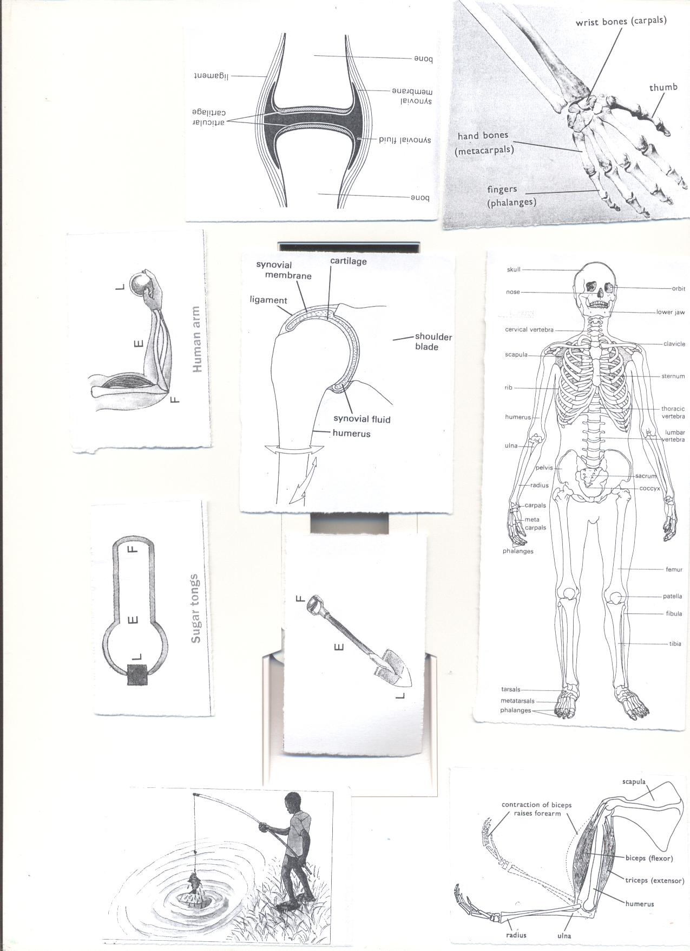

**Classifications of bones.**

1. **Long bones**-e.g. **femur**, **tibia**, fibula, **humerus, radius, ulna**.

They contain the **white** bone marrow used to produce **white blood cells.**

2. **Short bones**- e.g. sternum, cranium, vertebra, ribs

They contain **red bone marrow** usedto produce **red blood cells.**

**Red blood cells** are **destroyed** in the **liver or spleen**.  
3. **Flat bones** -e.g. **shoulder blade**, **cranium ,** [**rib cage**](http://en.wikipedia.org/wiki/Rib_cage)**, and** [**scapula**](http://en.wikipedia.org/wiki/Scapula)r**.**

1. **Irregular bones -**Bones of the neck **vertebr**a, sacrum.

**Activity**

**1.Using a tracing paper, draw the diagram of a human skeleton in your exercise book and label it.**

**Exercise**

1. Briefly explain the term bone.
2. Write down the three types of bones in human body.
3. Why do babies have many bones than adults?
4. State any examples of each of the bones below
5. Long bones b) irregular bones

4. How are the bone marrows important to people?

**Lesson three**

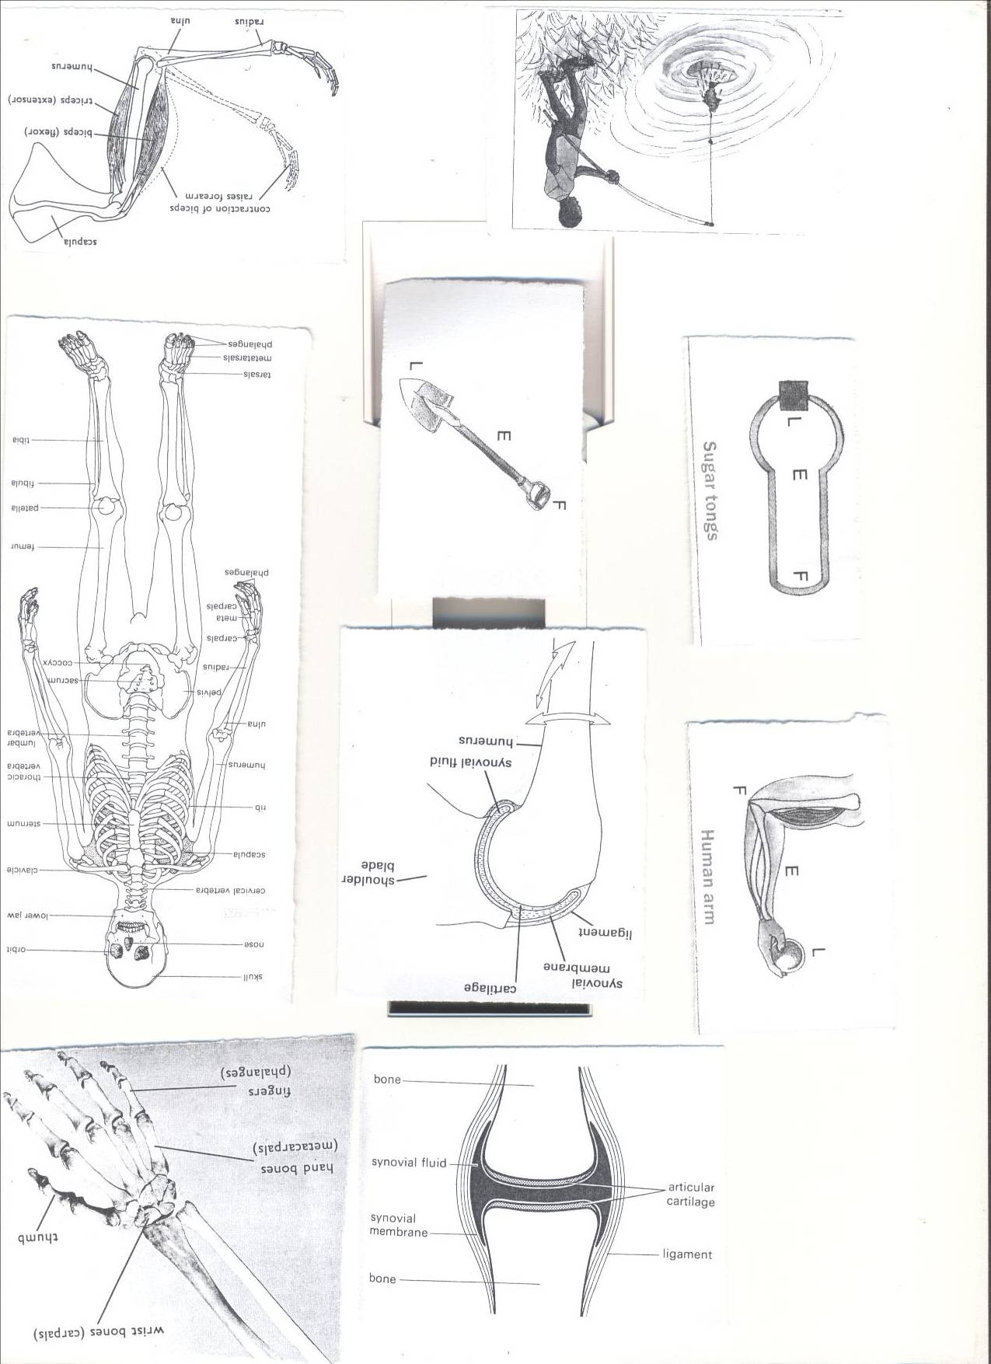**JOINTS**A joint is a place in a body where two or more bones meet.  
-It contains synovial fluid which reduces friction at the joint.  
-The bones are covered with cartilage at the ends.

**Structure of a joint.**

**A Tendon** is a tough fibrous tissue that connects muscles to bones.  
**A Ligament** is a fibrous elastic tissue that joins a bone to a bone.

**Cartilage** prevents the bone ends from frictional damage after rubbing directly onto each other.  
Inside a joint is **a lining of synovial membrane** which secretes **synovial fluid.**  
**Synovial fluid** reduces **friction** in a joint.

**Classification of joints:**   
Joints may be either Movable, immovable or slightly movable

However, the principle types of joints are: Ball and socket joints, hinge joint, pivot joint, gliding joint.

**Examples of movable joints**

**1.Hinge joint**-It allows movement in one plane e.g. knee, elbow, knuckle

**2.Ball and socket**- It allows movement in three planes e.g. shoulder, hip



**3.Gliding joint-** They allow flat bones to slide over one another.eg wrist/ ankle



**4.Pivot joint**- e.g. the neck.

**Example of immovable joint**.

Suture joints in the skull.

**Activity**

1. Observing different joints on the Human Skeleton.

**Questions**

1. How are joints important to people?
2. What is a joint?.
3. Write down any one example of a hinge joint.
4. Why is a shoulder joint grouped under movable joints?
5. State the substance in the human body that helps to reduce friction.

**Muscles (lesson five , week two)**

* A muscle is an elastic bundle of flesh under the skin that is attached to bones.
* A muscle is a special elastic tissue that contracts and relaxes to produce movement.

**There are two types of muscles.**  
i. Voluntary muscles.

ii. Involuntary muscles.

**Voluntary muscles / skeletal muscles.**

Voluntary muscles are **muscles** whose action is normally controlled by an individual's will.

**Examples of voluntary muscles include;**

1. Biceps (flexor) ii.Triceps (extensor)

**Involuntary muscles**

Involuntary muscles are those whose movement is not under our will.

Examples of involuntary muscles;

1. Cardiac musclesof the heart.
2. Muscles of the eye lids.
3. Muscles of the stomach and intestines

**Antagonistic muscles**

These are muscles that work in pairs but have an opposite effect to each other.

Examples of antagonistic muscles include;

1. Biceps (flexor) ii.Triceps (extensor



Learners Activity

1. Draw a diagram showing **biceps** and **triceps** muscles of the human arm.

Questions

1. What is a muscle?
2. State the two types of muscles in the human body.
3. Why are triceps and biceps grouped under antagonistic muscles?
4. How are muscles useful in our bodies?
5. Give any one disorder to the body muscle.

**Functions of the muscular skeletal system.(lesson six)week two**

**1.** Protects the delicate body organs.

* The [**skull**](http://en.wikipedia.org/wiki/Human_skull) protects the [**brain**](http://en.wikipedia.org/wiki/Human_brain)**,** the [**eyes**](http://en.wikipedia.org/wiki/Human_eye), and the [**middle**](http://en.wikipedia.org/wiki/Middle_ear) and [**inner ears**](http://en.wikipedia.org/wiki/Inner_ear)**.**
* The **vertebrae** (backbone) protect the[**spinal cord**](http://en.wikipedia.org/wiki/Spinal_cord).
* The [**rib cage**](http://en.wikipedia.org/wiki/Human_rib_cage), **spine,** and [**sternum**](http://en.wikipedia.org/wiki/Human_sternum) protect the [**lungs**](http://en.wikipedia.org/wiki/Human_lung)**,** [**heart**](http://en.wikipedia.org/wiki/Human_heart).

**2.** It provides supports to the body.

**3.** It is used in movement.

**4.** Storage of minerals like calcium and phosphorus.

**5.** The bone marrows are used to produce blood cells.

**6**. Provides room for attachmentof muscles.

**Diseases and disorders of bones, muscles and the system lesson seven,week two.**

**Disorders of the muscular skeletal system.**

* Fractures
* Sprain
* Spin bifida -The spinal cord does not form properly.
* Cuts
* Strains
* Dislocation

**Diseases of the muscular skeletal system.**

* **Rickets-**causes bowed legs in children due to lack of Vitamin D.
* **Poliomyelitis**- Cause by polio virus which attacks the nerve cells and spinal cord causing paralysis.
* **Arthritis-**pain, stiffness and swelling of joints.
* **Scurvy**- caused by lack of ascorbic acid (vitamin C) in the diet.

**Prevention of diseases and disorders of bones, muscles.**

1. Boil water for drinking to prevent polio.
2. Prepare and eat a balanced diet**.**
3. Do physical exercises.
4. Keep sharp cutting objects far from children’s reach.
5. Go for dental checkups *regularly.*
6. Put on shoes while walking.

**Health habits that help to keep the system in a healthy working condition**

1. Do daily physical exercises.
2. Eat a balanced diet.
3. Ensure proper body posture.
4. Brush and floss your teeth twice a day.

**POSTURE.**

* It is a way a person positions his body when sitting, standing or walking

**The correct sitting Posture.**

i. Sit up straight on the chair.

ii. Place both feet on the floor.

iii. Put all your weight on both bottoms.

iv.Do not tighten your ankles and knees.

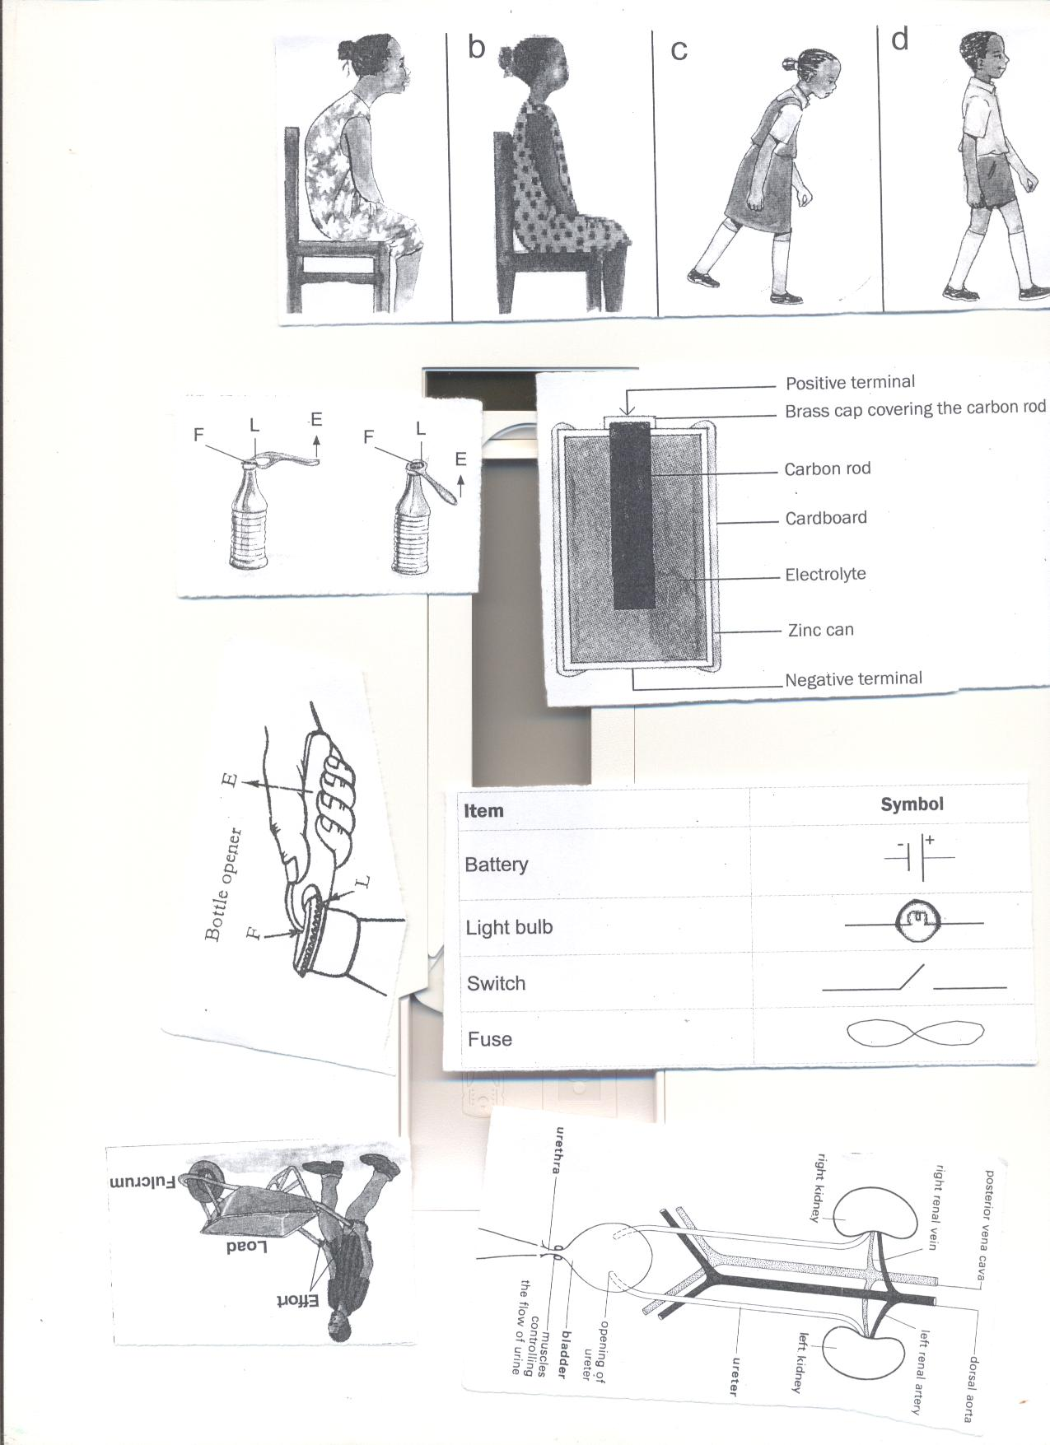

**Importance of correct posture**

1. Prevents one from growing bent bones.

**Learners Activity**

1. Learners demonstrate body posture with the guidance

**Topical questions.**

1. Which class of food is necessary for proper growth of bones?

2. Write down one example of each of the following

a) Skeletal muscles b) Smooth muscles

3. What is the functional difference between ligaments and tendons?

4State one disorder to each of the following

a) Ligaments b) tendons.

5. Which part of the skeleton protects the following?

a) Brain b) eye

6. State one health habit that can keep one’s skeleton in a healthy working condition.

**Topic 2: ELECTRICITY AND MAGNETISM lesson one, week two**

**VOCABULARY**

* **Electricity Fuse**
* **Circuit Switch**
* **Insulator Magnet**
* **Dynamo Electro – magnet**
* **Device**

**Electricity**

Electricity is a form of energy produced by the flow of electrons.

**Sources of electricity.**

-Cells i.e. Dry cell, Simple cell, chemical batteries, solar cell accumulators.  
- Running water  
-The sun.  
-Fossil fuels.  
-Wind.

**ELECTRIC CELLS**

Types of cells

1. **Primary cells** e.g.), Dry cells, a simple cell(wet cell)
2. **Secondary cells/accumulators/storage cells.** E.g. lead batteries, solar cells.

**The dry cell.**

**Dry cell**  
A dry cell is an electric cell.  
It stores chemical energy.  
**Structure of a dry cell**



**Functions of each parts of a dry cell  
1.Bras cap:** it acts as the positive terminal and contact.  
**2. Carbon rod**: It is a non metallic conductor of electricity that acts as a positive pole.  
**3. Electrolyte**: A liquid that conducts electricity.   
**4. Zinc can**: a container in which the dry cell content is put and It acts as a negative terminal.

**5.** **Insulating top seal**: It prevents the jelly from drying up.   
 **N.B**: I. A dry cell has voltage of 1.5 volts  
The energy needed to push an electric current through a electric circuit is called voltage. Voltage is measured in volts.

A dry cell stores chemical energy which is later changed to electric energy.

**Calculating voltage.**

**Activity**

1. **Opening and Observing parts of a dry cell.**
2. **Drawing a diagram of a dry cell**

**Exercise:**

1. Juliet’s radio uses **seven** dry cells.

How many volts are needed if he is to use it to listen to news.

Solution:

**1 dry cell= 1.5 volts**

**7 dry cells= ?**

**7dry cells X 1.5 Volts.**

**=10.5 volts**

1. **How is the carbon rod useful in a dry cell?**
2. **Give any one cause of dry cells losing their energy.**
3. **What is the difference between electricity and electric energy?**
4. **Identify any one source of electricity.**

**Simple cell (Wet cell): lesson two, week two**  
It consists of a zinc plate and a copper plate dipping in dilute sulphuric acid.  
The zinc plate acts as the **negative** pole.  
The copper plate acts as the **positive** pole.  
Sulphuric acid acts as the **electrolyte**.  
The zinc and copper are called **electrodes.**

**An electrode** is a piece of metal that allows electric current to pass through it when placed in an electrolyte.

HOME MADE

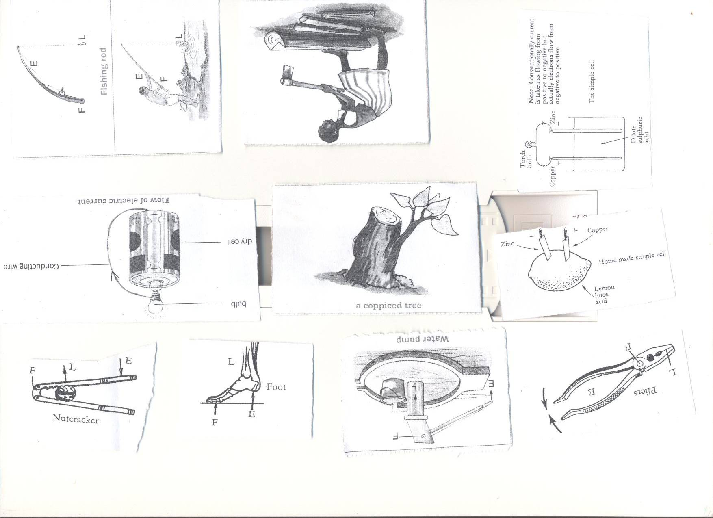 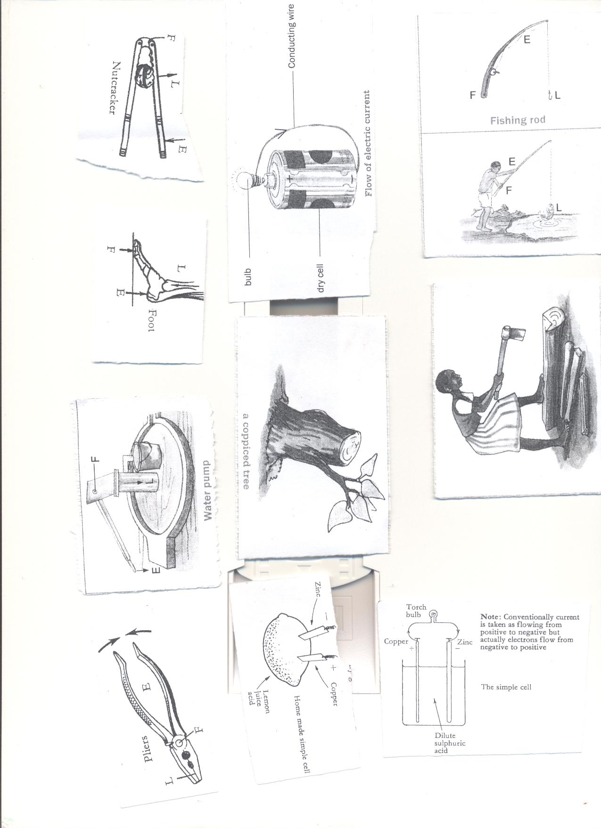 The bulb connected across the cell, begins to glow but after only a few minutes it becomes dimmer until it finally lights off.  
**Disadvantages of using a wet cell.**

1. It is not very efficient.
2. It can only be used in an upright position.
3. It works for a short time

**Activity**

**1.** Making a homemade wet cell.

**Exercise.**

1. Why do wet cells lose their magnetism easily?
2. State one disadvantage of using wet cells?
3. What acts as the electrolyte in a locally made wet cell?
4. Why does a wet cell light for a shorter time?

**Chemical Battery lesson three, week two.**  
A Car battery is an example of chemical batteries.

It has the positive **(+) {anode}** and negative **(-)** terminals {cathode} called **electrodes**

Chemical batteries convert **chemical energy** into **electric energy.**

**Advantage of using a chemical battery.**  
I. It can be recharged and used again when it has run down.  
**Running water**It produces hydro electricity {H.E.P}.  
For example electricity produced at Nalubale and Bujagali Dams in Jinja.

**The sun**  
The sun produces light which is converted into solar electricity using solar cells.  
A number of solar cells put together form a solar battery.  
Solar electricity is used for lighting and cooking.  
**Fossil Fuels.**  
Fossil fuels used in production of electricity are coal, petrol and diesel.  
**Coal / oil** can be burnt to produce Thermal electricity.

Coal stores chemical energy.  
**Petrol and diesel** are used to run fuel generators.  
  
**Uranium**

It is burnt to produce nuclear energy.  
Uranium stores chemical energy.  
**Wind**  
The wind turns windmills to produce electricity.

**Activity**

**1.** .Making a local wind mill.

2. Connecting a solar water heater.

**Exercise**

1. Give any two sources of electricity.
2. How is the sun useful in the environment?

1. Give one difference between wind and air
2. State any one example of a fossil fuel.

**Types of electricity.(lesson four)**

There are two main types of electricity;  
1. Current electricity

2. Static electricity.

**Current electricity**  
This is the electricity where there is flow of electrons.  
**The diagram showing the** **flow of current/ electricity/ electric current.**  
  
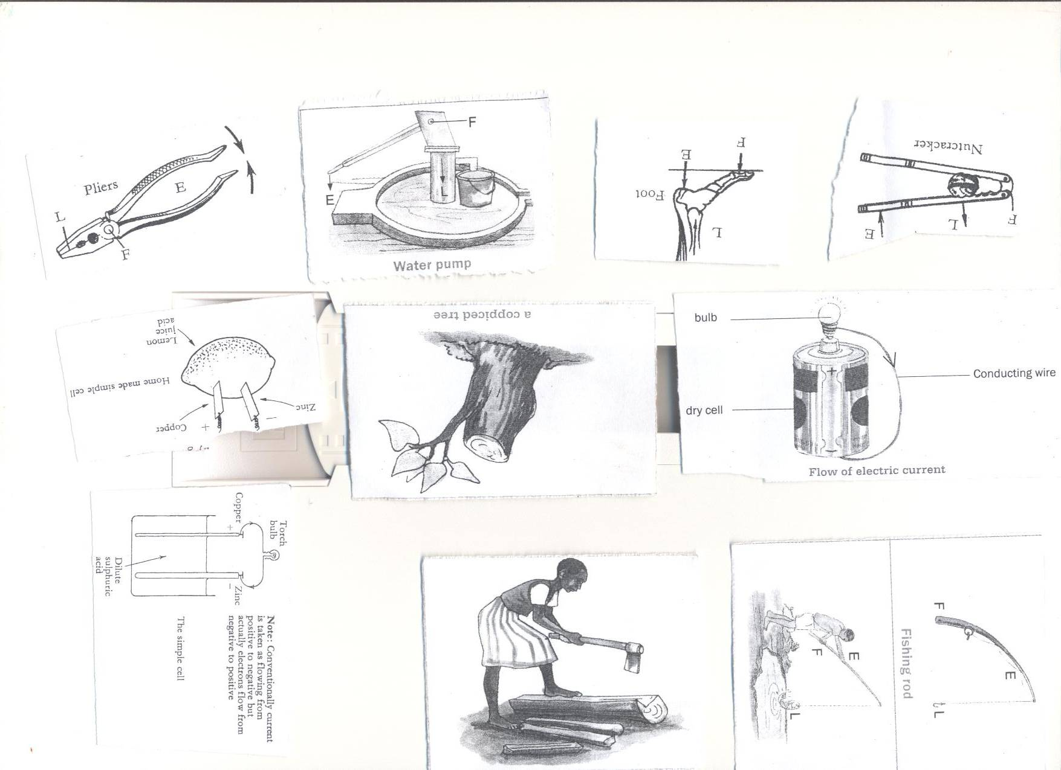

**The diagram showing the flow of electrons**  
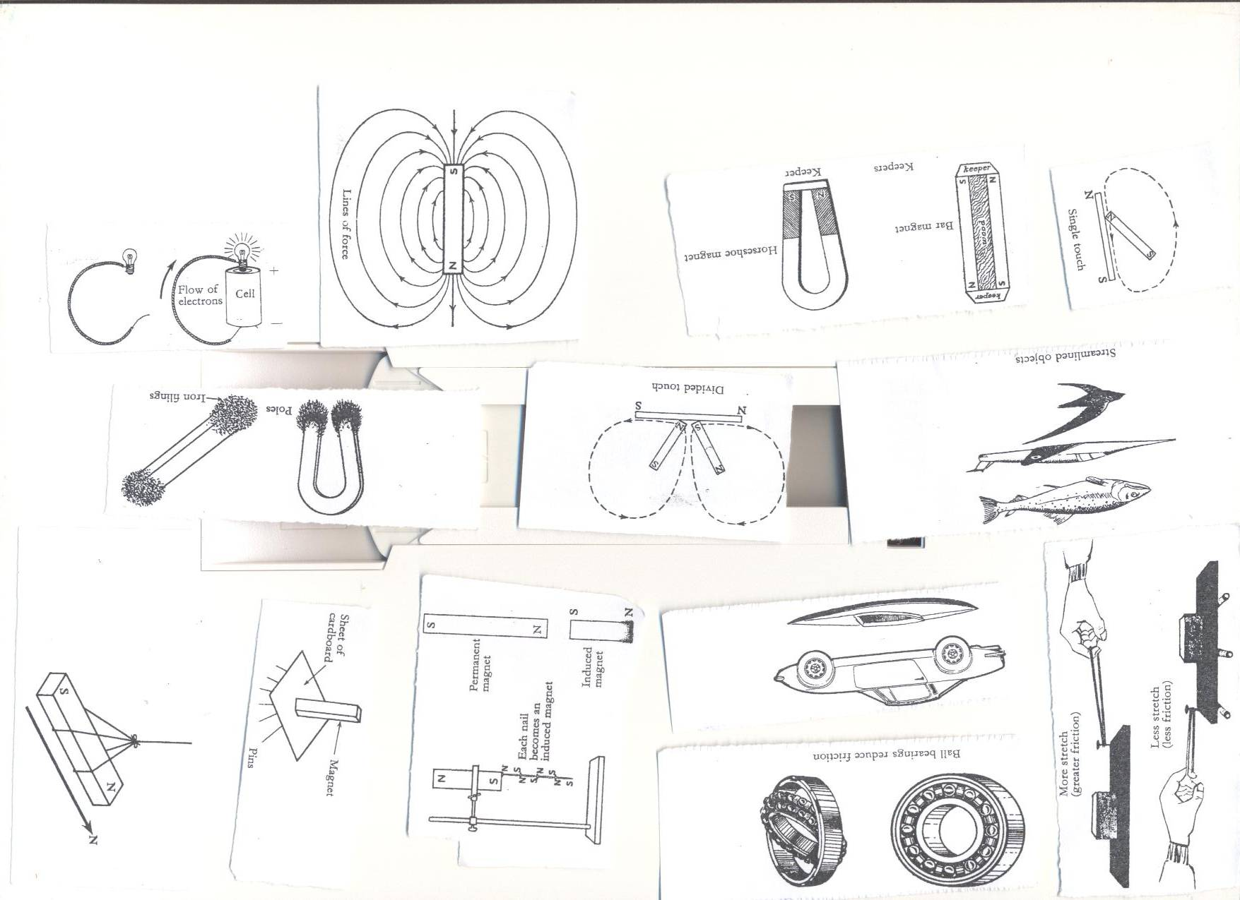

**Types of current electricity.**

1. **Direct current (DC) -** The current flows in one direction. ie from the source to the appliance. **Sources**: chemical batteries and dry cells.

**2.Alternating Current (AC) -** current flows in two directions. I e from the source to the appliance and the back.E.g. that one produced at **Nalubale dam in Jinja, generator**

**Forms of electricity.**

1. **Hydro electricity**; produced from water turning turbines at a dam.
2. **Thermal electricity;** Produced from fossil fuels.
3. **Solar electricity;** Produced from the sun.
4. **Nuclear electricity;** Produced from nuclear power stations**.**
5. **Geo thermal electricity;** Produced from hot rock in the earth.

**Learners’ Activity**

1. Assembling an electric circuit.

**Exercise**

1. **Write down the types of electricity**
2. **State any two forms of electricity**
3. **Draw a diagram to show flow of electricity**
4. **What type of electricity is commonly used by most urban areas in Uganda**

**Conductors of electricity lesson four, week two)**

Conductors are materials that allow electricity to pass through them.

**Examples of conductors of electricity.**  
1. Metals like; Iron, copper, Tin, Silver, zinc, lead, brass.  
ii. Materials like; spoons, pair of compasses, razor blades e.t.c.  
iii. Water from rivers, lakes, springs and wells.  
iv. Carbon {non metallic conductor)  
v. Salt solution.  
vi. Wet wood.  
**N.B:**  
1. Wet wood is a good conductor of electricity because it contains minerals.  
2. Pure water does not conduct electricity because it doesn’t contain minerals.  
**3. Silver** is the best conductor of electricity.  
4. We use aluminum to make electric wires because silver is expensive and rare.  
**Insulators of electricity.**  
These are materials that do not allow electricity to pass through them easily.  
**Examples of insulators;**

1. Rubber, plastic, dry wood, dry paper, dry cloth, air and porcelain  
   **Importance of insulators**

1. Used to insulate flat irons to prevent electric shocks.

2. Prevent conductors from meeting to cause short circuits.

**Activity**

1. Naming Conductors and Insulators of Electricity

**Exercise.**

1. How are insulators different from conductors of heat?
2. Give any two examples of insulators.
3. How are insulators important in our daily life?
4. State any two components of an electric circuit.
5. Why is wood said to be bad conductor of electricity?

**Electric circuit (lesson five)**  
An electric circuit is a path through which an electric current flows.  
**Components of an electric circuit.**

* A switch.
* A torch bulb
* A conductor (wire)
* Dry cells
* The conducting wire.
* Fuse

**A simple Electric circuit. (lesson five week two)**

**In symbol form In diagram form**

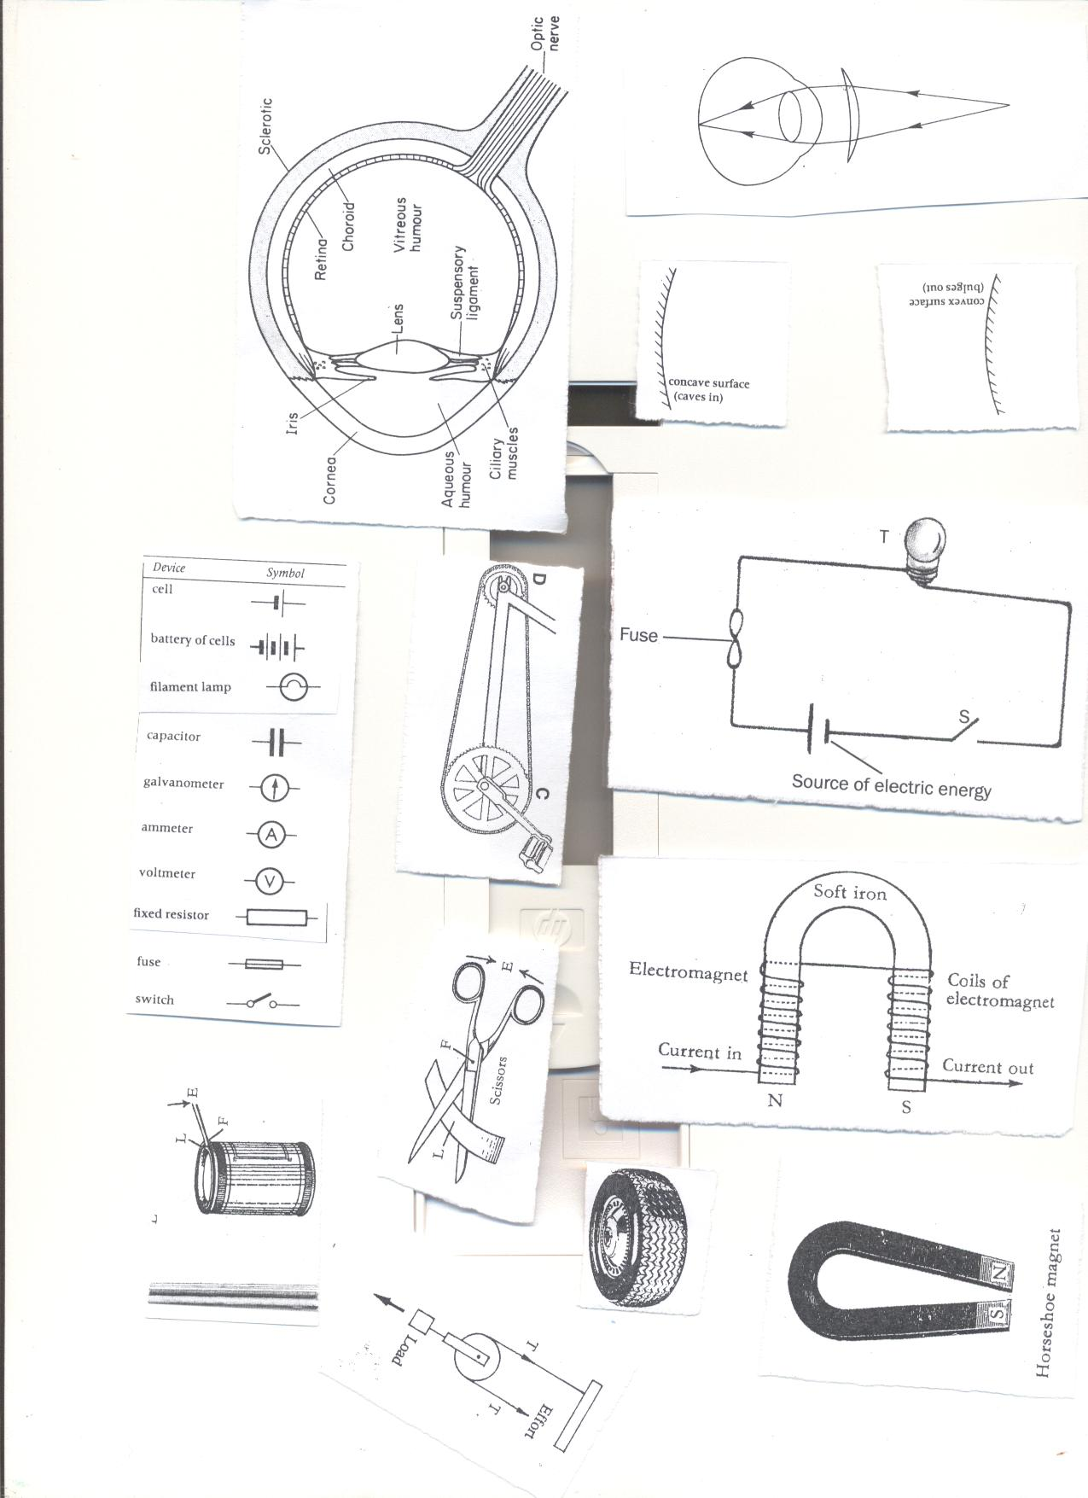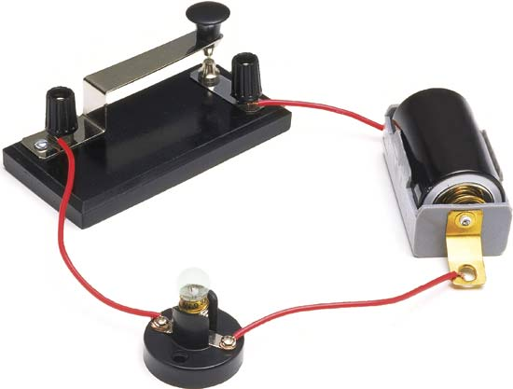

**Uses of parts of an electric circuit.**  
**1. Switch**: This breaks and completes the circuit at the users wish.  
**2. Battery/dry cells**: These provide electric energy in the circuit.  
**3. Conducting wire**: Transmits electric energy through the circuit.  
**4. Fuse**: It breaks the circuit when there is too much current flowing.

It is a thin wire(alloy) with a low melting point.  
**5. Bulb:** It gives out light.

**Symbols used in an electric circuit.**





**The conducting wire**

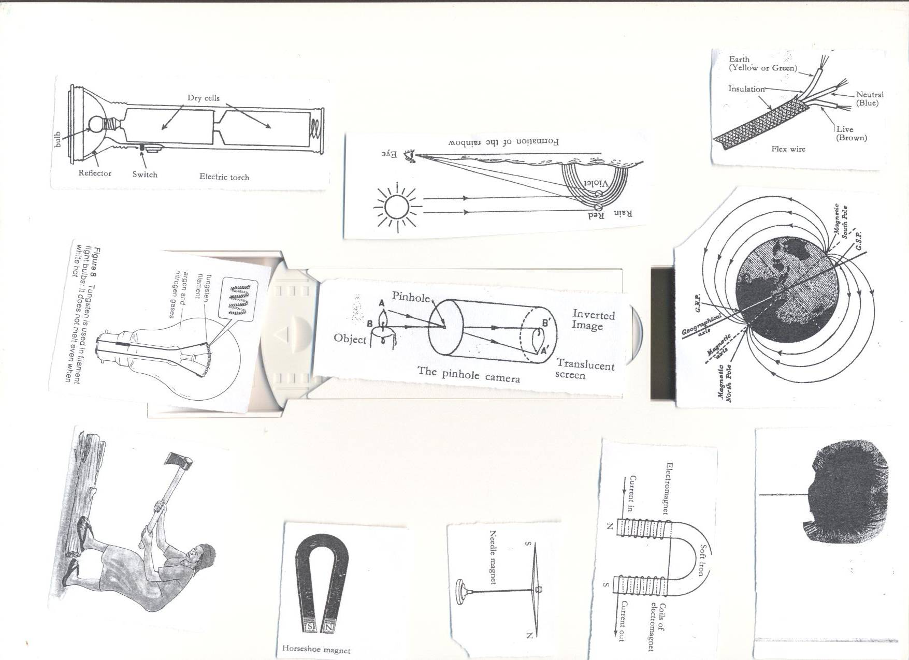

**Uses of each component of a conducting wire**  
i. **Earth (yellow or green):** Minimizes excess current to preventus from electric shocks.  
ii. **Neutral (Blue/black):** Takes back current to the source.  
iii. **Live (Red/brown):**  brings current from the source to the appliance.  
iv. **Insulation**: prevent electric shocks.

**Activity**.

1. Connecting an Electric Circuit

2. Naming parts of an electric circuit.

Drawing a diagram of a bulb.

**exercise.**

1. How are the following important in a circuit?
2. Switch
3. Fuse
4. How is a fuse similar to a switch?
5. How is a red wire useful in an electric circuit?

**The torch/flash light (lesson six), week two**



**Uses of parts of a torch**

**1. Reflector**: Directs lights into **a parallel** beam of light.

**2. Bulb**: It produces light.

It changes electric energy to heat then to light.  
**3. Dry cells**: It is the source of electric energy.   
**4. Glass**: It protects the bulb and reflector.  
**5. Switch**: Breaks and completes the circuit at the users wish.  
**6. Cover and springs**: Keep the dry cells tightly together.

**The Electric Bulb. (lesson seven) week two**

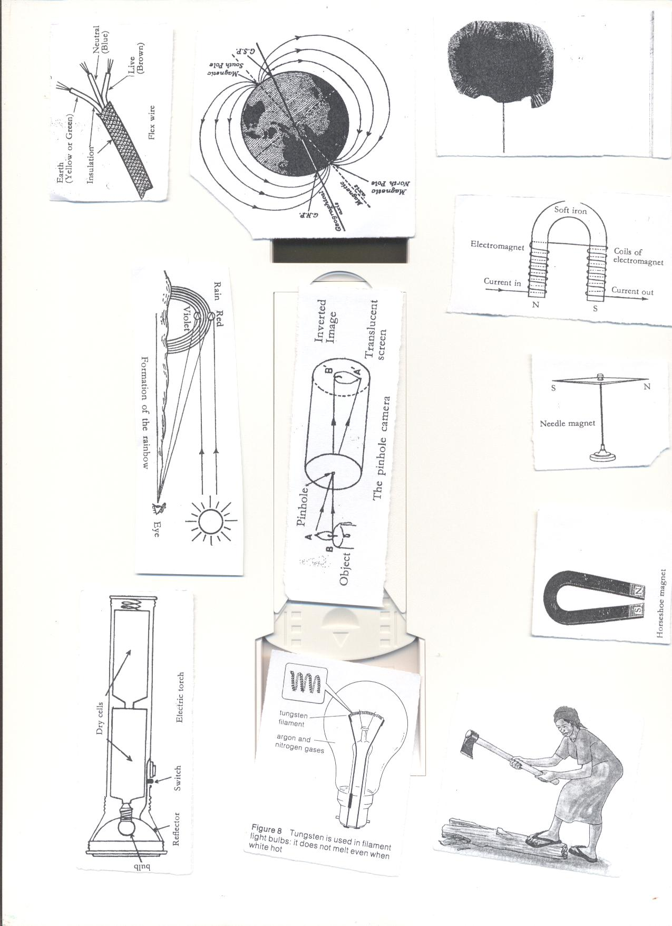

**Uses of parts of a bulb**  
**1. Filament:** It produces light.

It is made of **tungsten** from a mineral called **wolfram**

**Adaptation of the filament for its function.**

* It has a high melting point.
* It is coiled to increase electric resistance

**2. Conducting wire**: It conducts electricity to the filament.  
**3. Glass**: Protects the inside parts of the bulb.

It prevents nitrogen and argon gases from escaping.

It is transparent to allow light to pass through.  
**4. Filament support**: It supports the filament.  
**5. Contact**: It allows electricity into the bulb.  
**6. Insulating material**: It separates the conducting wires.

**Activity**

1. Identifying parts of a Torch.

2. Drawing the diagram of a torch.

**Exercise.**

1. Why is a filament of an electric bulb coiled?
2. State any component of a circuit that uses an alloy.
3. How is the reflector important in an electric torch?
4. Which gas is commonly used in electric bulbs?
5. Give one reason why the glass of a bulb is transparent?

**Short circuits.(lesson eight) week two.**A short circuit is a path of low resistance towards flow of current through circuit.  
**Causes of short circuit**

* Poor wiring when installing electricity in buildings.
* Pushing metallic objects in electric sockets.
* When bare electric wires get into contact.
* Wrong connection of wires in electric equipment.
* Overloading sockets.

**Effects of short circuit.**

* Destruction of electrical equipment.
* Fire that may burn the building.
* Lead to death of people and animals.

**How to avoid short circuit**

* Electric wires should be covered with an insulating material.
* Installation should be done by experts only.
* Repair of electric appliances should be done by experts.

**STATIC ELECTRICITY (lesson 9) week two**

* It is the type of electricity where there is no flow of electrons.
* It is formed when two insulators are rubbed against each other.
* In nature static electricity can be seen when lightning occurs.

**Lightning.**

* This is static electricity in nature.
* When a positively charged cloud meets a negatively charged cloud, a huge spark is formed and may pass to the ground.
* During the passage of lightning, the surrounding air is heated strongly, expands suddenly and then contracts quickly as it cools.
* This air vibrates to produce the sound called **thunder.**  
  **Advantage of lightning**.
* Lightning fixes nitrogen into the soil.

**Preventing effects caused by lightning.**

* Avoid sitting under tall trees when it is raining.
* Install lightning conductors on buildings.

**How lightning conductors reduce risks to the building.**

* They provide route for electrons to pass into the ground without damaging the building.  
  **Differences between static electricity and current electricity**

|  |  |  |
| --- | --- | --- |
|  | **Static** | **Current** |
| 1 | Takes place in insulators. | Takes place in conductors. |
| **2** | The charge is on the surface. | Charge is inside the conductor. |
| 3 | The charge does not flow. | Charge flows through the conductor from one place to another. |
| 4 | Protons (+) and electrons (-) are both necessary for this type of electricity. | Only electrons flow. |

**Importance of electricity**.(lesson ten), week two.

* Cooking
* Lighting
* Run machines like radios,

**Advantages of electricity in solving everyday problems.**

* It is quick.
* It is clean.
* Easy to use.
* Conserves the environment.  
    
  **Disadvantages of electricity**.
* It is expensive to install.
* Electricity can shock.
* It can burn buildings.

**Safety precautions in handling electricity and electrical appliances.**

* Never touch a switch with wet hands
* Avoid over loading the socket.
* Avoid repairing the appliance when not trained.
* Avoid pushing metallic objects into sockets.
* Never open anything that uses electricity if not an expert.
* Never touch an electric wire that has fallen from an electric pole.
* Never take shelter under tall trees during thunderstorm.

***Activity.***

**1. Making a simple Short circuit using dry cells.**

**2. Drawing a diagram of a short circuit.**

**Topical questions**

1. Briefly explain the term electricity.
2. Why electricity grouped under forms of energy?
3. Give any one way in which electricity can reduce deforestation.
4. Why is it important to properly handle electric appliances?
5. Draw a symbol of an electric bulb.
6. Give any one way in which we can prevent our electric appliances from being destroyed by electricity.
7. State any one difference between conductors and insulators.
8. Why are electric wires carrying current from the source raised some meters high from the ground?
9. Write any one disadvantage of using electricity in the environment
10. Draw a diagram to show the flow of current.
11. Write any one danger of lightning to the environment.
12. State the static electricity in nature.
13. Briefly explain how to overcome the dangers of caused by short circuits in the environment.
14. Why is the filament of an electric bulb coiled?
15. How is a fuse important in an electric circuit?

**MAGNETISM (lesson one), week three**

Is the property of a magnet which enables it to attract or repel other metals.

**Magnet**

Is a piece of metal that attracts other magnetic substances.

**What are magnetic materials?**  
Are materials that can be attracted by a magnet

They can easily be magnetized.

**Examples of magnetic materials**

* Iron (most common magnetic substances)
* Nickel
* Cobalt
* **What are non magnetic substances?**  
  Are substances that cannot be attracted by magnets.  
  **Examples of non magnetic substances**.
* Dry wood
* Plastic
* Lead
* Glass
* Cloth
* Copper
* Paper
* Aluminium
* Brass

**Types of magnets.**

There are two main types of magnets;  
i**. Artificial magnets.  
ii. Natural magnets.**

1. **Artificial magnets lesson two, week three.**  
   These are magnets made by people.  
     
   **Examples of artificial magnets and their shapes.**

* **Bar magnet**; this is a bar of uniform cross section. It may be rectangular or circular.

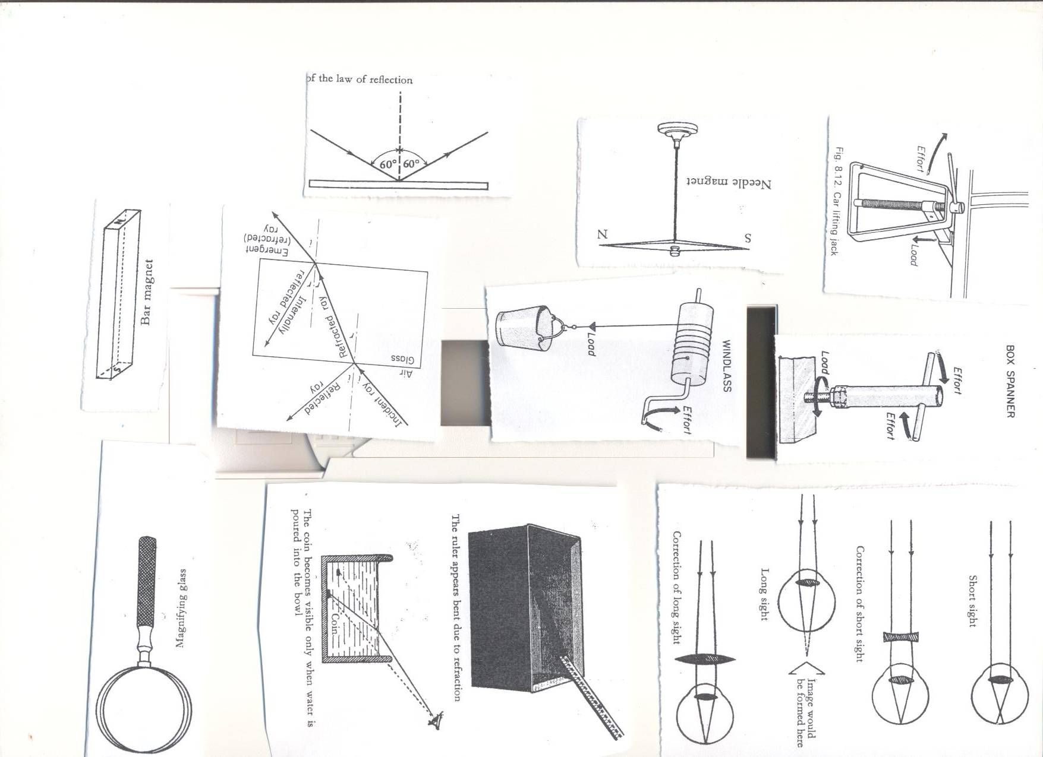

* **Horse shoe magnet**; It has u shape.

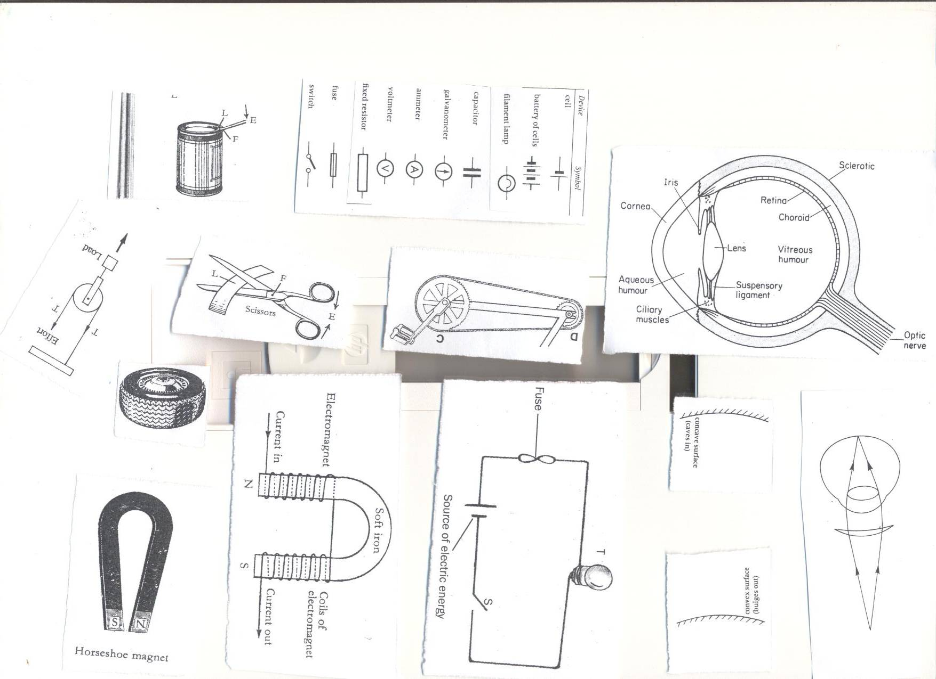

* **Needle magnet**; It has a thin pointed at both ends and balanced at the centre.

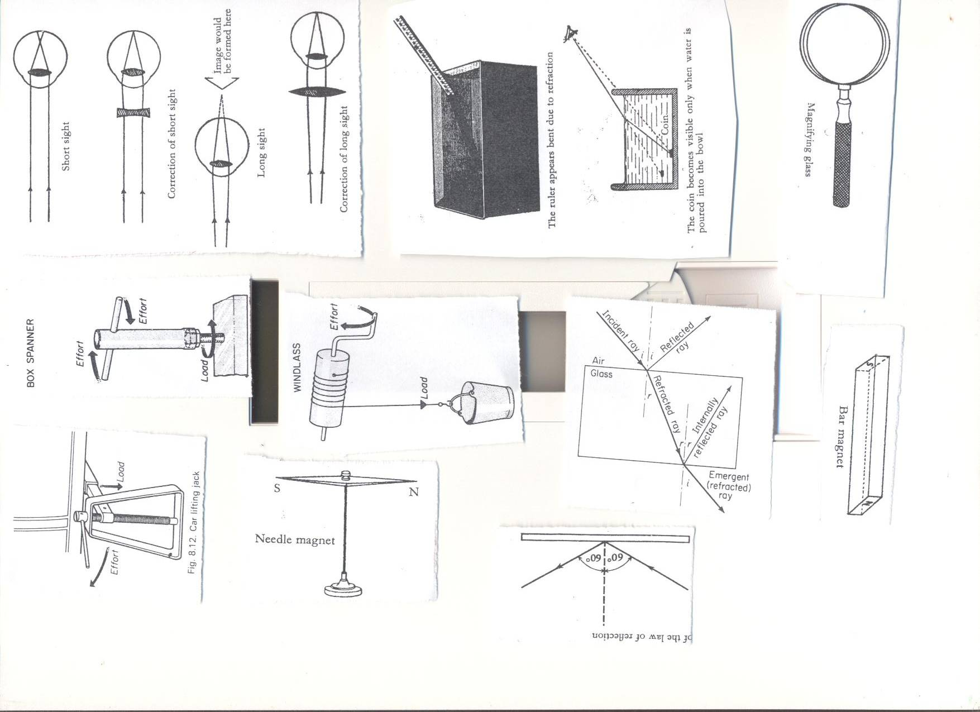

* **Electromagnet**



**Activity**

**1.** Observing the different kinds of artificial magnets.

2. Making Electromagnet in Groups.

**Exercise**

1. Give the difference between a magnet and Magnetism.

2. Name any two examples of magnetic materials and non-magnetic materials.

3. What are artificial magnets?

4. Identify any two examples of artificial magnets.

5. Mention any device that uses a needle magnet.

1. **Natural magnets Lesson three, Week three**  
   They don’t lose magnetism.

**Examples of natural magnets.**

* **The Earth**; It is a huge natural magnet. Its magnetic field is weak, that is why you can’t feel it.



* **Lodestone/magnetite**; Lodestone is a magnetic ore which occurs naturally in the earth. It was discovered near the ancient city of magnesia in Asia Minor. It was the first magnet to be discovered by people.

**Properties of magnets (lesson four week three.**

* Like poles of a magnet repel.

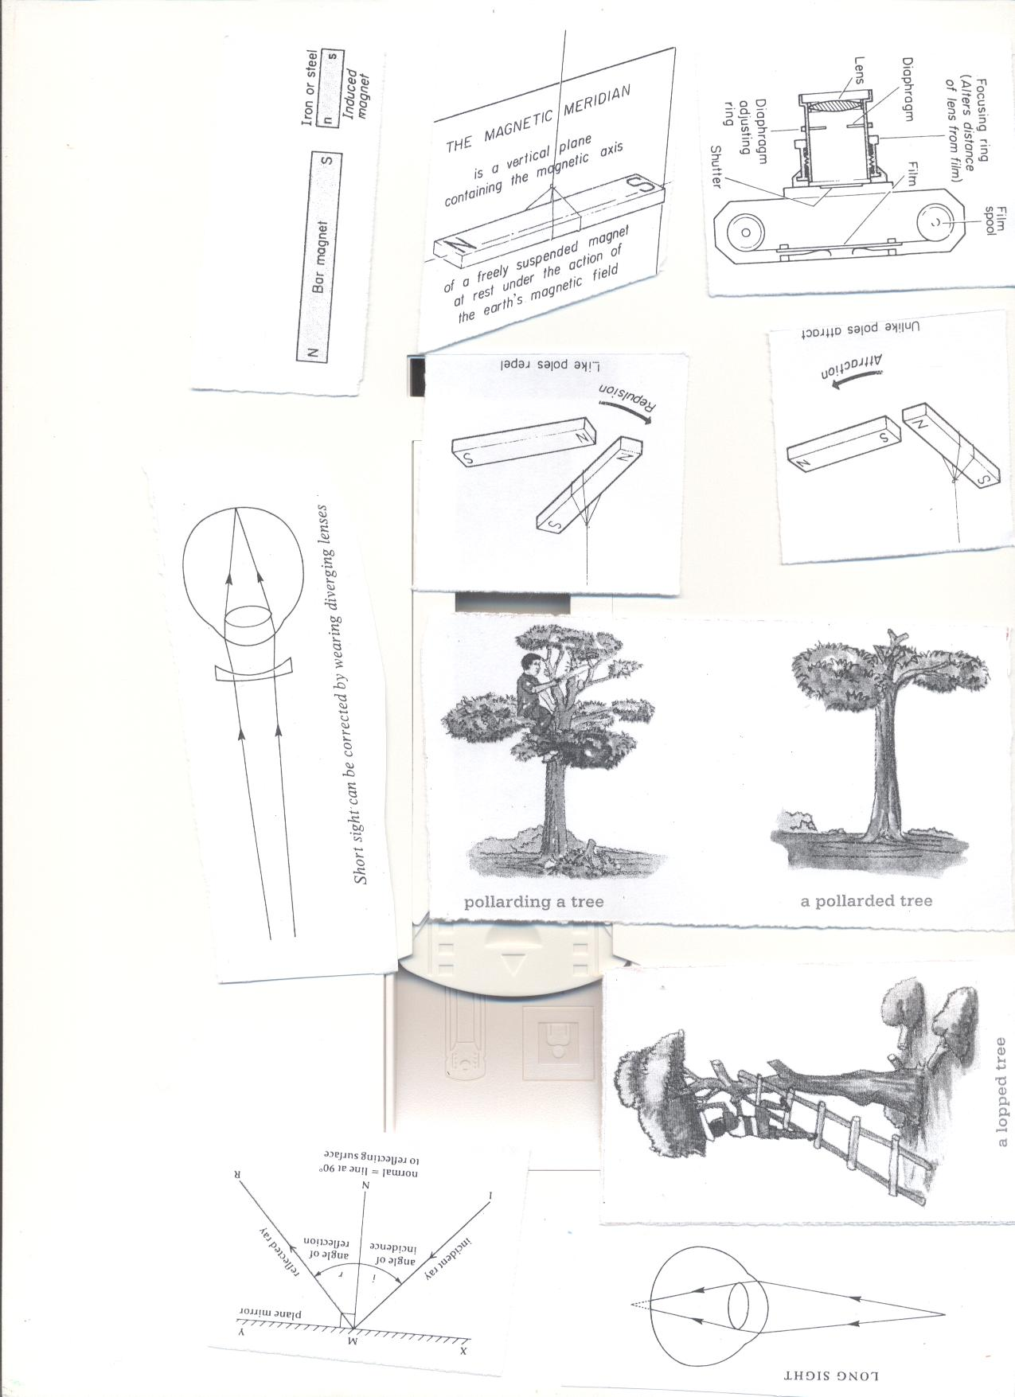

* Unlike poles attract each other.

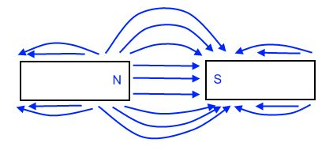

* When a magnet is freely suspended by a piece of thread it will always rest in the north –south direction.

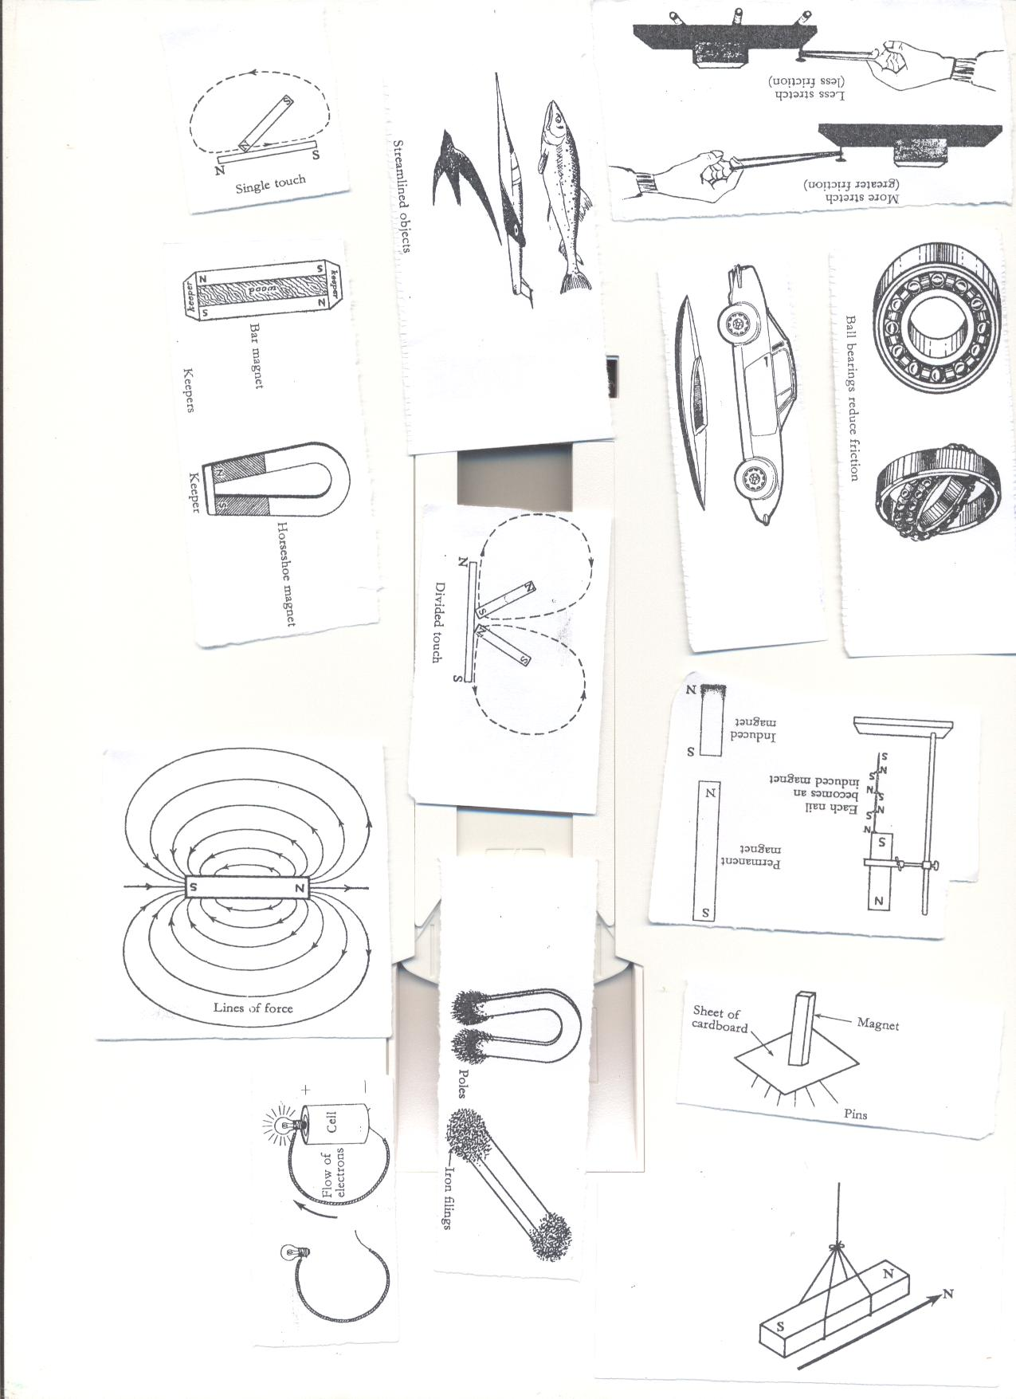

* The poles are the strongest part of the magnet.

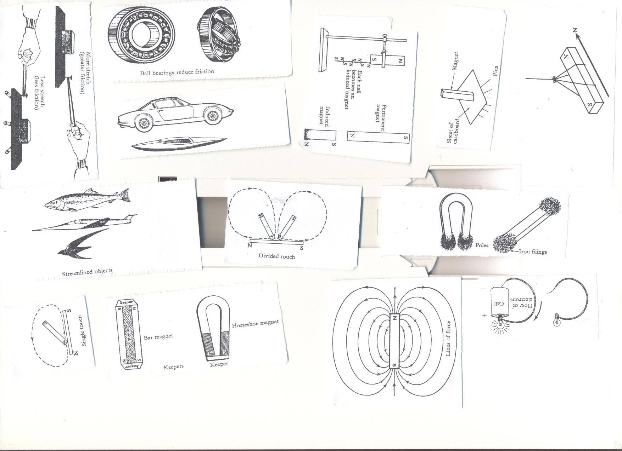

* Magnets have magnetic fields around them.



* Magnetism passes through **non magnetic materials** like wood and paper.



* Broken pieces of magnets regain their poles.ie When a magnet is broken ,each piece becomes an independent magnet.

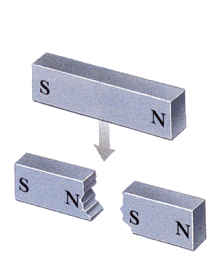

* Magnets become weaker with age.

**Preventing magnets from losing magnetism.**

* Keep them using iron keepers.



**Activity**

**1. What scientific name is given to the ends of a magnet?**

**2. State the property that describes the behaviors of magnetic poles.**

**3. Briefly explain the meanings of the following terms;**

**A. natural magnet**

**B. temporary magnets**

**C. permanent magnet.**

**Laws of magnets**  Lesson four, week three.

* Like poles of a magnet repel each other while unlike poles attract each other.

**What is magnetic field?**  
It is the area around the magnet in which it can attract other magnetic materials.

**Properties of magnetic fields.**

* They originate from **North Pole** and end at the **South Pole.**
* The lines forces do not intersect with each other.
* A line of force is continuous; it starts from the North Pole and ends at the south pole.
* There is no line of force within the magnet itself

**Methods of making magnets**.

* **Stroking by single touch:**

It is stroking by single touch method because one magnet is used.

Note. **The end after the stroke becomes the opposite pole of the magnet being used.**

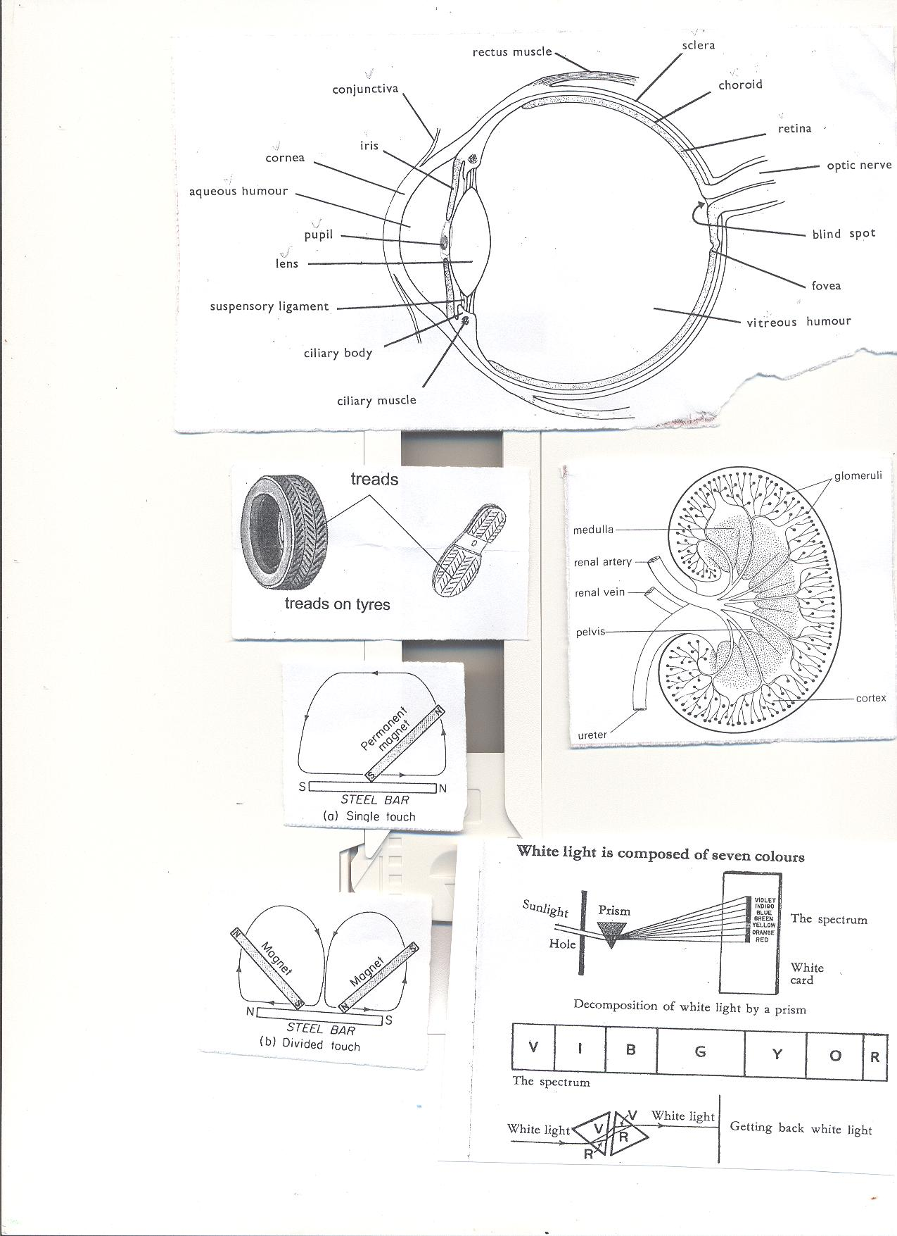

**Stroking by double/divided touch**

It is so because two magnets are used.



* **By induction** A magnetic object becomes magnetized by induction when it is nearer or contact with a magnet.

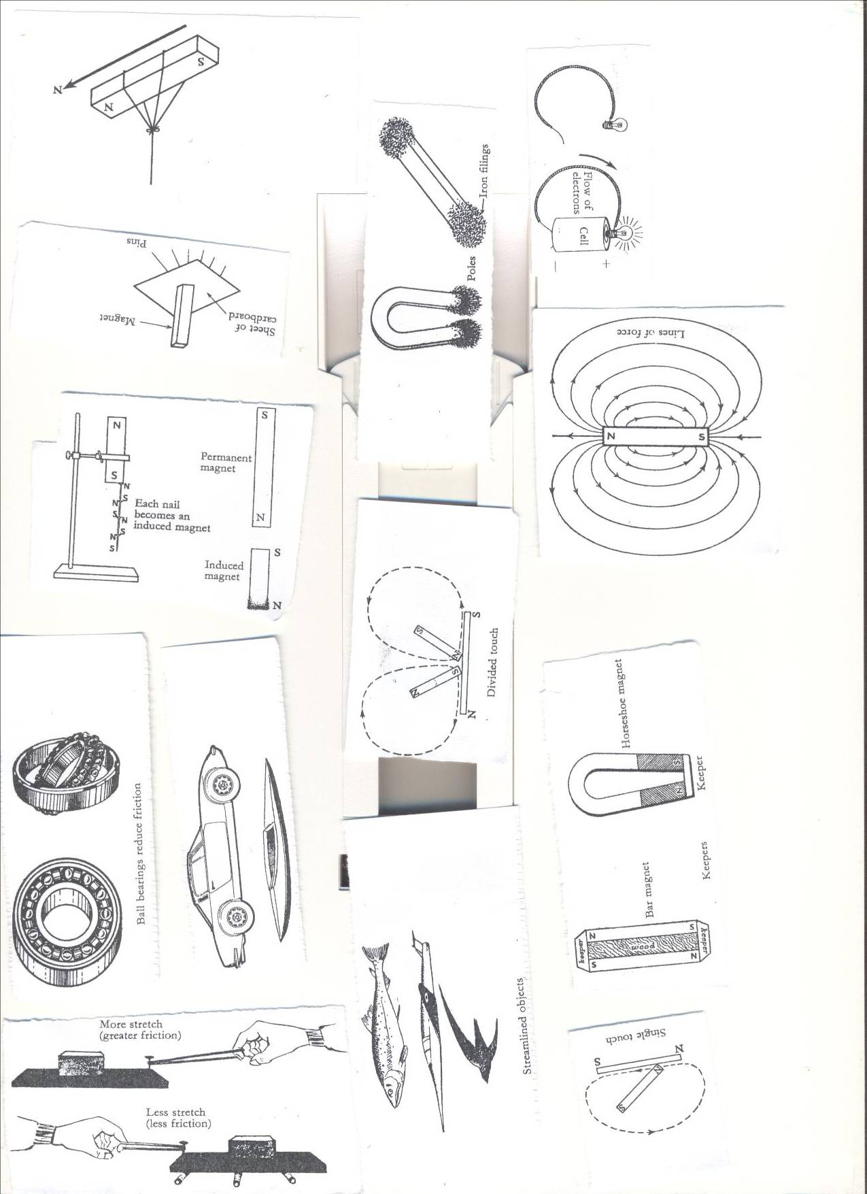

Lesson five and six , week three

* **By electrical method**  
  This is a method of making magnets using electricity.

A magnet made by using electricity is **electro- magnet.**

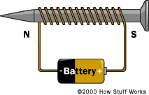 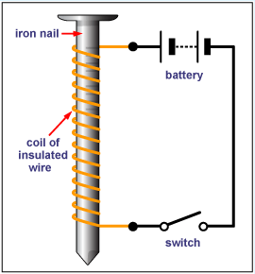

**Electro magnets are made stronger by;**

* By increasing the coils around the soft iron
* By increasing the voltage (electrical strength)

**Determining the poles an electromagnet.**

1. **The direction of flow of current.**

* Looking at it from either end;
  + If current flows in an **anticlockwise** way through the solenoid, the pole is **North (N)**
  + If current flows in **a clockwise** way through the solenoid, the pole is **South(S).**

**ii. Using the right hand grip rule.**

* Grasp the solenoid in the **right hand** with **thumb pointing in the direction of current.**
* The thumb points to **the North Pole.**

**Demagnetizing a magnet lesson seven, week three**

* It is making a magnet lose its magnetism.
* It is weakening or destroying a magnet.  
  **Ways of demagnetizing a magnet**
* Hammering/hitting strongly.
* Strong heating.
* Leaving a magnet in an east-west direction for a very long time.
* By keeping the magnets with like poles together.
* By passing an **alternating current** through a magnet.
* Leaving it to rust.
* **Uses of magnets in modern world of work.**
* Magnets are used in compasses by sailors, pilots and explorers.
* Electromagnets are used in industries to collect heavy scrap iron.
* An electric bell is also built on the principle of magnets.
* Magnets are used in telecommunication devices.
* Electric motors which produce electricity use magnets.
* They are used in loud speakers.
* They are used on doors of fridges.

**Appliances that use electricity**

* Flat irons
* Heaters
* Driers.
* Washing machines
* Electric fans
* Cooker

**Appliances that use magnetism**

* Magnetic compasses.
* Magnetic tapes.  
  **Appliances that use both electricity and magnetism.**.
* Fridges.
* Radios
* Televisions
* Mobile phones
* Electric bells

**An Electric bell lesson eight and nine, week three**

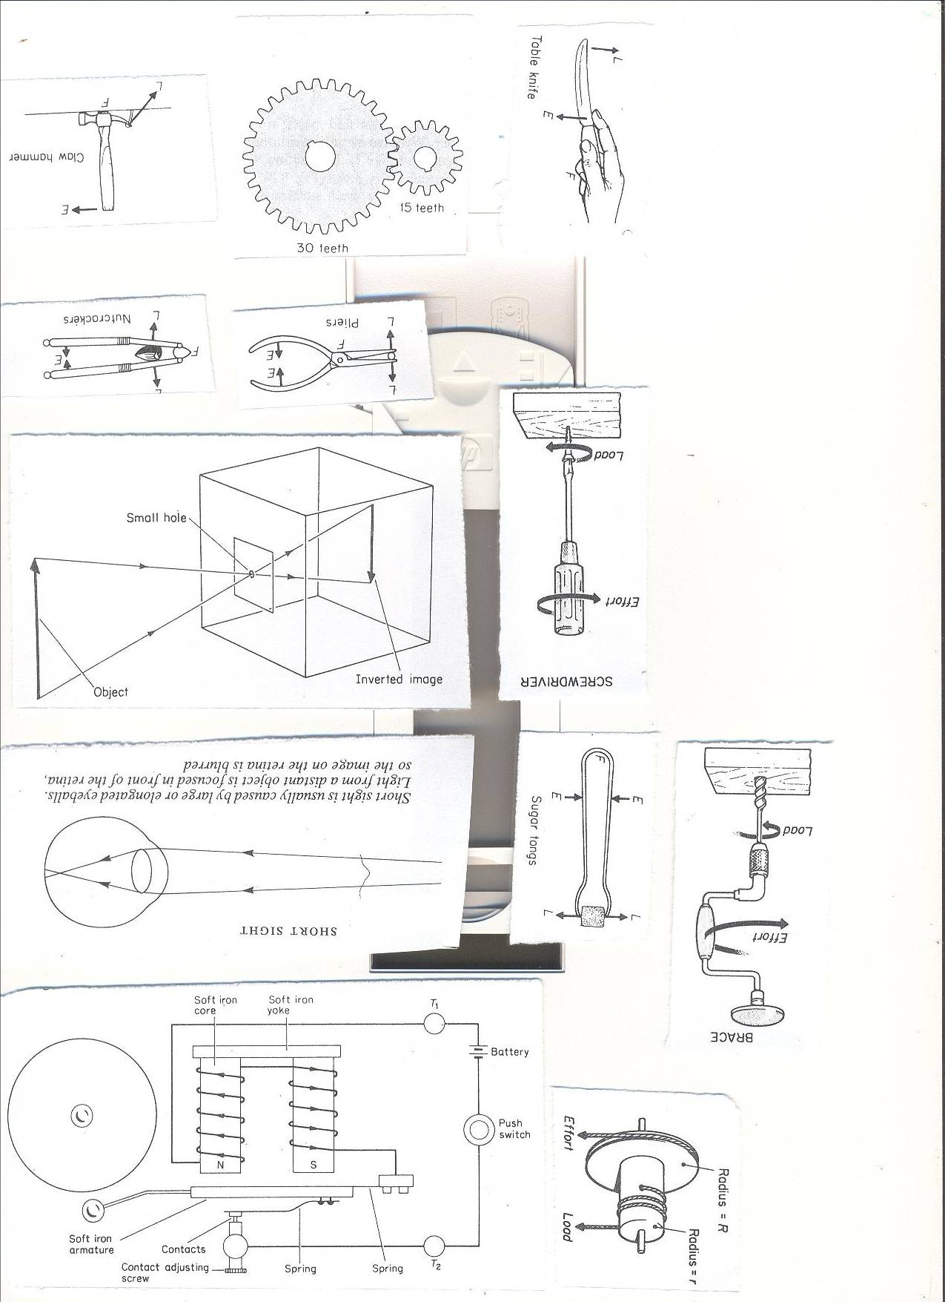

**How it works**

* When the contact is made the soft iron becomes magnetized.
* It pulls the soft iron strip with the hammer.
* The hammer hits the gong producing sound.
* When the strip is pulled the soft iron loses its magnetism and the contact is broken because current is not flowing.

**Generating electricity using a dynamo.**

**Dynamo.**

A dynamo is a device which converts mechanical energy into electrical energy.  
A dynamo uses **a permanent magnet** and a coil of wires on electro magnets

During the turning, the **mechanical energy** is turned into **electric energy.**

**Generator**

The type of current electricity produced is **A.C**

They change **Mechanical energy** to **electric energy.**

**Uses of dynamos and generators**

* Provide electricity for light.
* Provide energy to run machines.
* Provide energy for cooking
* Generators are used in hospital theatres incase power goes out

**Activity**

1. Connecting an Electric bell.
2. Describing how an electric bell works.

**Topical questions**

1. How is magnetism different from magnets?
2. State the any one law of magnetism
3. How are magnets important to the following?
4. Doctors b) pilots c) teachers
5. Give one item that uses both magnets and electricity.
6. How are magnets found in radios important?
7. In four sentences, briefly explain how an electric bell works.
8. Write the term AC in full as used in electrity.
9. What is the importance of the hammer found on an electro magnet?
10. State one way of making magnets.
11. In which one way can a p7 child make a magnet lose its magnetism?
12. Briefly explain how strong heating a magnet can make it lose its magnetism?

**TOPIC 3: ENERGY RESOURCES IN THE ENVIRONMENT.**

**VOCABULARY**

* **Resource Hydro**
* **Tidal Fossil**
* **Coal Petroleum**
* **Bio gas Bio fuel**
* **Wood fuel**

**A RESOURCE**  LESSON ONE- WEEK FOUR  
This is anything that people uses to satisfy their needs.

**ENERGY RESOURCE**  
It is anything that provides people with useful energy.

**TYPES OF RESOURCES.**  
1. Renewable resources. – Things that can be replaced naturally when used up.

**Examples:** Plants, animals, water, air,  
2. Non renewable resources. - Things that cannot be replaced when used up.

Examples: Minerals, rocks, fossil fuels.  
**Energy resources .**

-Sun, Water, Minerals, Air or wind, Plants and Animals.

**The sun as major source of energy in the environment (solar energy).**

**THE SUN**  
The sun is the main source of heat and light as forms of energy on earth.  
**Importance of the sun to people and environment**

* The sun helps in rain formation.
* Preserve our food by sun drying.
* Helps the human skin to make vitamin D.
* Helps to disinfect beddings.
* Light from the sun helps us to see.
* Light from the sun is used to make solar electricity.
* Light from the sun enables plants to make food.
* Dry our clothes.

**Water as an Energy resource:**

* It helps people to get the following form of energy.

**Hydro electricity:**

* It is the form of electricityproduced by the power of running water at a fall.
* When waterfalls at a greater height, **potential energy** is changed to **kinetic energy**.
* **Kinetic energy** turns the turbines connected to a generator with powerful magnetic field and a coil of wire turning it. In this way HEP is produced.

**Steam**

* Steam with Kinetic energy helps to power **steam engines.**

**Activity**

* + Naming different energy resources and their sources.
  + Experimenting on Steam and Propeller.

**Exercise**

1. Give any one example of energy resource.

2. What is the difference between plants and minerals as resources?

3. Name the two forms of energy provided by the Sun.

4. Mention any two uses of the Sun to people.

5. Give any two disadvantages of using fossil fuels as energy resources.

**Tidal energy** LESSON TWO ,WEEK FOUR

This is the form of energy got from **water tides** on the sea shores.

Tides are periodic rises and falls of large bodies of water.

The tides are caused by gravitational interaction between the earth and the moon.

**Importance of water as an energy resource to people and environment**

* Fast running water at a fall turns turbines to produce HEP.
* Used to cool machines in industries.
* Used for bathing and drinking.
* Tidal energy is used to produce electricity.

**Fossil fuels (coal, petroleum, Uranium) as energy resources.**

**Examples of fossils.**

* Coal
* Petroleum

Petroleum//crude oil

It is an energy resource from the ground formed from animals that died many years ago.

The changes in the earth created a lot of heat and pressure on them hence turning into petroleum.

Examples of petroleum.

* Petrol, diesel, oil, jet fuel, paraffin

These fuels are got from crude oil by the process called fractional distillation.

**Importance of petroleum products**

* Used to generate power that can run machines and vehicles.
* They are burnt to produce light and heat.

**Importance of coal.**

* Used as fuel in steam engines.
* Coal is burnt to produce thermal electricity
* It is used to make tar for surfacing roads.

**Other products from petroleum.**

* Plastics, polythene paper, tar, dye, detergents, Vaseline, mattresses, grease, paint, fertilizers, etc

**Other products from coal**

* Paints, fertilizers, perfumes.

**Uses of uranium**

* It is used to make atomic bombs.
* It is used as fuel in nuclear powered sub marines.
* Uranium is burnt to produce atomic electricity.

Geothermal energy

* It is got from hot springs// thermal springs where steam is trapped to turn turbines to produce electricity.

**ANIMALS AS ENERGY RESOURCES.**

* Animals like oxen are used to plough land.
* Some animals like the donkeys are used for transport.
* Some animals are used as source of food.
* Some animals like oxen and ass are used to pull carts.

PLANTS AS ENERGY RESOURCES.

* They are source of food.
* They are source of wood fuel.
* They are source of building materials.
* They are used as shelter by some animals.

**How to conserve plant resources.**

* Through a forestation.
* Use fuel saving stoves.
* Use other //alternative sources of fuel like biogas.
* Educate people about the advantages of plants in the environment.  
  **Wind as energy resources.**

**AIR/WIND**

Importance.

* Used for winnowing
* Used to turn wind mills to produce electricity.
* Used to sail boats
* Helps to disperse seeds
* Used in pollination.
* Used to fly kites.
* Speed up evaporation and hence increases the speed to dry things.  
  Plants (wood fuel, food) as energy resources.

**Activity**

1. Connecting a solar water heater

**Exercise**

1. Give one reason why wind is regarded as an energy resource.

2. Why is a donkey regarded as energy resource?

3. Mention any one use of Uranium.

LESSON THREE AND FOUR ,WEEK FOUR

**Animals as energy resources.**

**Biogas production from plants**  
**what is biogas?**  
It is methane that is produced from the rotting organic matter.

The waste plant materials.  
1. Cow dung.  
2. Plant materials.  
3. Animal urine.

**Steps of making biogas digester.**  
The above materials are put into an air-tight container called a biogas digester.  
Where they are worked on by anaerobic bacteria to ferment and biogas is formed.  
When the gas formation stops, the remains can be used as manure.

**Structure of Biogas digester**

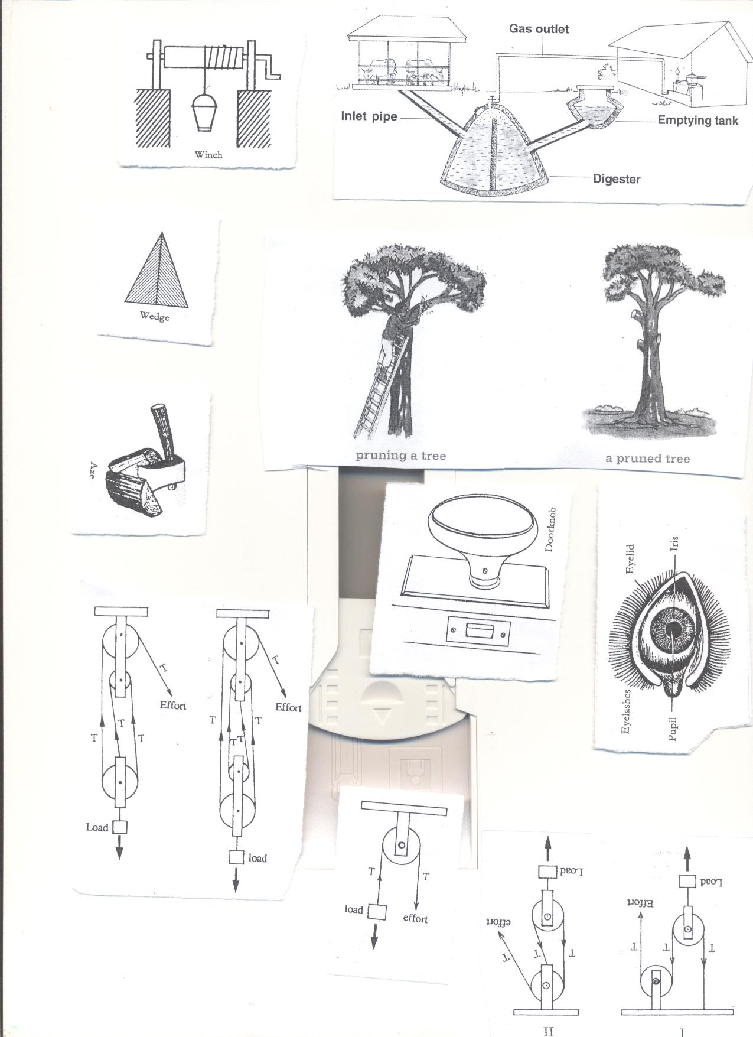

**Uses of the parts**.

* Inlet: For inserting in plant and animal matter.
* Inlet pipe: allows plant and animal matter into the digester.
* Outlet: For removing old used up matter to the garden.
* Emptying tank: Where used up matter is collected before it is taken to the garden.
* Biogas tube: It traps biogas and takes it to the heating or lighting equipment.
* **Uses of biogas**  
  1. For cooking  
  2. For lighting  
  3. For heating.

**Advantages of using biogas**  
1. It is cheaper than using natural gas  
2. It does not pollute the environment.  
3. The materials are readily available in the environment.

**Activity.**

**1. Naming parts of a biogas digester.**

**2. Drawing a biogas digester.**

**TOPICAL QUESTIONS**

1. In which one way do plants depend on?
2. Cattle b) human beings c) goats
3. Mention any one advantage of using biogas over firewood.
4. How is a biogas digester important in the production of biogas?
5. Give any one thing used in the making of biogas.
6. Write down any three ways how animals depend on non living things in the environment.
7. In what way can a farmer use the residue left after making bio gas.
8. State any two uses of biogas to human beings.
9. Why is wind said to be a form of energy?
10. How does use of biogas contribute towards the control of environmental degradation?

**(WRITING, MARKING AND GOING THROUGH MID TERM**

**EXAMINATIONS IN WEEK FOUR LESSONS 7,8,9,WEEK FIVE LESSONS: 1,2,3,4,5,6 and 7)**

**Topic 4: Simple Machines and Friction**

**VOCABULARY**

* **Friction Force**
* **Nuisance Moments**
* **Mechanical advantage Wedges**
* **Inclined Plane Axles**
* **Screws**

**LESSON ONE AND TWO ,WEEK FIVE**

**FRICTION**

* Is the force that opposes movement of objects?

**Types of friction  
1. Static friction**: It is found in objects which are fixed in one position.  
**2. Sliding or rolling friction**: It is found in moving objects.  
**3. Viscosity friction**: This occurs in liquids and gases.

**Properties of friction.**  
I. There is more friction with rough surfaces than with smooth or slippery ones.  
ii. The greater the load, the greater the friction force (weight increases friction)  
iii.Whenever friction occurs heat is produced.

**Friction as a useful force in our daily life.**1. It helps in moving and stopping vehicles.  
2. It helps when writing.  
3. It is used when sharpening objects.  
4. It helps when walking.

5. It helps in lighting match sticks.

**Friction as a nuisance force/ disadvantages.**

1. It wears away things e.g. shoe soles, parts of engines.  
2. It hinders work as it makes us use a lot of force.  
3. It produces unnecessary heat and noise.

**How to increase friction.**  
i. Making smooth surfaces rough.  
ii. Putting treads on vehicle tyres / on shoe soles.

  
iii. Putting spikes on sports boots.  
Iv. Putting grips on handles of bicycle.

**How friction can be reduced.**

i**. Using rollers**; they decrease areas of contact between moving parts.

  
ii. **Using ball bearings**; these are round metallic balls. They reduce friction by keeping moving parts separated.



iii. **Lubricating**; This involves using oil or grease.  
Oil and grease are referred to as **lubricants**.  
iv. Stream lining objects like aero planes, cars

   
v. Making rough surfaces smooth.

**Activity**

**1.** Naming streamlined objects

2. Drawing diagrams of streamlined objects.

**Exercise.**

1. What is friction?
2. In one way explain how friction can be increased on a slippery surface.
3. Write down any two advantages of friction in our lives.
4. Why is friction said to be a nuisance force?
5. Why are some objects stream lined?

**WEEK SIX LESSON 3 AND 4   
MACHINES**  
It is a device that simplifies work.

**How do machines simplify work?**  
1. By changing the direction of force.  
2. By reducing the effort required to do work.  
3. By increasing the speed of work.

**Types of machines**1. Simple machines.  
2. Complex machines.

**A complex machine**  
It is a machine that is made up of many parts and simplifies work.  
When two or more simple machines (tools) are put together a complex machine is made.  
**Examples of complex machines**Tractor, Bicycle, Sewing machine, Car, Aero plane etc.

**Simple Machine.**

It is a device that is made up of few parts and simplifies work.  
**Examples of simple machines.**

|  |  |  |  |  |  |
| --- | --- | --- | --- | --- | --- |
| A hoe | See saw | Claw hammer | Nut cracker. | Human arm. | Nut cracker. |
| A wheel barrow | Pincers. | Water pump | Sugar tongs. | Spade. | Sugar tongs. |
| A pair of scissors | Crow bar. | Bottle opener | Fishing rod | Ladder. | Stairs. |

**Classes of simple machines.**1. Levers  
2. Inclined planes/slope  
3. Pulleys.  
4. Screws.  
5. Wheel and axle  
6. Wedges  
**Levers**Is a stiff rod that turns on a fixed point called a pivot or fulcrum.

**Parts of a lever**

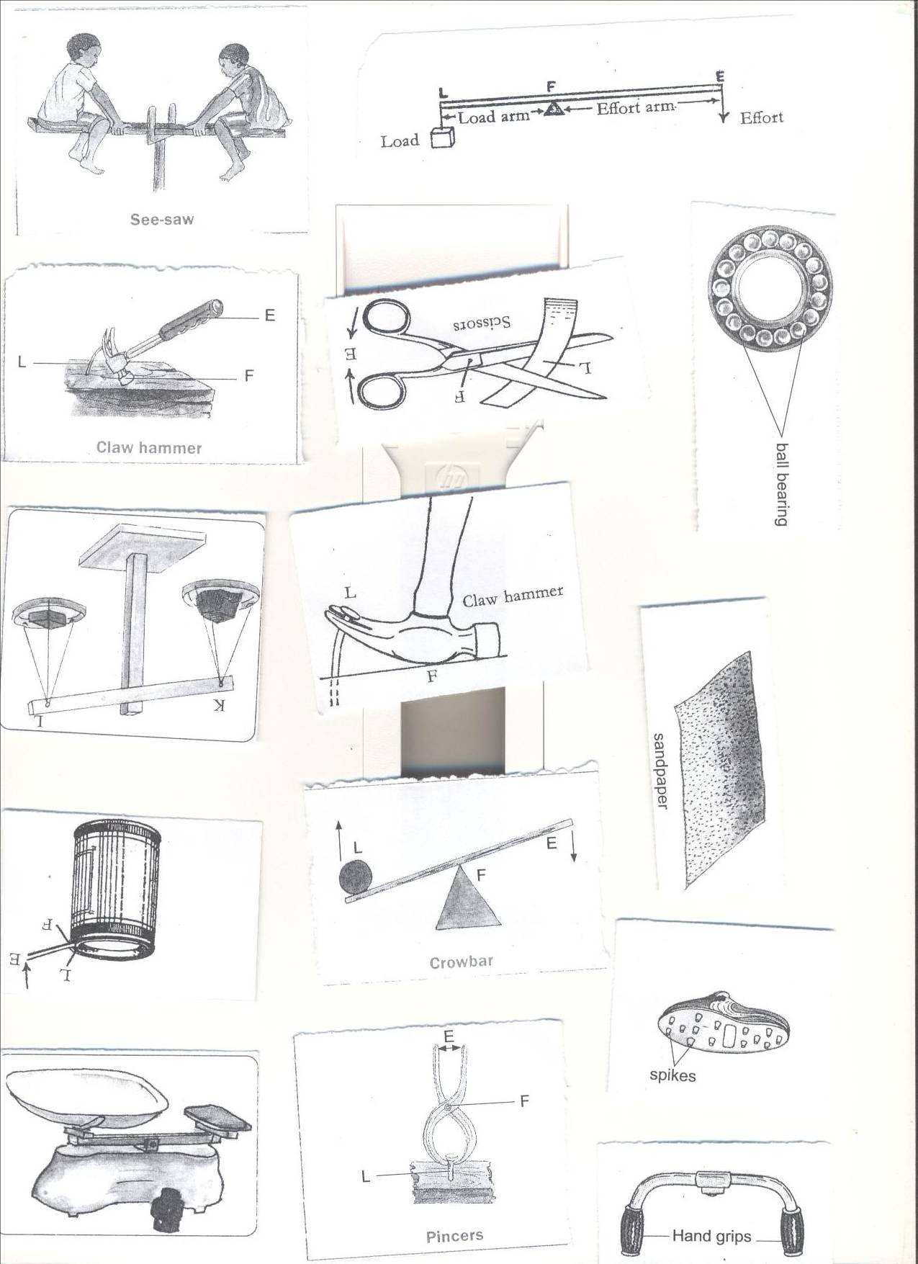  
**1. Effort:** is the force exerted on a machine to overcome the load.  
**2. Load / resistance:** it is the weight of the body to be lifted.  
**3. Fulcrum** **or Pivot:** is the turning point of a machine.  
**4. Load arm** is the distance between the fulcrum and the load.  
**5. Effort arm** is the distance between the fulcrum and the effort.

**Learners’ Activity.**

1.Observing different classes of machines.

2.Drawing diagrams of different types of Machines.

Exercise.

1.Sate the difference between a simple machine and a complex machine.

**WEEK SIX LESSON FIVE AND SIX**  
**Classes of levers.**  
There are three classes of levers depending on the position of the fulcrum(f), Load(l) and effort(E)  
**First class levers**  
Fulcrum/pivot is between the load and effort

In this class, the effort arm is longer than the load arm.  
The longer the effort arm, the smaller the effort applied.  
The advantage of the first class lever is that less effort is used.

**Examples of first class levers.**

|  |  |  |  |
| --- | --- | --- | --- |
| 1 | See saw | 5 | Crow bar |
|  | C:\Documents and Settings\Kirinya\Desktop\stepu\order form 3 016.jpg |  | C:\Documents and Settings\Kirinya\Desktop\stepu\order form 3 016.jpg |
| 2 | Pincers | 6 | Pliers |
|  | C:\Documents and Settings\Kirinya\Desktop\stepu\order form 3 016.jpg |  | C:\Documents and Settings\Kirinya\Desktop\stepu\order form 3 015.jpg |
| 3 | Claw hammer | 7 | Water pump |
|  | C:\Documents and Settings\Kirinya\Desktop\stepu\order form 3 012.jpg |  | C:\Documents and Settings\Kirinya\Desktop\stepu\order form 3 015.jpg |
| 4 | scissors | 8 | Lid opener |
|  | C:\Documents and Settings\Kirinya\Desktop\stepu\order form 3 007.jpg |  | C:\Documents and Settings\Kirinya\Desktop\stepu\order form 3 007.jpg |
| 9 | scales | | |
|  | C:\Documents and Settings\Kirinya\Desktop\stepu\order form 3 016.jpg | | |

**Second class lever**  
**Load** is between the **fulcrum** and **effort.**  
The fulcrum and the effort are on either side. (FLE OR ELF)

The load is closer to the fulcrum than the effort  
The effort applied is smaller compared to the load.  
First and second class levers are referred to as force multipliers.

**Examples of second class levers**.

|  |  |  |  |
| --- | --- | --- | --- |
| 1 | Wheel barrow | 3 | Human Foot |
|  | C:\Documents and Settings\Kirinya\Desktop\stepu\order form 3 014.jpg |  | C:\Documents and Settings\Kirinya\Desktop\stepu\order form 3 015.jpg |
| 2 | Nut cracker | 4 | Bottle opener |
|  | C:\Documents and Settings\Kirinya\Desktop\stepu\order form 3 015.jpg |  | C:\Documents and Settings\Kirinya\Desktop\stepu\order form 3 014.jpg |

**Learners Activity.**

**1. Observing different simple machines.**

**2.Demonstrating the use of different simple machines.**

**Questions.**

1. Write down any two examples of each of the following.
2. 1st class lever b) second class lever
3. State any one advantage of using first class lever?
4. Draw one any two items in 1st class lever.
5. How are machines important to people?
6. State any two ways in which machines are able to improve on the efficiency of a machine

**WEEK SIX LESSON FIVE AND SIX**

**Third class levers**  
Effort is between fulcrum and load  
The fulcrum and the load are on the either side. (FEL)

The effort is closer to the pivot than the load.  
The effort used is greater than the load.  
Third class levers are referred to distance multipliers.

The advantage of using this class is that the effort moves through a shorter distance  
**Examples of third class levers**

|  |  |  |  |
| --- | --- | --- | --- |
| 1 | Sugar tongs | 3 | Fishing rod. |
|  | C:\Documents and Settings\Kirinya\Desktop\stepu\order form 3 012.jpg |  | C:\Documents and Settings\Kirinya\Desktop\stepu\order form 3 015.jpg |
| 2 | Human arm.  C:\Documents and Settings\Kirinya\Desktop\stepu\order form 3 012.jpg | 4 | Spade.  C:\Documents and Settings\Kirinya\Desktop\stepu\order form 3 013.jpg |
| 5 | Table knife 6. Tweezers | | |
|  | C:\Documents and Settings\Kirinya\Desktop\stepu\order form 3 004.jpg http://shop.nouveaubeautygroup.com/media/catalog/product/cache/1/thumbnail/650x650/9df78eab33525d08d6e5fb8d27136e95/h/d/hdbrows_tweezers_1.jpg | | |

**N.B**  
The formula PLE or FLE can help to determine the class of lever

**The principle of moments. (The law of the lever)**  
The load force multiplied by the load arm is equal to the effort force multiplied by the effort arm.// it states that clock wise moments are always equal to anti-clock wise moments  
**Examples**

1. A man weighs 60 kgf. He sits 1.5 metres from the fulcrum of the see saw. How far from the fulcrum will the boy whose weight is 30 kgf sit in order to balance the man.  
   Let the man be the effort and the boy be the load.  
   Let the load be x metres.

X 1.5m

MAN

BOY

Load x Load arm = Effort x effort arm.  
30Kgf x X =60kgf x 1.5m  
 30x = 90  
 30 30  
 x =3 metres  
2. A boy weighing 60kgf sits 2 metres away from the fulcrum of the see saw.  
A girl sits on the other side at a distance of 3 metres from the fulcrum in order to balance the see saw. Find the weight of the girl.

2m 3m

60Kgf

X kgf

Let the boy be the effort and the girl the load.  
Let the girl’s weight be y  
Then, Load x Load arm=Effort x Effort arm  
 y x 3m =60Kgf x 2 metres.  
 3y =120  
 3 3  
 y = 40kgf  
3. A weight of 120 grams at a distance 3cm from the fulcrum is balanced by a weight of 30g on the other side. Find the distance from the 30kg weight to the fulcrum.

Take 120kgf as the effort and 30kg as the load.  
Let y be the distance of the load from the fulcrum.  
Then Load x load arm=Effort x Effort arm.  
 30 x y =120gf x 3cm  
 30y = 360  
 30 30  
 y =12cm

**4.**Using a see-saw shown below, find the length of the wooden plank AB.

A 2m B

3kgf

5kgf

**WEEK SIX LESSON SEVEN AND EIGHT**

**1.Find the value of X**

4m 2m X m

5kgf

15kgf

10kgf

1. **Find the weight at X**

4cm 2cm 3c m

5kgf

15kgf

**X**

1. Find the weight at X

3m 2m 2m 4m

30g

40g

**X**

25g

**WEEK SIX LESSON NINE AND TEN**  
**The inclined plane (slope)**  
An inclined plane is a slanting surface.

**Importance of an inclined plane.**

* It enables heavy loads to be raised using a lesser effort.  
  **Examples of inclined plane**

|  |  |  |  |
| --- | --- | --- | --- |
| 1 | Winding road | 3 | Winch |
|  | C:\Documents and Settings\Kirinya\Desktop\stepu\order form 3 010.jpg |  | C:\Documents and Settings\Kirinya\Desktop\stepu\order form 3 011.jpg |
| 2 | Stairs/ steps. | 4 | Ladders |
|  | C:\Documents and Settings\Kirinya\Desktop\stepu\order form 3 010.jpg |  | C:\Documents and Settings\Kirinya\Desktop\stepu\order form 3 006.jpgC:\Documents and Settings\Kirinya\Desktop\stepu\order form 3 012.jpg |

**Mechanical Advantage of machines.**

Mechanical Advantage is the ratio of the load to effort. i.e. M.A = Load/effort.  
M.A is the number of times a machine simplifies work.  
M.A has no units since it is a ratio.  
Friction lowers M.A.

Example;  
John used a slope to raise a load of 60kgf from the ground to the higher level as shown below.

c 60kgf  
   
 4m 5m

A B   
Work out the following  
The effort distance  
 =5m  
The load distance  
 =4m  
Work done  
 W=FXD

M.A= Load

Effort

= Distance effort moves

Distance load moves

**= 5**  
 **4**

**Work**  
Work is a product of force and the distance moved.  
Work=Force x Distance moved.

Work done by the effort=effort x effort arm.  
Work done by the load= load x load arm.  
The unit of work is a joule.  
The unit of force is the Newton.  
The standard unit of distance is the metre.  
1 kgf = 10N  
1 joule(of work) is done when one newton (of force) moves through one metre( of distance)  
1 joule=1 N x 1 m  
1 joule=1 Nm

**Activity.**

**1Moving within the school compound and using inclined planes available.**

**2. Observing different simple machines.**

Exercise

From comprehensive science book seven.

**WEEK SEVEN LESSON ONE**

**WEDGES**

A wedge is a cutting tool. It is double inclined plane/slope.

**Examples of wedges**

|  |  |  |  |
| --- | --- | --- | --- |
| **1** | Knife edge. | **5** | Axe bladder |
|  | C:\Documents and Settings\Kirinya\Desktop\stepu\order form 3 004.jpg |  | C:\Documents and Settings\Kirinya\Desktop\stepu\order form 3 011.jpg |
| **2** | Hoe | **6** | Razor blade |
|  | http://www.easydigging.com/images-new/home-grape-hoe.jpg |  | [http://t2.gstatic.com/images?q=tbn:ANd9GcTIE6EoqmU1uhn6oT3YYz7krE0IbWL1xY3_rCxkvI_eKjLOa1ctsHbPGZbI](http://www.google.com/imgres?imgurl=http://lunyole.webonary.org/wp-content/uploads/bantu/images/original/razor.png&imgrefurl=http://lunyole.webonary.org/?s=razor%20blade&partialsearch=1&usg=__BNcddsRX0bAoxj2PKoF09yyTX98=&h=1131&w=1351&sz=15&hl=en&start=20&zoom=1&tbnid=ZP5O7exX4QMmRM:&tbnh=126&tbnw=150&ei=fwYNUbGVNseKhQet3YHgDQ&prev=/search?q=razor+blade&um=1&hl=en&gbv=2&tbm=isch&um=1&itbs=1) |
| **3** | Nail. | **7** | Needle. |
|  | http://image.made-in-china.com/4f0j00VCLEmPsfsYgG/Iron-Nail.jpg |  | [http://adaptstudio.ca/blog/uploaded_images/needle-769303.png](http://adaptstudio.ca/blog/uploaded_images/needle-769308.png) |
| **4** | A wedge  C:\Documents and Settings\Kirinya\Desktop\stepu\order form 3 011.jpg | | |

**LESSON TWO**

**SCREWS**

**DIAGRAM SHOWING A SCREW.**

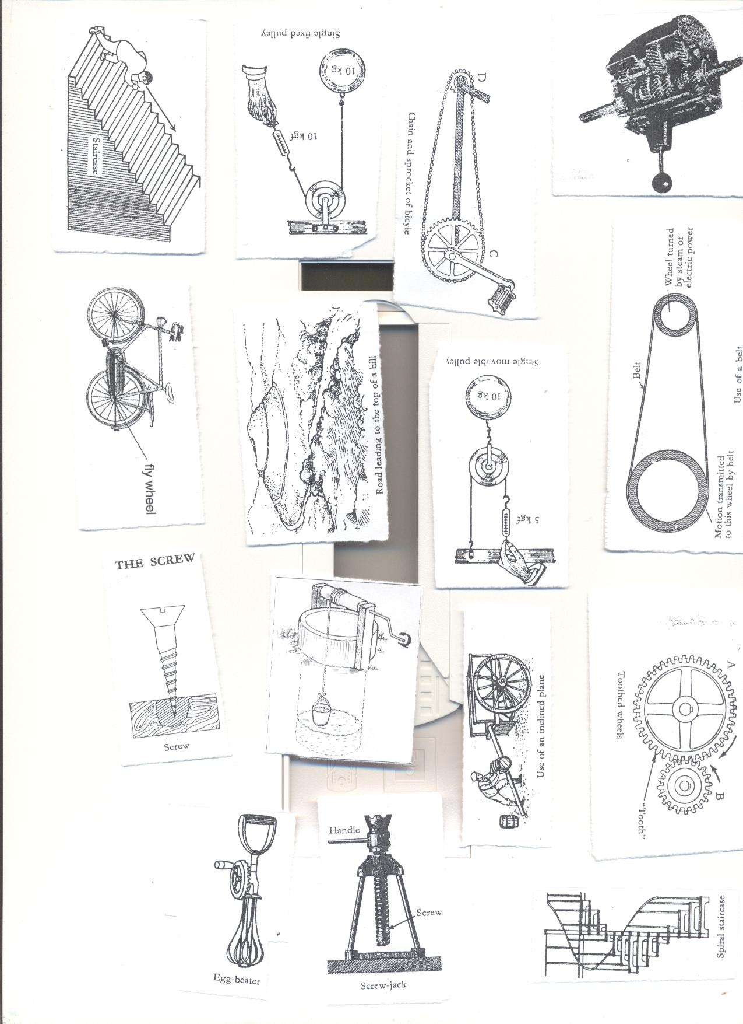

A screw is an inclined plane wound round  
We use it to make our work easier.  
**USES OF SCREWS**  
1.Lifting very heavy things e.g. screw jack.  
2. It makes movement upstairs easier e.g. using a spiral staircase

3. Used to fasten things together.  
EXAMPLES OF SCREWS

|  |  |  |  |
| --- | --- | --- | --- |
| **1** | Spiral staircase | **3** | Screw jack |
|  | **C:\Documents and Settings\Kirinya\Desktop\stepu\order form 3 010.jpg** |  | C:\Documents and Settings\Kirinya\Desktop\stepu\order form 3 012.jpg |
| **2** | Screw nails |  |  |
|  | C:\Documents and Settings\Kirinya\Desktop\stepu\order form 3 012.jpg |  |

**WEEK SEVEN LESSON THREE**

**Wheel and axle**  
An axle is a rod passed through a wheel.  
The wheel rotates on an axle.

**Examples of devices that use wheels and axles.**

|  |  |  |  |
| --- | --- | --- | --- |
| **1** | Door Knobs | **5** | Pedal wheels |
|  | C:\Documents and Settings\Kirinya\Desktop\stepu\order form 3 011.jpg |  | C:\Documents and Settings\Kirinya\Desktop\stepu\order form 3 007.jpg |
| **2** | steering wheel | **6** | Egg beaters |
|  | C:\Documents and Settings\Kirinya\Desktop\stepu\order form 3 012.jpg |  | C:\Documents and Settings\Kirinya\Desktop\stepu\order form 3 010.jpg |
| **3** | Screw drivers | **7** | Brace |
|  | C:\Documents and Settings\Kirinya\Desktop\stepu\order form 3 012.jpg |  | C:\Documents and Settings\Kirinya\Desktop\stepu\order form 3 004.jpg |
| **4** | Windlass  C:\Documents and Settings\Kirinya\Desktop\stepu\order form 3 005.jpg |  | Handles of a bicycle.  http://www.benluiindia.com/cycle_imgs/handles-a,b2.jpg |

**USES OF WHEEL AND AXLE**  
1. Drawing water from underground tanks using windlass/winch.  
2. Drilling holes in wooden materials using the brace.  
3. Turning screws to fix things together using a screw jack.  
4. It helps in loosening the screws.  
5. Preparing eggs for frying using egg beaters.

Activity.

1. Observing different Screws and wheel and axles.

2. Demonstrating the uses of screws and wheel and axles

**Exercise**

1. Give any two examples of each of the following:
2. Wheels and axles
3. screws
4. How are screws important to people?
5. Give any two examples of screws.
6. How are inclined planes important to human beings?

**WEEK SEVEN LESSON FOUR AND FIVE**

**PULLEYS**  
A pulley is a wheel with grooved rim that rotates freely about an axle through a centre.  
A rope or chain passes over the pulley and is prevented from slipping by the grooved rim. The frame which holds the pulley is called block.  
**IMPORTANCE OF PULLEYS.**  
1. They help in lifting objects from the lower level to higher level.  
2. They help in lifting heavy loads during building.  
3. They help in off loading heavy vehicles.  
4. They help in towing vehicles.  
5. They are used to raise flags on the poles. 6. Help to move window curtains.  
**TYPES OF PULLEYS.**  
1. Single fixed pulley  
2. Single movable pulley.  
3. Block and Tackle system.  
**SINGLE FIXED PULLEY.**  
The effort applied is equal to the load.  
It changes the direction of force  
Boy applying the down ward force, work becomes easier.  
The M.A of a single fixed pulley is one (1).

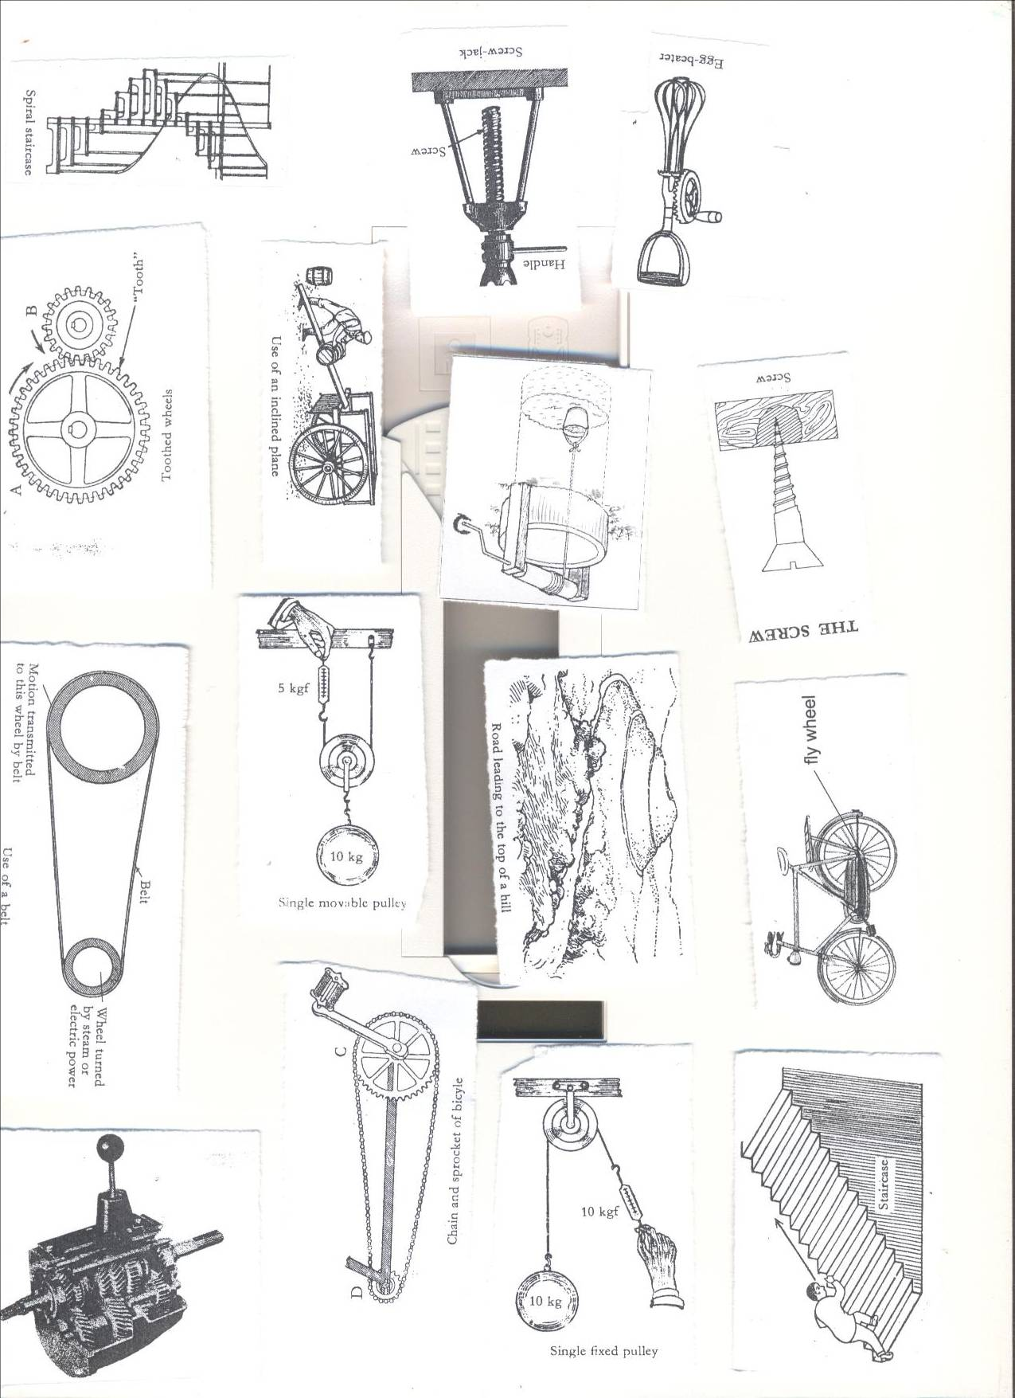

**Example;**  
If a load of 30kgf is to be raised using a single fixed pulley, find the effort needed  
M.A =1  
L=30kgf  
E=??  
M.A = load/Effort  
 1 = 30/E  
E x 1 = 30  
 E = 30kgf.

**LESSON SIX**

**SINGLE MOVABLE PULLEY**  
It is supported on two ropes.  
The rope is pulled up wards.  
The pulley moves with the load.  
Each of the ropes share a half of the effort needed.  
The rope moves twice as far as the load.  
The M.A advantage of single movable pulley is 2 (two)

Effort applied is half the load force. (It reduces the effort needed)

  
**Example**. If a load of 30kgf is to be raised using a single movable pulley, Find the effort needed.  
M.A = 2  
L = 30kgf  
E =??  
M.A = L/E  
 2 = 30/E  
2 x E = 30  
 2E = 30  
 2 2  
 E =15kgf.

**DIFFERENCES BETWEEN FIXED AND MOVABLE PULLEY**

|  |  |
| --- | --- |
| **Fixed pulley** | **Movable pulley** |
| Work is done faster | Work is slower |
| Change direction of force | No change of in direction of force |
| Force used is equal to the load. | Effort applied is half the load force. |

**WEEK SEVEN LESSON SEVEN**

**BLOCK AND TACKLE SYSTEM.**   
It does work more easily because it is a combination of both fixed and movable pulleys.  
It changes direction of force.  
It reduces effort needed.  
The ratio of load to Effort is determined by the number of pulleys.

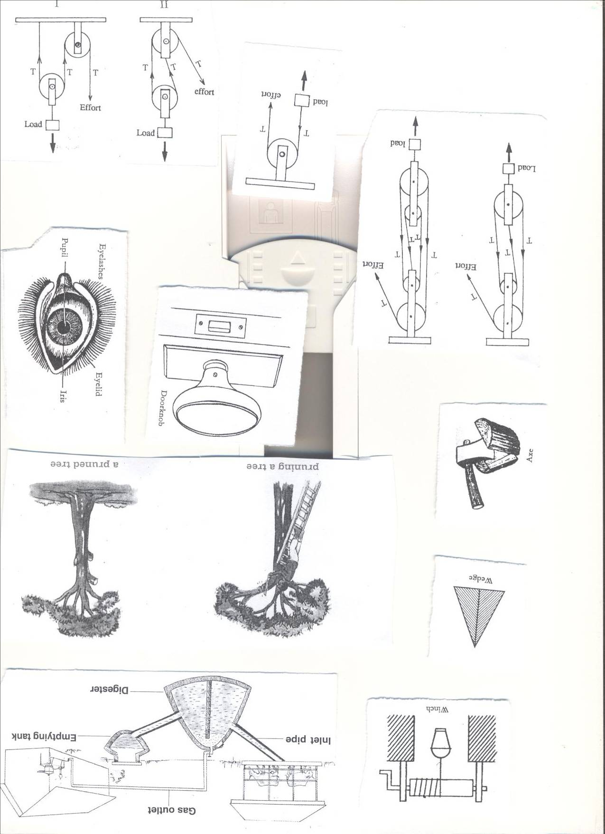 

**GEARWHEELS/COG WHEELS OR TOOTHED WHEELS**  
A gearwheel is a special form of the wheel  
It has teeth around its edge.  
These teeth interlock with the teeth of another gear wheel.  
When one turns it causes the other one to turn.

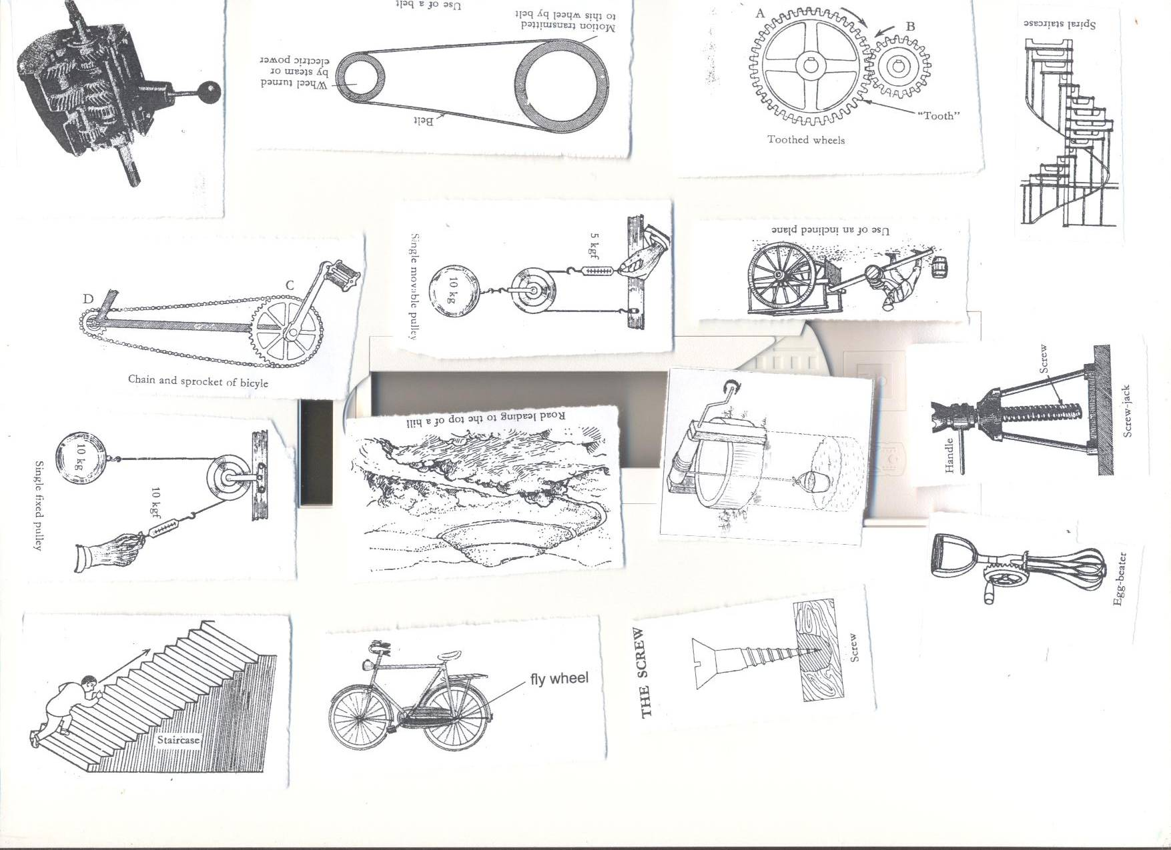  
If A has 30teeth and B has 15 teeth, how many rotations does B make in one revolution?  
30divided by 15  
=2 turns.

**Activity**

1. Demonstrating the use of pulleys and Gearwheels.

**Exercise**

1. Give any two types of pulleys.
2. How are pulleys important at school?
3. Calculate the Mechanical Advantage of a machine that needs an effort of 20kg to over come a load of 60 kg.
4. State one difference between a single fixed pulley and a single movable pulley.
5. Give any two importance of the rope on a pulley.

**WEEK SEVEN LESSON 8 AND 9**

**Topic 5: EXCRETORY SYSTEM**

**VOCABULARY**

* **Excretion Ureter**
* **Urinary system Wastes**

**Excretory system is a system that collects waste products in the body cells and removes them from the body.**

**Importance of the excretion to our bodies.**

* Maintains homeostasis by keeping the body’s internal environment stable and free from dangerous substances.

**EXCRETION:**

It is the process by which harmful materials are removed from the body.

This is the removal of harmful substances from the body.

**EXCRETORY PRODUCTS FROM THE BODY.**

|  |  |
| --- | --- |
| **Excretory organ** | **Excretory products** |
| Lungs | Carbon dioxide ,water |
| Kidneys | Uric acid, excess water ,salts, urea |
| Skin | Water, salt |
| Liver | Bile pigments |

Note: **Urea, inactive hormones, excess salts and water** are waste products in **Urine.**

**Water** and **salts** are waste products in **sweat**

**WEEK EIGHT: LESSON ONE AND TWO.**

**THE HUMAN SKIN**

It is the largest organ of the body.  
It covers most part of the body.  
It is a sense for feeling  
The skin removes sweat from the body.  
Through sweating, the body cools down.

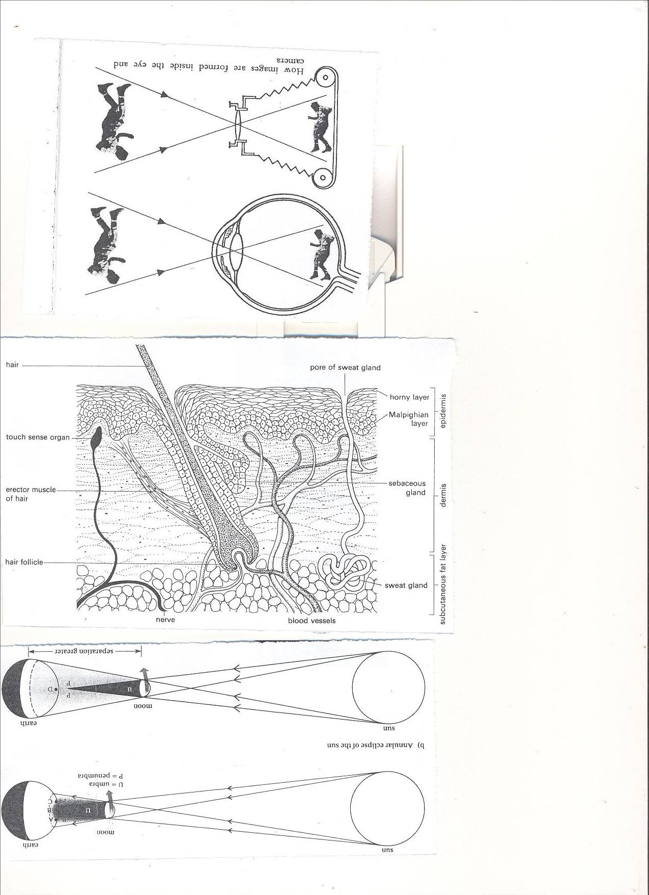**STRUCTURE OF THE SKIN.**

**Activity**

Observe their skins using a magnfying glasses.

Drawing the basic parts of the human skin.

**The skin consists of two main layers.**

* Epidermis.
* Dermis layer.  
  **Epidermis.**  
  - It is the outer layer.  
  **The layers that make up the epidermis**.  
  a) Cornified layer.  
  b) Granular layer  
  c) Malpighian layer.  
  **Cornified layer**  
  It is the tough outer most layer with dead cells.
* It prevents bacteria/germ invasion to the skin.
* It provides resistance to damage.
* It reduces excessive loss of water by evaporation.  
  **Granular layer**  
  It contains living cells and produces new cells which die continuously to form the cornified layer.  
  **Malpighian layer.**  
  It is made up of young cells.  
  It contains melanin that determines skin colour and hair colour.  
  Melanin also protects the skin against strong radiation from the sun.
* NB: When you lack melanin, you become an albino
* On the finger nails are cells called keratin that helps to produce toes and finger nails.

**Dermis.**  
It is the inner layer of the skin.  
**Parts of the dermis.**

Capillaries, Sweat glands, Hair follicle, Sebaceous glands, Sweat duct, Pore,

* Erector muscles, Nerves, Subcutaneous fat .  
  **Uses of some parts of the skin.**
* **Hair**: For keeping the body warm.
* **Sweat glands**: They produce and store sweat  
   Absorbs sweat from blood.
* **Pore**: It let’s sweat out of the body.
* **Capillaries**: Transport food and oxygen to all parts of the skin.
* **Sebaceous glands**: Produce an oily substance called sebum.  
   Sebum protects, lubricates and water proofs the skin, helps repel water, damaging chemicals and microorganisms.
* **Erector muscle**: It keeps the hair standing.
* **Nerves:** Conduct sensations of pain and touch.
* **Subcutaneous fat:** It contains fat cells where fat is stored.

**Function of human skin.**

* Excretes salts, water and urea (sweat).
* Stores fat for keeping the body warm.
* Prevents the entry of germs in the body.
* It regulates the temperature of the body.
* It is a sense organ for feeling.
* It water proofs the body.
* It helps in making vitamin D
* Protects the body from mechanical injury.

**How does the body regulate body temperature?**

**When it is hot, the skin regulates the body temperature through:**

* Sweating.
* Vasodilation- widening of arterioles to allow blood flow to the skin surface.

**When it is too cold, it regulates the temperature by:**

* Shivering
* Vasoconstriction- arterioles become narrow to reduce the flow of blood to the skin surface.
* Furry mammals and birds fluff out fur of feathers to improve insulation and reduce heat loss from the body.
* Production of goose pimples in man.

**LESSON THREE AND FOUR**

**Diseases of the human skin.**

* Scabies- caused by itch mites.
* Athlete’s foot- caused by fungus.
* Dhobi itch- caused by fungus
* Leprosy- Caused by bacteria.
* Impetigo- Caused by bacteria
* Boils- Caused by bacteria.
* Skin cancer- using strong chemicals on the skin.
* Chicken pox- caused by a virus.
* German measles- Caused by a virus.
* Scurvy- Lack of vitamin c

**Disorders of the human skin.**

* Albinism: Lack of colour in the skin.
* Burns.
* Scalds
* Cuts  
  **Care of the human skin.**
* Wash the body with clean warm water and soap.
* Smear the body with Vaseline to make it soft.
* Avoid sharing clothes towels, basins and sponges.
* Wash and iron clothes before wearing them.
* Eating foods rich in a balanced diet.
* Avoid playing with sharp cutting materials.
* Do regular physical exercises.

**KIDNEYS**

* They remove nitrogenous compounds from the body.
* Regulate the amount of water and salt in the body.
* They belong to the excretory and urinary systems

**LESSON FIVE AND SIX**

**Structure of the kidney**





**FUNCTIONS OF THE PARTS OF THE KIDNEY.**

* **Cortex**: For filtration of blood.
* **Medulla**: Re absorption of water, salt and other substances.

The process of re absorption of water from urine is known **as osmoregulation.**

* **Pyramid:** A hole through which urine from the cortex pours into pelvis.
* **Pelvis**: receives urine from the cortex before it goes down to the urinary bladder.
* **Ureter**: It is a passage of urine from pelvis to the urinary bladder.
* **Renal artery**: It carries oxygenated blood from the aorta to the kidney.
* **Renal Vein:** It carries deoxygenated blood from the kidney to the vena cava.
* **Kidney**- It filters blood to remove urine// regulate amount of salt and water.
* **Urethra**-It is a tube through which urine is passed out of the body.
* **Sphincter muscle**-They control the flow of urine out of the urinary bladder.
* **Urinary bladder**-It stores urine before it is passed out of the body.

**Functions of the kidney.**

* Filters blood
* Regulates the level of water, sugars and salts in the body.

**Good habits for the kidney**

* Doing daily physical exercises.
* Avoid holding back urine for a long time.
* Go for medical examination in case of long time back pains
* Drink boiled water.  
  **Why do we urinate frequently on a cold day than a hot day**?  
  On a hot day, you sweat a lot, therefore there is less work of kidneys  
  On a cold day, there is less or no sweating as the pores are half or fully closed. So, the kidneys take over the work of removing excess water from the body.  
  **Why do you pass out urine when you drink a lot fluids?**  
  Kidneys keep a constant amount of water in the blood.

**Why is the left kidney located slightly higher than the right kidney?**

* The right kidney is found under the liver which is the largest internal organ than the left kidney which is under the spleen.

**DISEASES OF THE KIDNEY AND THE URINARY SYSTEM.**

* Kidney stones.
* Kidney failure
* Bilharzia.
* Nephritis: this is an inflammation of the kidne**y**

**activity**

**Observe the kidneys of a domestic animal.**

**THE LUNGS AS EXCRETORY ORGANS.**

* The Lungs remove carbon dioxide and water from the body.
* Lungs are both **excretory and respiratory organs.**
* As air goes through the nose it is warmed, moistened and cleaned. (filtered)
* When we breathe through the mouth we take in cold air which may affect our lungs.
* Gaseous exchange takes place in the alveoli.

**DISEASES OF LUNGS.**

* Diphtheria, Lung cancer, Asthma, Pneumonia, Bronchitis, Tuberculosis Whooping cough
* Haemophilius influenza, Laryngitis, Emphysema, Pleurisy

**DISORDERS OF THE LUNGS.**

* Choking
* Hiccups
* Yawning

**LESSON 8 AND 9**

**LIVER**  
It is the largest internal body organ.  
**Function of the liver.**

* Regulation of blood sugars.
* Produces bile salts which aid absorption of fats.
* Stores iron.
* It reduces on excess amino acids in the body (deamination)
* Manufacture of plasma proteins.
* It burns fats to forms glucose and release energy.
* It converts poisonous compound into harmful substances (Detoxication)
* It stores vitamin A, D and B12
* It produces heat.

**Circulation to and from the liver.**

* **Hepatic artery**: It supplies oxygenated blood to the liver.
* **Hepatic portal vein**: It supplies blood with digested food from the stomach and intestines to the liver.
* **Hepatic vein**: Caries deoxygenated blood from the liver to the venacava.

**Diseases of the liver.**

* **Hepatitis:** Caused by a virus spread by contaminated water.
* **Cirrhosis:** Hardening of liver tissue as a result of alcoholism.

**Abscesses** There are pus filled sacs on the liver.

**Activity**

Observe the liver of a domestic animal  
Questions.

1. How are the following important in our bodies:
2. Kidneys c) liver
3. Lungs
4. **State any two excretory organs.**
5. **Write down any one waste material from the body.**
6. **Why is it important to keep our bodies clean?**
7. **State any one disorder of the following:**
8. **Skin b) kidneys.**
9. **State any two ways of keeping the following in good working conditions**
10. **Skin b) lungs c) liver**
11. **Why is the skin grouped under excretory organs?**
12. **Write down any two diseases of the following:**
13. **Skin b) lungs**

**TERM II 2018**

**MACHINES**

What is a machine?

* A device or tool used to simplify man’s work.

How do machines simplify work?

* By reducing the forced used to do a piece of work.
* Changing the direction of forces.
* Increasing the speed of doing work.

**Types of machines.**

What are the types of machines?

The two types of machines are

1. Complex machines – are those made of many component parts and need training to use them. Eg tractor, sewing machine.
2. Simple machines – are those with few parts and do not need special training to use them. Eg knife , panga , hoe

Common terms used in machines.

1. Work:- is a product of force and distance moved by the load.

Work can also be defined as the result of any action requiring energy.

Work done = force x distance.

Work is measured in units called joules

1. Force: is a push or pull exerted on an object. Force measured in Newtons (N).

**NB:** 1kg ≈ = 10N.

1. Power: Is the rate at which energy is changed from one form to another i.e. rate of doing work. Power is measured in units called watts (W) or Kilowatts (KW).

**NB:** 1KW = 1000w.

1. Mass: is the quantity of matter contained in a body. Mass is measured in grams.

**TYPES OF SIMPLE MACHINES.**

What are the main groups of simple machines?

The six main groups of simple machines are;

1. Levers
2. Inclined plane (The slope)
3. Wedges
4. Screws
5. Pulleys
6. Wheels and axle
7. LEVERS

What is a lever?

* Rigid Bar (rod) turning freely at a fixed point called pivot (fulcrum).
* Name the main parts of a lever. The main parts of a lever are;

1. Load (L) – the force (weight) that is to be overcome.

- some times load is called resistance.

1. Effort (E) – the force we exert (apply) when using a lever.
2. Fulcrum (F) is a fixed turning point.
3. Effort arm – the distance from effort to the fulcrum.
4. Load arm – is the distance from load to the fulcrum.

**CLASSIFICATION OF LEVERS**

* Levers are grouped according to position and arrangement of load, fulcrum and effort.
* They are classified into three groups, namely;
* First class lever.
* Second class lever.
* Third class lever
* The classes are determined basing on the force that lies between the other two.

FIRST CLASS LEVERS (**EFL / LFE**)

* This is where the fulcrum lies between the load effort.
* Examples: First class levers are;

1. Crow bar. (ii) scissors (iii) Pliers (iv) See saw

(v) Lid opener (vi) Beam balance

* How do first class levers simplify work?
* By reducing the load arm and increasing effort arm so that less force is used.
* Load and effort move in different directions.

NB : A pair of scissors and pliers are called double lever because they have two stiffrods with one turning point

SECOND CLASS LEVERS (**PLE/ ELP)**

* This is where the load is placed between the pivot (fulcrum) and effort.
* What are the examples of 2nd class levers?

1. Wheelbarrow (ii) Human foot (iii) Bottle opener (iv) Oar of a boat

(v) Nut cracker.

How does a second class lever simplify work?

* Makes load and effort move in the same direction.
* Reduces the load arm and increases effort arm so that less effort is used.

THIRD CLASS LEVER

* This is the lever where the effort lies between the load and fulcrum.

Give the examples of third class levers.

1. Pair of tongs (i) Pair of tweezers (iii) Human arm

(iv) A spade when in use (v) fishing rod (vi) A hoe in use

What is the advantage of using a third class lever?

* The effort moves through a shorter distance.

**MOMENTS**

What is a moment?

* This is the turning effect of a force about a point.
* A force acting on a point left of the pivot tends to turn it anti clockwise while a force acting on the right tends to turn the lever clockwise.
* For the lever to balance or be in equilibrium, the left side moments must be equal to the right side moments.

The Law of levers

* The sum of clockwise moments equals the sum of anticlockwise moments. OR the product of clockwise moments is equal to the products of anticlockwise moments i.e. Load X Load arm = Effort x Effort arm.

WORKED EXAMPLES ON LEVERS.

* A man weighs 80kg and sits 4m away from the pivot of a sea saw. Where will his wife who weighs 60Kgs sit in order for them to balance?

Solution:

Load = 80Kg Load x Load arm = Effort x Effort arm

Load arm = 8m 80 x 4m = 60 x X

Effort = 60Kg 320 = 60x

16 1

Effort arm = Xm 320 = 60x

60 60

3 1

16 51/3 = X

3

1

The wife should be 51/3m away from the fulcrum.

EXERCISE

Example 2.

Calculate the value of Y needed to balance the scale.

4m 2m ***Y***m

15Kg 5Kg 10Kg

(L x LA ) = (Ex EA) + (E x EA )

(15 x A ) = (5 x 2) + (10 x (2 + y) )

60 = 10 + 20 + 10Y

60 = 30 + 10y

60 - 30 = 30 - 30 + 10y

30 = 10y

30 = 10y

10 10

3 = y

∴ Y = 3m

Exercise

**TERMS USED WITH MACHINES**

Mechanical advantage (MA)

* This is the number of times a machine simplifies a given work.
* MA is the ratio of load to effort i.e.

MA = Load

Effort.

**NB:** If the MA of machine is greater than 1 less effort is used. Whereas when the MA is less than one a lot of effort is needed.

Worked example:

An effort of 40N is applied to a lever to overcome a load of 200N.

Calculate the MA of the machine.

Solution: MA = Load

Effort

5

= 200N

40N

= 5

**NB:** It means work becomes five times easier to do.

2. VELOCITY RATIO: (VR)

* This is the ratio of the distance effort moves to distance moved by the load.

VR = DME i.e. Distance Effort moves

DML Distance load moves.

The velocity ratio of a lever is the ratio of length of effort arm

Length of Load arm

3. EFFICIENCY OF A MACHINE

The efficiency of a machine is the ratio of the work output to work input of a machine.

Efficiency of a machine is always expressed in % and is normally less than 100 due to friction.

* The output is the work done on the load by the machine.
* The input is the work done by the effort on the machine.

How can the efficiency of a machine be improved?

* Replacing and repairing worn out parts.
* Regular oiling (lubrication) to minimize friction.

Efficiency = output x 100.

Input

Example: By using a machine, an effort of 30N was moved through a distance of 15m to raise a load of 120N to a height of 3m. Calculate the efficiency of the machine.

Efficiency = Load x Load distance x 100.

Effort x Effort distance.

= 120N x 3m

30N x 15m

= 4 x 100.

5

= 80%

**INCLINED PLANES /SLOPES.**

* An inclined plane is a sloping (slanting) surface connecting a lower level to a higher level.

Slanting surface

Vertical height

Angle of inclination

* The vertical height of the inclined plane is the distance moved by load while the slanting surface is the distance moved by the effort.

How do inclined planes simplify work?

By increasing the length of the plane and reducing the angle of inclination.

Give the examples of inclined planes. (illustrate them)

* Stair case (steps)
* Winding road (uphill).
* Ramp
* A ladder leaning against the wall.

Work done on inclined planes.

Calculation on inclined plane B

5m 1m

1kg

A C

Calculate the work done if the load is moved from A to B.

Work done = force x distance

= 10N x 1m

= 10Joules

Velocity ratio = DEM

DLM

= 5m

1m

= 5

**USES OF INCLINED PLANE.**

* Loading heavy goods onto Lorries.
* Climbing tall buildings.
* Helps vehicles ascend (climb) steep hills.
* For builders to carry materials to higher levels.

Exercise.

**WEDGES**

What is a wedge?

* An inclined plane with two sloping surfaces i.e. double inclined plane.

Give the examples of wedges, illustrate them. (diagrammatically)

* An axe
* A panga
* Bullet
* Knife
* Scissors
* Nails
* Chisel

Uses of wedges:

* For splitting logs of wood
* For cutting objects.
* For sewing
* For digging

**SCREWS.**

What is a screw?

* An inclined plane wound round a rod.

Illustration.

Examples of machines that use screws: (illustration)

* Bolts and nuts
* Bottles lids
* Motor car jack
* Spiral stair cases.

Uses of screws

* Car screw jack is used to lift vehicles.
* To hold two or more things together.
* To drill holes in wood or metal.
* To tighten bottle tops.

WHEELS AND AXLE

What are wheels and axle?

These are machines which are composed of two rotating wheels fixed together.

The wheel is fixed on a small wheel called axle or shaft onto which it rotates.

Examples of wheel and axle machines.

* Car steering wheel.
* Handle of bicycles.
* Pedal and chains of bicycles
* Door knobs
* Windlass.
* Sewing machine
* Windmill

Application of wheels and axle in daily life.

* Used in windlasses to draw water.
* Sprocket wheels and chains used driving bicycles.
* Car steering wheels.
* Door knobs used to open doors.

**GEARS AND BELT DRIVES.**

* What are gears?
* Gears are special forms of wheels with teeth around their edges.
* They are sometimes called cog-wheels or toothed wheels.
* If teethed-wheels are connected with chains / belts they move in the same direction.
* When cog-wheels are joined together, the teeth interlock.
* As one wheel rotates, it turns the other but they move in opposite directions.

Examples of machines that use gear wheels

* Watches
* Gear boxes
* Motor cycles
* Bicycles
* Electric toys
* Bulldozers.

What are the advantages of using gear wheels?

* They help to multiply force.
* They change the direction of movement (rotation)
* They multiply the speed of rotation.
* They can slow the speed of rotation.

**DRIVE BELTS:**

* Drive belts transmit motion from one wheel to another.
* Both wheels move in the same direction.
* If a driven wheel has 48 teeth and the driving wheel has 12 teeth, the driving wheel will make 4 revolutions in each single revolution of the driven wheel.

EXAMPLES OF ACHINESS THAT USE DRIVE BELTS.

* Bicycles.
* Sewing machines.
* Grain mills.
* Cooling fan of car radiators.
* Conveyor belts – that move things from one place to another as in escalators, bottling line in factories, moving luggage in air posts e.t.c.

**PULLEYS:**

What is a pulley?

* A freely rotating wheel with a grooved rim.
* A rope / chain passes over the grooved rim.
* The groove prevents the rope from sliding.
* The frame to which the pulley is fixed in called a block.

There are three types of pulleys.

What are the types of pulleys?

* Single fixed pulley
* Single movable pulley.
* Block and tackle / multiple/ fixed movable pulleys

a) SINGLE FIXED PULLEY.

* In a single fixed pulley, the block in attached to a frame and only the wheel moves.
* A single fixed pulley acts as a first class lever, with the axle at the centre as a fulcrum.
* A single fixed pulley changes the direction of force.
* By pulling down wards it is easier to raise an object.
* It has a mechanical advantage of one.

Question: Find the effort applied to pull a load of 50kgf using a single fixed pulley.

MA = L MA = 1

E L = 50kg

1 = 50kgf E = ?

E

E x 1 = 50 x E

E

E = 50Kgf

The force needed to lift the load is the same as the load.

1. SINGLE MOVABLE PULLEY.

* In a movable pulley, the whole pulley block moves along the rope.
* It does not change the direction of force, both load ad effort move in the same direction.
* It has a mechanical advantage of 2.
* The effort needed is half the load.

Qn: What force will be needed to raise a load of 50kgf using a single movable pulley.

1 1 25

MA = 2 MA = L 2 x E = 50 x E 2E = 50

L = 50Kgf E E 1 2 1 2 1

E = ? 2 = 50 E 25Kgf

E

* Single movable pulley acts as a second class lever with the fulcrum and effort at either sides of the wheel.

**Double pulley system (combined fixed and movable pulley)**

This is the type of pulley system composed of movable and illustration

**BLOCK AND TACKLE**

* This is the type of pulley system which consists of several movable pulleys and several fixed pulleys

The mechanical advantage of a block and tackle is determined by the number of wheels in the block.

Uses of pulleys in daily life.

* They are used by break down vehicles to pull stranded vehicles.
* They are used in lifts / elevators.
* They are used on cranes to lift and load heavy loads.
* They are used in scaffolds by painters to paint tall buildings.
* They are use on flag poles to raise flags at school.
* They are used in curtain boxes to draw curtains.

**FRICTION**

What is friction?

* A force that tends to oppose motion between objects.

Name the types of friction:

* Static friction; is the friction between two surfaces which are trying to move but have not yet started moving.
* Dynamic friction; is the friction between two surfaces when one is moving over the other.
* Viscosity friction is the friction in liquids and gases.

What are the advantages of friction as a useful force?

Friction helps us in:-

* Walking without sliding.
* Movement of vehicles.
* Lighting a match stick.
* Braking of moving vehicles.
* Climbing trees.
* Writing using a pen.
* Grinding corn, grain, flour etc.
* Washing clothes.

Name the demerits (disadvantages of friction as a nuisance force.

* Friction reduced the speed of movement.
* Reduces the efficiency of machines.
* Causes unnecessary heat in machines.
* Causes wear and tear of things.
* Delays work.
* Makes one use a lot of effort.

Ways of increasing friction.

* By putting treads on tyres or shoes.
* Putting grips on handles of objects.
* Putting spikes or studs on playing or sports shoes.
* Making surfaces rough.
* Putting tarmac on road surfaces.

Ways of reducing friction.

* Making rough surfaces smooth.
* Oiling or greasing (lubrication) of moving parts.
* Using ball bearing.
* Using rollers.
* Streamlining the bodies of moving vessels.

**BODY SYSTEMS**

Definition of a system.

A group of organs specialized to perform a similar function.

Examples;

* Digestive.
* Reproductive.
* Muscular and skeletal.
* Nervous.
* Circulatory.
* Respiratory.
* Endocrine.
* Lymphatic.
* Excretory system.

EXCRETORY SYSTEM.

* Excretion is the removal of waste products from the body.
* Excretory system is a body system that deals with the removal of waste products from the body.

Organs of excretory system.

* The body organs which carry out excretion are;

1. The skin.
2. The kidney.
3. The lungs.
4. Liver

**THE SKIN**

Illustration of the structure of the skin.

The skin is made of two main layers.

1. Epidermis.
2. Dermis.

The Epidermis:

* This is the outer most layer / region of the skin.
* The epidermis is made up of these layers.

1. Cornified layer.
2. The granular layer.
3. The malpighian layer.

Cornified layer:

* It is found on the top surface of the skin.
* It consists of dead cells that offer resistance to damage and bacterial invasion.

Malpighian

* Is a layer of cells which divide actively to produce the epidermis.
* In this layer, there are pigments granules and melanin that determine the skin colour

Granular layer.

* Contains living cells that gradually give way to form the cornified layer.
* Increases resistance to damage and bacterial invasion.
* It reduces the loss of water by evaporation.

The dermis

* This region is the inner most layer of the skin and it stores fats under it.
* This region contains the following parts.

1. Capillaries; Supply food and oxygen to the skin and removes excretory products.

Capillaries help in temperature control.

1. Sweat glands.

Secretes sweat, sweat contains excess salts, urea and water.

1. Sweat duct. Is an opening / pore that lead sweat to the surface of the skin.
2. Hair follicle. Is a deep pit of granular and malpighian layer cells that multiply to build hair.
3. Sebaceous glands; These produce oily substances called sebum that keeps the skin water proof.
4. Sub cutaneous fat; The fat layer beneath the skin act as a heat insulator that helps to control heat loss.
5. Nerves – Transmit impulses for heat, touch etc.

Functions of the skin.

* Excretes salts, water and some urea.
* Regulates body temperature.
* Stores fats.
* Makes vitamin D by the help of sun light.
* Protects the body against germ infections.
* Is the sense organ for feeling.

Body temperature regulation.

* Blood vessel vasodilate / widens allowing more blood to flow near the surface and more heat is lost by radiation.
* Sweat glands produce more sweat through which heat is lost by evaporation.
* Erector muscles relax causing hair to lie flat on the body to allow wind to easily sweep off heat.

On cold days.

* Blood vessel narrow (vasoconstriction) and so blood is withdrawn from the surface limiting heat loss by radiation.
* Decrease in sweat produce thus reducing heat lost by evaporation.
* Through shivering, heat is produced by the contracting muscles.
* Fats under the skin act as heat insulators.
* Erector muscles contract causing hair to erect and trap air around the skin which act as an insulator to heat loss.
* When hair erect, goose pimples appear on the skin.

Diseases of the skin.

The skin is commonly affected by diseases like;

* Ring worm.
* Scabies.
* Athletes foot
* Leprosy.

**Disorders of the skin**

* Dandruff
* Pimples
* Bruises
* Cuts
* Corns
* Acne
* Herpes zoster

Care of the skin:

* Wash your body daily with warm clean water and soap.
* Rub your body with a towel after bathing.
* Wounds and cuts should be well covered with sterilized bandages.
* Take exercises daily to keep it working in proper order.
* Eat a balanced diet.

**Urinary system**

Is made up of organs that eliminate wastes from the body in form of urine.

**Other organs of urinary system.**

* Kidney
* Ureter
* Urinary bladder
* Urethra

Structure of urinary system

**THE KIDNEYS**

Kidneys are two brown bean shaped organs at the back of the abdominal cavity.

Illustration of the internal structure of the kidney.

Parts of the kidney and their functions.

1. Renal artery:

Is a branch of aorta that supply oxygenated blood to the kidney.

1. Renal vein:

Takes deoxygenated blood from the kidney to the vena cava.

1. Cortex: Blood is filtered to remove Urea, Uric acid, excess salts and water.
2. Medulla – Is a region where selective re-absorption takes place by the nephrones.
3. Pelvis- Urine is collected here from the numerous nephrones.
4. Urethra: is a passage of urine to the Urinary bladder.

**NB:** Urine is formed through ultra-filtration and selective re-absorption in the kidney

1. The Urinary bladder: Is an elastic and muscular sack that stores urine briefly.

**Diseases of the kidney.**

1. Cancer of the kidney.
2. Kidney failure.
3. Kidney stones.
4. Bilharzias

Waste products excreted by the kidney.

* Uric acids.
* Urea.
* Excess salts.
* Excess water.

**THE LIVER**

1. The liver is said to be the most important organ in the body because it performs many functions compared to other body organs.
2. The liver is a large reddish brown organ below the diaphragm.
3. It is supplied with oxygenated blood by the hepatic artery. The liver receives blood rich in digested food from the alimentary canal by the help of the hepatic portal vein.

**FUNCTIONS OF THE LIVER**.

1. The liver regulates blood sugar.
   * Too much sugars and lack of enough sugar in blood causes diabetes.
   * The liver control sugar levels by the help of insulin.
   * Insulin is produced by the pancreases and help to stimulate the liver to remove glucose from blood by converting it into glycogen for storage.
   * The liver deaminates amino acids and convert them into carbohydrates.
   * Alcohol, poisonous substances and poisonous drugs produced during metabolism are ma de harmless by the liver through the process of detoxication.
2. It helps in the process of excretion.
3. Stores vitamins and mineral slats.
4. It helps in detoxication process.
5. It produces heat energy.

**Diseases of the liver.**

* Cirrhosis of the liver.
* Hepatitis.
* Liver abscess. These are boils which form pus in the liver.

**Care of the liver**

* Avoid taking too much alcohol.
* Have a balanced diet.
* Always have exercises to keep it in a good working condition.

**THE RESPIRATORY SYSTEM.**

* Respiration is the process by which the body uses oxygen to burn down food to produce energy, carbondioxide and water vapour.
* Respiration takes place in the body cells.

**Types of respiration.**

* There are two types of respiration i.e.

1. Aerobic respiration – One which uses oxygen.
2. Anaerobic respiration –One which does not use oxygen.

* Difference between breathing and respiration.

1. Breathing is the taking in of air rich in oxygen and taking out of air with more carbondioxide.

Illustration (diagram) of the internal structure of the lungs.

**ORGANS OF RESPIRATION AND THEIR FUNCTIONS**

* Epiglottis – Is a flap which protects the opening of the trachea during swallowing of food.
* Nose- The air passage into the trachea.
* It contains cilia and mucus which help to trap germs and dirt which enter the nose.
* In the nose, air is cleaned, warmed and moistened.
* It is not advisable to breathe through the mouth because;

1. The air will not be warmed so it can chill or make the lungs very cold.
2. The mouth has no cilia to trap dust and germs.

**THE TRACHEA.**

* Also called the wind pipe.
* It is a passage of air down the lungs.
* The trachea contain tiny cilia for trapping dirt and germs.
* The trachea is made up of cartilage rings to keep it open.
* It divides into the bronchi which continues to divide into bronchioles and end up into the air sacs / alveoli.

**The lungs.**

* The lungs are both excretory and respiratory organs.
* This is because they are used in respiration and also putting out waste products.
* The lungs excrete carbondioxide from the body which is a waste product of respiration.
* It is in the lungs where gaseous exchange takes place in the body. However, in the lungs, gases exchange takes place in the air sacs or alveoli.

**Adaptations of air sacs / Alveoli to their function.**

* They are thin walled to allow gases diffuse through easily.
* They are surrounded by a net work of blood capillaries which supply them with blood.

**COMPOSITION OF AIR BREATHED IN AND OUT.**

|  |  |  |
| --- | --- | --- |
| **Type of air** | **Inspired air** | **Expired air** |
| Oxygen 02  Carbondioxide Co2  Nitrogen N2  Water vapour  Rare gases | 21%  0.03%  78%  Less  0.97% | 16%  4%  78%  More  0.97% |

Explanation:

* 21% of oxygen is breathed in but only 16% is breathed out because most of it is used by various body reactions.
* 0.03% of carbondioxide is breathed in and 4% is expired because more of it is produced by various reaction like respiration.
* 78% of Nitrogen is inspired and 78% expired because no body reaction needs nitrogen to occur.
* Less water is inspired but more is expired because more water vapour is produced by different body organs.
* 0.97% rare gases is inspired 0.97% expired because no body reactions required it to occur.

**Mechanism of breathing (expiration and inspiration)**

Inspiration:

* The volume of the chest and lungs increase.
* The diaphragm and the intercoastal muscles contact.
* The ribs go up and out wards.
* The lungs expand.
* The stomach enlarges and swells.

Expiration:

* The volume of the chest and the lungs decrease.
* The ribs go down wards and in wards.
* The diaphragm and intercoastal muscles relax.
* The lungs and the stomach go to their original size.

The pleural membranes.

* The lungs are covered by the pleural membranes which secrete fluid called pleural fluid.
* This fluid lubricates and reduces friction between the lungs and the ribs.
* The ribs are held together in position by the intercoastal muscles.

Diseases and disorders of the respiratory system.

Disorders:

* Hiccups.
* Sneezing.
* Choking.
* Yawning.
* Coughing

Diseases.

**Communicable Non-communicable**

* Tuberculosis - Emphysema
* Influenza - Lung cancer
* Diphtheria - Asthma
* Whooping cough (pertussis) -
* Pneumonia
* Bronchitis

Care for the respiratory system.

* Eat a balanced diet.
* Perform regular exercise.
* Eat meals containing low animals fats.
* Avoid smoking.

Advantage of regular body exercises.

* The heart muscles grow stronger and larger.
* The heat delivers more blood to the body muscles.
* They reduce the level of fats in the body.
* The risk of high blood pressure and heart diseases is reduced.
* Ligaments and tendons become stronger and reduce chances of injury.
* Joints become flexible.
* Weight is lost.

**FORMS OF ENERGY**

Energy – Energy is anything that enables man to do work.

Examples of forms of energy.

1. Light energy.
2. Sound energy.
3. Electricity.
4. Heat energy.
5. Chemical energy.
6. Mechanical energy.
7. Solar energy.
8. Magnetism.

**LIGHT ENERGY.**

Light is a form of energy which enables our eyes to see objects.

Light is a form of energy which stimulates sense of seeing.

How we see objects.

* We see objects when they reflect light in our eye.
* Light travels from the objects to our eyes.
* Some objects give out their own light while others reflect light falling on them from other sources.

Sources of light.

* A source of light is an object which gives out light.

There are two types of sources of light.

1. Natural sources of light.
2. Artificial sources of light.

Examples of natural sources of light.

* The sun.
* The stars.
* Erupting volcanoes.
* Glow worms.
* Fire flies.

Examples of artificial sources of light.

* Electric bulbs.
* Torches.
* Lamps.
* Candles.
* Fires
* Charcoal stoves.

These sources of light can either be luminous or non-luminous sourced of light.

Luminous sources of light

These are sources of light which emit (send) or produce their own light.

They are also called direct sources of light.

Examples of luminous objects.

* The sun.
* The stars.
* Red hot charcoal.
* Fire flies.
* Hands and fingers of some clocks and watches.
* Some kinds of rocks.
* Working filament of the bulb.
* Bulbs.
* Burning charcoal.
* Erupting volcanoes.

**NB:**

Among luminous sources of light, some emit light when they are red hot. These sources are called incandescent sources of light.

Examples of incandescent sources of light.

* The sun.
* The stars.
* Hot filament of bulbs.
* Hot charcoal e.t.c

Non-luminous objects.

These are sources of light which do not emit their own light but just reflect light from another source. They are also referred to as indirect sources of light or reflectors.

Examples of non-luminous objects.

* The moon.
* The planets.
* Plane mirrors.

Importance of light.

* Light enables us to see objects using our eyes.
* Plants use sunlight to carry out photosynthesis.
* Heat and light from the sun help the eggs of reptiles, amphibians and fish to hatch.
* Our bodies use sunlight to make vitamin D.

Transmission of light (how light travel)

* Light travels in straight lines to all directions from the source.

Light rays

Source of light

Experiments to show that light travels in straight lines.

Light travels in a straight line in any transparent medium e.g. glass, air, water and vacuum.

We cannot see around corners behind corners because light travels in straight lines.

* The experiment above shows that light travels in straight lines.
* The three card boards have holes in their centre at exactly the same position.
* If arranged in a straight line, light travels through the holes from the candle to eye.
* When you shift one of the candles slightly, you will not see the light.

Experiment two.

* In (i) when the tube is straight light can be seen.
* In (ii) when the tube is bent, light can’t be seen.
* This is why we can’t see around corners.

**NB:**

We hear sound around corners because sound travels in waves but we can’t see around corners because light travels in straight lines.

Rays and beams of light.

A ray of light is a line along which light travels.

A ray of light is represented by an arrow.

A ray of light.

A beam of light

A beam is a group of light rays.

There are three types of beams of light.

1. Parallel beams.
2. Diverging beams.
3. Converging beams.
4. **A parallel beam**

This is a type of beam where the light rays travelling from the source can not meet.

A parallel beam.

1. **A diverging beam**

This is a beam where the light rays from the source spread out (diverge) e.g. car head lamp, bicycle head lamp and torches.

.

Source of light

1. **Converging beam.**

This is a beam of light where the light rays from the source come towards a point (converge).

**Speed of light**

The speed of light is about 300,000Km/s in air and vacuum.

Light travels faster than sound in air.

Examples to prove that light travels faster than sound.

* We hear thunder after we have seen lightning.
* At a race track, we see the flash of starter’s gun before we hear the bang.
* The sound of an axe is heard after we have seen the axe strike when cutting.

Effects of light on different materials.

When light meets an object, one of the following will happen.

* Light can be absorbed, diffused or scattered.
* Light may be allowed through transmission.

Materials which affect light are grouped into:

1. Transparent objects.
2. Translucent objects
3. Opaque objects.

Transparent objects

These are objects which allow most of the light to pass through and we can see through them.

Examples of transparent objects.

* Glass
* Water
* Air etc.

Translucent objects

These are objects which allow some light to pass through but we cannot see through clearly.

We can not see through them because they diffuse or scatter light rays in all directions.

Light passing through is little

because of diffusion.

Examples of translucent objects:

* Frosted glass.
* Waxed paper
* Cloth
* Tissue paper
* Light bulbs.

Opaque objects.

These are objects which don’t allow any light to pass through them.

* We cannot see through them because light travels in straight lines.
* Opaque objects instead form shadows.

Examples of opaque objects.

* Wood
* Stones
* Metals.
* Walls.
* Bricks etc.

No light passes through.

Shadows

A shadow is a region of darkness caused by obstruction of light by an opaque object.

* When the source of light is a small point, a sharp complete shadow is formed called a total shadow or umbra.
* When the source of light is big, a total shadow called umbra is surrounded by half or partial shadow called penumbra.
* If the source of light is put further away from the opaque object, the shadow will be smaller.
* If the source of light is nearer the opaque object the shadow is bigger than the object.

**Eclipse**

An eclipse is a shadow formed by the obstruction of light by either the moon or earth.

The word eclipse means ‘cut off’

Note:

* The sun is stationary (in one place)
* The earth revolves round the sun on its fixed path called orbit.
* The moon revolves round the earth but its orbit is not fixed.

Eclipse of the sun-solar Eclipse.

* It occurs when the moon comes in between the sun and the earth.
* When this happens the sun casts the shadow of the moon onto the earth.

Illustration.

**P** – Penumbra (partial eclipse)

U – (total eclipse)

Annular eclipse of the sun.

* It occurs in the same way as the solar eclipse. But when the moon is far away from the earth and the umbra fails to reach the earth.
* When this happens the earth only receives the penumbra and the sun will be encircled by a ring.

Eclipse of the moon – Lunar eclipse.

The eclipse of the moon occurs when the earth comes in between the sun and the moon.

This happens only when there is a full moon.

The moon is in total eclipse so it doesn’t reflect any light.

Reflection of light.

Reflection is the bouncing back of light rays when they strike a shining opaque object.

Types of reflection.

There are two types of reflection.

Regular reflection.

* Is the type of reflection where the beam of light is sent back in a definite direction.
* It is produced when light falls on a smooth shinny surface e.g. mirrors.
* We are able to view ourselves in plane mirrors because they are highly polished and give a regular reflection.

Irregular reflection.

* Is a type of reflection where the beam is scattered and thrown back in all directions.
* Rough unpolished surfaces give irregular reflection (diffuse reflection)
* We are unable to see clear images on walls because they give irregular reflection.

**Reflection principles and its laws**

* AO - Incident ray.
* OB - Reflected ray.
* ON - Normal
* i - angle of incidence.
* r - angle of reflection
* O - Point of incidence

Laws of reflection:

* The incident ray, the reflected ray the normal at the point of incidence all lie in the same plane.
* The angle of incidence is equal to the angle of reflection.

**NB:** when the incident ray strikes the mirror at an angle of 900 the reflected ray takes the same route and this is called total internal reflection.

**Qn:**

The incident ray makes an angle of 600 to the mirror. What is the angle of reflection?

The normal makes 900 to the mirror

600 + i = 900.

60 - 60 + i = 900  - 600

i =300.

∠ of incidence = ∠ of reflection.

∴ ∠of reflection = 300.

Reflection of light by different materials.

* Dark dull materials are good absorbers of light which is converted to heat.
* In hot weather people prefer white clothes and in cold weather they prefer dark clothes.
* A black dress appears black because it absorbs all colours and reflects none.
* White objects appear white because they reflect all colours and absorbs none.
* Green objects appear green because they absorb all the other colours and reflect only green into our eyes.

Image and Objects:

An image is a light picture.

Characteristics of images formed by plane mirrors.

* The distance of the object from the mirror is the same as the distance of the image behind the mirror.
* The images are laterally inverted.
* The image is the same size as the object.
* The image is always upright / erect.
* The image is virtual i.e. cannot be cast on the screen.

Use of plane mirrors.

* They are used to see certain parts of the body that we cannot see directly. E.g. behind the head.
* They are used in periscopes.

A periscope is an instrument which consists of a tube with two mirrors fixed inside facing each other and inclined at 450.

The mirrors are parallel to each other.

* A periscope is used to see around corners by soldiers in trenches and in submarines.

**Illustration**

**Curved mirrors.**

* These are mirrors which are sphere like in shape.
* They obey the laws of reflection.
* The different types of curved mirrors are made by silvering on one side.

**Types of curved mirrors.**

* There are two types of curved mirrors.

1. Concave mirrors.
2. Convex mirrors.
3. **Concave mirrors ( converging mirrors)**

* It is made by silvering the outside of the sphere.

**Characteristics of images formed by concave mirrors**

* The image is larger than the object (magnified).
* They are erect (upright)
* They are laterally inverted.
* They are virtual (i.e. Formed behind the mirror so they cannot be cast on the screen)

A beam of light on the concave mirror.

Uses of concave mirrors.

* They are used by barbers as shaving mirrors.
* They are used by dentists.
* They are used in search lights, electric torches, head lamps as polished and silvered concave metals
* They are also used in telescopes.

Telescopes have large concave mirrors, which assist in focusing beams of light from heavenly bodies.

Telescopes help in studying about the stars and planets.

**Convex mirrors (Diverging mirrors)**

They are made by silvering the inside of the sphere.

Characteristic of images formed by convex mirrors.

* The image is smaller than the object – diminished.
* The image is upright – erect.
* The image is laterally inverted.
* The image is virtual – behind the mirror.

**A beam of light on a convex mirror.**

Use of convex mirrors.

* They are used as a driving mirror on vehicles.

1. They form upright images.
2. They give a wide view of the distant object.
3. They are used in super markets to see what customer do.
4. Security mirrors in bus and cars.

Refraction of light.

* Refraction is the bending of light as it passes from one transparent medium to another.

e.g - From air to gas

- From air to water.

- From glass to water.

Refraction is caused by change in speed of light as it passes from one transparent medium into another which have different densities.

- BO is the ray of incidence it is in air.

- O is the boundary and point of refraction.

- NR is the normal.

- i is the angle of incidence.

- r is the angle of refraction.

- OC is the refracted ray. It is in water

**Note**

When a ray of light passes from one medium to a more optically dense medium, the ray bends towards the normal and vice versa is true.

The law of refraction

* The incident ray and the refracted ray are on opposite side of the normal.
* The incident ray, the refracted ray and the normal all live in the same plane.

Refraction of light through a glass block / prism.

**IR** is the incident ray in air.

**RR** is the refracted ray. It is within the glass.

**ERR** is the emergent refracted ray, it is in air.

**i**  is the angle of incidence.

**r** is the angle of refraction.

Effects of refraction.

1. A swimming pool appears shallower than its real depth because of refraction. This is seen by placing a stone in a glass, and then view it from the top.
2. A ruler or stick partly dipped at an angle into some water in a glass appears bent or broken due to refraction.
3. Refracted stick fixed vertically and partly dipped in water appears to be shorter than it’s real length.
4. A mirage is an optical illusion caused by the bending of light rays due to layers of air having different densities and temperature e.g. sheet of water seen on a high way during a hot day. It appears like a pool of water seen ahead on the road on a hot day.

Effects of mirages.

* Mirages may lead to accidents on high ways.
* Mirages cause false images along high ways in deserts.

1. Words under a glass block appear to be raised on a different line from those away from the glass because of refraction.

**LENSES**

A lens is a transparent material with curved side capable of refracting light.

The curved surfaces of a lens help to bend or refract light passing through the lens.

Types of lenses.

There are two types of lenses.

1. Convex lens.
2. Concave lens.

Convex lens (converging lens)

Is a lens which is thicker in the middle and thinner at the edges.

Illustration.

Convex lens Convex meniscus

(Converging lens)

* When a parallel beam strikes a convex lens comes together at a point in front of the lens.

Concave lens (diverging lens)

* This is a lens which is thinner in the middle and thicker at the edges.

Concave lens concave

Meniscus

**NB:** The converging meniscus and diverging meniscus are used in spectacles.

When a parallel beam of light reaches the concave lens it spreads outwards after passing through the lens.

Uses of lenses.

* Lenses are used in photographic cameras.
* Lenses are used in microscopes used by doctors to see germs.
* Used in spectacles worn by people with eye defects.
* Used as magnifying glasses.
* Used in projectors which focus information on film slides into big pictures on the screen.
* Used in binoculars to see distant things in magnification.

In general lenses are used in optical instrument.

**Optical instruments.**

Optical instruments are instruments which use either lenses, prisms, plane mirrors or curved mirrors.

**Examples of optical instruments.**

* Cameras.
* Microscopes.
* Spectacles.
* Magnifying glasses.
* Telescopes.
* Binoculars.
* Projectors.

**Dispersion of light.**

Dispersion of light is the splitting of white light into the seven colours of the spectrum.

* Dispersion of light is due to refraction of light.
* A spectrum is a band of seven distinct colours.
* A spectrum is formed when white light is split by the act of a prism.
* A prism is a device that splits white light into seven colours.
* An example of a natural light spectrum is a rain bow.

**Colours of the spectrum.**

**Primary colours and secondary colours.**

A primary colour is one that cannot be obtained by mixing other colours e.g. red, blue and green.

A secondary colour is colour made by mixing two primary colours e.g. yellow, magenta, peacock blue pr cyan.

How to make secondary colours.

* Red + green = Yellow.
* Red + Magenta = white.
* Blue + yellow = Cyan or peacock blue.

**Illustration:**

White is a universal colour.

**A pin hole camera**

A pinhole camera works on the principle that light travels in straight lines.

That is why an inverted image is formed on the screen.

**Characteristics of images formed by a pinhole camera.**

* The image is diminished – smaller than the object.
* The image is inverted – upside down.
* The image is real i.e. it can be cast on the screen.

**The lens camera:**

* A camera is an optical instrument because it uses a convex lens.
* It consists of a light proof box with five functional parts. i.e. the lens, diaphragm, shutter, film and focusing ring.

**The structure of a lens camera.**

**Functions of each part.**

* **The film** – Is a light sensitive piece of paper on which an inverted image is formed.
* **The diaphragm** – It regulates the amount of light energy that has been allowed into the lens. It has the aperture (a circular hole) which can be changed according to the amount of light required.
* **The lens** – the lens focuses the image on the film. The film works as a screen. The camera uses a convex lens.
* **The shutter** – The shutter uncovers the aperture for a fraction of a second thus admitting light into the camera. This exposes the film.
* **The focusing ring**. This adjusts the distance of the lens from the film i.e. moving the lens forward or backward.

**How the camera works**

* Light is allowed into the camera by the lens, diaphragm and shutter, it falls on the film and the film is exposed.
* The exposed film is removed from the camera in a dark place and put a certain chemical to develop it. The result of developing is a negative.
* It is called a negative because the bright parts of the object photographed appear dark and the dark parts appear bright.
* The negative is printed to give a positive (photograph) which has the same shades as the object.

Characteristics of images formed by a camera.

* The images are real.
* The images are inverted.
* The images are diminished.
* **Retina.**
* This layer contains light sensitive cells called rods and cones.
* Human being see clearly during day because they have more cones than rods.
* Cones help in day light and colour light.
* Rods help in dim and night vision.
* It is on the retina when the images are formed.
* **Fovea (yellow spot)**
* It has the highest concentration of cones.
* It gives accurate interpretation of the image and is where the sharpest image is formed.
* **Blind spot.**
* This spot doesn’t have any light sensitive cell.
* It is where the optic nerve leaves the eye and also where blood vessels and nerves join the optic nerves.
* **Lens**
* Refracts light rays and focus the image on the retina.
* **Suspensory ligament**
* Holds the lens in position by attaching it to the ciliary body.
* **Aqueous and vitrous humour.**
* These are salt solutions, sugar solution and proteins in water.
* They refract light to produce an image on the retina.
* They help to maintain the shape of the eye.
* **The optic nerve**
* Transports nerve signals to the brain for interpretation.
* **Eyelashes.**
* They help to trap large air borne particles.
* **Tear glands.**
* They lie under the eyelids.
* They secrete a solution of sodium hydrogen carbonate and sodium chloride (Tear).
* They have an enzyme which kills bacteria.

**NB:**

The eye has the ability to focus near and far objects on the retina by changing the shape of the lens.

This focusing of near and far objects by the lens is called accommodation.

**Characteristics of images formed by the eye.**

* The images are real.
* The images are inverted.
* The images are diminished.

**The Human Eye**

The eye is an organ of sight.

It is spherical in shape and enclosed in a socket of the skull called the orbit.

**The structure of the eye.**

**Front view of the eye**

**Functions of parts of the eye.**

* The eyelids.
* They cover and protect the eye.
* Blinking can be voluntary or by reflex action.
* Blinking distributes a fluid (tears) over the surface of the eye to prevent it from drying.
* Tears clean up the eye and kills some germs which enter the eye.
* Conjunctiva.
* Is a thin layer which lies inside the eyelid.
* It is kept moist and clean by a slow continuous stream of liquid from the tear glands.
* Sclerotic.
* It is a tough non-elastic coat around the eyeball.
* It supports and maintains the shape of the eyeball.
* Cornea.
* It is a transparent part of the sclerotic. It helps to refract and converge light.

**Choroid**

* It has a dense net work of blood capillaries supplying food and oxygen to the eye.
* It is pigmented black to reduce internal reflection of light within the eye.
* **Iris**
* It regulates the size of the pupil and controls the amount of light entering the eye.
* It also determines the colour of the eye.
* **Regulation of the size of the pupil.**

**Dim light Bright light**

* **Pupil.**

Admits light into the eye.

**Similarities between the eye and camera.**

|  |  |
| --- | --- |
| The human eye | The photographic camera |
| * Image falls on the light sensitive retina * Has a convex lens. * It is covered by a black layer choroid. * Iris controls the amount of light by regulating the size of the pupil. * The image is real, inverted and diminished. * The eyelids keep out light. * The ciliary muscles determines accommodation of the lens. | * Image falls on alight sensitive film. * Has a convex lens. * It is covered by a light proof box. * The diaphragm controls the amount of light by regulating the size of the aperture. * The image is real, inverted and diminished. * The shutter keeps out light. * Focusing ring determines the distance of the lens from the film. |

Difference between a human eye and camera.

|  |  |
| --- | --- |
| The human eye | The photographic camera |
| * Distance between the lens and retina is fixed. * Shape of lens easily to focus at different distances. * Lens is soft and elastic. * Image is focused by making lens thicker. * Aqueous and vitreous humour refracts light. * The iris adjust itself. | * The distance between the lens and film changes. * The shape of the lens does not change. * The lens is hard. * The image is focused by moving lens. * Only the lens refract light. * The diaphragm can be adjusted. |

**Eye defects:**

* It is the inability for an eye to focus certain distance normally.
* **Cause**
* The eye ball being too long or eye lens being too thick.
* This causes the image from distant objects be brought to focus infront of the retina.
* Short sightedness can be corrected by wearing spectacles with diverging lens (concave lenes).
* Eye strain.
* Abnormal shape of the eye ball.
* Abnormal shape of the lens.
* Colour blindness.

**Examples of eye defects.**

* There are four eye defects in common in humans namely.

1. Short sightedness (myopia)
2. Long sightedness (hypermetropia)
3. Old age sight (presbyopia)
4. Astigmatism.

* **Short sightedness**

Short sightedness is a condition when a person can only see near objects clearly but cannot see distant objects.

Normal eye sight.

Both near and distant objects can be

focused on the yellow spot on the retina.

Short sightedness (myopia)

This occurs when the eye ball is longer than the normal or when the lens is too thick and the objects close to the eye can be focused properly but the point of focus for distant objects is infront of the retina.

Correction of short sightedness.

Short sightedness is corrected by wearing spectacles with diverging lenses (concave lenses).

Long sightedness:

Long sight is a condition when certain people can see distant objects clearly but can not see near by objects.

Small or short eye ball or too thin eye lens.

The above causes the image from close objects be brought to focus behind the retina.

**Illustration**

This occurs when the eyeball is shorter than the normal or when the eyeball is small or the lens is too thin.

Distance objects can be focused properly but the point of focus for close objects is behind the retina.

Correction of long sightedness

Long sightedness is corrected by wearing spectacles with convex lenses.

Old age sight (presbyopia)

When the lens loses its elasticity it can no longer change in shape.

It becomes suitable for only distant vision (long sight). Old age sight people usually require reading glasses which have converging lenses. This happens in old age above sixty years.

Astigmatism.

It is the most common of all eye defect.

It is caused by the surface of the cornea not being perfectly smooth or spherical.

This results is blurred vision.

Astigmatism is corrected by wearing spectacles with cylindrical lenses.

**DISEASES OF THE EYE**

Conjunctivitis.

* It causes the swelling of conjunctiva.
* It is caused by bacteria or virus.

There are three types of conjunctivitis.

* Acute conjunctivitis.
* Chronic conjunctivitis.
* Gonorrhoea conjunctivitis.

signs

* The white part of eye becomes pink.
* Waterly discharge from the eyelid with mucus and pus.
* Scratching and burning sensation in the eyelid.
* Looking at light cause pain.

Trachoma

Caused by bacteria.

* It is highly contagious and infectious disease.
* It is common in places with poor hygiene and overcrowding where water is scarce and people don’t wash hands and their eyes.

How trachoma spread

* By houseflies.
* Sharing hands with an infected person.
* Sharing of the same basin with an infected person.
* Shaking hands with another infected person.

Signs and symptoms

* Redness and itching on the eye.
* Waterly discharge from the eyelids.
* Swelling of the eyelids.
* Pain while looking at light.

River blindness.

* It is caused by a tiny filaria worm (onchocerca vulvulus).
* It is carried by a small hump called black fly known as a black fly or simulium fly.
* This fly breeds in fast flowing rivers.

Signs and symptoms

* Itching skin rashes.
* Severe skin itching.

Prevention and control.

* Spraying using insecticides against the adult fly.
* Treatment of the infected person.

**Other diseases.**

Blephartitis.

* An inflammation of the margin of the eyelid.
* The eyes itch and burn and swell.

Cataracts.

* This is when the lens of the eye becomes grey and opaque.
* They are caused by an injury or continued exposure of the eye to high temperature.

Glaucoma.

* Caused by increased internal pressure of fluids.
* It can come about by itself or progress from another diseases.

Iritis.

The swelling caused by other diseases or injury to eye.

Sty

* This is a small inflammation on the eyelid. It looks like a small boil.
* It is usually a sign of poor general health, anaemia or diabetes.

Corneal ulcer.

It is caused by an injury to the cornea.

Night blindness

Care of the eye.

* Don’t rub your eyes with dirty fingers.
* Don’t strain your eyes by reading;

1. Very small prints with too little or direct sunlight.
2. In moving vehicles.
3. In wrong postures like in bed.

* Don’t expose your eyes to very bright or glaring light.
* Always wash your eye with clean water and soap, every morning and evening.
* Never look directly at the sun, it may spoil your retina.
* If there is anything wrong with your eyes visit an eye specialists.
* When reading use a correct distance of about 30cm.
* Don’t share towels or clothes with people who have sick eyes.

**P.7 TERM TWO S.S.T NOTES**

**THE PEOPLE OF AFRICA**

**VOCABULARY**

Ethnic group, Tribe, Clan, Migrations, Ancestors

1. Give the meaning of;

a) **Ethnic group**: This is a group of people who share the same origin and speak related languages.

b) **Tribes:** This is a group of people who share the same ancestors.

c) **Clans:** This is a group of people who share the same totem.

d) **Migration:** This is the movement of people from one place to another for settlement.

e)**Culture:** The accepted way of behavior in society.

f) **Customs:** The accepted practices of society.

g)**Totem:** The object that is respected as symbol in a clan.

The people of Africa are grouped under ethnic groups.

These include the following:

**-**Bantu **Others:**

-Cushites -The British

-Caucasians -The Pygmies

-Semites -The Asians

-Berber -The Negroes

-Nilotes -The Khoisans

**THE BANTU:**

-This is the largest ethnic group in Africa.

-**The Bantu are in four groups namely;**

**a)**Eastern Bantu c)Central Bantu

b)Western Bantu d)Southern Bantu

**Western Bantu:**

They moved from Cameroon highlands and settled in East Africa at around 100AD through the Western direction.

**Examples of Western Bantu:**

-Banyoro -Banyankole -Bagisu, etc.

-Baganda -Basoga - Batooro

**-** Bagwere - Bakiga - Basamia

**The Eastern Bantu:**

-They moved from Cameroon highlands and settled in Zambia.

-Then they split into two groups.

-One group moved northwards to Tanzania and Kenya.

-Another group moved southwards and formed the Southern Bantu.

**Examples of Eastern Bantu:**

-Akamba -Nyamwezi

- Kikuyu -Taita

**Examples of Southern Bantu:**

**-**Herero, Ovambo and Griqura in Namibia.

**-**Tswana in Botswana.

-The Shona in Zimbabwe

-The Sotho: These settled in S.Africa along R.Vaal and Orange.

-The Ngoni: They split and formed tribes like Zulu, xhosa, Ndebele,Venda and swazi who are in South Africa

NB.The Southern Bantu have click sounds in their language which they borrowed from Khoisan.

**Central Bantu:**

They are settled in Congo and Domecratic Republic of Congo.

**Examples of Central Bantu:**

-Bemba, Lozi of Zambia.

-Bakongo, Balunda and Baluba of Congo.

-Yao, Makwa of Mozambique.

-Nyanja, Chewa of Malawi.

-Mbundu, Ovimbundu of Angola.

**Problems faced by the Bantu during their migration:**

i)Attacks from dangerous wild animals.

ii)Attacks from hostile tribes.

iii)Harsh weather conditions.

iv)Shortage of food.

v)Poor transport

vi)Rough terrain

vii)Loss of lives and property.

**Reasons for Bantu’s migration:**

i)Desire for adventure.

ii)Due to outbreak of diseases in Cameroon highlands.

iii)They were looking for areas with fertile soils for farming.

iv)They wanted areas with reliable rainfall.  
v)Due to internal and external conflicts in their homeland.

vi)Due to population increase in Cameroon highlands

1.**Historical factors that influenced the Bantu’s migration.**

i.Outbreak of diseases.

ii.Internal and external conflicts.

iii.Drought in their cradle land.

3.**Effects of Bantu’s migration:**

i).They introduced / introduction of new culture.

ii).New crops were introduced.

iii).Population increase in areas of settlement.

iv).New skills were introduced.

v).Intermarriages leading to new cultures.

vi).Some Bantu formed kingdoms

**Interlacustine region:**

The area between the great lakes of East Africa.

**Kingdoms that were found in the interlacustine region:**

-Buganda kingdom -Wanga kingdom

-Ankole kingdom -Toro kingdom

-Karagwe kingdom -Bunyoro kingdom.

**Great lakes of East Africa:**

-L. Victoria -L.Kyoga

-L. Tanganyika -L.Edward

-L. Albetr -L.George

-L. Malawi

R**easons why Bantu settled where they are living today.**

-Presence of fertile soils for farming.

-Presence of good climate.

-Areas were free from epidemic diseases.

**Problems were faced by Bantu during their settlement.**

-They faced a problem of hostile tribes.

-Harsh weather.

-Diseases.

-Attacks from wild anima

P**eople who formed Wanga kingdom.**

Abaluhya

**Causes of migration today:**

-To look for better jobs.

-To Look for better social services.

-To look for fertile areas for farming.

-To look for areas with good climate.

-To look for better security

**THE NILOTES:**

The Nilotes are divided into three groups namely;

**River- Lake Nilotes are** believed to have migrated from Bahr el Ghazel in Sudan.

**Plain Nilotes are** believed to have migrated from Ethiopian highlands.

**Highland Nilotes** are believed to have migrated from Ethiopian highlands.

The main occupation of the Nilotics was pastoralism.

The River –Lake Nilotes first settled at Pubungu when they came to Uganda.

**Examples of River- lake Nilotes**

-Acholi of Uganda. -Japadhola of Uganda

-Alur of Uganda - Jaluo of Kenya

**Examples of the Plain Nilotes (Nilo- Hamites)**

-Karimajongs in Uganda -Turkana of Kenya

-Dodoth of Uganda -Iteso in Uganda

-Kumam of Uganda -Masai of Kenya and Tanzania

-Pokot of Kenya

**Examples of the Highland Nilotes**

-Sabiny of Uganda -Kalengin of Kenya

-Kipsigis of Kenya -Nandi of Kenya

**What made the Nilotes to migrate from their cradle land?**

-Due to the outbreak of diseases.

-Due to prolonged drought in Bahr-el-Ghazal.

-Due to internal conflicts.

-Overpopulation in their cradle land.

-Drought and famine.

**Questions**

1.Give two reasons why most Nilotes have changed from pastorolism (cattle keeping) to crop farming?

2.Write four pastoral tribes in East Africa.

3.Write the pastoral tribes in Africa outside East Africa.

4.Mention the problems faced by pastoral tribes.

5.Write two disadvantages of nomadic pastoralism.

6.Suggest ways in which nomadic pastoralists can be helped to live a better life.

**THE CUSHITES**

-The cushites migrated from Arabia and settled in the Horn of Africa.

-They moved southwards into East Africa.

--They were the first people to move and settle in East Africa.

**Questions**

1.**Name the countries that form the Horn of Africa**

-Somalia

-Djibuti

-Eritrea

-Ethiopia

2.**What was the economic activity of the cushites?**

Pastoralism

**Examples of Cushitic groups**

-Somali

-Boran

-Bahima

-Ttutsi

-Oromo

-Ogaden

**The Semites**

-The Semitic group has a mixture of Arabic and Jewish blood.

-The Semites came as a result of intermarriages between the Arabs ad the Jews.

-The Semites live in Northern Africa and in the Middle East.

**Tribes under Semites**

-The Amhara

-Bagara

-Tigreans of Ethiopia

-The Eritrea of Eritrea

-The Nubians of Sudan and Uganda

-The Arabs of Sudan.

**NB:**

The Semites are pastoralists.

**The Khoisans**

-The Khoisans are the earliest inhabitants of Southern Africa.

-They comprise of the Khoi Khoi and the Sans.

-The Khoisan speak a language with click sound.

-They are pastoralists and hunters.

-They were displaced by Bantu and Europeans from their homelands.

-Today they live in Kalahari and Namib deserts.

**The pygmies**

-They lived in the tropical rainforests of Democratic Republic of Congo.

-They are short and dark skinned with broad nose.

-They are about 137cm tall.

-They are hunters and fruit gatherers.

**The Negroes**

-The Negroes are considered to be Bantu.

-Their origin is from the forests of West Africa.

-They are mainly crop farmers.

**Examples of Negroes in Africa are;**

-Mandika / Mande of Mali

-The Asante of Ghana

-The Yoruba and Igbo of Nigeria

**NB**

Most Negroes were taken as slaves to America.

**MAJOR ETHNIC GROUPS IN AFRICA**.

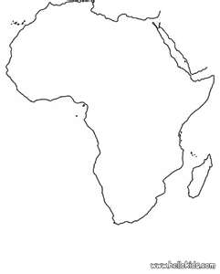

**Question**

**How were the people of Africa organized during the pre-colonial time?**

-Africans were organized under kingdoms.

-Under clan systems.

Under chiefdoms

-Under empires

**Kingdoms of Africa**

|  |  |  |  |
| --- | --- | --- | --- |
| **Eastern** | **Western** | **Southern** | **Central** |
| Buganda kingdom | Ghana kingdom | Zulu | Great Zimbabwe |
| Toro kingdom | Songhai |  | Luba – Lunda |
| Bunyoro kingdom | Benin |  | Mwenomutapa |
| Ankole kingdom | Kanem Bonu |  |  |
| Wanga kingdom | Mali |  |  |
| Karagwe kingdom | Asante |  |  |
| Rwanda Kingdom |  |  |  |
| Burundi kingdom |  |  |  |

**A map showing kingdoms of Africa**



1. **How were Africans economically organized in pre-colonial time?**

Africans were engaged in many traditional activities such as;

1. Trade iv. Keeping animals
2. Farming v. Iron working and painting
3. hunting

2.**What is a kingdom?**

A state ruled by a king.

**W hy were kingdoms restored in Uganda?**

i).To promote and preserve culture among the people of Uganda.

ii).To promote peace and unity in Uganda.

iii).To unite people for national development.

4.**Which constitution abolished kingdoms in Uganda?**

The 1967 constitution.

5.**Which kingdoms were restored in Uganda by the 1995 constitution?**

i.Buganda Kingdom.

ii.Toro kingdom

iii.Bunyoro Kingdom

iv.Busoga kingdom

6.**Give the importance of kingdoms**

i.They promote culture.

ii.They promote unity.

iii.They promote morals.

iv.They promote peace.

v. They unite people for national development.

7. **Write down two characteristics of a kingdom**

i).They have royal regalias.

ii).They have hereditary leadership.

iii).Their kings are the fountain of honor.

8. **Mention the factors that led to the expansion of Buganda kingdom.**

i).Buganda had a strong leadership.

ii).Buganda had enough food.

iii).Buganda had a good location of being near L. Victoria.

iv).Buganda had acquired guns during the long distance trade.

Buganda had good climate.

9.**What caused the decline of Bunyoro-Kitara empire**

i). The large size of the empire which was hard to manage.

ii). The out break of epidemic diseases which led to the death of their beloved cow Bihogo.

iii). The coming of the Luo-Babito.

iv). Internal conflicts from the Princes which resulted into the creation of Tooro and Bunyoro kingdoms.

10.**What were the contributions of Bunyoro-Kitara empire to modern economy?**

i).They introduced coffee cultivation.

ii).They introduced iron smelting.

iii).They introduced long horned cattle.

**Social contributions**

i.They introduced bark cloth making.

ii).They introduced local chess.

iii).They introduced wooden sandals.

iv). They introduced centralized system of government.

v). They introduced Pet names.

**Who were the founders of Bunyoro-Kitara empire?**

Abatembuzi

**Who was the first and last ruler of the Chwezi?**

-The first was Ndahura.

-The last was Wamala.

**What caused the rise of Ghana kingdom?**

-Ghana had a lot of gold.

-Ghana had a lot of food.

-Ghana had strong weapons made of iron.

**What caused the fall of Ghana kingdom?**

-Due to external attacks.

-The loss of gold.

**FOREIGN INFLUENCE OF THE EUROPEANS IN AFRICA**

1.**Who were the first Europeans to come to the Coast of South Africa?**

The Portuguese

2.**Who named cape of storms the cape of Good hope?**

3.**Who was the leader of the Dutch that settled at Cape Province in South Africa?**

Sr. Jan Van Riebeck

4**.Name the first trading company to come to East Africa.**

The Dutch East India Company led by Sir Jan Van Riebeck

5.**Name the first area in Africa to be colonized Cape province in South Africa**

6.**Who were the Boers in South Africa?**

These were the Dutch farmers.

7.**Which Europeans displaced the Dutch from Cape colony?**

The British

**The Great Trek**

This was the journey of the Boers from Cape Colony North-East wards across R.Vaal.

**What caused the Great Trek?**

i).The Dutch were stopped from carrying out slave trade.

ii).The introduction of English as the official language.

iii).The British imposed harsh rule to the Dutch.

**What problems were faced by the Dutch (Boers) during the Great Trek?**

i).Shortage of food.

ii).Poor transport.

iii).Disease outbreak

iv) Harsh climate.

v)They fought wars with the people they met around R.Vaal. (Shaka Zulu)

**Results of Great Trek**

i. New states such as orange free state, Transvaal state and Natal province were formed.

ii. Gold was discovered.

iii. There was loss of lives during the battles.

iv. It led to the discovery of diamond and gold.

v. New crops were introduced eg maize.

vi. Much land of Africans was taken by the Boers.

**The Asians in Africa**

-The Asian included the Indians, Malaysians, Arabs and Chinese.

-The Asians came to Africa as traders and settlers.

-Other groups of Asians came as workers on the railway line.

**How did the Asians contributed to the development of African?**

i).They constructed Kenya-Uganda railway.

ii).They built shops.

iii).They built industries.

iv).They introduced new crops.

v).They introduced new forms of money e.g the Indian rupees.

vi).They started plantation farming.

**The Arabs in Africa**

-Most people in North Africa are Arabs.

-The Arabs came to Africa to;

i).spread Islam.

ii).trade.

iii).settle as refugees.

-Arabs came from Saudi Arabia.

**Questions**

**Give three contributions of the Asians to E. Africa**

i).They built shops.

ii).They built industries.

iii).They constructed Kenya – Uganda railway.

2.**Give three reasons for building the Kenya- Uganda railway**

i).To transport goods from Uganda to the coast.

ii).To transport British administrators from the coast to the interior.

ii)i.To stop slave trade.

iv).To promote Legitimate trade.

3.**What problems were faced by the builders of Kenya-Uganda railway?**

i).Attacks from hostile tribes.

ii).Attacks from dangerous wild animals.

iii).Epidemic diseases.

iv).Crossing the rift valley was difficult.

4.**Why were Indian coolies invited to construct the Kenya-Uganda railway?**

i The Africans never wanted to leave their families.

ii The Indian coolies were more experienced in the railway construction than the Africans.

5.**What were the results of constructing Kenya-Uganda railway?**

i).Slave trade was stopped.

ii).Transport was made easy.

iii).It led to the development of towns.

iv).Trade was promoted.

6.**How did the following affect the construction of Kenya-Uganda railway?**

a)**Rift valley**

-It was difficult and expensive to construct the railway across rift valleys.

b)**The Nandi people**

-They never wanted the railway to go through their land.

-They killed some builders of the railway line.

c)**Lions of Tsavo**

They killed the builders of the railway line.

7.**What role was played by each of the following people during the construction of the Kenya-Uganda railway.**

i).**Engineer George White House**

He was the chief engineer during the construction of the railway.

ii).**Major MacDonald**

He was the chief surveyor during the construction of the railway.

iii).**Colonel Patterson**

He killed the man eaters of Tsavo.

iv).**Sir William Mackinnon**

He brought the ideas of the construction of the Uganda railway.

v).**Sir Guild Ford**

He was the last engineer to inspect the Uganda railway.

**FOREIGN INFLUENCE ON THE AFRICAN CONTINENT**

**Foreign influence**

There were the changes that were brought to Africa by foreigners from Europe and Asia.

**Question**

**How did the foreigners influence the people of Africa?**

-Some people in Africa became Christians.

-Some people in Africa became Moslems.

-Africana learnt how to read and write.

-Africans learnt practical skills

-Africans started growing cash crops.

-Africans got modern weapons for defense and protection.

-Africans started speaking foreign languages.

For many years, Africa was referred to as a dark continent by Europeans because they did not have information about its interior.

**Reasons why Africa took long to be known to the outside world**

-Africa had thick had thick impenetrate forests that made transport difficult.

-It was due to hostile tribes.

-Africa had hot deserts.

-Africa has dangerous wild animals.

**NB:**

The above problems were feared by the foreigners.

**Foreign groups / groups of foreigners that came to Africa**

-They were grouped as Arabs and Europeans

-The following were some of the foreigners under European;

i)Explorers

ii)Missionaries

iii)Traders

iv)Colonialists / Administrators

V)Settlers

**NB:**The Arab traders were the first foreigners to come to Africa.

**Reasons why foreigners came to Africa**

1.They came to spread religions.

2.They came to get materials for their industries.

3.They wanted to get market for their finished goods.

4.They wanted to invest their surplus capital.

5.They wanted to find new lands for settlement.

6.They wanted to stop slave trade.

**The coming of the Arabs (to the African continent)**

-Arabs came from Saudi Arabia and some from Persia.

-They came by means of special boats called dhows which were powered by the monsoon winds.

-They came mainly to trade.

-They also wanted to spread Islam.

-They were running away from religious conflict.

**Effects of the coming of the Arabs**

1.They introduced the Islamic faith.

2.They promoted trade.

3.They introduced the new ideas of architecture.

4.They introduced some crops e.g cloves, rice, sisal.

5.They introduced Zebu cows.

6.They introduced new styles of dressing.

7.Their coming led to the growth and development of coastal towns of East Africa.

8.Slave trade was introduced in Africa.

9.They introduced many items like guns, beads.

**SLAVE TRADE**

**What is Slave Trade?**

The buying and selling of human beings.

**What was slavery?**

This was the possession of a person by another people illegally.

**How were slaves obtained?**

i).Through raids.

ii).Through barter trade.

iii).Fuelling was between chiefdoms and kingdoms or getting war captives.

**Why were slaves needed?**

i).The Arabs wanted slaves as domestic workers.

ii).The French wanted slaves to work in their sugarcane plantations in the Indian ocean.

iii).The other Europeans wanted slaves to work for them in their mines and sugarcane plantaions in

America.

iv).The African leaders needed them for bartering.

**People who took part (participated) in slave trade**

a)The Arab traders.

b)The African chiefs and kings

c)The Khartoumers.

d)The Europeans (the Dutch, the French, Spaniard, Portuguese)

**Slave trade markets in East Africa**

-Zanzibar was the largest slave trade market in the world.

-Tabora (Kaze) was the largest slave trade market in the interior.

**EFFECTS OF SLAVE TRADE**

-Kings and chiefs gained a lot of wealth.

-It led to the growth of some kingdoms and societies.

-It led to the growth of towns e.g Mombasa, Malindi, Kilwa, Sofala, etc.

-Africas interior was known to the outside world.

-It led to the introduction of new items of trade e.g guns, beads, plates, cups, etc.

**Negative effects**

-Loss of lives

-Human suffering

-Loss of culture

-Famine

-Depopulation

-Tribal conflicts emerged

-Destruction of property

**Reasons why slave trade was difficult to stop**

-It was profitable to the traders and to the African chiefs.

-Many Europeans wanted it to continue so that they could get cheap labour.

**People who participated in abolition of slave trade**

-Sir Samuel Baker

-Dr. David Livingstone

-Abraham Lincoln

-Willian Wilberforce

-Adam Smith

**Questions**

1.a)**Mention the treaties that were signed to stop slave trade in East Africa**

-Moresby treaty – 1871

-Harmattan treaty – 1876

-Frere treaty – 1878

b)**Who signed each treaty above?**

-Capt Moresby and Sultan of Zanzibar signed the Moresby treaty.

-Harmattan and the Sultan of Zanzibar signed the Harmattan treaty.

-Frere treaty was signed by Sultan of Zanzibar and Frere.

2.**How did the following help to end slave trade?**

a)**Dr. David Livingstone**

He invited trading companies to carryout legitimate trade.

b)**The railway line**

It was used to transport goods instead of using slaves.

c)**William Wilberforce**

He decampaigned slave trade in the British parliament.

d)**The missionaries**

They preached against slave trade.

3.**Write down three tribes in Uganda under the Sudanic group of people.**

-Lugbara

-Madi

-Kakwa

1.a)**What was Trans-Saharan trade?**

This was the trade between the Berbers and the people of West Africa across Sahara desert.

b)**Name the goods that the Berbers brought to West Africa.**

i)salt iv)glasses

ii)silk v)camels

iii)Cotton clothes vi)perfumes

c)**Name the items of trade which the Berbers got from West Africa during the Trans-Saharan trade**

i)Ivory

ii)Gold

iii)Skins and hides

iv)Ostrich feathers

2.**Why did the trades move in Caravans during the Trans-Saharan trade?**

For protection

3.**What makes a camel an ideal means of transport in the desert?**

-It has strong lids to protect the eyes from sand dust.

-It has a fatty hump that gives energy.

-It has flat homes that cannot sink in sand.

4.a) **What was Trans Atlantic trade?**

This was the trade that involved the people of West Africa, America and Europe across Atlantic ocean.

**b) Mention the items of trade that were got from Europe to Africa**

- clothes

- guns

- cups and plates

c) **From Africa to America**

- Slaves

- Ivory

- Gold

d) **From America to Europe**

- Sugar - gold

- silver - cotton

- Tobacco - Tea

- Copper

**Europe**

Sugar clothes

Silver guns

Tobacco cups and plates

Gold

Cotton

Tea

Copper

**America** slaves  **Africa**

Ivory

Gold

**A MAP SHOWING THE KINGDOMS OF EAST AFRICA**

|  |
| --- |
|  |

**THE EXPLORERS IN AFRICA**

1.**Who is an explorer?**

A person who leaves his country to another country or continent to search for information.

2.**Why did the explorers come to Africa?**

-To find the sources of R. Nile.

-To find areas of trade.

-To find geographical information about Africa.

3.**Problems that were faced by explorers in Africa**

-Hostile tribes

-Tropical diseases.

-Poor transport

-Harsh climate

-Shortage of supplies.

-Attacks from wild animals

-Language barriers.

4. **What were the effects of the European explorers (results)**

-Physical features were renamed.

-Africa was opened to the rest of the world.

-Friendship and links between Africa and Europe started.

-They discovered areas of trade.

-Explorers gave information to traders and missionaries.

5.**Name the first explorer to come to Africa.**

Bartholomew Diaz

**Bartholomew Diaz**

-He was a Portuguese.

He wanted to find a sea route to India.

He was the first explorer to sail around Cape Town.

6.**Why did Bartholomew Diaz call Cape Town the Cape of Good Hope?**

7.**What made Bartholomew Diaz not to complete his journey to India?**

-He was affected by storms.

-He lacked supplies.

**Vasco Da Gama**

-He was a Portuguese explorer who discovered the sea route to India.

-He started his journey from Lisbon, Portugal.

1.**What problems were faced by Vasco Da Gama during his journey to India?**

- Lack of supplies.

- Storms

- Diseases like scurvy

2.**Why was it necessary for Vasco Da Gama to find the sea route to India?**

-To avoid the high taxation from the Ottoman empire.

-He wanted to ease trade between India and Portugal.

3.**Name the items of trade the Portuguese wanted from India**

- Spices

- Silk

- Gold

**EXPLORERS TO WEST AFRICA**

**Mongo Park**

-He tried to find the source of R. Niger

-He died at Bussa Falls.

**Other explorers**

Richard Lander, John Lander, Gordon Laing and Hugh Clapperton also tried to find the source of R.NIGER

**Questions**

1. **Why was West Africa called the White man’s grave?**

Many white men died from there.

2. **How did Mungo Park meet his death?**

He drowned at Bussa Falls.

3. **Mention three problems that were faced by Explorers in West Africa.**

i) Hostile tribes.

ii) Tropical diseases.

iii) Attacks from wild animals

**EXPLORERS IN CENTRAL AFRICA**

**Dr. David Livingstone**

-He was from Scotland.

-He crossed Africa from Indian Ocean to Atlantic Ocean.

-He discovered Victoria falls on R. Zambezi in Zambia.

-He treated people suffering from sleeping sickness.

-He discovered Lake Tanganyika.

-He spread Christianity.

-He stopped slave trade in East and Central Africa.

-He invited trade companies to promote legitimate trade.

Qn1.**Who were the servants of David Livingstone?**

- Chuma

- Susi

**EXPLORERS IN EST AFRICA**

**Sir Samuel Baker**

-He followed R.Nile from its mouth.

-He discovered L. Albert and Murchion falls.

-He was the first governor of Equatorial province.

-He stopped slave trade in Acholi land.

-He tried to colonise Uganda for Egypt.

-He built A Fort at Patiko.

Qn 1.Whydid Sir Samuel Baker not welcomed in Bunyoro Kitara Kindgom?

Qn 2.Why did Omukama Kabalega resist Sir Samuel Baker?

Qn 3.Why did Kasagama of Toror welcome Sir Samuel Baker and Lugard?

**JOHN SPEKE**

-He discovered the source of R.Nile.

-He was the first European to see L. Victoria.

-He renamed Kiira falls as Rippon falls.

**Questions**

1. Why is it wrong to say that Speke discovered the source of R. Nile?

2. Why were the Europeans interested in finding the source of R.Nile?

3. In which way was R.Nile responsible for the coming of the first Europeans to Africa.

**HENRY MORTON STANLEY**

-He discovered Mt. Rwenzori and named it mountains of the moon.

-He moved around L. Victoria to prove Speke’s discovery about the source of R.Nile.

-He wrote a letter inviting missionaries to Uganda.

-He came to East Africa three times.

a) 1871 -He came to look for Dr. David Livingstone.

b) 1873 /4-To prove Speke’s discovery about the source of R.Nile.

c) 1879 -To rescue Emin Pasha

- He discovered L. Edward and L. George.

**Questions**

1. Why did Stanley call Mt. Rwenzori mountains of the moon?

2. Who requested Stanley to write a letter inviting missionaries?

3. Who took the letter which Stanley wrote?

4. Why did Muteesa I invite christen missionaries to his kingdom?

**Other explorers and their contributions**

|  |  |
| --- | --- |
| **Explorer** | **contributions** |
| Joseph Thompson | He discovered Mt. Elgon and L. Balingo |
| Count Teleki | He discovered L. Turkana |
| James Bruce | He discovered L. Tana and Blue Nile |
| Dr. Fisher | He discovered L. Naivasha |
| Johann Rebmann | He discovered Mt. Kilimanjaro |
| Jacob Erhardt | He attempted to draw the map of East Africa. |
| Dr. Steer | He built a mission centre at Zanzibar. |
| Johann Ludwig Krapf | He discovered Mt. Kenya |

**Questions**

1. Apart from Dr. David Livingstone, write other explorers that moved to central Africa.

2.a) Write down two organizations that sponsored the above Explorers.

b) In which ways were the above organizations important to explorers.

3. How did the explorers lead to the exploitation of Africa’s resources?

4. Mention two positive effects of explorers to Africa.

5. How did the coming of explorers affect Africa negatively?

**MISSIONARIES IN AFRICA**

1.**Who is a missionary?**

A person who leaves his country to another country to spread the word of God.

2.**Give reasons why missionaries came to Africa.**

-They came to spread Christianity.

-They came to stop slave trade.

-They introduced formal education.

**MISSIONARIES WHO CAME TO AFRICA**

**1.John Ludwig Krapf**

-He was sent to Africa by the church missionaries society.

-He spread Christianity in Ethiopia and Kenya.

-He built a mission station at Rabai Mpya in Kenya.

-He translated the English Bible into Kiswahili.

-He was an explorer as well as a missionary.

Qn1 .**How did the mission station at Rabai Mpya contribute to the spread of Christianity?**

It helped people to learn how to read religious books.

Qn2 .**How dis Ludwig Krapf contribute to the spread of Christianity in East Africa?**

-He build a mission station at Rabai Mpya.

-He translated the English bible into Kiswahili.

**2.Johann Rebmann**

-He was a missionary who helped Krapf to start a mission station.

-He discovered Mt. Kilimanjaro.

Qn1.**Name the first missionaries to come to East Africa.**

-Johann Ludwig Krapf

-Johann Rebmann

**3. Dr. David Livingstone**

-He preached Christianity in Central, Southern and South Western part of Africa.

-He helped to start a University mission station in Central Africa.

Qn 1.Mention the missionaries that came to Uganda in 1877?

Qn 2.Mention the missionaries that came to Uganda in 1879?

**4. Alexander mackay:**-He was a practical missionary who trained people economic skills such carpentry, trailing and brick laying.

-He introduced a printing press in Uganda in 1878.

-He built a carpentry workshop at Natete.

-He built a mission station at Mpwampwa in Tanzania.

1.How did Alexander Mackay contribute to the economic development in Uganda?

2.How did the introduction of the printing press by Alexander Mackay promote the spread of Christianity?

**5.Dr. Albert cook:**-He build Mengo Hospital.

-He treated people suffering from sleeping sickness.

**Qn.**1.How did Dr. Albert Cook help to control the spread of sleeping sickness around L.Victoria?

**6.Bishop Hannington:**-He was the first Anglican Bishop to be murdered in Uganda.

-He was murdered in Busoga by Chief Luba on orders of Kabaka Mwanga of Buganda Kingdom.

**Qn.**1a) Who ordered for the killing of Bishop Hannington?

b) Why was Bishop Hannington murdered?

**7.Apollo kivebulaya**-He spread Christianity in Western Uganda and some parts of DRC.

**8.Phillip Mitchell:-**He turned or changed Makerere College into a University.

**9.Bishop turker**:-He requested for funds from Church Missionary Society to support IBEACo.

**Problems which were faced by missionaries in Africa**

-Attacks from hostile tribes.

-Tropical diseases.

-Language barriers

-Harsh climate

-Poor transport

-Attacks from wild animals

**Questions**

1.How did the missionaries contribute to the development of Africa?

2. State the negative effects of missionaries to Africa.

3. Write down the economic contributions of missionaries to Africa.

4. Give the social contributions of missionaries to Africa.

5. Mention the political effects of missionaries to Africa.

6. What were the achievement of missionaries in Africa?

7. State the missionary groups in Africa.

8. a) Mention the missionary that promoted health services in Uganda.

b) How did the above missionary promote health service in Uganda?

9. a) Which missionaries contributed to the economic development of Uganda?

b) How did the above missionaries contribute to the development in Uganda?

**EUROPEAN TRADERS IN AFRICA**

It was the third group of Europeans to come to Africa.

**Reasons why traders came to Africa**

-They wanted raw materials for their home industries.

-They wanted to invest their surplus capital.

-They wanted market for their finished goods.

**Trading companies that came to Africa**

i) Imperial British East Africa Company.

ii) The Germany East African Company.

iii) The Dutch East Indian Company.

iv) International African Association.

v) British South African Company.

vi) Livingstone Central African Company.

vii) British Indian Steam Navigation Company.

**IMPERIAL BRITISH EAST AFRICA COMPANY**

-It was formed by Sir William Mackinnon in 1888.

-Capt. Fredrick Lugard became its representative in East Africa.

**Why was IBEACo formed?**

-To carryout trade in East Africa.

-To establish British rule in East Africa.

-To protect missionaries.

**Qn: What was the role of Fredrick Lugard in the IBEACo?**

He signed the agreements in Buganda and Ankole on behalf of the British government.

**Capt. Fredrick Lugard**

-He was the representative of IBEACo in East Africa.

-He signed treaties to establish British rule in Uganda.

-He restored Omukama Kasagama of Toro.

-He supported the prostestants against the Catholics.

**Questions**

**1.What were the results of the Agreement that was signed between Mwanga and Lugard?**

-Lugard was to protect Mwanga.

-Lugard was to trade in Buganda.

-Mwanga was not to conduct trade without the concent of Lugard.

2. Why did Lugard support the protestants during the conflict?

3. Apart from Uganda and Kenya , write other two countries in Africa where IBEACo went.

4. Why did IBEACo withdraw from East Africa?

5. What factors made IBEACo to run bankrupt?

6. Which organization provided IBEACo with more funds?

7. Why did the above organization provide funds to IBEACo?

8. Which Bishop requested funds for IBEACo?

9. Why did Capt Fredrick remain in Uganda after the collapse of his company?

**THE GERMAN EAST AFRICA COMPANY**

-It was founded by Carl Peters in 1888.

-It was formed to carry put trade in Tanganyika and to administer Tanganyika on behalf of the Germans.

-GEACo attempted to colonise Uganda for Germany.

-Carl Peters signed treaties with the local chiefs in Tanganyika.

**Questions**

1. Why was the Heligoland treat signed?

2. What were the contributions of GEACo to the people of Tanganyika?

3. In which way was GEACo a disadvantage to the people of Tanganyika?

4. Who spear headed the colonization of Tanganyika?

5. Who were the Akidas and Jumbes in Tanganyika?

6.Mention the goods which the European traders got from Africa.

7.Mention the goods which the European traders brought to Africa?

8.How did the European traders contribute to the development of Africa?

**COLONIAL RULE IN AFRICA**

1. **Give the meaning of the following.**

a) **Colonialists:** These were people who came from Europe to rule Africa.

b) **A colony:-**Is a country ruled by another stronger country for her citizens to have a permanent

settlement.

c) **A protectorate**:It is a weaker country ruled by a stronger country for only economic exploitation.

d) **A mandate territory:**These were former colonies of Germany that were ruled by Britain on behalf of League of Nations and UN.

e) **Scramble for Africa:**This was the struggle among European countries to get colonies in Africa.

**PARTITION OF AFRICA**

This was the peaceful division at African territories among European countries for colonization.

R**easons for scramble / partition of Africa.**

a)**Economic reasons**

-The Europeans wanted raw materials for their industries.

-They wanted to invest their surplus capital.

-They wanted market for their finished goods.

-They wanted to settle their unemployed population.

b)**Social reasons**

-They wanted to stop slave trade.

-They wanted to spread Christianity.

-They wanted to introduce formal education.

**THE BERLIN CONFERENCE**

It was the meeting held in Germany in 1884 / 5 to partition Africa.

R**easons why the Berlin conference was held.**

-To agree on how European countries would partition Africa.

-To start trading companies.

R**esults of the Berlin conference?**

-Africa was partitioned.

-Trading companies were started.

-European countries were to stop slave trade in their colonies.

-Solving international conflicts diplomatically started

C**ountries that participated in the Berlin conference.**

- Germany - France

- Britain - Portugal

- Italy - Belgium

- Spain

NB: -Otto Van Bismarck **chaired the Berlin Conference?**

8.**Name he countries in Africa that were colonized by the colonial masters above.**

|  |  |  |  |  |  |  |
| --- | --- | --- | --- | --- | --- | --- |
| **Britain** | **France** | **Belgium** | **Germany** | **Portugal** | **Spain** | **Italy** |
| South Africa | Madagascar | Democratic Republic of Congo | Namibia | Angola | Equatorial Guinea | Somalia |
| Botswana | Chad | Congo Brazaville | Tanzania | Mozambique |  | Libya |
| Zimbabwe | Niger |  | Rwanda |  |  |  |
| Zambia | Benin |  | Burundi |  |  |  |
| Malawi | Burkina Faso |  | Cameroon |  |  |  |
| Uganda | Ivory coast |  | Togo |  |  |  |
| Kenya | Sierra Leone |  |  |  |  |  |
| Sudan | Guinea Bissau |  |  |  |  |  |
| Eritrea | Gambia |  |  |  |  |  |
| Egypt | Mali |  |  |  |  |  |
| Nigeria | Mauritania |  |  |  |  |  |
| Ghana | Algeria |  |  |  |  |  |
|  | Morocco |  |  |  |  |  |
|  | Tunisia |  |  |  |  |  |

**Questions**

1. Name the countries in Africa that were not colonized.

2. What name is given to the above countries?

3. Give reasons why Ethiopia was not colonized.

4. Why was Liberia not colonized?

5. Mention the methods that were used by colonialists to establish their rule in Africa.

6. Write down the methods of administration that were used by colonialists in Africa.

7. What is indirect rule?

8. What was direct rule.

9. What was assimilation?

10. Write the advantages of indirect rule.

11. Why did the colonialists use the direct rule system of administration in their colonies?

12. Mention one country in Africa where direct rule system of administration was used.

13. How did the Africans react to the colonialists?

14. Mention the Africans who resisted against colonial rule.

15. Give some reasons why some Africans resisted against colonial rule.

16. Why were African defeated as they resisted colonialists?

17. Mention the Africans who collaborated with the colonialists.

18. Give reasons why some African collaborated with colonialists.

19. How did the Africans suffer during their resistance against colonialists>

20. What were the characteristics of colonial rule in Africa?

21. Why were Europeans interested in colonizing Africa?

22. What were the positive effects of colonial rule in Africa?

23. What were the negative effects of colonial rule on Africa?

24. Mention the countries in Africa which are known as European colonies.

25. Mention the countries that founded the federation of Central Africa.

26. What were the disadvantages of direct rule where it was applied?

27. Give the humanitarian reasons for the coming of foreigners to Africa.

**THE SETTLERS IN AFRICA**

It was the last group of foreigners to come and settle in Africa.

**The settlers include;**

-Europeans

-Asians (Indians, Malay, Chinese)

-Arabs

C**ountries in Africa where the Europeans settled.**

-Kenya -The Republic of South Africa

-Zimbabwe -Namibia -Angola

**Reasons for the coming of settlers in Africa**

-They came to trade.

-They came to settle as refugees.

-They came to construct the Uganda – Kenya railway.

-They came because they were unemployed due to the industrial revolution in Europe.

**How Africans benefited from the settlers**

-Africans got industries.

-Africans learnt modern methods of farming.

-Africans got hospitals.

-They got schools.

-New roads were constructed in Africa.

-They brought diseases like small pox..

**Questions**

1. How did the industrial revolution in Europe contribute to the exploitation of Africa’s resources?

2. How did the agricultural revolution contribute to the colonization of Africa?

3.a) Why do you think the colonialists never encouraged the building of heavy industries in Africa?

b. How has this affected the economic development of Africa?

c) Why is it important to process agricultural products before export?

d) Why did the colonialists intend to keep low prices for the raw materials from Africa?

e) How were foreign religions to Africa hindered unity among African?

4. Give any three advantages of the introduction of Christianity and Islam in Africa.

5. How were colonialists able to communicate to the Africans?

6. Why did the colonialists refuse Africans to grow cash crops?

7. In which way is traditional education different from formal education?

8. Why did the colonialists introduce cash crop growing in Africa? Give three reasons.

**Effects for the coming of foreigners.**

**a)Political**

-Africans lost their independence

-New laws were introduced.

-New states were created.

b) **Economic**.

-New goods were introduced.

-Led to exploitation of raw materials

-Led to the development of roads and railway lines

-New crops were introduced.

c) **Social**

**-**Weakened African culture.

-Led to inter marriages

-Led to introduction of Christianity

-Foreign languages were introduced

-Led to introduction of formal education

**Methods used by the colonialists to administer their colonies**

**-**assimilation

-Direct rule

-Indirect rule

**Methods colonialists used to acquire colonies;**

**-**Forceful method

-Signing agreements.

**Ways Africans reacted towards colonial rule:**

**-**They resisted

-They collaborated

**NATIONALISM AND THE ROAD TO INDEPENDENCE**

**Language competences:**

**1**. N**ationalism:** -It is the love for one’s country.

-It is the way a person gets committed to work or fight for his country.

**2**. **A nationalist:**-A person who gets committed to work or fight for his country.

-A person who has strong love for his / her country.

**3. Patriotism:-**Love for one’s country and willingness to defend it.

**4**. **Pan-Africanism:-**It was a movement of people who believed in brotherhood and sisterhood of black people.

**5.Detention:-The state of being kept in a place with out leaving as a punishment.**

**5.Feeling of nationalists:**

-They work hard for economic development of their countries.

-They are proud of their countries.

-They want their countries to be free from bad rule.

**People who practice the spirit of nationalism.**

-The army during war time.

-Teachers in schools.

-Doctors and nurses in hospitals.

**Examples of pan Africanists:**

1.**Marcus Garvey**

-He was a black Jamaican.

-He became a leader of Pan African Movement.

-He founded a newspaper called the Negroe World.

-He advocated for economic power for Africans and advised them to start business.

2.**Sylvester Williams**

-He was in West Indies where many blacks lived.

-He organized the first Pan-African conference in 1900.

-He paid for the Pan African conference in 1900.

3.**Dr. Web Dubois**:-He organized the second Pan African conference in 1918.

4.**Booker T. Washington**

-He encouraged Africans to improve their welfare through education.

-He organized the third Pan African conference in 1945.

5.**Dr. Kwame Nkrumah**

-He was a young Africanist from Ghana.

-He organized the first Pan African conference in African in 1958 in Ghana.

**Methods used by Pan Africanists in their struggle:**

**-**Meetings/conferences.

-Media.

**Problems Pan Africanists faced:**

**-**Lack of unity.

-Lack of enough funds.

-Differences in political ideologies.

**People who attended the Pan African conference in 1958 in Ghana**

i)Kwame Nkrumah from Ghana.

ii)Emperor Haile Sellassie fro Ethiopia.

iii)Abdel Nasser from Egypt.

iv)Muhammed Adris from Libya.

v)King Hassan II of Morocco.

vi)William Tolbert from Liberia.

**NB:**The nationalists who attended the 1958 Pan African conference were from countries which were

independent before

Qn 1.**How is nationalism practiced at home?**

By caring and protesting family members.

Qn 2.**How is nationalism practiced in schools?**

By singing and respecting the national anthe

Qn 3.**When do we celebrate Heroes Day in Uganda?**

9th June every year.

Qn 4.**Why do we celebrate Heroes Day in Uganda?**

-To remember the people who died for their country or for Uganda.

-To recognize Ugandans who have contributed to its social, political and economic development

7.**Write down any three heroes of Uganda.**

-Kabaka Mwanga

-Omukama Kabalega

-Ignatius Kangave Musaazi

-Namaganda from Buddo Junior

- Dr. Mathew Lukwiya

8.**What were the objectives of the pan-African movement (congress)** -To fight for the rights of black people.

-To unite the Africans as they fought for independence.

9.**How is nationalism practices in Uganda?**

-Participating in national elections.

-By working hard to bring economic development.

-By preserving and promoting culture.

-By signing the National Anthem.

10.**What inspired people to develop nationalism.**

-They wanted independence.

-They wanted to end discrimination.

-They wanted their land back like in Kenya.

-They wanted to end harsh laws.

**INDEPENDENCE**

1.**What is independence/**

When a country is free from colonial rule.

2.**How did the Africans fight for independence?**

-By forming political parties.

-By staging rebellions.

-Staging riots.

-Boycotting the European goods.

-Through demonstrations.

3.**Mention the economic reasons why Africans wanted independence?**

-Africans wanted their land back.

-To end unfair taxation.

-They wanted freedom of growing cash crops.

-Africans wanted higher salaries.

4.**Political reasons why Africans fought for independence.**

-Africans wanted to rule themselves.

-They wanted to b represented on LEGCO.

-Africans chiefs and kings had lost their authority.

-They wanted freedom of electing leaders.

5.**Social reasons why Africans fought for independence.**

-Africans wanted to practice their culture.

-They wanted better education.

-They wanted freedom of movement.

-They wanted racial discrimination to end.

6.**Problems faced by Africans during their struggle for independence**.

-Loss of lives. -Imprisonment.

-Destruction of property. -Torture.

-Intimidation -Harsh laws

-Oppression -Segregation

-Separation of families.

**Political party:**

-It is a group of people who share the same ideas about how the country should be governed.

-It is a group of people aiming at taking over power and exercising it.

**Roles of political parties:**

**-**To nominate candidates to represent their belief.

-To conduct political campaigns.

-To monitor the work of the elected officials.

-To direct resources towards a common goal.

**Political parties in Uganda:**

|  |  |
| --- | --- |
| **Political party** | **Leader** |
| Conservative party | Ken Lukyamuzi |
| Democratic Party | Norbert Mao |
| Forum for Democratic Change | Mugisha Muntu |
| Justice Forum |  |
| National Democrats Forum | Karuhanga Chapaa |
| National Resistance Movement | Yoweri Kaguta Museveni |
| Uganda People’s Congress | Olara Otunnu |
| People’s Progressive Party | Jaberi Bidandi Ssali |
| Uganda Federal Alliance | Betty Olive Kamya |

**Multiparty system:**

This is where there are more than one political party in a country competing for power.

**Advantages of multiparty system:**

-There is room to choose better leaders.

-It provides peaceful means of changing the government.

-It promotes respect for human rights.

-The ruling party tries to develop the country in fear of losing the elections.

-It develops government organs.

**Disadvantages of multiparty system.**

-It causes confusion, quarrels and conflicts.

-It leads to high chances of rigging elections.

-It leads to the killing, torture,and imprisonment of members of opposition.

-It leads to division among people.

-It increases favouritism and corruption.

-Decisions and programmes take long to be worked on.

-It increases injustice

-It leads to more election petitions.

**Single party system:**

It is a system where only one political party controls the government.

**Advantages of single party system:**

-The leadership is respected.

-There are less conflicts.

-It is easy to take decisions.

-There is less rigging of elections.

-There are few election petitions.

-It is easy to conduct elections.

**Disadvantages of single party system:**

**-**It encourages dictatorship.

-New ideas are not accepted.

-There is less accountability.

-Human rights abuse is common.

**Questions**

**1.In which way was education important during the struggle for independence in Africa.**

-Education helped people to form political parties.

-Africans learnt English and French to ease communication.

- Africans were able to write newspapers which mobilized people.

- Africans gained confidence to discuss with colonialists.

- They became responsible and respectable.

2. **How did the Second World War help Africans to fight for independence?**

- Africans acquired the skills of fighting.

- Africans came to know that whites can be defeated.

3. **Name the people who attended the pan-African conference of 1945 in Manchester in England.**

- Kwame Nkrumah of Ghana.

- Jomo Kenyatta of Kenya

- Kamuzu Banda of Malawi

-Peter Abrahams of South Africa.

4 . **What were the recommendations of the 1945 Pan-African Conference in Manchester in England.**

- Africans were to start political parties.

- They were to form trade unions.

- To form cooperative societies.

**Important Africans who struggled for independence.**

11.**Kwame Nkrumah**

-He was a pan-Africanist.

-He formed the convention peoples part which led Ghana to independence in 1957.

-He was the first Prime Minister of Ghana.

-He was one of the founder members of OAU.

-He hosted the 1958 Pan-African Conference in Accra.

-He built Akasombo Dam.

12.**Julius Nyerere**

-He formed TANU which led Tanganyika to independence.

-He was the first Prime Minister of Tanganyika.

-He agreed with Abed Karume and united Zanzibar and Tanganyika to form Tanzania in 1964.

-He was one of the founders of OAU.

-He was one of the founders of the East African community in 1967.

**Questions**

1.**How was Julius Nyerere important to the political development of Tanganyika?**

He formed TANU that led Tanganyika to independence.

2.**How did Julius Nyerere contribute to the economic development of Tanganyika?**

i)He called the Chinise to build the Tazara railway.

ii)He built the Hale dam on River Pangani.

3.**Why did the Tanganyika achieve independence before Uganda and Kenya?**

-Tanganyika was a mandate territory.

-Governor Richard Turnbull demanded for the independence of Tanganyika.

-The people of Tanganyika demanded for independence before Kenya and Uganda.

4.**Why was Ghana called Gold Coast?**

Ghana had a lot of gold at the coast.

5.**Why was Gold coast named Ghana after independence?**

To remember the famous kingdom of West Africa called Ghana.

13.**Jomo Kenyatta**

-He led Kenya to independence.

-He was a leader of KANU.

-He was a political leader of MAU MAU rebellion.

-He was one of the founders of OAU.

-He was one of the founders of the East African community.

14.**Dr. Benjamin Nnamdi Azikiwe of Nigeria**

-He led Nigeria to independence.

-He formed a political part called National Council of Nigerian Citizens.

-He formed a newspaper called The West African pilot.

15.**Patrice Lumumba of DRC**

-He was the first Prime Minister of DRC (Zaire)

-He led Zaire to independence.

-He formed the Movement National Congolese.

16.**Colonel Gamel Abdel Nasser**

-He was the first president of Egypt.

-He attended the Pan-African conference in 1958 in Ghana.

-He helped to build Aswan High Dam.

-He put the Suez Canal under the control of Egyptian government.

-He overthrew King Farouk.

17.**Tom Mboya**

-He was the General Secretary of Kenya African National Union.

-He helped to form KANU.

-He represented Nairobi to the LEGCO.

-He fought for the release of political prisoners.

18.**Emperor Haile Selassie**

-He helped to fight the Italians who attempted to colonise Ethiopia.

-He was the first chairman of OAU in 1963.

-He formed a new constitution for Ethiopia.

-He improved social services in Ethipia.

19.**Kenneth Kaunda of Zambia**

-He was the first president of Zambia.

-He formed Zambia African National Congress which later became The United Zambia Independence

Party.

-He was one of the founders of OAU.

20.**Dr Apollo Milton Obote**

-He formed UPC which led Uganda to independence.

-He was the first executive prime minister of Uganda.

-He was one of the founders of OAU in 1963.

-He formed East African Community.

21.**Nelson Mandela (South Africa)**

-He opposed the apartheid policy in South Africa.

-He was the first black president of South Africa.

-He was imprisoned for 27 years.

-He won the first multi racial election in South Africa.

22.**Benedicto Kiwanuka**

-He was the first prime minister of Uganda.

-He was the first chief minister of Uganda.

-He was the first chief justice of Uganda.

-He was the leader of Democratic party.

**Questions**

1.Who formed the Democratic Party?

2.Why did Kiwanuka go to the Lanchester House Conference in London?

3.Who was the first president of Uganda?

4.How did Muteesa II become the first president of Uganda?

5.How did KY help Obote to become the first executive prime minister of Uganda?

6.What title was given to the leader of government in 1962.

7.How many constitution has Uganda had?

**23.Ignatius Kangave Musaazi**

-He formed the first political party in Uganda (Uganda National Congress (UNC)

-He formed the Uganda Africa Farmers Union to fight for the rights of the Africa farmers.

**Questions**

1.**What did Musaazi form UNC?**

To fight for Uganda’s independence.

2.**How did UNC fight for Uganda’s independence?**

-It United Ugandans to demand for independence.

-It demanded more seats for Africans in the Legislative council.

3.**Why did Musaazi form the Uganda African farmers Union?**

-To demand for high prices for cotton.

-He wanted Africans to process their cotton.

-He wanted farmers to have freedom of exporting their cotton.

4.**Which organization was formed by Kamya to demand the rights to farmers?**

Uganda Farmers Union.

5.**Why did Kamya form the Uganda Farmers Union in 1945.**

-To demand for high prices for cotton.

-He wanted Africans to process their cotton.

-He wanted farmers to have freedom of exporting their cotton.

24.**Yusuf Lule**

-He was once a president of Uganda.

-He was the first chairman of NRM.

25.**George William Kakoma**

He composed the Uganda National Anthem.

26.**Lukongwa Binaisa**

-He was once a president of Uganda.

-He wrote a constitution of Uganda in 1967.

**Questions**

1.Write the first line of the first stanza in the National anthem.

2.What do we learn from the first stanza of the National Anthem.

3.Write the first line of the second stanza.

4.What do we learn from the second stanza of the National anthem.

5.Write the first line of the third stanza of the National anthem.

6.What do we learn from the third stanza of the National Anthem?

7.Who named Uganda the Pearl of Africa?

8.Why did Winston Churchill call Uganda the Pearl of Africa?

**Political parties which led some African countries to independence**

|  |  |  |  |
| --- | --- | --- | --- |
| **Political Party** | **Country** | **Nationalist** | **Year of Independence** |
| Convention peoples party (CCP) | Ghana | Kwame Nkrumah | 1957 |
| TANU (Tanganyika African National Union) | Tanganyika | Julius Kambarage Nyerere | 1961 |
| KANU (Kenya African National Union) | Kenya | Jomo Kenyatta | 1963 |
| UPC (Uganda People’s Congress) | Uganda | Dr. Apollo Milton Obote | 1962 |
| NCNC (National Council of Nigerian Citizen) | Nigeria | Nnamdi Azikiwe | 1960 |
| Movement of National Congolese (MNC) | DRC | Patrice Lumumba | 1960 |
| United National Independence Party (UNIP) | Zambia | Kenneth Kaunda | 1964 |
| African National Congress (ANC) | South Africa | Nelson Mandela | Ended apartheid in 1994 |

**POST INDEPENDENCE IN AFRICA**

-This is the period when African countries were free from colonial rule.

-African countries formed the organization of African Unity in 1963.

-The Pan – Africa movement was the fore runner of OAU.

**THE FORMATION OF OAU**

OAU was formed by some leaders of African countries on5th May, 1963.

**The leaders who formed OAU include;**

-Milton Obote – Uganda -Julius Nyerere – Tanzania

-Kenneth Kaunda – Zambia -Haile Selassie – Ethiopia

-Kamuzu Banda – Malawi -Kwame Nkrumah – Ghana

-Leopold Senghor – Senegal -Abdel Nasser – Egypt

-Jomo Kenyatta – Kenya

**Reasons for forming OAU**

-To defend the independence of African countries.

-To remove all kinds of colonialism in Africa.

-To promote unity among African states.

-To improve the standard of living of Africans.

-To promote international co-operation.

**Questions**

1.Which African countries has the headquarter of OAU?

2.Which countries qualified to be members of OAU?

3.Why was S. Africa not a member of OAU?

4.Which African country was not a member of OAU?

5.Which organization replaced OAU?

**Achievements of OAU / successes of OAU.**

-OAU helped South Africa to end the apartheid.

-It encouraged the formation of regional bodies.

-It started the African development bank. (Head quarters in Abidjan – Ivory Coast)

-It helped some African countries to get independence

e.g : Angola, Namibia, Guinea Bissau

-It promoted International cooperation with united nations.

-It led to the formation of AU.

- states It helped to solve boarder conflicts between some member e.g

**i)Between Kenya and Somalia**

**ii)Between Chad and Libya**

**iii)Between Morocco and Algeria**

**FAILURES OF OAU.**

-Failed to have a military force.

-Failed to prevent coups in some African countries.

-Failed to end civil wars in some African countries.

-Failed to promote co-operation between some African countries.

**Problems faced by OAU**

-Lacked funds to run its activities.

-Civil wars.

-Influence of colonial powers (Neo-colonialism)

-Diseases like AIDS.

-Interference from other international bodies.

-Greed for power by African leaders.

-Different ideologies among African leaders.

**Principles of the OAU.**

-All member countries were independent and equal.

-Peaceful settlement of disputes.

-Respect for one another.

-No interference in another state’s internal affairs.

**Organs of OAU.**

-Assembly of heads of state.

-The council of ministers.

-The secretariat.

-The special committee.

**THE AFRICAN UNION**

-It was formed in 2002 after dissolving OAU.

-Its formation was proposed by Gadafi – the former president of Libya.

-It was formed by leaders from 53 African countries.

**The objectives of African union.**

-To promote democracy and good governance.

-To promote regional bodies.

-To Aid development.

-To support and defend African interest.

-To improve the standards of living in Africa.

-To promote and protect human rights.

-To promote trade.

-To promote co-operation.

**Questions**

1. Where are the Headquarters of AU?

Addis Ababa in Ethiopia.

2. Who is the current chairman of AU?

Yayi Boni (Benin 2012)

3. Who is the secretary general of AU?

Dr. Nkozana Dlamini Zuma

**AGENCIES OF AFRICAN UNION**

**i-Peace and security council**

-It resolves conflicts in the continent.

ii) **Legislature**: It makes policies and programmes to develop Africa.

iii) **Economic development plan**

-It opens up activities to reduce poverty.

-It encourages international investors from outside Africa.

- Economic development plan works with New partnership for African Development (NEPAD) to

identify resources.

**Problems facing African Union**

-High number of refugees. -Lack of funds

-Poverty. -Poor roads.

-Diseases like AIDS. -Civil wars eg. Somalia

1. **ECONOMIC GROUPINGS / COMMON MARKET / REGIONAL BODIES**

These are organizations formed by countries to promote common interest like trade.

2. **What is a common market?**

-It is an organization formed by countries to promote common interests like trade.

3. Name the largest economic grouping in Africa.

COMESA

**EAST AFRICAN COMMUNITY (E.A.C)**

1.- It was formed in 1967 by the president of East Africa by then.

**They were**;

-Obote from Uganda.

-Nyerere from Tanzania

-Jomo Kenyatta from Kenya.

**2. The headquarters are at Arusha in Tanzania**.

**3. Services provided by E.A.C**

i) East African airway (Headquarters) at Nairobi.

ii) East African post and Telecommunication.

iii) East African development bank – Kampala.

iv) The East Africa examination council.

v) East Africa virus research.

4. **Services provided by E.A.C**

i) **Communication** by the East African post and telecommunication.

ii) **Education** by the East African examinations council.

iii) **Banking** by the African Development bank.

iv) **Transport** by the East African airways and the East African Harbours and East African airways.

**v) Health** by the East African virus research at Entebbe.

**5. The collapse of East African community.**

It collapsed in 1977.

6. **Reasons for its collapse.**

a) Political misunderstandings between Uganda and Tanzania.

b) Kenya was benefiting more than Uganda and Tanzania.

c) Each country wanted to develop on its own.

d) external interference.

7. **The revival of the East African Community**

It was revived by the presidents of East Africa – 1996.

-Museveni of Uganda.

-Mkapa of Tanzania.

-Arap Moi of Kenya.

9. **Reasons for reviving the E.A.C**

- To promote regional trade.

- To promote peace and security in the region.

- To promote transport and communication in the region.

- To develop industries in E.Africa.

- To provide market.

- To promote cooperation.

- To reduce taxes on goods.

**Questions**

1. What is a common market?

2. How do member countries benefit from the common markets?

3. How do common markets promote trade in the region?

4. Which common service remained operating after the collapse of the East Africa?

5. What were the functions of the East African post and telecommunication?

6. Name the recent countries to join EAC.

7. State the problems or challenges facing EAC.

**ECONOMIC COMMUNITY OF WEST AFRICAN STATES (ECOWAS)**

1. It was formed by the Western African countries in 1975 in Lagos.

2. **Members of ECOWAS are;**

-Ghana - Benin -Niger

-Nigeria -Burkina Faso -Liberia

-Togo - Ivory Coast -Sierra Leone

-Senegal - Mauritania

3. **Reasons for forming ECOWAS (Objectives)**

-To promote free movement of people and service.

-To promote economic co-operation.

-To improve the standard of living among member states.

-Headquarters are in Lagos – Nigeria.

1. **COMMON MARKET FOR EAST AND SOUTHERN AFRICA (COMESA)**

-COMESA replaced preferential Trade Area (PTA)

2. **Member countries of COMESA include;**

- Uganda - Ethiopia - Lesotho

- Burundi - Sudan - Comoros

- DRC - Zambia - Mozambique

- Kenya - Madagascar

3. **Reasons for forming COMESA**

-To improve on transport and communication.

-To raise the standard of living.

-To create a common trade market.

-To promote economic cooperation.

4.**Questions**

a) Which country has the COMESA headquarter?

-Zambia at Lusaka.

b) Which country has the COMESA bank?

-Burundi

c) Who is the Chairman and general secretary of COMESA?

-Chairman – King Mswati – Swaziland.

-General secretary – Sindiso Ngwenya – Senegal.

5**.Problems facing COMESA**

-Political instability.

-Shortage of funds.

-Similar goods.

-Poor road network.

1**.SOUTHERN AFRICA DEVELOPMENT COMMUNITY (SADC)**

**-**It was formed in 1979**.**

**-Member countries are;**

i)South Africa ii)Namibia iii)Botswana iv)Zimbabwe

v)Angola vi)Malawi vii)Zambia viii)Mozambique

2.**Reasons for forming SADC**

-To improve on the regional transport.

-To help landlocked countries access the seaport.

-Regional co-operation.

3. **State the advantage of regional organizations to member countries**

-They create a large market for the goods.

-They have a political co-operation.

-They exchange technical skills.

-They use local currency trade instead of dollar.

4. **Problems facing regional co-operations**

-Economic differences. They are not on the same level of development.

-Different political ideologies.

-Political insatability (civil wars in some countries)

**Questions**

1. What were the functions of the East African Development Bank?

2. What were the functions of the East African Examination Council?

3. Why do you think it was necessary to receive the East African Community?

4. Which economic grouping unites countries in the regions below;

a) East Africa.

B) Central Africa.

c) Southern Africa.

d) West Africa

e) Oil exporting countries.

5. Mention the organ of African Union responsible for day to day affairs of the organization.

6. Which organ of African Union is responsible for economic development in Africa?

7. Why was it important for African countries to unite after getting independence?

8. Give these reasons why most African countries continue to depend on foreign countries.

9.a) Write in full NEPAD.

b) State the aim of NEPAD.

10. Why is Tanzania not a member of COMESA?

11.Give the functions of UNEB.

12. Give three reasons why most countries in Africa are not developed yet they have common markets.

13. Mention two economic achievements of AU.

14. Why do you think it was necessary for AU to replace OAU?

**THE FIRST WORLD WAR**

-This was the war that involved almost all the countries in the worl

-It took place from 1914- 1918.

**- The first World War was caused due to:**

i.The assassination of Arch Duke of Australia.

ii.The rise of nationalism.

**Effects of the first world war.**

-Loss of lives.

-Destruction of property.

-High number of refugees / displacement of people.

-It led to the formation of League of Nations.

-Tanganyika suffered most in World War I because it was a colony of Germany which started the first

World War.

**Questions**

1. How was Germany punished for starting the first world war?

-Germany lost all her colonies

2. Mention any three countries that were colonized by Germany.

-Tanganyika -Rwanda

-Burundi -Cameroon

-Namibia

**The League of Nations**

-League of Nations was formed in 1920 after the First World War

**Countries that formed the League of Nations:**

-Britain - France-

-Italy - Germany (Joined later)

**Why the League of Nations was formed.**

-To promote peace and security world wide.

-To promote respect for human rights.

**Reasons why the League of Nations failed or collapsed.**

-It lacked a military force.

-It lacked funds.

-It had few member countries.

-Members countries were interested in their domestic affairs.

**Questions**

1. What was the Heligoland treaty?

- It was a treaty signed by Britain and Germany for Germany to take the Heligo Islands and Britain to

take Uganda in return.

14.Which European country ruled Tanganyika to the time of her independence?

-Britain

15.Why was Tanganyika called a mandate territory?

-It was a former colony of Germany.

16. How did Tanganyika being a mandate territory contribute to her achievement of independence?

-Tanganyika had become expensive for Britain to develop.

17. What name was given to Kenya and Uganda during colonial time?

-British spheres of influence.

**THE SECOND WORLD WAR**

1.The second World War took place from 1939 – 1945.

-Germany attacked Poland.

**2.What caused the second World War?**

-There was need for independence.

-The weakness of the League of Nations.

3.**What were the effects of the second World War?**

-Loss of lives.

-Destruction of property.

-The formation of United Nations.

4.**Name the countries that participated in the second World War?**

-Germany, Britain, Italy, France and their allies.

**THE FORMATION OF UNO (UNITED NATIONS ORGANISATION)**

1. United Nations Organization was formed in1945

2.It replaced the League of Nations.

**3.Reasons why UNO was formed.**

-To keep peace and security world wide.

-To promote co-operation among member countries.

-To promote respect for human rights.

**4.The organs of UN.**

-The security council.

-The secretariat.

-Economic and social council.

-International court of justice.

-General assembly.

-Trusteeship council.

5.**Role played by each of the organs of UN.**

a)Security council

-It comprises of 15 members of which 5 are permanent members.

-**The permanent members are;**

a)United Kingdom

b)United states of America.

c)France

d)Russia

e)China

-It sends peace keepers to countries with political instability.

-It encourages peace talks.

b)**The secretariat**

-It is headed by the General secretary.

-It runs the day to day affairs of United Nations.

-It makes the budget for UN.

-It makes the agenda for the UN General assembly.

c)**Economic and social council**

It works through UN agencies to make life better for people.

d)**General Assembly**

-It is composed of representatives of all the member nations.

-It admits new members.

e)**International Court of Justice**

It settles disputes among member countries.

**Achievements of United Nations Organization**

-It has maintained world peace since its formation.

-It has promoted respect for human rights through.

-It has settled border conflicts.

-It has lived up to today trying to improve the welfare of people.

**Challenges of United Nations Organization**

-It has failed to maintain peace in some parts of the world.

-It has failed to eradicate poverty in some parts of the world.

-It has failed to control AIDS.

**The United Nations Agencies**

-These are specialized organization under United Nations.

-The UN agencies work hard to improve the social and economic welfare of people.

**Examples of UN agencies**

-IMF – International Monetary Fund.

-UNICEF – United Nations Children’s Fund.

-FAO – Food and Agriculture Organisation.

-IBRD -International Bank for Reconstruction ad Develop.

-ILO – International Labour Organization.

-WHO – World Health Organization.

**N.B**

The UN agencies get funds from United Nations Organisation.

**Questions**

1.**In which way has UNICEF tries to improve welfare of people in Uganda?**

-It has provided drugs for immunization.

-It has funded schools / provided books to schools.

-It has constructed health centres.

-It has provided safe water to schools.

-It has constructed latrines in schools.

2.**In which way is FAO important to African countries?**

-It helps in providing quality seeds to farmers.

-It provided food to countries affected by famine.

-It helps to teach farmers better methods of farming.

**IMF-** It lends money to poor nations to pay their debts.

-Advises poor nations on how to run their economy.

**ILO**-It creates a good working relationship between employers and employees.

-Labour day is celebrated on 1st May every year.

3.How is Red Cross similar to UNHCR?

4.How is Red cross different from UNHCR?

5.Give one function of UNESCO.

6.Mention any three UN agencies operating in Uganda.

**THE COMMON WEALTH ORGANISATION**

-It is the organization that unites colonies, dominion and protectorate of Great Britain.

-It is headed by the Queen of England.

-It was formed in 1931.

-It has its headquarter in London.

-The current secretary general of common wealth is Sharma Karmalesh from India.

**Dominions**: They regard the queen as their head.

They use laws made by British Parliament. For example Canada, Australia, New Zealand.

**Colony:** They were formerly controlled by Britain with the aim of making settlements e.g Kenya, Zimbabwe.

**Protectorate:** Countries controlled by a stronger country for only economic exploitation.

**The aims of the common wealth**

-It was formed to assist former British colonies, in matters of education, health and agriculture.

-To unite member states into one big family.

-To promote trade among member state.

**Benefits of common wealth to member states**

-They get common fund to improve agriculture and industrialization.

-They get scholarship.

-Sharing of expertise e.g Doctors.

-Participating in common wealth games.

-Grants and donations.

**The things that Common Wealth countries share**

-They use English as their official language.

-They regard the Queen of England as their head.

-They are similar education system.

**The activities of common wealth**

-The common wealth heads of government meeting.

-The common wealth games.

-Organises trade fair.

-Monitoring elections.

**The challenges of common wealth**

-Constant civil wars in some member countries.

-Failure to remove dictatorship from power.

-Poverty among some member countries.

-Failure to promote democracy.

**Questions**

1. What are common wealth countries?

2. In which way does Uganda benefit from being a member of Common Wealth.

3. How does common wealth promote democracy among member countries.

4. When did Uganda host CHOGM?

5. How did Uganda benefit from hosting CHOGM?

6. State the activities organized by the Common Wealth?

7. Give three reasons why Common Wealth was formed?

8. How is Common Wealth different from United Nations?

9. What do Common Wealth countries share?

**P.7 THIRD TERM LESSON NOTES FOR SOCIAL STUDIES**

**AFRICA’S ECONOMY**

1. **Give the meaning of the following**

a) **Economy:** It is the way goods and services of a country are produced, distributed and consumed.

b) **Economic activities**

The work which people do to earn income.

**Questions**

1. **Give examples of goods**.

- **Minerals** e.g gold, diamond, cobalt

-**Crops** e.g coffe, cotton, tea

-**Fish** e.g tilapia, nile perch

- **Animal products** e.g milk, butter, e.t.c

- **Timber**

2 **Examples of service**

- Health services - Transport services

- Security services - Banking services

- Insurance services - Education services

- Tourism services

3. **Examples of economic activities**

- Fishing - Farming / crop farming

- Tourism - Mining

- Lumbering - Latex tapping

- Animal rearing

4. **What is a resource?**

Anything that people use to satisfy their needs.

5. **Economic resource of Africa**

- Land -Vegetation

- Human labour -Water

- Minerals -Climate

- Energy resources -Wildlife

6. **Give the importance of land as an economic resource**

**- Land is used for crop growing.**

- We build industries on land.

- We build houses, school, hospitals, e.t.c on land.

- We get minerals from land.

- We construct roads on land.

- We use land for brick making.

- We get stones for building from land.

7. **Give the importance of farming**

- Source of food.

- Employs people.

- Sources of raw materials for agro-based industries.

- Sources of income from cash crops.

**Human labour as a resource**

There are three types of labour.

-Skilled labour.

-Semi-skilled labour.

Unskilled labour.

**Give the importance of human labour**

-To do work. -To operate machinery.

-To carryout farmin -To manage a factory.

-To train new workers. -To carryout mining.

-Providing services like education, medical, transport.

**How can we improve labour in Africa?**

-By training workers.

-Constructing vocational institutions.

**In which way has the unskilled labour affected Africa’s economic development?**

-It has created unemployment.

-Africa has failed to exploit the economic resources.

-It has promoted a dependence on developed countries.

-It has caused low industrial development.

-It has led to importation of skilled labour which is expensive.

**Give the importance of vegetation as an economic resource**

-It is a source of timber.

-It is a source of wood fuel.

-It is a source of herbs.

-They attract tourists for income.

-It is a source of rubber.

-We use vegetation to grace animals.

**Give the importance of wildlife as an economic resource**

-They attract tourists for income.

-Create employment.

-They provide hides and skins.

-They provide ivory (tusks).

-Sources of wild meat.

**Mention the items from skins and hides**

-Belts - crafts

-Shoes - Drums

-Bags - Cultural wear

**Give the importance of water bodies as economic resources of Africa**

-They provide fish to people.

-They provide water for irrigation.

-They are used for water transport.

-They attract tourists for income.

-They generate hydro electricity.

-They provide water for domestic and industrial use.

-They provide sand.

-They provide salt.

**Importance of climate as an economic resource.**

-Climate supports farming.

-Climate attract tourists for income.

-We get solar energy from the sun.

**MUNERALS AS A NATURAL RESOURCE**

**MINING**

This is the extraction of minerals from the ground.

**What are minerals>?**

Minerals are substances that are found in rocks of the earth.

**Give examples of minerals.**

Petroleum -Gold

Zinc -Silver

Copper -Tin

Diamond -Cobalt

Phosphates -Uranium

Bauxite -Ion

Salt -Limestone

Coal -Asbestos

**Importance of minerals**

-They earn foreign income to the country.

-They are used as a raw materials in industries.

-They create employment for people.

-They help to improve social services in a country.

**Why are most countries in Africa not able to exploit the mineral wealth?**

-Due to low level of science and technology.

-Lack of machinery.

-Lack of capital.

-Poor transport network.

-Political instability.

**Give the solutions to the above problems**

-Training people skills.

-Importing machinery e.g tractors, excavators

-By getting loans from rich countries and international organizations.

-By constructing better road networks.

-By promoting / encouraging peace talks.

**Write down the problems faced by the mining industry in Africa**

-The mining centres collapse and kill the miners.

-Price fluctuations of minerals in the world market.

-Poor transport.

-Lack of machinery.

-Political instability.

-Lack of capital.

**Identify the methods used to mine the minerals**

1. Open cast method.
2. Drift method / shaft method
3. Alluvial mining.
4. Underground mining
5. Submarine mining
6. Drilling

**Questions**

1. Mention the types of mining used when the minerals are in horizontal rocks.

2. What method of mining is used to get minerals found near the surface of the earth?

3. Write down two minerals mined by alluvial method.

4. Which method of mining is used to extract crude oil from the ground?

5. How is underground mining different from submarine method?

**MINERALS AND THEIR USES**

**Petroleum**

-It is a source of income.

-It creates employment.

-It is used to make the following;

* Petrol -Diesel
* Kerosene / paraffin -Jet fuel
* Jelly, e.t.c

**Gold**

-It is a source of income.

-It creates employment.

-It is used to make the following;

* Rings -Necklaces
* Earrings -Watches

-It is used as a medium of exchange.

-It is used to make golden teeth.

-It is used to make expensive medals. Trophies and plates.

**Copper**

-It is a source of income.

-It creates employment.

-It is used to make the following;

* Bullets -Electric wires
* Coins -Refrigerators

**Diamond**

-It is a source of income.

-It creates employment.

-It is used to make the following;

* Jewels

-It is used to make other strong metals e.g padlocks.

**Uranium**

-It is used in making atomic bombs.

-It is a source of income.

-It creates employment.

**Coal**

-It is used to make thermal electricity.

**Asbestos**

-It is used to make roofing sheets and water pipes.

|  |  |  |
| --- | --- | --- |
| **Country** | **Area** | **Minerals** |
| Uganda | Hima / Tororo | Limestone |
| Democratic Republic of Congo | Katanga | Diamond |
| South Africa | Kimberly | Diamond |
| Wit waters rand | Gold and Uranium |
| Tanzania | Mwadui near Shinyanga | Diamond |
| Nigeria | Niger delta | Petroleum oil |
| Zambia | Zambia copper belt | Copper |
| Nigeria | North of Nigeria | Zinc |

**Questions**

1.Mention the factors that influences the distribution of resources in Africa

-Vegetation influence good climate.

-Climate influence vegetation.

-Vegetation influence wildlife.

-Areas where vulcanicity took place there are many minerals.

-Some countries have rocks with minerals.

2.What is energy resource?

Anything that makes work possible.

**OR**

Something that makes work possible.

3.Give examples of energy resources.

-Coal -Sun

-Waterfalls -Hot springs

-Wind -Uranium

-Oil -Wood fuel

**INDUSTRIALISATION**

**What is industrialization?**

This is the development of industries in an area.

**Mention the advantages of industrialization in country.**

-Creates employment.

-People get market for their goods.

-The government earns revenue in form of taxes (excise tax)

-Leads to the development of social services.

-People get finished goods.

**Disadvantages of industrialization to a country**

-Industries pollute the environment.

-Industries displace people during expansion.

-They lead to development of slums.

-They cause environmental destruction e.g deforestation and swamp drainage.

**Factors influencing industrial development**

-Availability of raw materials.

-Raw materials are processed into finished goods.

**Examples of raw materials**

-Cotton -Crude oil

-Coal -Iron ore, e.t.c

**Availability of labour**

These include;

-Skilled labour

-Semi-skilled labour

-Unskilled labour

- Labour is used to operate machines, to manage industries.

-To work ad porters.

**iii) Availability of market.**

These are the buyers of industrial products.

**iv) Availability of transport.**

-It is used to transport industrial products on the market.

-It is used to transport workers to and from the industry.

-It is used to transport raw materials to the industry.

**v) Availability of land**

-It is where an industry is built / established.

**vi)Government policies**

-They encourage or discourage industrial development.

-They give tax holiday to new industries.

-They protect workers from mistreatment by industrial owners.

**Questions**

1.Give four reasons why Kampala has become the industrial centre of Uganda.

2.Give the difference between a factory and an industry.

3.List down the types of industries.

4.Give the effects of industrial development to the following;

a)Environment

b)People

5.Why are most industries / factories found in towns?

6.In which way does rural electrification contribute to the development of rural areas?

7.In which way does industrial development lead to high population density in an area.

8.Which industries / factorise can be opened up in the following areas?

a) Kalangala b) Mbarara c)Mukono

d)Tororo e) Jinja

9.Give two reasons why most African countries export unprocessed goods (raw materials).

10.State the disadvantages of exporting processed goods.

11.Give the advantages of exporting processed good (finished goods).

12.What steps has the Uganda government put in a place to promote industrial?

13.Mention four factors that hinder industrial development in Africa.

14.Mention the most industrialized countries of Africa.

15.Mention the factors that have promoted Egypt’s industrial growth.

16.Which factors have influenced Nigeria’s industrial growth?

**THE LOCATION OF LIBYA**

i)Libya is located in North Africa.

ii) Libya has a coastline.

**ii) Libya has the neighbours below**;

a) In the south-Niger-Chad

b) In the South East **-**Sudan

c) In the East-Egypt

d) In the West -Algeria

e) In the North West-Tunisia

iii) The capital city of Libya is **Tripoli.**

**Questions**

1.**Write down any three sea ports of Libya**

i)Tripoli

ii)Tobruk

iii)Benghazi

2. **Name the waterbody in the North of Libya?**

-Mediterranean sea

**THE CLIMATE OF LIBYA**

-99% of Libya is a desert (hot and dry).

-The coast of Libya has Mediterranean climate (hot dry summers and warm west winters)

-In the desert, goats and camel are common.

-Oil mining is the major economic activity in the desert.

**What factors make camels suitable for desert condition?**

-They have strong eye lids which can protect the eyes from sand dust.

-They have flat hooves that can move well on sand.

-They have a fatty hump for energy.

**HISTORICAL BACKGROUND OF LIBYA**

-Libya was colonized by Italy.

-Libya got independence in 1951 by the help of King Muhammed Iddris.

-King Muhammed Iddris was overthrown by colonel Gadaffi in 1959.

**THE POPULATION OF LIBYA**

-Libya has a very small population.

-Most people in Libya live in the North. This i9s because of the reasons below;

i)Presence of employment opportunities in the North.

ii)The good climate at the coast.

iii)Presence better social services in the North.

iv)Presence of the capital city in the North.

v)Presence of the coastline in the North.

**Question**

**1 Name the tourist attractions found in Libya?**

i) Sand dunes ii) Oases

iii) Desert climate iv) Coastal beaches

v) Oil fields

**Differences between Uganda and Libya**

i)Uganda was colonized by Britain while Libya was colonized by Italy.

ii)Uganda is landlocked while Libya has a seaport.

iii)Uganda has tropical climate while Libya has desert climate.

iv)Uganda is a member of EAC and COMESA while Libya is a member of OPEC.

v)Uganda is located in East Africa while Libya is located in North Africa.

vi)Uganda had a bigger population than Libya.

vii)The economy of Uganda depends on agriculture while the economy of Libya depends on oil mining.

viii)Uganda is a member of common wealth organization unlike Libya.

ix)Uganda’s official language is English while Libya’s official language is Arabic.

**MAP SHOWING OIL WELLS IN LIBYA**

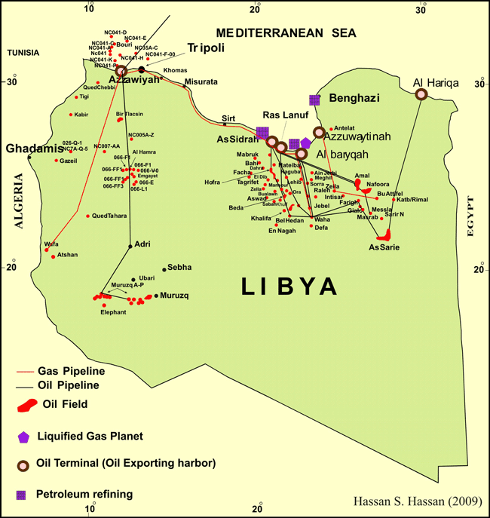

**Questions**

1. How was crude oil formed?

2. Name the rocks where crude oil is found.

3. Which other natural resource is found with crude oil?

4. Mention the method of mining used in getting out crude oil.

5. Describe the location of oil fields in Libya.

6. What machine is used to drill crude oil?

7. How is crude oil transported to the refinery in Libya?

8. Give three advantages of transporting crude oil used pipelines.

9. What is a refinery?

10. Mention the tank where crude oil is put and heated at the refinery.

11. Mention the products from crude oil.

12. State the by products of crude oil.

13. How does Libya benefit from oil exploitation?

**PROBLEMS FACED BY THE OIL MINING INDUSTRY IN LIBYA**

* Pollution
* Shortage of labour in other economic sectors.
* Price fluctuation of oil.

**Questions**

1. How has the oil mining industry affected other economic sectors in Libya?

2. How does climate affect the economic development of Libya?

3. Suggest two advantages of Libya has of her population.

4. Suggest the difference in terms of oil benefit in Nigeria and Libya.

5. Give two reasons why Libya’s oil is on great demand compared to other countries.

6. Give one reason why Uganda does not import oil.

7. Give one advantage of importing crude oil.

8. Give four reasons why Libya is more developed in the North than in the South.

9. Give two reasons why Southern Libya is not developed.

10. Give two reasons why OPEC was formed.

**THE LOCATION OF NIGERIA**

Nigeria is located in West Africa. It has a coastline. The parts of Nigeria are; por Harcout, post Warri, Port Lagos.

**NEIGBOURS OF NIGERIA**

**North South**

-Niger -Atlantic Ocean

-East -Northeast

-Cameroon -Chad

-West - Benin

**NIGERIA’S LOCATION**

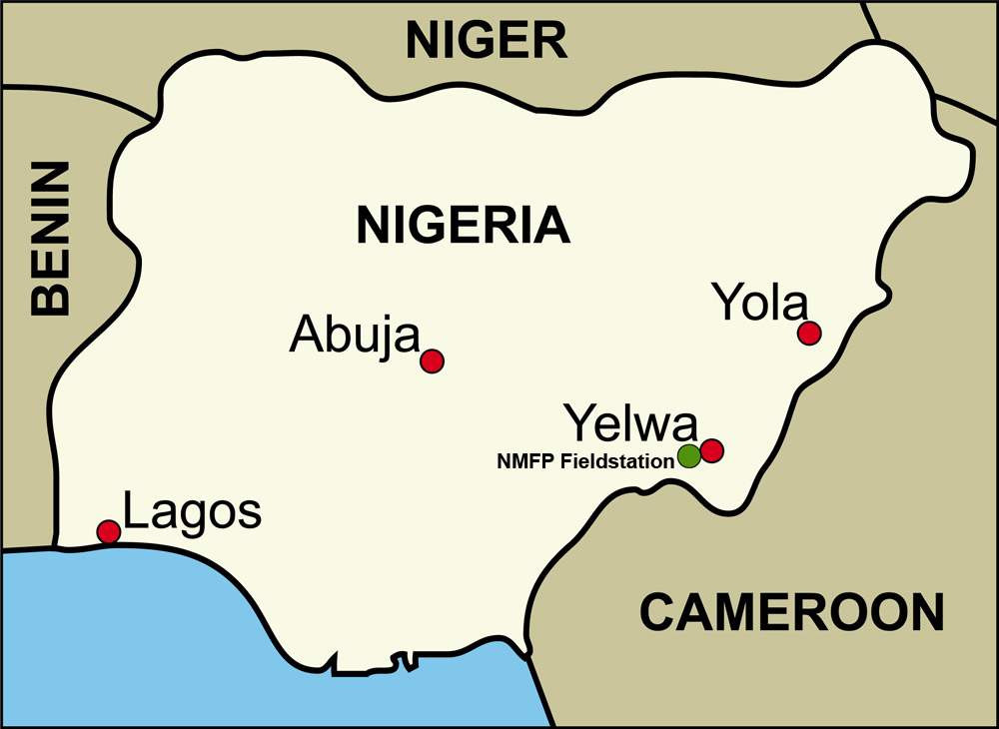

.

**HOW HAS NIGERIA BENEFITED FROM PETROLEUM**

* It earns Nigeria foreign exchange.
* It has created employment to people.
* It has led to improvement of infrastructure.
* Nigeria gets fuel for home use.
* Nigeria gets taxes from oil companies.

**DISADVANTAGES OF PETROLEUM TO NIGERIA**

* Leads to air pollution.
* Leads to environmental destruction during drilling.
* It has led to low production in other sectors.

**Questions**

1. Write down member countries of OPEC in Africa.

2. Name food crops grown in Nigeria.

3. Name cash crops grown in Nigeria.

4a) How has Nigeria benefited from her large population?

b) In which way is the population of Nigeria a disadvantage?

5. Compare Uganda and Nigeria in terms of;

a) Population

b) Development

c) Location

d) Economy

e) Historical background

f) Climate

**THE LOCATION OF SOUTH AFRICA**

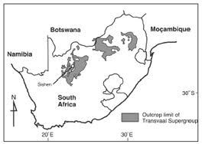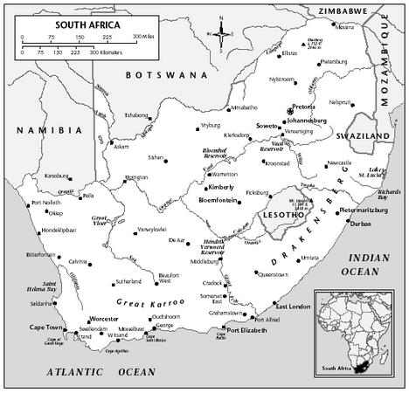

1.**Describe the location of South Africa.**

- It is located in South Africa.

- It has a coastline with Atlantic ocean and Indian Ocean.

- It has the following sea ports

* Port Durban

* Port Cape town

* Port Elizabeth

* Port East London

* Port Richard’s Bay

2.**Name the neighbouring countries of South Africa to the North**

- Botswana

- Namibia

- Zimbabwe

- Mozambique

- Swaziland

3.**Name the enclave country of South Africa.**

- Lesotho

4.**Describe the climate of South Africa**

- South Africa has the types of climate below;

i) Mediterranean climate

ii) Temperate climate

iii) Montane climate

iv) Tropical climate

v) Semi-desert climate

vi) Desert climate

5.**Mention the factors that yhave contribute to the agricultural development of South Africa**

- favorable climate

- Fertile soils

- Developed science and technology

- Availability of capital

- Availability of market

6.**Give examples of citrus fruits grown in South Africa**

- Lemons

- Oranges

- Vines

- Grapes

7.**Mention the crops grown at Natal province**

- Maize

- Sugarcane

- Barley

8.**Which economic activity takes place to Temperate grasslands (velds)**

Sheep rearing for wool / goat rearing

**9. Describe the relief of South Africa**

South Africa has Cape Rangers (by folding), Drakensburg mountains (By Vulcanicity, great Karoos ( by vulcanicity).

10.**Mention the factors that have contributed to the industrial development of South Africa.**

- Availability of raw materials.

- Labour (skilled and unskilled)

- Availability of markets.

- Availability of capital.

- Good transport.

- Availability of power

11.**Factors that have contributed to the development of the mining sector to South Africa**

- Availability of minerals

- Availability of market.

- Availability of skilled and unskilled labour.

- Availability of capital.

- Availability of machinery.

- Good transport network.

12.**Apart from South Africa, stat any other two countries in Africa which have developed industry.**

- Egypt

- Nigeria

13.**Mention the economic advantages South Africa has over Uganda**

- South Africa has a coastline while Uganda is landlocked.

- South Africa has more industries than Uganda.

- South Africa had better transport network than Uganda.

- South Africa has more foreign investors than Uganda.

- South Africa has more skilled labour than Uganda.

- South Africa has more mineral resources than Uganda.

- South Africa has more developed tourism industry than Uganda.

14.**How has industrial development of South Africa affected other economic sectors?**

- It has caused lack of labour in other economic sectors.

- It has led to low production in other economic sectors.

15.**How has the mining industry of South Africa supported the development of a country?**

- It has provided raw materials to industries.

- It has created employment.

- It is a source of revenue to the country.

- South Africa has improved the infrastructure.

16.**What caused the apartheid policy?**

- The whites never wanted to share economic resources with blacks.

- The whites never wanted to share with blacks the politics of the country.

17.**Who started the apartheid policy?**

- Dr. Henrik Verwoed

- Dr. D. F. Mallon

18.**How was the policy of apartheid practices in South Africa?**

- Whites and blacks never shared hospitals.

- Whites and blacks never shared schools.

- Whites and blacks never shared roads.

19.**How did OAU help South Africa to end the policy of apartheid?**

- OAU eliminated South Africa from all African games.

- Put trade sanctions against South Africa.

- Put transport sunctions against South Africa.

20.**What were the conditions in Botswana?**

- Poor roads.

- Poor health services.

- High spread of diseases.

- Poor schools.

**PLANTATION FARMING**

This is the growing of one perennial crop on a large scale for sale.

**State the factors that influence the location of a plantation farm**

i) A large piece of land ii) Capital

iii)Labou iv) Market

v) Machinery vi) Transport

**Advantages of plantation farming**

i) Plantation farms provide employment to people.

ii) They provide raw materials to industries.

iii) They earn foreign income by exporting the produce.

iv) They provide market to out growers.

v) They give high yields since scientific methods are used.

**Problems faced by plantation agriculture**

i) Pests and diseases.

ii) Poor transport (poor roads)

iii) Climatic changes.

iv) Low prices of the procedure on the world market.

**Disadvantages of population agriculture**

i) It requires a lot of capital.

ii) it requires a lot of land.

iii) It promotes monoculture that leads to soil exhaustion.

iv) Over production leads to price fluctuation.

**Characteristics of plantation farming**

i) One perennial crop in grown.

ii) Crops are grown on a large scale.

iii) Requires machinery

iv) It requires a lot of labour force.

v) It involves a processing centre ( a factory)

**Give examples of plantation crops**

i) Sugarcane

ii) Oil palm

iii) Tea

iv) Coffee

v) Cocoa

vi) Sisal

vii) Rubber

|  |  |
| --- | --- |
| **crops** | **Areas of production** |
| Tea | Kasaku in Mukono  Kericho in Kenya  Hoima |
| Sugarcane | Kakira, Kinyara, Lugazi in Uganda.  Kirombero –Tanzania  Kenana Sudan  Natal province –South Africa |
| Cotton | Mubuku, Lira, Soroti – Uganda  Gezira – Sudan  Liberia |
| Rubber | Liberia |
| Oil palm | Kalangala, Nigeria |
| Cocoa | Ghana, Nigeria, Ivory Coast  Mukono, Bundibugyo |
| Coffee | Buganda region  Slopes of Mt. Elgon  Arua, Ethiopia  Slopes of Mt. Kilimanjaro by the Chagga |

**Give three reasons why plantation is not commonly practiced in East Africa**

i) Lack of capital

ii) Lack of land

iii) Lack of machinery

**How does plantation farming promote economic development to a country?**

i) It employs people.

ii) It earns foreign income.

iii) Develops infrastructure in the country.

iv) Provided raw materials to industries.

v) It is a source of taxes to the government. They provide taxes to the government.

vi) They provide market to the out growers.

**Mention the services that are provided by plantation farms**

* Transport -Education
* Medical -Housing
* Banking

**Suggest any four ways in which plantation farming can be promoted in Uganda**

1. Giving loans to plantation farmers so as to improve their farms.
2. Providing land to plantation farmers.
3. Improving road network in the country.
4. Providing chemicals to plantation farmers.
5. Providing quality seeds to plantation farmers.

**Mixed Farming**

1.**What is mixed farming?**

The growing of crops and rearing of animals on the same piece of land.

**2. Factors that influence the starting of a mixed farm**

i) Enough land with fertile soils.

ii) Capital

iii) Enough labour

iv) Market

v) Water source

vi) Machinery

v)Animals e.g cattle, pigs, chicken

vi)Selected seeds

**Advantages of mixed farming**

i) A farmer get double income

ii) A farmer gets a balanced diet.

iii) Crops can be used to make animal feeds.

iv) Animals provide manure to crops.

v)A farm employs people.

vi)A farm is used for study purposes,

**Disadvantages of mixed farming**

i) It is very expensive to start and maintain

ii) Animals can destroy the crops.

iii) It requires a lot of land.

iv) It requires a lot of labour

v) It needs high technology

**Problems affecting mixed farming**

i) Crop pests and diseases.

ii) Animal disease and parasites

iii) Climatic changes

iv) Lack of enough land

v) Poor transport

vi) Shortage of market

**Q**n a)Mention the area in East Africa where mixed farming is developed.

Qn b) Give two factors that have contributed to the development of mixed farming in Kenya highlands.

Qn c Give two reasons why mixed farming is not common in East Africa.

**Dairy Farming**

This is the rearing of animal for milk production

**Factors that influence the starting of a diary farm**

i) A large piece of land

ii) Good pastures

iii) Favourable climate iv) Labour

v) Reliable source of water vi) Good veterinary services

vii) Market viii) Capital

ix) Good breeds of animals

**Advantages of dairy farming**

i) Employs people

ii) A farmer gets a lot of income

iii) Good breeds of cattle can be got

iv) Sources of raw material for the dairy processing factory

**Disadvantages of dairy farming**

i) It requires skilled labour

ii) It is expensive

iii) It needs a large piece of land

iv) Lack of ready market for dairy products

**Problems affecting dairy farming**

i) Animal diseases and parasites.

ii) Poor transport network.

iii) Lack of pasture for animals.

iv) Lack of water for the animals

v) Lack of ready market

vi) Lack of good breeds / poor breeds of cattle.

**Qn.Suggest any three ways in which dairy farming can be improved in East Africa.**

**Ranching**

**1.What is ranching?**

The rearing of cattle mainly for beef production.

**2.Write down the product form a ranch**

* Beef
* Hides and skins
* Horns

**3.In which way does a ranch contribute to the development of an area where it is located?**

* Provides employment to people.
* Helps to develop infrastructure in the region.
* People yet beef from the farm
* They get skins from the farm.

**4.How does a ranch benefit from people where it is located?**

-A farm gets labour.

-A farm gets market.

**5.What is livestock farming?**

This is the rearing of domestic animals and birds.

**6Give the importance of livestock farming**

- Creates employment.

- It is a source of income by selling the animals and products.

- Source of raw material.

- Source of food.

**7Mention three problems facing livestock farming**

i) Animal diseases and parasites.

ii) Shortage of water and pasture.

iii) Climatic changes.

iv) Cattle rustling.

**8Mention any three ways of improving livestock farming in East Africa?**

i) By crossbreeding the animals.

ii) Constructing valley dams to proved water to animals.

iii) By feeding the animals well.

iv) By vaccinating animals to control diseases.

v) Planting drought resistant pasture for animal.

vi) By disarming the cattle rustlers.

**9.What is nomadic pastoralism?**

This is the movement of cattle keepers from one place to another looking for water and pasture for their animals.

**10.Give three reasons why people keep cattle?**

- To get milk and beef.

- Source of income / for home use.

- For bride price.

- For prestige.

- For hides and skins.

- For ploughing

**11.Write five pastoral tribes in Africa**

Hausa Fulani

Turkana Masai

Tuareg Bahima

Dodoth Boran

Pokot Rendille from Somali and Kenya

Somali

**12. Mention the modern methods of keeping cattle**

i) Zero grazing

ii)Paddocking

iii)Tethering

**13. State the traditional methods of keeping cattle**

Herding

**14. Give two disadvantages of herding as a method of keeping cattle**

i) Animals destroy people’s crops.

ii) Animals can be stolen.

iii) Lead to spread of diseases.

iv) They were conflict among people.

**15. Give advantage of keeping local breeds over exotic breeds**

i) Local breeds are more resistant to diseases than exotic breeds.

ii) Local breeds are more resistance to harsh climate than exotic breeds.

iii) Local breeds produce better meat than exotic breeds.

**16. Give the advantage of keeping exotic breeds over local breeds**

i) Exotic breeds mature faster than local breeds.

ii) Exotic breeds produce more meat than local breeds.

iii) Exotic breeds produce more milk than local breeds.